Website Copy (content and graphics)
In this document, please a find a brief website description and two (2) headers/graphics options with information pertaining to senior food assistance and other resources to help with common expenses such as phone, internet, and utilities. The content includes a link that directs seniors to an NCDHHS senior-specific webpage where they can learn more about food assistance and other programs that they may be eligible for. Please feel free to utilize these resources on your organization’s website to inform seniors about these programs.
Website Content:
As grocery prices continue to rise, senior citizens can get help filling their baskets. Individuals age 60+ who are balancing a limited income may be eligible to participate in several North Carolina programs that offer food benefits and help with common expenses such as utilities, phone, and internet. These programs include food assistance such as NC Food and Nutrition Services (FNS).
Learn more about the different types of assistance available to you, as well as how to qualify and apply, at www.NCDHHS.gov/SeniorResources.

Graphic #1:
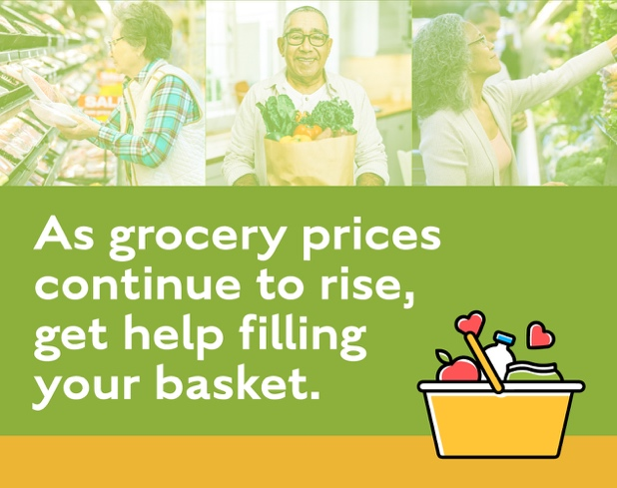

Graphic #2:

