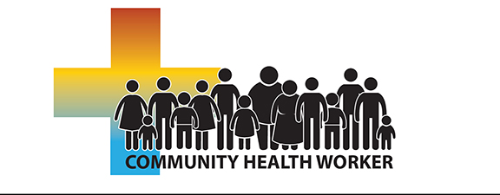
ROBESON COMMUNITY COLLEGE PRESENTS:
North Carolina
Community Health Worker Online
This course is designed to provide individuals with the required knowledge, tools, and resources to become recognized as a certified Community Health Worker (CHW) in North Carolina, working in a variety of healthcare and community settings. (Health Departments, Hospitals, Federally Qualified Health Centers, Clinics, Faith-based Organizations, etc.) Upon successful completion of this class, student may be eligible for listing as a NC Certified Community Health Worker.
DATE: April 5th, 2021 – August 2nd, 2021
LOCATION: Online, Blackboard, LMS (with exception of required CPR)
REGISTRATION: www.robeson.edu/healtho Then press “Click to Register”
CONTACT: Christy Locklear at 272-3609 or chlocklear@robeson.edu
Required Course Material: Foundations for Community Health Workers
Second Edition by Tim Berthold, (2016) Published by Josey-Bass
ISBN 978-1-119-06081-9
PRE-REQUISITES: High School Diploma or GED

