***Following the Pathway to Opportunity***

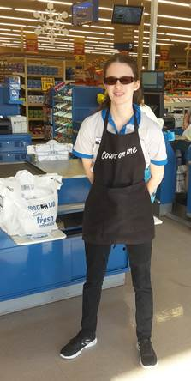

**Christina Gralak, Front End Associate**

Food Lion, Inc.

&

Division of Services for the Blind Success Story

**NORTH CAROLINA**

*Department of Health and Human Services*

**DIVISION OF SERVICES FOR THE BLIND &**

**STATE REHABILITATION COUNCIL**

**2016 ANNUAL REPORT**

**NORTH CAROLINA**

**DIVISION OF SERVICES FOR THE BLIND AND STATE REHABILITATION COUNCIL**

**2016 ANNUAL REPORT**

As part of the North Carolina Department of Health and Human Services (DHHS), the Division of Services for the Blind (DSB) strongly supports the department’s mission, which is, in collaboration with its partners, to protect the health and safety of all North Carolinians, and provide essential human services.

DSB has a long and rich history of providing specialized and individualized services to people who are blind, visually impaired and deaf-blind. Established in 1935, with the assistance of Helen Keller, the N.C. Lions Foundation, the Governor Morehead School for the Blind, and others, DSB offers an array of programs and supportive services funded with federal, state and county resources. DSB provides services statewide, covering every county in the state through staff located in seven district offices, through third party agreements with local Department of Social Services offices and County School systems, and through the Rehabilitation Center for the Blind.

Vision loss can occur at any time and to anyone, completely overturning life as it was previously known. People may be unable to find a job, continue to work, care for themselves, organize their home, and even function in their normal role within the family. Vision loss can have devastating financial costs, in addition to the emotional and psychological costs. Losing one’s livelihood to vision loss is shattering. A single year of blindness for a working age American costs the federal government approximately $12,000, which is less than the income that may have been earned if working.

With services available through programs at DSB, along with their partnership with a variety of other programs across the state, individuals of all ages that experience blindness, significant vision loss, or a combination of vision loss and hearing loss can obtain the required assistance that relates to their vision. Gaining the skills necessary to remain independent is the foundation for quality of life and obtaining, maintaining, or returning to work is a vital part of this need for many people.

**North Carolina**

**DSB and State Rehabilitation Council**

**2016 Annual Report**

***Following the Pathway to Opportunity***

**Table of Contents**

Page

N.C. DSB, State Rehabilitation Council 2015 - 2016 4

Chairperson’s Message 5

Director’s Message 6

Consumer Satisfaction Survey 7

DSB Vocational Rehabilitation Services 8

DSB VR Business Development & Placement Services 9

Working Together on the Pathway to Success 11

DSB Assistive Technology 15

DSB Business Enterprise Program 17

DSB School to Work/Transition Services 18

WIOA: Pre-Employment Transition Services 20

DSB Transition Summer Youth Mini-Centers 21

DSB Supported Employment 23

Community Based Work Adjustment 24

DSB Rehabilitation Center for the Blind and Evaluation Unit 25

DSB Independent Living Services Program 36

DSB Medical Eye Care Program 38

DSB Independent Living Rehabilitation Program 39

ILRC Case of the Year 41

DSB Deaf/Blind Program 43

Following the Pathway to Re-Acquired Independence 44

Collaboration and the Deaf-Blind Community 47

How to Contact DSB 48

**N.C. DSB**

**STATE REHABILITATION COUNCIL**

**2015 - 2016**

**David Barnwell, Chairperson Winston-Salem Industries for the Blind**

**David Horton, Vice Chairperson Representative of Community Rehabilitation Services**

**Sandra Hicks Statewide Independent Living Council**

**Agreta Limerick N.C. Division of Workforce Development**

**Debra Pickens Parent Training and Information Center**

**Karen Kelly Parent of a Child with a Disability**

**Anastasia Powell Advocacy Group for People with Disabilities**

**Vacant Department of Public Instruction**

**Community Rehabilitation Services Provider**

**Helene C. Wells Recipient of DSB VR Services**

**Celeste Hunt Directors of Projects under Section 121 of the Rehab Act**

**Ex-Officio Members**

**Cynthia Speight Interim Director, DSB**

**Jordan Thomas Vocational Rehabilitation Counselor, DSB**

**STATE REHABILITATION COUNCIL**

**CHAIRPERSON’S MESSAGE**

As the Chairperson of the North Carolina State Rehabilitation Council, I am privileged to present the 2016 Annual Report for the council and the North Carolina Division of Services for the Blind (DSB). The theme for this annual report is, “Following the Pathway to Opportunity.” In the ensuing pages, many examples of true pathways emerge from the opportunities provided by DSB.

Many opportunities came to the council and DSB this past year. Several of these opportunities came, and continue to come, with the final rollout of the Workforce Innovation Opportunity Act (WIOA) regulations. Rehabilitation services, especially in the youth services area, are being enriched and driving consumers to substantial vocational rehabilitation outcomes.

For instance, DSB’s School to Work Transition Services program provides a tailored set of services for students with visual impairments for successful graduation through school to a successful employment outcome. This past year, 335 students aged 14-21, were active with DSB with 43 youth work experiences provided.

Additionally, the Pre-Employment Transition Services (PETS) program continued to grow in 2016 with five main tenants: a) job exploration counseling; b) work-based learning experiences; c) counseling on opportunities in higher education; d) workforce readiness training, such as independent living skills; and e) instruction in self-advocacy, such as peer mentoring. The staff at DSB have provided these necessary services with enormous success and regularity throughout our state.

Beyond these recent and vital services to our youth with visual impairments, the staff of DSB have also seen to serving the whole state with vocational rehabilitation. This past year, DSB provided vocational rehabilitation services for 2296 individuals and achieved 370 successful employment closures. In addition, 99 percent of vocational rehabilitation consumers closed successfully began wage earning employment.

I am quite proud to share with you the successes of this past year and share my excitement for the new year.

**David Barnwell, Chairperson**

**North Carolina State Rehabilitation Council for the Blind**

**DSB**

**DIRECTOR’S MESSAGE**

Opportunity is defined as “a set of circumstances that makes it possible to do something.” The Division of Services for the Blind (DSB) provides a full-range of comprehensive services, supports, or “opportunities” to assist individuals who are blind, visually impaired and deaf-blind achieve their employment and independent living goals. DSB’s vocational rehabilitation services for students and youth with disabilities have been expanded and enhanced. Additional career development resources and tools have been obtained, and are available to consumers across the state. Stronger employer relationships have been cultivated and greater alignment with our workforce partners has been created. Consumers who began their training with reservations about their abilities at the N.C. Rehabilitation Center for the Blind, or in our community-based learning centers, i.e. Mini Centers or one-on-one in the home, have completed the training with confidence and new skills. I am honored to introduce you to our 2016 Annual Report. Please enjoy the story of the various pathways of opportunity that consumers have followed to achieve success!

**Cynthia Speight, Interim Director**

**N.C. Division of Services for the Blind**

**Department of Health and Human Services**

**2016 CONSUMER SATISFACTION SURVEY**

Each year, the DSB, in cooperation with the State Rehabilitation Council, conducts a *Consumer Satisfaction Survey* of people who completed rehabilitation programs for the fiscal year. DSB sent 223 surveys and 89 were returned completed.

Here is what our consumers had to say:

**Did DSB staff…**

* Treat you with courtesy and respect: most or all the time – 96.7 percent
* Promptly return telephone calls: most or all of the time – 95.5 percent
* Schedule appointments in a timely manner: most or all of the time – 93.3 percent

**Did your DSB Rehabilitation Counselor…**

* Provide information about your eye condition and how it may affect your employment: most or all the time – 91.0 percent
* Discuss your job skills, abilities and interests with you: most or all the time – 84.3 percent
* Refer you to other programs for assistance, if needed: yes – 61.8 percent

(32.6 percent stated such referral was not necessary and were therefore not referred)

**When developing your Individual Plan for Employment (IPE)…**

* Your counselor and you discussed your options together, then you chose your job goal or you chose your job goal: 68.5 percent (4.5 percent did not answer the question)
* Your counselor provided information about the services you would require to be able to obtain, regain or maintain your job: 34.8 percent (44.9 percent indicated that they researched such information on their own, 6.7 percent did not answer this question, and 9.0 percent stated they were not sure)

**Overall, were you satisfied with the services you received from DSB?**

* Overall rating of experience with the Division as satisfied – 87.5 percent

**DSB VOCATIONAL REHABILITATION SERVICES**

People with blindness or visual impairment who want to work may be eligible for DSB Vocational Rehabilitation (DSB VR) services. DSB provides vocational rehabilitation to help individuals obtain, maintain or regain employment. All services provided by this program are geared toward gainful employment that will result in self-support and independence. Eligible people develop an individualized plan of services to help them reach their vocational goal which may include guidance and counseling, medical, training, and job search and development services that best suit their individual vocational needs.

DSB’s vocational rehabilitation counselors and specialized transition rehabilitation counselors serve as counselors and case managers for people requesting vocational rehabilitation services. They are responsible for providing and coordinating the services necessary to go to work. Teamwork with specialists in specific areas – DSB business services representatives, community employment specialists, a rehabilitation engineer, assistive technology consultants, assistive technology instructors, a vocational evaluator and various Rehabilitation Center staff, as well as deaf-blind specialists who work with people with both blindness and hearing loss – is coordinated through the DSB VR staff. In addition, all support staff in the area and district offices, as well as the team of administrators in the state office, strive to find ways to assist people achieve successful employment outcomes. Services are coordinated with DSB social workers for the blind, independent living rehabilitation counselors, orientation and mobility specialists, and nurse eye care consultants as needed.

Accessible services are planned according to each person’s employment goals and needs. Some services provided are based on economic need, while others are provided regardless of income. These services may include:

* **Guidance and counseling services**, such as vocational/career counseling, job retention counseling, adjustment to vision loss counseling, and supportive counseling
* **Training services**, such as vocational and/or job specific or academic training, orientation and mobility services to teach individuals safe travel skills (use of a sighted guide and white cane, and safety techniques to travel independently), on-the-job training, supported employment, or work adjustment job coaching;
* **Independent living training** at the residential training DSB’s Rehabilitation Center for the Blind or through local staff;
* **Assistive technology** required for the vocational goal, such as low-vision evaluations and equipment purchase, assistive technology evaluations and purchase of equipment, video magnification (CCTV) evaluations, or training in use of the equipment either locally or at the Rehabilitation Center for the Blind;
* **School to work services**, such as counseling with students beginning at age 14 as they plan their future and providing the Summer Adapting to Blindness Vital to Visually Impaired Youth (SAVVY) program at the Rehabilitation Center for the Blind, Youth Mini-Centers, and various specialized programming for youth
* **Job placement services**, such as job matching, job search skills training, work experiences, job modification, and follow-up services
* **Medical services** that are required for eligible people to obtain, maintain, or regain employment, such as diagnostic eye examinations, eye glasses or other types of corrective lens, eye treatment, eye care education and eye surgery.

**DSB VR Business Development and Placement Services**

To improve employment outcomes of people with blindness, visual impairments, or deaf-blindness, DSB supports the dual customer approach – consumers and businesses are welcomed as customers of DSB services. Business services, such as work observations, on-the-job training, and job modifications address the recruiting and hiring needs of employers with attention to supporting businesses’ bottom lines.

A major initiative over the past year has been to increase the number of Unpaid Work Experiences provided to consumers in an effort to increase a client’s work experience, which would positively affect their resume and job application appearance, general confidence in their ability to work, opportunities to meet and work with area employers, knowledge of the world of work and how they fit into it as well as working knowledge of their assistive technology, orientation and mobility skills and other supports that may be used by them in the workplace to increase success. This program has been widely used by the DSB Transition Program, and its use continues to increase among the adult population and has met with much success. Consumers reported gaining confidence and valuable work experience that has helped shape their job goal and for some, resulted in gainful employment. This is a tool that will continue assisting consumers in meeting their goals.

**DSB VR OUTCOMES FOR FY 2016:**

* DSB Vocational Rehabilitation Services were provided to 2296 individuals with blindness or low vision
* DSB VR has achieved 370 successful employment closures
* Average wages for successfully employed consumers: $12.44
* DSB VR assisted 4 Veterans in achieving successful employment
* 107 VR consumers were supported through sponsorship and assistive technology to participate in Unpaid Work Experiences to prepare them for their chosen profession
* Ninety-nine percent of VR consumers closed successfully entered wage earning employment

**Unpaid Work Experiences and Internships** are training tools that can provide unique opportunities to place consumers in positions with businesses, permitting the individual consumer an opportunity to gain valuable work skills and the business an opportunity to consider the individual for employment. These initiatives are supported by the Workforce Innovation and Opportunity Act, and have proven to be a valuable tool in preparing for successful employment.

**Working Together on the Pathway to Success**



Life for Christina is looking up! Christina has two goals in her young life that she wants to achieve. One is to find employment and the second is to move into her own apartment. Christina is a 20-year-old woman who has a primary congenital eye condition called optic neuropathy. This eye condition damages the optic nerve, causing vision loss. Christina also has moderate to profound mixed bi-lateral hearing loss. She can see images better when they are close-up. Christina uses “Total Communication” to communicate with the hearing world, including her residual hearing for English, lip reading, ASL, and a 20/20 pen and paper.

When Christina first came to DSB, she was a teenager, somewhat shy with no confidence, preferring her mom to answer questions for her. As the DSB team of professionals began working with Christina, she flourished before their eyes.

Christina’s DSB team consisted of VR Counselor Britany Greer, Orientation and Mobility Instructor Eileen Walsh, Community Employment Specialist David Branch, and Deaf-Blind Specialist Debra Lyons. The first DSB team member to gain Christina’s trust and begin working with her toward her goal of employment was her VR Counselor. She provided Christina with guidance and counseling in the areas of independent living, reasonable accommodations, self-advocacy and appropriate job behavior, including what an employer expects from an employee. Perhaps the catalyst that set a fire under Christina to eagerly seek employment was her decision to accept Greer’s offer to attend a four-week Summer Program called the World of Work (WOW). WOW is one of three Summer Programs offered by DSB VR counselors for blind, visually impaired or deafblind youth. This program is for rising juniors, seniors and recent high school graduates, and is based at the Rehabilitation Center for the Blind in Raleigh, NC. The main goal is to prepare students for the world of work. Teens learn work ethic and work behaviors through paid internship experiences. Teens also increase communication skills and interpersonal skills, build confidence and self-reliance, and learn employer expectations. During this summer program, Christina went to work at the Slightly Worn Thrift Shop as a retail clerk. For four weeks, Christina filled out a time sheet and received a pay check. If she was sick, she did not get paid for the hours missed. She loved it!

Christina was ready to seek employment full time, but needed the opportunity to prove herself. David Branch is a DSB team member that worked with Christina as a Community Employment Specialist. He set up a work experience for Christina at a local super market. A trial work experience opportunity is an excellent tool that DSB VR uses to prove to the employer the consumer can do the job at no cost to them, and to see if the consumer is interested in pursuing the job. Many times, it leads to permanent employment for the consumer.

Another DSB team member working with Christina is the Orientation and Mobility person, Eileen Walsh. Eileen taught Christina how to ride the bus to the work experience job site, providing Christina with the independence to travel to work by herself, if she chooses to.

Deaf-Blind Specialist Debra Lyons assisted with communication during the bus ride. The DB Specialist joined the DSB team working with Christina when she was introduced to Christina about a year-and-a-half ago, after receiving a referral from her VR counselor. The Deaf-blind Specialist completed a Deaf-Blind Assessment with Christina, and recommended a pocket talker device that amplifies sound and a vibrating alarm clock to ensure she could independently wake up on time for work.

The DB Specialist provided sensitivity training to the managers and other employees, making Christina and everyone working with her comfortable. The Deaf-Blind specialist taught staff how to properly use an interpreter with Christina, educating them to speak and directly look at Christina and not the interpreter, when present. Also, to not use third-person tense, such as, “ask her, or tell her,” how to best get Christina’s attention by lightly tapping her on the shoulder, how to communicate using a 20/20 pen and paper when the interpreter is not present, and answered all questions from the staff. The Deaf-Blind Specialist also reviewed rules with Christina regarding using the reflective safety vest when outside in the parking lot.

The Deaf-Blind Specialist began job coaching Christina at her work experience site and stated that she started off with flying colors! She is a quick learner and picked up on all duties of the “front end” position at Food Lion. To ensure her success during the first few weeks, the Deaf-Blind Specialist worked alongside Christina as her job coach/support member. Christina needed almost no prompting and showed wonderful initiative within her work duties. Soon, Christina was surveying the parking lot to see if the carts needed to be pushed to the store. She went to the parking lot alone, wearing the required reflective vest, collected the scattered carts and pushed them to the store. While bagging groceries, she is always on the lookout for the next cashier to ensure she is bagging the groceries for everyone without being told to do so. Christina keeps her pen and paper in her pocket at all times when on the job, and prefers to write back and forth to communicate with people she cannot hear. An interpreter was used with Christina the first day to learn essential duties, but after that Christina has relied on her 20/20 pen and paper.

Christina is the star of this success story. She has received nothing but compliments from all employees, and her supervisor has already shared that when Christina completes her work experience and has an opening, Christina will be hired! That is wonderful news for Christina! When asked if she is enjoying her work experience job, she always replies with, “yes, I want to work all the time.” Christina’s manager stated that people with perfect hearing and vision do not do as well. Christina is the role model for work ethic and hard work!

Christina is now in line for training within the produce department. Christina will learn the proper procedure for preparing vegetables and fruits to be placed in the coolers for sale. Christina is always eager to learn new duties and this training will put her in the running for permanent employment.

This is a wonderful example of how the DSB team used a work experience opportunity as a stepping stone to achieve permanent employment. As of now, a confident, motivated Christina is well on her way, using DSB as a stepping stone to achieve her two goals: finding employment and moving into her own apartment!

**DSB ASSISTIVE TECHNOLOGY SERVICES**

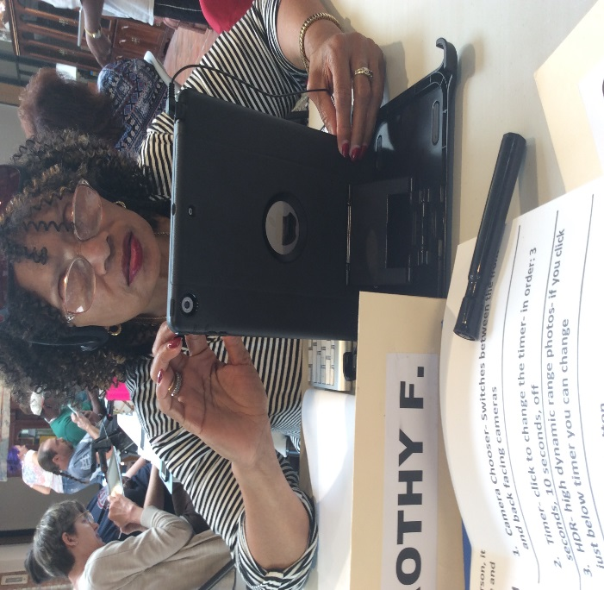

Visually Impaired and Blind Students Learning to Use Ipads

There are six Assistive Technology (AT) Consultants and one Rehabilitation Engineer located across the state in the district offices to provide technology assessments and services in a person’s job site, school setting or home. Four Assistive Technology Instructors are available to provide small group instruction and assistance to individuals across the state. Modifications may include making a change in lighting, adapting telephones, installing safety measures, adapting computer equipment and Braille displays. Services are provided until the best modification is found and the individual can perform the necessary tasks.

**Technology Resource Center**

Located at the Rehabilitation Center for the Blind, the Technology Resource Center has adaptive equipment for large print, speech and Braille access. The center has computers, software, scanners, a variety of closed circuit TVs, and Braille equipment that are available for demonstration and evaluation. The Center provides training on how to use adaptive technology.

Rehabilitation Engineering Services assist people who require AT to be successful in post-secondary training, to obtain jobs where modification is required, or to maintain jobs that require modification or modification updates. These services are made available to program participants who require AT to achieve employment outcomes. Each office has a selection of equipment for evaluation and training purposes. The AT Consultants conduct assessments, recommend equipment, facilitate the purchase procedure, deliver and set up the equipment either in the home or at a job, and follow-up to make sure the equipment is being used as designed. The AT Instructors are available to guide persons in learning the maximum operation of the adaptive equipment.

**DSB VR Assistive Technology Outcomes for FY2016**

There were over 460 DSB VR clients served by Assistive Technology field staff.

**Business Enterprises Program**

The Business Enterprises Program gives legally blind participants the opportunity to operate their own food service or vending facility. This program provides initial training for potential licensees, and ongoing counseling and management services to established operators. Food service and vending facilities are located in federal and state buildings, rest areas and welcome centers, and other public/private locations. Facility operators retain the majority of net proceeds. A small percentage goes to DSB, to assist with program operations. This program was created as a result of the Randolph-Sheppard Act and its amendments, a federal law which was originally passed in 1935, and Chapter 111 of the North Carolina General Statues.

Gross sales from all Business Enterprises facilities increased during FY 2016 to $10,811,989 from $10,450,168 in FY 2015. Net proceeds paid to operators totaled $3,200,767 compared to $3,000,996 during this same period last year. The median net earnings for operators in the state for FY 2016 was $30,327.

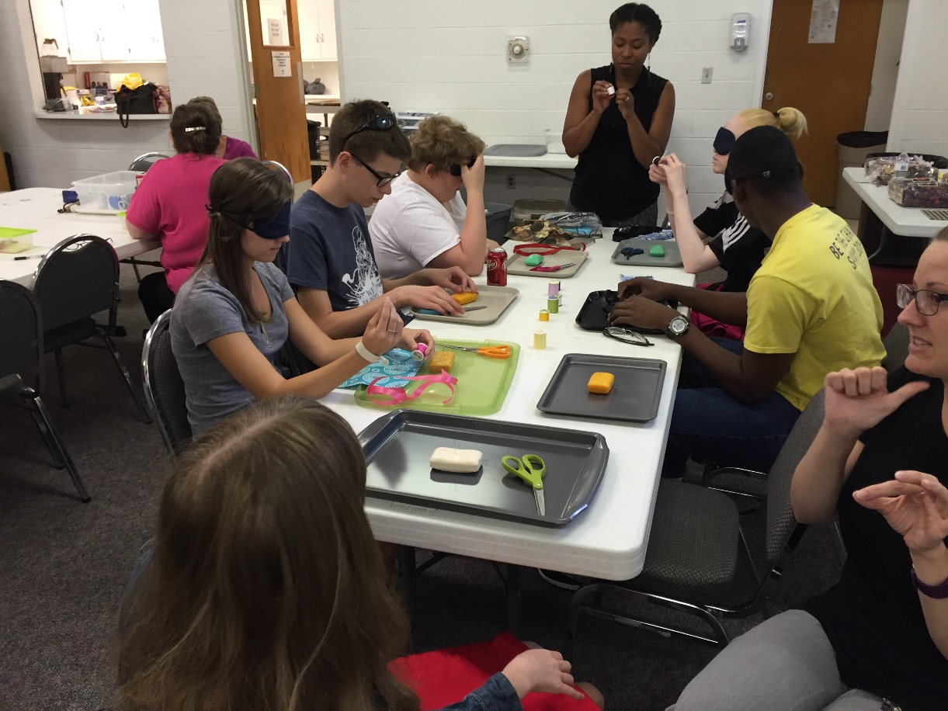

Youth Mini-Center students learn pre-employment transition skills

**DSB School to Work Transition Services**

School to Work Transition Services provides eligible North Carolina high school students with visual impairments a personalized set of services for successful movement through secondary school, post-secondary school, post-school activities and successful employment outcomes. The services can start as early as age 14, and include vocational counseling, career exploration, post-secondary education, vocational training, integrated employment (including supported employment), independent living or community participation. The services consider the student’s preferences and interests, and include counseling, community experiences, development of plans for employment and other post-school adult living objectives, and if appropriate, acquisition of daily living skills and functional vocational evaluation.

In 12 school systems, specialized third-party agreements have been established, and specialized programs are in place to serve students at the Governor Morehead School for the Blind. These programs provide trained DSB VR Counselors and community employment specialists to work with students, as well as with school systems to enhance opportunities in students’ home communities. These students participate in summer jobs, World or Work (WOW) internships and other summer programs, such as learning independent living skills at available Mini Centers, surfing, kayaking or canoeing.

Students needing education after high school to reach their vocational goals are assisted by a DSB VR counselor in planning and obtaining the required training. The counselor can assist in locating a vocational or post-secondary training site featuring classes that prepare them for their job goal, help identify financial resources to cover part or all of their training coasts, including financial assistance from DSB, and in obtaining assistive technology required to complete the training. The counselor continues working with the student throughout the post-secondary program to ensure success.

Students planning to go to work after high school receive assistance in job exploration, job seeking, job development and placement from a DSB Community Employment Specialist and counselor. If the student requires additional one-on-one assistance, specialized job seeking and training programs, such as community-based work adjustment or supported employment, is available to help in many cases.

DSB Transition Services provide summer programs for students who are blind or visually impaired, in collaboration with DSB’s Rehabilitation Center for the Blind’s Summer Adapting to Blindness Vital for Visually Impaired Youth (SAVVY) programs in Raleigh. This program includes three focus areas: a WOW internship program, training for independent living skills and career exploration for younger youth and college preparation for older students.

Approximately 30 students with the Transition Program are graduating from high school this year, and DSB is prepared to support them as they transition to work, school-to-job training or post-secondary training.

Our Assistive Technology consultants provide AT assessments to youth transitioning from high school to post-secondary educational institutions. AT assessments are also performed for consumers who need accommodations at their worksite in order for them to maintain employment. For consumers already enrolled in college, DSB purchased the recommended technology needed to be successful in college, including computers, printers, portable CCTV’s and JAWS or ZoomText software.

Transition counselors and community employment specialist throughout the state continue to seek job-shadowing opportunities and trial work experiences tailored to each student’s vocational interest and career goals. DSB transition counselors and community employment specialists also continue to seek internship opportunities with employers. This past year, the Transition Program provided 43 work experiences to youth in several settings. These students did various jobs, including laundry assistant at a Nail Spa, a political journalist at a local newspaper, an audio-visual technical assistant at a church and working with a college athletic coach in recruiting of high school students for the college.

The goal of the transition program is to work with the student as early as possible to assist in the development of independence and a career path of their choice, and to be successful in reaching their goal of competitive integrated employment.

**DSB Transition Outcome for 2016**

* **Total students age 14 – 21 active with DSB: 335**
* **Youth Work Experiences Provided: 43**

**Pre-Employment Transition Services**

DSB’s Transition Program has continued to provide exceptional transitional services to youth with visual impairments in North Carolina that are eligible for DSB’s Vocational Rehabilitation program. The program’s continued partnerships with high school visual impairment instructors, and exceptional children staff at the Department of Public Instruction (DPI) and in various school systems remains very strong. These partnerships have been reinvigorating and the support of the administrative staff, guidance counselors, EC case managers, and EC teachers has proven beneficial in the growth of the Transition Program.

With the passing of the Workforce Innovation and Opportunity Act that was signed into law July 22, 2014 DSB has begun a program of Pre-Employment Transition services to students with disabilities (including potentially eligible students) so they can successfully obtain competitive integrated employment.

The law defines student with a disability as: “student with a disability” applies to all students enrolled in educational programs, including postsecondary education programs, so long as they satisfy the age requirements set forth in final §361.5(c)(51) (ages 14 – 21). The definition is also inclusive of secondary students who are homeschooled, as well as students in other non-traditional secondary educational programs.

There are five pre-employment transition services that the act requires to be provided. They are:

(1) Job exploration counseling

(2) Work-based learning experiences, which may include in-school or after school opportunities, or experience outside the traditional school setting (including internships provided in an integrated environment to the maximum extent possible

(3) Counseling on opportunities for enrollment in comprehensive transition or postsecondary educational programs at institutions of higher education

(4) Workplace readiness training to develop social skills and independent living

(5) Instruction in self-advocacy, which may include peer mentoring.

DSB is implementing methods to ensure that these services are provided to students with visual disabilities across North Carolina with the highest of quality. A major tool that DSB has used to accomplish this has been through the Youth Mini-Centers

**DSB Transition Summer Youth Mini Centers**

DSB continues to provide a week-long Youth Mini Center in various parts of the state during the summer, in collaboration with DSB independent living counselors. During this week-long Mini Center, transition counselors and community employment specialists assist ILR counselors and Mini Center instructors in teaching self-advocacy skills, life skills, cooking, cleaning, labeling, introduction to braille, and other self-help skills. DSB orientation and mobility specialist and nursing eye care consultants participate in the week-long Mini Center, providing orientation and mobility skills assessments and low vision assessments to students. They are also given an opportunity for cultural enrichment and community inclusion through participation in various recreational activities and programs offered in the local community. Many students participating this summer gained independent living skills training, while also learning from peers in a group environment.

There were eight Youth/PETS mini-centers held from February through August 2016. A total of 59 youth were served through these centers. Of those, approximately 48 were considered PETS students.

Some of the training/services that were received included organizational skills training, workplace readiness training, career planning, time management, self-advocacy, job exploration, assistive technology, counseling on higher education, orientation and mobility training, money identification, low vision services, and writing techniques. Independent living skills were also taught in the areas of cooking, laundry, and personal grooming, labeling and color identification.

There were many different community inclusion activities offered during the weeks of the centers. Some of the activities included waterfront lunch cruise, visit to estuarium, visit to a dairy farm, adaptive bowling, lunch at a buffet restaurant, Zumba class, descriptive movie, visit to the mall and tour of historic landmark. Also, college tours and visits to disability services offices were held at a number of different locations.

Many of the mini-centers had outside speakers to come in to talk with the youth. They ranged from professionals speaking on their individual careers, to past clients of DSB talking about their success and how they got to where they are today. Community Employment Specialist and Business Service Representatives also talked with them regarding resumes and interviewing skills. There was a speaker at one center that spoke regarding bullying and the negative effects of a criminal background.

June 28 – June 30, 2016 the Winston-Salem District office partnered with the Adaptables CIL to present DSB Youth Empowerment Program Mini Center. This was a three-day program of self-advocacy training. There were 13 participants. There were presentations on goal setting/decision making, communication, disclosure, advocacy, self-advocacy and disability history. The youth learned about some famous people in history who had disabilities, yet became famous despite the disability. They were involved in interactive activities each day that helped them to become more confident in speaking out regarding their feelings.

**DSB Supported Employment Services**

Supported Employment Services is designed for people with the most significant disabilities who struggle to find competitive employment. With the assistance of supported employment services, these people obtain competitive work in integrated work settings, receive specialized on-site job training, then receive ongoing support services to perform their job. Supported employment is a way to move people from dependence on a service delivery system to independence via competitive employment.

The DSB VR program provides supported employment services for the most significant disabilities to achieve competitive employment. Services include assessment, direct job placement, intensive individualized on-site job training and coaching, and extended follow-up on the job site with the person and the employer to ensure a good job match. Supported Employment services are purchased from various Community Rehabilitation Programs (CRP), serving all 100 counties in North Carolina. Job coaches are employed by the facilities to provide specialized on-site training to assist the employee with a disability in learning and performing the job.

The job coaches work with the employer for training of their staff for development of natural supports for these people at the job site. Natural supports are provided by supervisors and co-workers, and include mentoring, friendships, socializing at breaks and/or after work, providing feedback on job performance, or learning a new skill when required. These natural supports are particularly effective for enhancing social integration between an employee with a disability and his/her coworkers and supervisor. Natural supports are more permanent, consistently and readily available and greatly facilitate long-term job retention.

**DSB VR Supported Employment Outcomes for FY 2016**

* The number of individuals receiving services in community-based assessments, job development, placement, job coaching and training has almost tripled over the past year
* Four Community Rehabilitation Programs were added as vendors for SE services over the past year

**Community-Based Work Adjustment**

DSB created a community-based work adjustment training program in 2010 with services purchased from Community Rehabilitation Programs (CRP). The outcome-based program involves a brief situational- or community-based assessment, work adjustment plan development, job placement services and job coaching services.

This program is designed for eligible people ready to work but need intensive job placement services and initial on-the-job support to be successful in employment. All services, such as medical, adjustment to blindness, low vision and access technology, safe traveling skills training (outside of learning safe travel at the job site), and training services must be completed prior to referral for this service.

This program does not provide extended services, such as those provided through a Supported Employment (SE) program. Community-based employment is competitive, integrated employment with employers in the community and is outside any type of community rehabilitation facility.

**DSB REHABILITATION CENTER FOR THE BLIND**

**AND EVALUATION UNIT**

The North Carolina Rehabilitation Center for the Blind (RCB) and Evaluation Unit are located at the Governor Morehead School for the Blind in Raleigh. Consumers at RCB receive the opportunity to participate in assessments of their rehabilitation needs, general vocational evaluations and hands-on training to help them develop personal and pre-vocational goals and skills needed to obtain, regain and maintain employment, as well as increase independent living skills. Evaluation and skills training areas available at RCB include specialized vocational and psychological testing, work readiness skills, low vision services, assistive technology assessments and training in the use of adaptive equipment, personal and home management skills, safe travel skills, recreation therapy, leisure education, and community awareness and integration among others.

**DSB Evaluation Unit Services Provided**

* Sixty-seven total consumers received EU services
* Fifty-seven general evaluations
* Forty-six low vision evaluations
* Four small business stand evaluations (BEP)
* Eight college evaluations
* Three psychological-only evaluations
* Five vocational-only evaluations
* Fifteen Rehabilitation Center teacher evaluations

**DSB Rehabilitation Center Results**

* Fifty-two VR eligible individuals received training in the Adapting to Blindness in a Learning Environment program
* Twenty-nine teens were provided transition services through the SAVVY Youth in Transition, College Prep and World of Work programs
* Thirty-eight individuals received assessments by classroom instructors
* Three hundred and thirty-two class assessments were provided
* Forty-two individuals received low vision evaluations and/or low vision therapy

**The DSB Evaluation Unit Goes Mobile**

During the past year, several DSB VR Counselors have requested service provision from the DSB Evaluation Unit that require DSB EU staff to go to the home community to provide testing. With the awareness of this need, the Evaluation Unit has been approved to travel, if necessary, to provide testing in the local community. Criteria for this service requires notification of why an individual would not be able to travel to Raleigh and then coordination would begin re: EU service provision. We have had three referrals for the Evaluation Unit staff to travel to the home community during this FY. Both DSB’s Vocational Evaluator and Psychologist have each traveled to meet this unique need. Locations and travel dates are coordinated with the referring DSB VR counselor and the local DVR office.

**NEST**

During the 2015 Fall and 2016 Spring NEST New Employee Sensitivity Trainings, 19 new DSB employees, Community Employment Specialists and special guests of DSB participated in the week-long training at the DSB Rehabilitation Center for the Blind. The employees were provided the opportunity to experience aspects of the Center’s training programs and were exposed to the skills essential for working with persons with a visual impairment. The skills training included areas such as cooking and home management, orientation and mobility, Braille, adaptive computer usage, careers, college prep, consumer education and recreation therapy. Sessions on the psychological effects of visual impairment, diabetes, low vision concerns and adaptations, issues related to deaf-blindness, and business enterprise were also provided during this training. Employees also attended a 1Touch (self-defense) demonstration and engaged in evening campus and community activities of choice. The employees resided in the Cox and Milsap dormitories located on the historical Governor Morehead School campus.

**Training Highlights**

Knowing the importance of staff development, the College Prep instructor attended the On Course - Part II Workshop in May 2016. The workshop was led by Dr. Skip Downing, the author of the textbook used in College Prep. This workshop enhanced the instructor's ability to engage the students in interactive, engaging projects and assignments that would prepare them for future success in college and in life. Aspects of the *On Course* training was shared during the RCB/EU Annual Inservice where staff experienced a variety of teaching strategies that centered around three goals: accepting personal responsibility, making learning stick, and celebrating success.

Coaching for Client Success! At this year’s annual in-service training, RCB staff learned to identify opportunities to coach clients and lead them toward positive outcomes, considered tips to provide positive feedback to clients and redirect when they are doing tasks incorrectly, discussed ways to motivate clients, and get them to think and act for themselves, and applied learned skills and gained self-assurance through skill practice.

Conference Presentations - The College Prep instructor collaborated with an AT Instructor and a Transition Counselor for a session on "Essential Assistive Technology Skills for College Bound Students" at the 2016 NCCVIB. RCB staff also gave presentations on the SAVVY program at the 2016 NCCVIB and at Transition Conference.

**ABLE2WORK**

Two consumers participated in the pilot program of ABLE2Work during this past fiscal year. Upon successful completion of the ABLE program, the consumers immediately enrolled in the ABLE2Work pilot program. This program allows consumers to explore careers and gain valuable work experience. In addition to the work experience, individuals also participate in career class assignments to assist with understanding the job market and potential jobs for which one might qualify.

* Consumer No. 1 - Completed an eight-week work experience with a DSB ILR counselor, whom they accompanied on home visits to potential and active consumers, provided one-on-one and group independent living training, observed the paperwork and phone calls involved in the process and were able to learn what a Counselor/Teacher for the Visually-Impaired is really about. This experience also could be added to his resume as related work experience. He worked part-time from April 4, 2016 – May 27, 2016.
* Consumer No. 2 - Completed a four-week work experience (15 work days at three hours/day for a total of 45 work hours). Their work place assignment was at the N.C. Library f/t Blind and Physically Handicapped (NC LBPH) and they were assigned clerical duties, including sorting, folding and stuffing envelopes for newsletter mailings, inspecting books, and tagging and carting out of date materials. Job coaching services were contracted through Community Workforce Solutions to assist learning to be independent with work assignments, ask for assistance or direction when needed and for building confidence and self-advocacy skills through reinforcement and supportive coaching.

**SAVVY**

The 2016 SAVVY theme, "Make It Your World," provided a framework for the 2016 SAVVY students to learn about their unique strengths and how they can positively impact their world. The SAVVY Summer Program served a total of 30 teens.

**Youth In Transition**

Fifteen teens participated in the Y.I.T. Program. The 2016 SAVVY YIT students were given a glimpse of the future, and tools needed for independence and success as a visually impaired student transitioning to life after high school. Each day, students attended a variety of classes to learn skills needed, specifically for the visually impaired, to be as independent and successful as possible as an adult. In Careers class, students had the opportunity to think about their future and understand what plans would need to be set in place to achieve a long-term goal. Students explored a career of their choice and presented information gained to an audience of family and friends during a presentation at the end of the SAVVY program. In other classes, the students learned skills and techniques specific to the visually impaired that are needed to be independent and successful along the journey to adulthood. Orientation and Mobility class provided travel skills in the form of cane skills, route travel, and transportation. Techniques of Daily living class offered students the skills to live independently. Consumer Education class taught students about budgets, insurance, housing, and banking along with new ways of accessing these areas through smart phone apps. Assistive Technology class gave students exposure and skills needed to utilize cutting edge technology through accessibility features and devices specific to the visually impaired. Cooking class gave many students the first chance they have had to prepare a dish from start to finish using adaptive techniques for the visually impaired. Exposure to workshops pertinent to students in transition as well as recreational activities helped to balance out the learning experience for YIT students. It was a summer of fun and learning while getting teenage students to think ahead about success as an adult and giving them the skills and confidence needed to make the goal attainable.

*“I serve a student who attended the YIT program in the summer of 2016.*

*Before attending YIT this student had never spent the night away from his parents.*

*His self – confidence soared after YIT. He now spends the entire week including nights in his residential program and participates more actively in on and off campus activities. He has greater social interactions and even has better posture (holds his head-up).*

*Thank you YIT program – You made a difference.”*

Submitted by Candice Halley, Transition Counselor DSB 2016

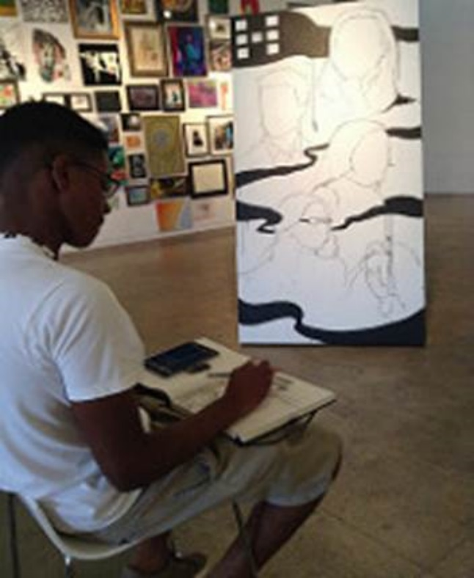

**The World of Work**

Seven teens participated in the World of Work program. After participating in career assessments at RCB in June, students discovered more about themselves through designated work experiences with local employers during the four-week summer program. WOW students also participated in activities and discussions structured to encourage self-awareness and self-advocacy. A peer mentor, a student at Campbell University School of Law, modeled and discussed behaviors that have helped him succeed and reach his goal of attending law school, including how to network and market yourself to potential employers. One of the WOW students, Kanal, is very interested in the graphic and visual arts as a potential career. Kanal was assigned to assist with art education for young visitors at the contemporary art museum in Raleigh. Kanal took advantage of networking and asked about the possibility of a future summer internship with CAM Raleigh. The museum director said that Kanal would be welcomed back at any time, since he excelled at engaging and working with young visitors on projects during his assigned work experience. Kanal is one of several WOW students this summer who took charge of their future and made it their world!

**College Prep**

Eight teens participated in the College Prep program. The 2016 SAVVY program emphasized 21st Century Skills by assigning students to teams and team roles that helped develop study, critical-thinking, communication, collaboration and self-advocacy skills. Students also use these skills during the Eye Retreat where they conducted a research project at North Carolina State University on the accessibility of the Talley Student Union and presented their results and recommendations to the group. Field trips also were taken to Wake Technical Community College and Campbell University. The trip to Campbell included a presentation on "Tips for College Success" by a former SAVVY student who is currently a rising senior at Campbell.

A major highlight for the year occurred when a College Prep student initiated contact with Chris Hendricks, a local musician and co-founder of Perfectly Afflicted, an organization working to reduce teen-suicide. This contact led to a lunch visit from Mr. Hendricks during SAVVY College Prep. During his visit, he shared his advice for personal success. Mr. Hendricks was impressed by one of the student’s musical talent. The following week, he gave her a Fender electric guitar and encouraged her to pursue her dreams.

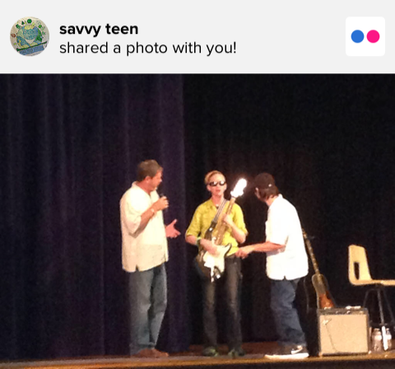

After a long and hard day’s work the teens from Y.I.T., W.O.W. and College Prep came together to participate in a variety of evening activities to include rock climbing, bowling, swimming and horseback riding. The highlight of the summer was once again the day trip to Kure Beach and visit to the N.C. Aquarium at Fort Fisher!

**ABLE College Prep**

The ABLE College Prep program served Adult consumers during 2015-2106. Adult students participated in field trips to Duke University, North Carolina State University, North Carolina Central University, and Wake Technical Community College. During these trips students learned about disability services, professors’ expectations, and student responsibilities (the trip to Duke included a workshop present by a graduate student who is also a former College Prep student). Students also attended Toastmasters International meetings to develop their presentation skills before their final project.

**Motivational Speakers**

In spring 2016, the RCB invited a motivational speaker to address the consumers, regarding visual impairments and vocational skills in the workplace. Speakers included the former director of Student Health Service at N.C. State, the Founder/Executive Director over Disabilities Education Support Center Inc., an IBM Consultant, a hardware engineer and a Technical Writer. Topics included how to dress for interviews, being on time for work, job readiness and employment, are you up to the challenge of starting your own business, how to find jobs, employment skills and training, job readiness and providing programs services for IBM persons with disabilities.

**Health and Wellness Initiatives**

*Well On Your Way To Work* is an informational health education class designed to encourage consumers to get focus on returning to the work force with a healthy mindset. Many consumers have chronic medical concerns that they manage on a daily basis. These concerns also need to be addressed and managed independently when they return to work. Some topics include time management and the importance of timely medication administration, how to pack healthy meals, and obtaining the proper sleep and rest. There is an opportunity for open floor discussions where consumers can ask questions or bring up topics they want to further explore.

**New Technology Acquisitions**

This year, an **iPad Pro** was purchased by the N.C. Rehab Center for the Blind for the IOS training class. The iPad Pro is Apple’s biggest tablet to date. Apple also created a keyboard that is specifically designed for the tablet. For the most part, using the iPad Pro is identical to using any other IOS device. All the gestures, buttons and voiceover commands are the same. However, the larger screen size is useful to low vision users. In addition to a larger screen, it has more pixel density and color accuracy than other devices on the market. Some students who couldn’t visually navigate a regular iPad can use the iPad Pro with much more ease. It’s also important to note that the iPad Pro comes with the latest operation system. The operation system manages the device’s memory and processing ability. It’s important to have these up to date for the IOS training class so we can download apps for the blind and have the device run quickly and smoothly.

The BrailleNote Touch was purchased for the Braille Technology class. It is a modern braille tablet with the new concept of TouchBraille. Braille can be written on the screen itself with the fingers. The Touch has access to the apps in the Play Store and cloud. It can be used in the classroom and the work setting, as well as a tool to learn braille. Students can write documents, send e-mails, and download books or access the Web. In the office, it can be used to create professionally formatted documents and share documents using Google Docs. The BrailleNote Touch is a user-friendly braille tablet suitable for the 21st century.

**University Partnerships**

DSB and the Rehabilitation Center for the Blind has worked to increase their collaborative efforts with N.C. universities. During the Spring of 2016, 18 UNC students and a psychology postdoctoral fellow from the Medical Aspects of Disabilities Class were provided a tour the Center. This tour is scheduled each spring Semester. The students visited each classroom and engaged in brief Q&As with the instructors. A short presentation from the Low Vision Specialist was also provided. This tour is noted as the highlight of the semesters!

During the fall of 2015, RCB partnered with UNC-CH in providing opportunities for Master Level Rehabilitation Counseling students to observe a “Day in the Life of” our consumers participating in the ABLE program. Each UNC student is assigned a RCB student to shadow in various classes, such as Braille, Techniques of Daily Living, Assistive Technology, Orientation and Mobility, etc. Another key component is interviewing two staff members regarding expectations of their vocational rehabilitation role in the facility. They also met with the College Prep teacher who is most informative regarding needs of VI consumers pursuing college. DSB considers opportunities like this as a method of developing future rehabilitation professionals and their impressions of persons who are blind or visually impaired.

The summer intern program continued to provide work experiences for former College Prep students. The intern this year attended SAVVY in 2012 and currently is a rising senior at North Carolina University-Pembroke majoring in Social Work.

**Facility Updates**

There are unique signs of the times at DSB! The NC Rehabilitation Center for the Blind has updated the signs in the classroom building and the dorms with braille and large print. Each sign has the room number and the title. With the collaboration of a professional graphic designer and former DSB consumer, the Center is ADA compliant and updated to UEB! The consumer developed the signs using the Corel graphics program along with learning braille as his project in the braille class. The signs will help the students in O&M and Braille classes as they progress through their ABLE program. Visitors and NEST participants will easily find their way to various locations in the buildings. The signs were developed by Correction Enterprises.

**DSB Independent Living Services Program**

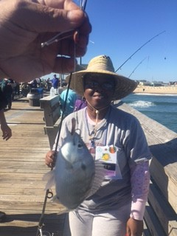

The Division of Services for the Blind is unique and fortunate to have social workers on staff who are primarily located in the local Department of Social Services offices throughout the state. Social workers provide services to eligible individuals who are visually impaired, blind, and deaf/blind to assist them in managing daily living activities with the intent of reducing or preventing institutional care. The services are offered in all 100 counties of the state. During FY 2016, 2,974 consumers received adjustment services (counseling, basic instruction in adaptive techniques for daily living and assistive devices), assistance in securing health services available through Medicaid, Medicare or other public/private providers and arranging in-home assistance provided by aides who assist with minor tasks within the home to enable eligible individuals to continue to live safely within their homes. Most of the services provided are without regard to income and at no cost to the consumer. However, in-home aide assistance is a financial needs-based service. Thirty-two individuals benefited from this service during the 2016 FY.

Social workers also cultivate relationships with other agencies and organizations to advocate for the specialized needs of consumers and their families. They work with local agencies to identify resources and build support systems within the community that are so important for individuals who are blind, visually impaired or deaf-blind such as home health, targeted housing and mental health agencies, support groups, civic groups, doctors, charities, disability advocates, senior centers, adult care facilities, hospitals, community colleges, food banks and local school systems.

Our partnership with the N.C. Lions Clubs is crucial in meeting the needs of those we commonly serve. Many Lions Clubs also assist the social workers in providing eye exams and/or glasses for N.C. citizens with limited incomes. Social workers coordinate with N.C. Lions clubs to support all aspects of the Annual N.C. VIP Fishing Tournament. The tournament provides an amazing opportunity for participants to engage in educational and recreational activities with their peers from around the state. The tournament is reportedly one of the largest service projects of its kind in the world with typically over 500 visually impaired participants and their guests in attendance.

**MEDICAL EYE CARE PROGRAM**

The Medical Eye Care Program’s goal is to provide services to help save or restore sight and prevent blindness. The program offers financial assistance for individuals who have no comparable benefits and limited resources to pay for medication, eye treatments and surgeries. These services are rendered by our nurse eye care consultants. During FY 2016, 2,368 medical eye care services were authorized for eligible North Carolinians. This program utilizes state funds only.

The Nurse Eye Care Consultants also provide additional services that are not based on income eligibility. The services include but are not limited to low vision screenings, evaluations for video magnification systems, and diabetes education. During FY 2016, 2,071 individuals were provided low vision services.

**Program Achievements:**

* Eye exams - 904
* Treatments - 1529
* Eyeglasses - 13
* Chore - 32

**Independent Living Rehabilitation and Independent Living Older Blind Programs**

DSB’s Independent Living Rehabilitation (ILR) program provides services for individuals of any age and the Independent Living Older Blind program provides services for individuals age 55 or older. DSB’s 14 Independent Living Rehabilitation Counselors (ILRC’s) serve as case managers for both programs which seek to maximize the ability of individuals who are blind or visually impaired to function independently in the family, home, community or employment.

Comprehensive independent living skills training in the home or Mini Centers are provided in Mini Centers, and/or the home. Mini centers are community-based learning programs in which individuals receive instruction in adaptive living skills, cooking, safe travel techniques, peer support and hands-on instruction with a variety of low and high tech devices. Instruction and adjustment counseling is also provided in the home for individuals unable to attend Mini Centers or before and/or after attending a Mini Center to ensure successful achievement of independent living goals.

ILR and ILOB services are available in all 100 counties in N.C. ILRC’s collaborate with numerous partners to ensure successful outcomes for service recipients by coordinating services as needed with other DSB case managers, including Social Workers for the Blind and Vocational Rehabilitation Counselors, as well as DSB specialists including Orientation & Mobility Specialists, Nursing Eye Care Consultants, Deaf-Blind Specialists and Assistive Technology specialists. DSB’s ILR and ILOB services are only as strong as our community partnerships and ILRC’s work throughout the year to build and maintain partnerships with local transportation services, churches, senior centers, Lions Clubs and other civic groups, fire and police departments, local health departments and many other invaluable community resources.

This year, the need for assistive technology services among individuals receiving services continued to grow and additional instruction in the use of iPads was provided to staff to address iOS-specific needs. Five iPad-specific Mini Centers were held with 49 consumers participating. Independent Living Rehabilitation Counselors also received instruction in holding Self-Advocacy Mini Centers, working with individuals with secondary mental health conditions and conducting lighting assessments. The ILR program partnered with the Vocational Rehabilitation program on two Mini Centers for 22 Pre-Employment Transition Services consumers.

**ILR and ILOB Results for 2016**

* 994 eligible individuals served – 359 ILR and 635 ILOB

* 434 eligible individuals rehabilitated

* 27 Mini Centers held

* 330 eligible individuals attended Mini Centers

**ILRC Case of the Year**

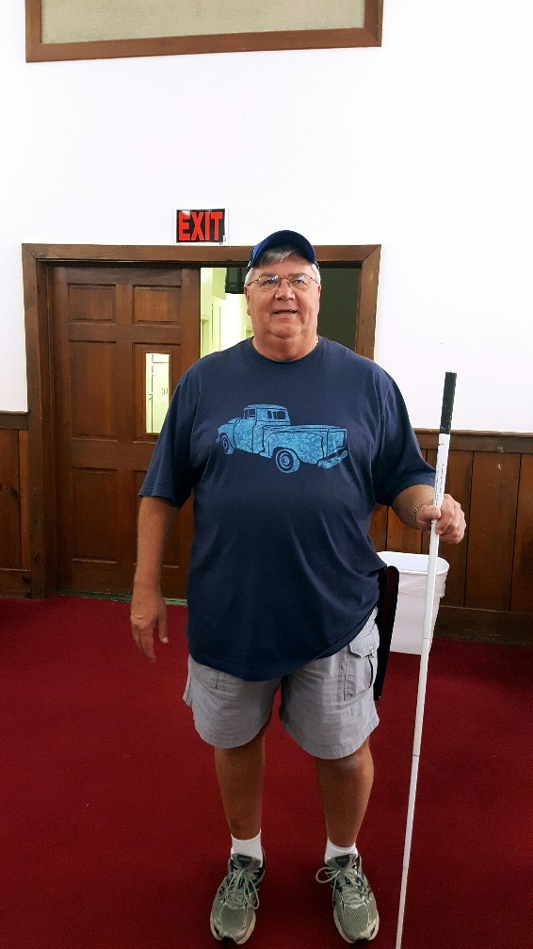

Larry was not new to vision loss, as he witnessed his brother lose vision many years ago. ­­­­­­Now, Larry himself was going blind. He was already aware of N.C. Division of Services for the Blind, because his brother had utilized services from our agency. Larry referred himself to us and at that point, he began his personal success story.

The Social Worker for the Blind who served Larry’s county assessed his needs, opened his case and provided services. Some services provided were inclusion in a support group, referrals to the Independent Living Older Blind program, the Nursing Eye Care Consultant, and the Orientation and Mobility Specialist. Through DSB services, he learned how to use a variety low vision and blindness assistive devices, how to use a long cane for travel purposes, travel techniques for local travel as well as on public transportation and was connected to the N.C. Library for the Blind and Physically Handicapped.

Larry voiced the desire to go even further, so assistive technology training on the computer was provided and his computer skills flourished. Larry participated in a full Mini Center and in a Braille-specific mini center. During this time, he was elected by his peers to become the president of the local VIP support group, which he gladly accepted and served in this role. Larry still wanted to be more active, so he connected to Vocational Rehabilitation services. Through that program, he attended the DSB Rehabilitation Center for the Blind in Raleigh. At the Rehabilitation Center, his Braille skills advanced and he went on to study Braillewriter repair at the Perkins School for the Blind in Watertown, Mass. He now has a part-time business repairing Braillewriters. Larry independently uses public transportation to go to the gym every day. This year he began teaching as a Mini Center Instructor and was elected the Second Vice President of the NC National Federation of the Blind.

Larry exemplifies what feats can be accomplished in the face of adversity and was, therefore, selected as this year’s Case of the Year for the ILR and ILOB programs.

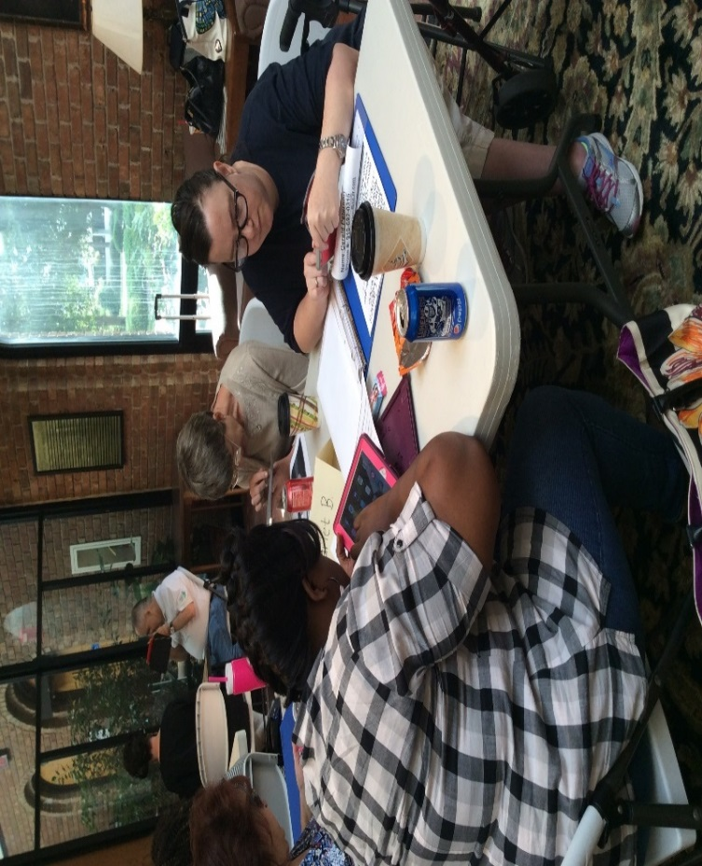

**DSB DEAF-BLIND SERVICES**

Each year, DSB serves individuals with vision and hearing loss through the Vocational Rehabilitation Program, and the Independent Living Rehabilitation Program. This history of service runs long and deep. Since the inception of the agency in 1935, with assistance from Helen Keller, DSB has provided support, training, and other services to people with hearing and vision loss. DSB’s goal is to provide training and support that helps people reach their maximum potential. Many times, assessments are conducted with people who are skeptical of services, since dealing with the onset of another sensory loss can be overwhelming. There are five deaf-blind specialists employed by DSB who serve every county in North Carolina.

When someone experiences both vision and hearing loss, serious issues and self-doubt can arise. With the help of a DSB intervention, empowerment can thrive within many, instead of feelings of misfortune.

Here are some real stories of DSB interventions that empowered individuals with hearing and vision loss in areas of employment and independent living.

**Following the Pathway to Re-Acquired Independence**

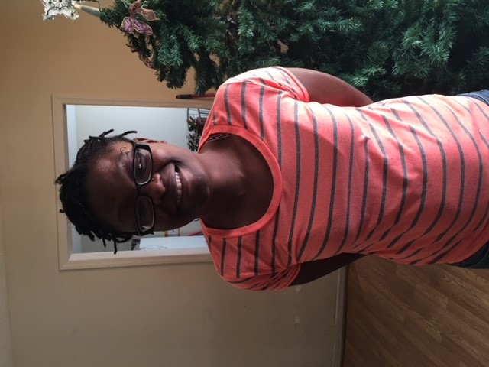

Marquetta Moise was born Deaf and over the years had become legally blind. At the age of 12, she was diagnosed with Usher’s Syndrome. Usher’s Syndrome is inherited and consists of the progressive eye condition, Retinitis Pigmentosa (RP) and hearing loss. Initially, RP steals your peripheral vision leaving central vision intact, but progressively the person can go totally blind. With Usher Syndrome, each person is different with severity and timeline when vision or hearing loss progresses. Marquetta started losing her vision in high school, but was not adjusting to it at first. Because she grew up culturally Deaf, she uses American Sign Language (ASL) to communicate, this being her first language and not English. For a culturally Deaf person, their eyes are vital to seeing sign language and thus communicating to the world. When that vision is compromised, it is a very scary and complex situation. As her vision decreased, she requested services from the N.C. Division of Services for the Blind. Marquetta wanted to work, but her vision and hearing loss had placed impediments to her employment. Her Vocational Rehabilitation Counselor referred her to the Deaf-Blind Specialist in that area, who is fluent in ASL and knowledgeable about Deaf culture.

With the assistance of Supported Employment, Marquetta VR Counselor, Eddie Everett, and the DB Specialist were able to find her employment with a faith-based child development center where she worked as a dietary assistant. With employment secured, her DSB case was closed. Marquetta worked in this position for a year-and-a-half, and then unfortunately was laid off. DSB re-opened her case. During the year-and-a-half that she worked as a dietary assistant, Marquetta’s vision began to deteriorate rapidly. She began to be withdrawn and was losing her ability to maintain her independence. In addition, she now required a new skill-set to be able to have the vocational skills needed to obtain and maintain employment. Her VR Counselor and DB Specialist started discussing the possibility of attending the Helen Keller National Center (HKNC) in New York with Marquetta. The HKNC is a nationally funded facility for training the Deaf-Blind to obtain vocational and independent living skills. Marquetta’s family was in total support of her attending HKNC and informed her that they would make sure her son was cared for. Marquetta gave many excuses of why she could not go, but it came down to the fact that she was scared to travel that far and did not want to be away from her son. Her family again reassured her that they would support her in this. It took almost a year. Marquetta finally made the decision to apply. The Deaf Blind Specialist assisted her in filling out the paperwork, getting her medical information/physical done and her VR Counselor filled out DSB’s portion of the funding paperwork. When the entrance packet for HKNC came in, the Deaf Blind Specialist assisted Marquetta in reading and explaining the Dorm Rules and Regulations in Tactile ASL, as well as familiarizing her with the various programs she would have available to her at HKNC.

When the time to go to HKNC neared, Marquetta’s desire to go faltered. The DB Specialist could not let this much-needed opportunity for Marquetta go by, and coordinated a meeting with an HKNC Alumni to talk about the benefits of attending HKNC as a culturally Deaf person. The DB Specialist spoke with the Helen Keller Representative from NC, and set up a meeting for Marquetta to speak with the HKNC Alumni who also has Usher Syndrome and is a tactile ASL user. Tactile ASL is used when a Deaf-Blind person can no longer see sign language but must feel it with their hands. The Deaf Blind Specialist transported Marquetta and her mother to Greensboro for the meeting. This person told her story to Marquetta of how she also had to be convinced to go to HKNC. As a result, Marquetta decided to go to HKNC!

At the end of August 2015, Marquetta took her first plane ride ever to New York and was met by HKNC staff. During her first month of evaluation, Marquetta became very homesick and informed her Case Manager that she wanted to come home before completing her training program. Marquetta agreed to speak with HKNC staff and the Deaf-Blind Specialist in a staffing. The Deaf-Blind Specialist was prepared to cheer Marquetta on and try to persuade her to finish her program. But during the staffing, Marquetta informed everyone that she had decided to stay herself! Marquetta completed eight weeks of evaluation and continued with 26 more weeks of training. During her stay, Marquetta gained knowledge and experience in the following areas: Uncontracted Braille skills, better cane and mobility skills, communication skills (English, writing, use of communication cards), vocational skills with a trial work experience at the GAP, independent living skills, use of alerting systems, and use of various assistive technologies. While these skills are important for daily living, two of the most important skills Marquetta came back with was the ability to self-advocate and confidence in herself. When the VR counselor and the Deaf-Blind Specialist met with her after her return home, they were amazed at the change in her. She was confident, self-motivated and ready to work. The DSB team is now moving forward to assist Marquetta with finding permanent employment in her home area. We now know that when she does find employment, Marquetta will be able to perform her job duties with skill and confidence.

**Collaboration with other agencies to serve the Deaf-Blind Community and Additional Services provided to the N.C. Deaf-Blind Community**

Our Deaf-Blind Program works closely with our sister agency, DSDHH regarding the National Deaf-Blind Equipment Distribution Program (NDBEDP). This program exists to provide 21st century telecommunication assistive technology to individuals who are Deaf-Blind. Our five DB Specialists are fluent in American Sign Language and uniquely qualified to provide assessments on assistive technology needs based on the goals, communication mode, and the level of AT knowledge of Deaf-Blind individuals. DSB has been an active partner working with DSDHH since the NDBEDP pilot, and will continue to assist with completing assessments, as this ongoing program became permanently funded by the Federal Communications Commission. Our Specialists complete the assessment, deliver the equipment to the DB consumer’s home, coordinate trainers, and provide a 60 day follow up session. In FY 2016, our DB Specialists have served 28 Deaf-Blind individuals in this program.

Our Deaf-Blind Program also collaborates with the Department of Public Instruction Deaf-Blind Project, as well as having an active member on the Deaf-Blind Advisory Council facilitated by the DPI DB Project Director. We work together on issues and concerns related to Deaf-Blind consumers and their families that are in the school systems age 14 and above.

DSB has been an active supporter of the North Carolina Deaf-Blind Associates, (NCDBA) since its inception. One of our first DB Coordinators was the co-founder of the NCDBA over 30 years ago. We assist Deaf-Blind individuals across the state with finding sponsorship to the annual Camp Dogwood Deaf-Blind Weekend. We work closely with our local NC Lions clubs who sponsor many of our DB campers based on what county they live in. Our DB Specialists also assist with transporting our campers and working as a Support Service Provider (SSP) while at Camp. That means we serve as the eyes and ears of our DB campers as needed. In addition, one of our first DSB DB State Coordinator was instrumental in initially starting the Camp Dogwood Deaf-Blind Weekend over 30 years ago as well! NCDBA has many additional activities throughout the year that we gladly support including the NCDBA Conference, the NCDBA Helen Keller Deaf-Blind Awareness Day, the NCDBA Holiday Party and quarterly Board meetings. Our Deaf-Blind Program is honored to actively better the lives of our Deaf-Blind consumers in employment, independent living, and full participation in society.

**HOW TO CONTACT DSB**

Administration (866) 222-1546.

Office of the Director (919) 527-6700

Aids and Appliances (919) 527-6770

BUSiness Enterprises Program (919) 527-6790

Communications Unit (for materials in

alternate format) (919) 527-6760

Evaluation Unit (919) 527-6800

Independent Living Services (919) 527-6780

Medical Eye Care Program (919) 527-6780

Rehabilitation Center for the Blind (919) 527-6800

Rehabilitation Services (919) 527-6711

* Vocational Rehabilitation Program
* Deaf/Blind Services
* Independent Living Rehabilitation Program
* Supported Employment Services
* VR Business Services
* School to Work Transition Services
* Rehabilitation Engineer
* Staff Development

Technology Resource Center (919) 527-6698

DHHS Customer Call Center 1-800-622-7030 for access to a Spanish Interpreter

**District Office Locations**

**Asheville District Office**

50 South French Broad Avenue

Asheville, NC 28801

(828) 251‑6732

1 (800) 422‑1881

**Charlotte District Office**

5855 Executive Center Drive, Suite 100

Charlotte, NC 28212

(704) 563-4168

1 (800) 422‑1895

**Fayetteville District Office**

225 Green Street

Fayetteville, NC 28301

(910) 486‑1582

1 (800) 422‑1897

**Greenville District Office**

404 St. Andrews Drive

Greenville, NC 27834

(252) 355‑9016

1 (800) 422‑1877

**Raleigh District Office**

309 Ashe Avenue

Raleigh, NC 27606

(919) 527‑6740

1 (800) 422‑1871

**Wilmington District Office**

3240 Burnt Mill Road, Suite 7

Wilmington, NC 28403

(910) 251-5743

1 (800) 422‑1884

**Winston‑Salem District Office‑**

4265 Brownsboro Road, Suite 100

Winston‑Salem, NC 27106

(336) 896-2227

1 (800) 422‑0373

TDD: (336) 896-7047

Website: <http://www.ncdhhs.gov/dsb>

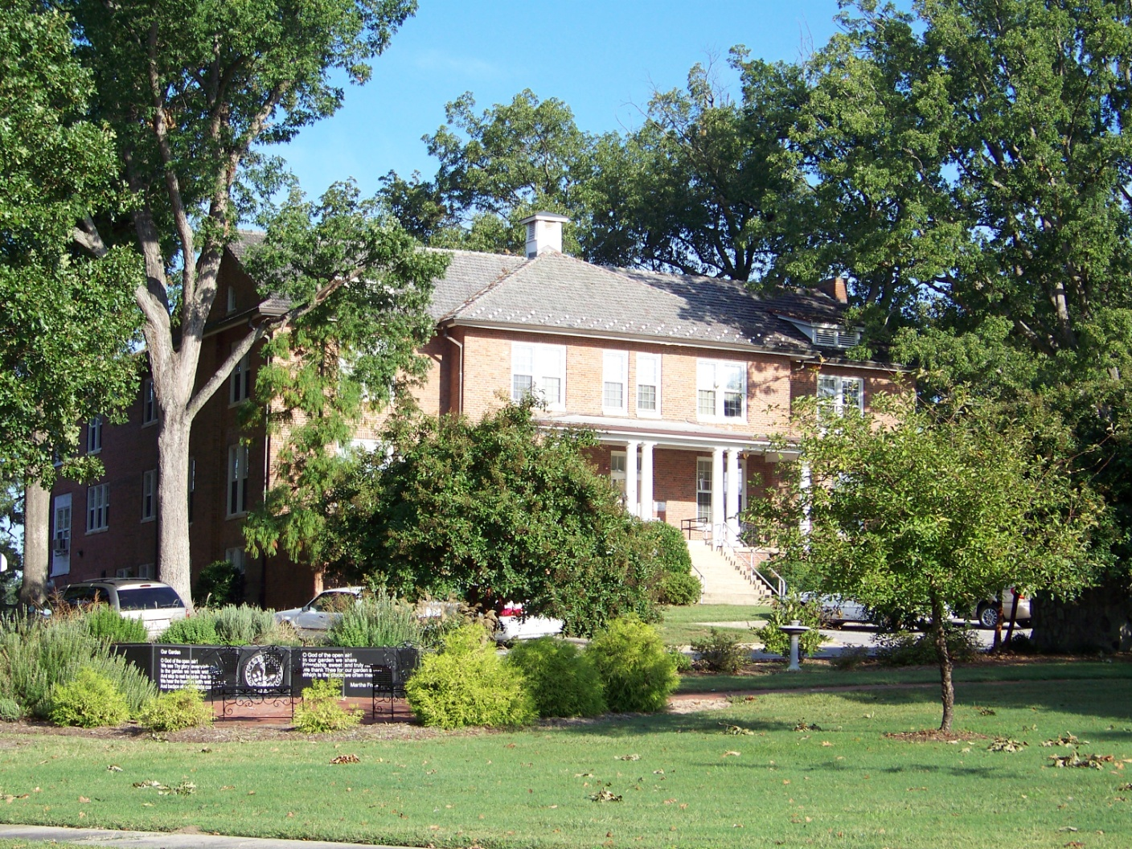

Fisher Building, Governor Morehead Campus, Raleigh, NC

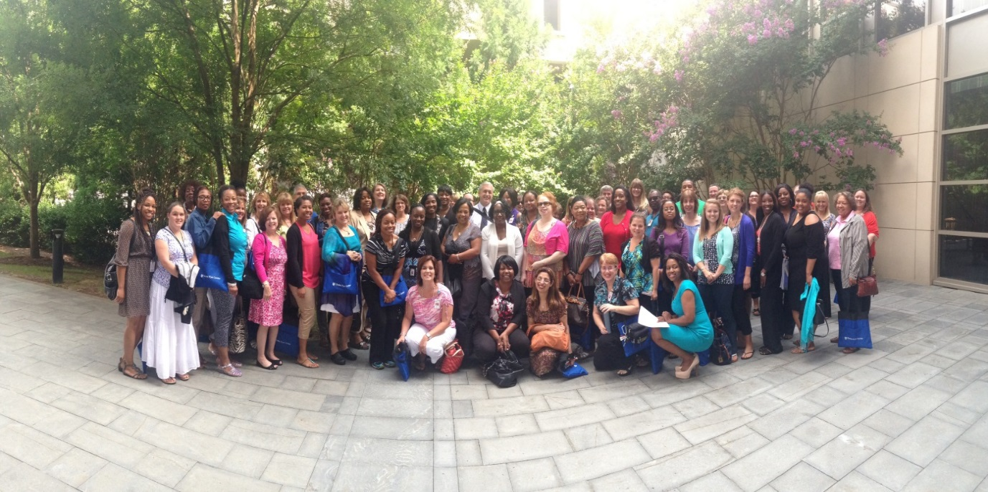

DSB Staff, 2014