DRIVING WHILE IMPAIRED (DWI) SUBSTANCE ABUSE SERVICES REPORT
G.S. 122C – 142.1

Prepared for:

NORTH CAROLINA GENERAL ASSEMBLY

JOINT LEGISLATIVE COMMISSION ON

GOVERNMENTAL OPERATIONS

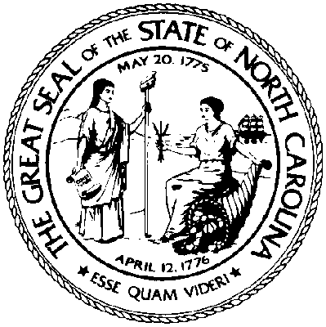

February 1, 2016

NORTH CAROLINA DEPARTMENT OF HEALTH AND HUMAN SERVICES
Division of Mental Health, Developmental Disabilities and Substance Abuse Services

INTRODUCTION

This report as required by North Carolina General Statute 122C-142.1 is a summary of data from the Driving While Impaired (DWI) substance abuse services Certificates of Completion (DMH-508-R) submitted within the fiscal year ending June 30, 2015. This is an annual reporting requirement on substance abuse assessments due on February 1 of each year to the Joint Legislative Commission on Governmental Operations.

G.S. 122C – 142.1 (i) defines the information to be included in this report on substance abuse services for those convicted of Driving While Impaired or Driving While Less Than 21 Years Old After Consuming Alcohol Or Other Drugs. That information is as follows:

(1) The number of persons required to obtain a certificate of completion during the previous fiscal year as a condition of restoring the person’s driver’s license under G.S. 20-17.6.

The following data was obtained from the NC Judicial Branch - Administrative Office of the Courts Management and Information Services - for individuals convicted of impaired driving offenses during State Fiscal Year (SFY) 2014-2015. There were 59,370 impaired driving charges reported. Of those, the total number of convictions for an impaired driving offense was 36,842. The percentage of impaired driving cases resulting in conviction in this report is about 62%. The remaining 22,528 cases, or about 38%, were not convicted either by being found not guilty; no probable cause; voluntary dismissal by the prosecutor; voluntary dismissal with leave; or guilty of a charge other than impaired driving.

CONVICTIONS SFY 2014-2015
DWI (Levels 1-2) | 8,573
DWI (Levels 3-5) | 25,533
DWI (aid and abet) | 5
Driving after consuming under age 21 | 2,400
DWI (commercial vehicle) | 14
Habitual DWI* | 317
TOTAL | 36,842
* Certificates of Completion (DMH-508-R) are not required for these cases.

(2) The number of substance abuse assessments conducted during the previous fiscal year for the purpose of obtaining a certificate of completion.

During this report period, 51,509 Certificates of Completion (DMH-508-R) were submitted to verify that a clinical substance abuse assessment was completed as required by law.

(3) Of the number of assessments reported under subdivision (2) of this subsection, the number recommending attendance at an Alcohol Drug Education Traffic School (ADETS), the number recommending treatment for a substance use disorder, and for those recommending treatment, the level of treatment recommended.

Of the 51,509 assessments reported, 10,825 or about 21% recommended an ADETS program and the remaining 79% recommended treatment (Figure 1).

Approximately 35% of individuals assessed had a diagnosis of substance dependence or moderate or severe substance use disorder. The majority of diagnoses were alcohol abuse and alcohol dependence at 66% of the total. The most common substance identified after alcohol was cannabis. Other common substances included: cocaine, opiates, and sedatives.

Approximately 33% had prior convictions with an average of 2 priors. The average blood alcohol concentration (BAC) was 18.66 and 12% refused the breathalyzer. The underage group accounted for 33% of assessments.

(4) Of the number of persons recommended for an ADET School or treatment for a substance use disorder, under subdivision (3) of this subsection, the number who completed the school or treatment. Of the individuals who were assessed during SFY 14-15, 28,746 or about 56%, completed treatment or education (Figure 2).

(5) The number of substance abuse assessments conducted by each facility and, of these assessments, the number that recommended attendance at an ADET school and the number that recommended treatment for a substance use disorder.

Attachment A is an accounting of DWI assessments conducted by each authorized facility in SFY 2014-2015 and their recommendations to ADETS or treatment for a substance use disorder.

(6) The fees paid to a facility for providing services for persons to obtain a certificate of completion and the facility’s costs in providing those services.

The DWI substance abuse assessment fee is $100.00. The fee for the standardized ADETS program is $160.00. Both fees are set by NC General Statute and are paid to the facility providing the service. For those attending treatment for a substance use disorder, a minimum payment of $75.00 is also required by statute. Service providers typically charge additional fees for treatment. The average cost for short term outpatient treatment for substance use disorders is about $360.00 at $18.00 per hour; this service is a minimum of 20 hours of counseling. The average cost for longer term treatment is about $600.00 for a minimum of 40 hours of counseling; this reflects a rate of $15.00 per hour. Day treatment is provided at an average of $10.00 an hour.

