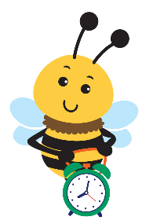
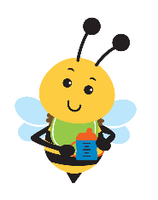
NC Infant-Toddler Program
the earlier you know, the better they’ll grow

Developmental Milestones
Children grow, learn and develop at different rates. One may walk earlier than another, while another might talk first. Use this chart as one way to check whether your child is meeting developmental milestones during the first three years. Remember that every child is unique. If you have questions or concerns about how your child sees, hears, moves, communicates, learns, plays or interacts with others, talk with your primary care physician or contact your local Children’s Developmental Services Agency (CDSA). Success in your child’s growth and development benefits from EARLY action if you have a concern.
- month: Lifts head when lying on tummy
Stares/looks at faces
Responds to sounds
- months: Makes sounds - coos and gurgles
Follows objects with eyes
Holds head up for short periods of time
Notices his/her hands
- months: Recognizes faces
Holds head steady and upright
Begins to develop a social smile
Can bear weight on legs when feet placed on firm surface
Follows moving objects
- months: Smiles, laughs, and coos when talked to
Rolls over from back to side or stomach
Reaches for and bats objects
Recognizes parent’s voice and touch
- months: Reaches, grasps, and puts objects in mouth
Holds out arms to be held
Plays peek-a-boo
Plays with hands and feet
- months: Sits and stands with support
Rolls over in both directions
Turns towards sounds and voices
Imitates sounds
- months: Responds to other’s expressions of emotion
Uses hands to explore, pat, touch, stroke
Babbles series of sounds

10 months: Waves bye-bye
Crawls well on hands and knees Drinks from a cup when cup is held

- months: Passes objects from hand-to-hand
Pulls self up to standing
Starts to crawl or scoot
- months: Says “Ma-ma” or “Da-da” to either parent
Exchanges expressions with you (smile)
Jabbers or combines syllables
Responds to own name

11 months: Says “Ma-ma” and “Da-da” to appropriate parent
Walks holding onto furniture
Drinks from cup and picks up small objects
12 months: Makes sounds and simple gestures
Uses at least three words
Lets you know what he/she wants and doesn’t want
Continued on next page www.beearly.nc.gov

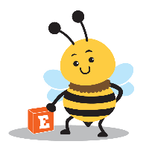
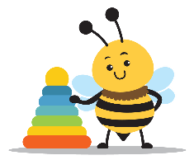
the earlier you know, the better they’ll grow

Developmental Milestones

  - months: Stands well
Bends over to pick up objects and can take a few steps
  - months: Imitates others’ activities
Plays with a variety of toys like blocks, cars,
books, stuffed animals and dolls
Empties containers of contents
  - months: Plays with a ball
Walks well and can stoop
Listens to stories
Can point to own body parts
  - months: Turns pages of a book
Forms attachment to a stuffed toy or other object
May have temper tantrums when frustrated
  - months: Learns the correct way to use common objects
like a telephone
Likes pretend games Likes riding toys
  - months: Can say 10-20 words
Asks for help
Uses single words to make his needs/wants known
Scribbles with a crayon
Shows affection, kisses
Follows simple directions
Can walk backwards

- months: Uses a spoon or fork
Can run
Throws a ball underhand
Enjoys helping around the house
- months: Can undress him/herself
Can understand as many as 200 words
- months: Will combine words like “want
bottle” and “go bye-bye”
Can walk up stairs one step at a time
Sets simple goals like where to put toys
- months: Kicks ball forward
Follows two-step requests like
“get the doll and bring it to me”
- months: Can identify simple pictures in a book
Refers to self by name - uses “me/mine”
Can open cabinets and boxes
Uses “hi”, “bye”, and “please” if reminded
24 months: Will answer simple questions like
“What’s this?”
Names at least six body parts
Uses two- and three-word phrases
Kicks a ball
Goes up and down stairs one step at a time
Takes turns in play with other children
At two years of age, toddlers are increasingly more verbal, using two– to three-word phrases and making requests like “more juice.” They have a vocabulary of 50-100 words and understand 250-300 words. They can feed themselves and open cabinets and boxes. They also like to take things apart, explore their surroundings, and imitate their parents and other children. Common socio-emotional behaviors are showing affection, playing independently, and acting shy around strangers. Two-year-olds can be very determined to have things their way, thus temper tantrums can occur.
By three years of age, children may be very independent. Physically, they can walk up and down steps and put on their own shoes. With the verbal ability to say three-to-five-word sentences, they can repeat common rhymes, understand most sentences, and say their names and age. Three-year-olds can play make-believe with toys, animals, and people. They can play simple games with other children, name at least one color correctly, and ride a tricycle. Three-year-olds express a wide range of emotions.
Though exact times for reaching these milestones can vary among children, these milestones can serve as a guide as you watch your child grow and develop.

State of North Carolina | Department of Health and Human Services www.ncdhhs.gov Division of Child and Family Well-Being | Early Intervention Section
N.C. DHHS is an equal opportunity employer and provider. 12/13, Updated 4/22, 1/23
www.beearly.nc.gov

