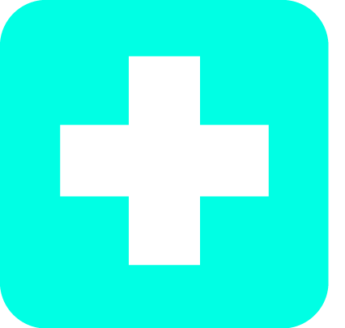
August 24th & 25th
Thursday 8:00-5:00
Friday 8:00-5:00
Training Location
Solid Waste Management
1207 Eubanks Road
Chapel Hill, NC 27516
Space is limited, registration is required.
ASIST TRAINING
Applied Suicide Intervention Skills Training

click below to register

ASIST Training Application

ASIST is a two-day interactive workshop in suicide first aid. This training teaches participants to recognize when someone may have thoughts of suicide and how to work with them to create a plan that will support their immediate safety.
Results demonstrate that ASIST helps participants become more willing, ready, and able to intervene when someone is at risk of suicide.
Important Notes
- Registration ends Friday, August 4th at 11:59pm.
- Final selections for the ASIST Training will be made by August 11th. Those selected will be notified by email.
- Lunch is provided both training days.
- Participants will need to bring a smart phone or a laptop to take the pre and post assessment.
Questions: Divya.Venkataganesan@DHHS.nc.gov

We strive to host inclusive, accessible events that enable all individuals, including individuals with
disabilities, to fully engage. Please contact us at the email above if you need to request an accommodation or for inquiries about accessibility.
*This training is made possible through the CARES Act funding from the Administration for Community Living.

