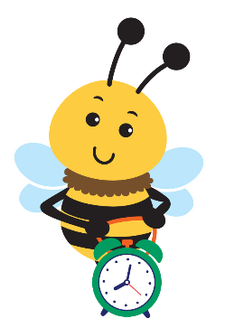
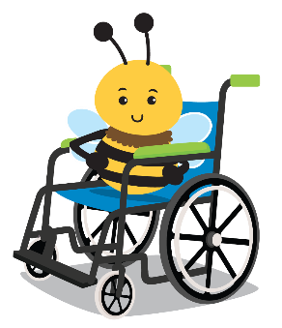
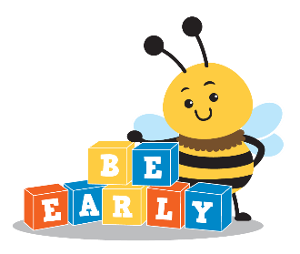
NC Infant-Toddler Qhov kev pab cuam
Yog tias peb txhua tus tau siv zog los tuav lub tsev qiv ntawv qiv nyiaj siv thev naus laus zis, nws tuaj yeem siv los ntawm cov tsev neeg thiab cov menyuam xav tau.
kev tshawb pom ntxov ua rau muaj kev vam meej

Assistive Technology Loaning Qhov kev pab cuam

Cov lus qhia rau kev tu thiab tu
Kev ntxuav cov cuab yeej siv thev naus laus zis tom qab txhua qhov siv lossis ua ntu zus yog qhov tseem ceeb ntawm kev tswj xyuas nws.Txhawm rau kom koj tsev neeg tau txais txiaj ntsig zoo tshaj plaws ntawm lub cuab yeej, koj yuav tsum tswj nws kom zoo los ntawm kev ua kom huv si.Nws yog ib qho kev ntsuas uas muaj txiaj ntsig zoo rau koj tus menyuam txoj kev nyab xeeb.

Txhawm rau ntxuav cov khoom kom zoo, sab laj nrog phau ntawv qhia yog tias muaj.Lwm yam:
- Txhawm rau ntxuav lub gadget, tsuas yog siv cov tshuaj ntxuav tes los yog tshuaj tua kab mob rau hauv daim ntawv phuam lossis daim txhuam cev me ntsis thiab so nws.Tsis txhob tsuag cov cuab yeej nrog cov tshuaj ntxuav.
- Tsis txhob tso kua dej ntau dhau los yog siv cov tshuaj ntxuav hnyav, vim tias ua li ntawd yuav ua rau nws puas.
- Tom qab so qhuav, qhuav nrog
ib daim ntaub huv.

Cov Lus Qhia Ntxiv
- Hu rau koj tus kws saib xyuas Kev Pabcuam Thaum Ntxov Thaum Ntxov (EISC) yog tias koj ntsib teeb meem nrog lub cuab yeej (xws li ua haujlwm tsis zoo lossis cov hlua uas ploj lawm).
- Thaum tsis siv, tshem lub roj teeb ntawm lub roj teeb ua haujlwm.
- Khaws cov cuab yeej cov hlua thiab cov roj teeb npog kom nrawm kom tsis muaj dab tsi poob thaum lub sijhawm qiv.

CDSA Cov ntaub ntawv tiv tauj

Npe ntawm EISC:

North Carolina Department of Health ntawm Human Services www.ncdhhs.gov
Division of Child and Family Well-Being | Kev Pabcuam Thaum Ntxov
N.C.DHHS yog ib qho chaw ua haujlwm muab kev pab sib zog sib luag.12/11, 3/22, 1/23
www.ncdhhs.gov/itp-beearly

