date
Nyob zoo parent or caregiver
address
city, NC zip code
Koj tus menyuam muaj hnub nyoog peb child's name xyoos hauv 30 hnub thiab tam sim no koom rau hauv Infant Toddler Qhov location of CDSA. child's name kev pab cuam ntawm Children's Developmental Services Agency (CDSA). Tam sim no CDSA tab tom muab kev pabcuam rau koj tsev neeg, thiab ib qho ntawm lawv yog qiv nyiaj pabcuam thev naus laus zis (AT) cov cuab yeej (hais hauv qab no) los pab koj tus menyuam ua tiav cov hom child's name phiaj uas tau teev tseg hauv nws Txoj Haujlwm Pabcuam Tsev Neeg (IFSP).
AT cov cuab yeej ntawm kev qiv nyiaj:
Tsab ntawv no raug xa mus ceeb toom tias tag nrho AT cov cuab yeej qiv nyiaj yuav raug them rov qab rau koj tus menyuam tus kws saib xyuas kev pabcuam, service coordinator's name, ntawm CDSA name CDSA ua ntej koj tus menyuam muaj hnub nyoog peb xyoos. Thov xa txhua yam khoom siv los ntawm date.Yog tias koj tsis tuaj yeem xa rov qab, thov hu rau koj tus kws saib xyuas kev pabcuam lossis AT Loan Program ntawm (828) 438-6502 txhawm rau npaj kev tuaj tos.Yog tias koj ntseeg tias koj tus menyuam tseem yuav xav tau cov cuab yeej siv tom qab koj tus menyuam muaj hnub nyoog peb xyoos thiab tsis tau rau npe nrog NC Infant Toddler Qhov kev pab cuam, thov hu rau koj tus kws saib xyuas kev pabcuam uas tuaj yeem muab cov ntaub ntawv qhia txog koj.
Peb cia siab tias cov cuab yeej no tau muaj txiaj ntsig zoo rau koj cov menyuam thiab tias Qhov Kev Pabcuam Thaum Ntxov tuaj yeem ua tau raws li nws cov kev xav tau.Yog tias koj muaj lus nug, thov qhia rau peb paub.
Ua tsaug,
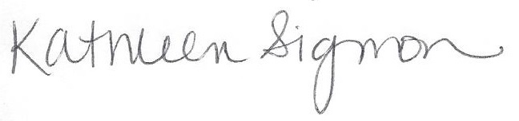
Kathleen Sigmon
Tus Kws Pab Tswv Yim
NC Infant Toddler Assistive Technology Program
Xov tooj: (828) 438-6502
CC: | EISC name |  | EISC | name of CDSA |  | CDSA
 | name of AT Contact |  | AT Contact | name of CDSA |  | CDSA

