date:
Dear, parent or caregiver,
address:
city, NC zip code
Ku bijanye n’umwana wanyu, (child's name), asanzwe ari ku rutonde rw’abana bafashwa n’umugambi witaho abana b’impinja ukorera mu gisata citaho ibijanye n’ibikorwa vy’ingene umwana agenda arakura (Children’s Developmental Services Agency CDSA). (child's name), mu kiringo c’imisi mirongo itatu (30), azokwiza imyaka itatu. Ubu umwana wawe, biciye mu gisata citaho ibijanye n’ibikorwa vy’ingene umwana agenda arakura (Children’s Developmental Services Agency CDSA), aronswa ingurane harimwo bimwe mu bikoresho umuryango wifashisha mu bujanye n’ubuhinga bugezweho mu kurera abana (family assistive technology (AT) equipment) bisanzwe biri muri uru rutonde rukurikira kugira bifashe child's name mu bijanye n’inyungu ziwe hisunzwe itegeko ryerekeye imiryango ku giti c’umwana bwite.
Iyo ngurane y’ibikoresho ikaba igizwe:
Uru rwandiko ruraheza rukarungikwa nk’icemezo c’uko ingurane yose y’ibi bikoresho yemezwa n’umuhuzabikorwa akurikirana umwana wawe, service coordinator's name, ku biro vya CDSA name imbere y’uko umwana ashikana imyaka itatu. Tukaba tubasavye kuzosubiza iyo ngurane y’ibikoresho vyose [date]. Mu gihe bitagukundiye ko ushobora kubisubiza, uraheza ukabimenyesha umuhuzabikorwa akurikirana umwana wawe canke abajejwe umugambi ujanye n’ingurane y’ibikoresho mu guhamagara ku nomero ya terefone (828) 438-6502 kugira bige ingene bashobora kuza kubitora. Mu gihe naho umwana wanyu amaze gukwiza imyaka itatu, ariko mukabona ko yoba agikeneye ivyo bikoresho, murumva ko ataba akiri ku rutonde rw’abana berwa n’umugambi, muraheza mukegera umuhuzabikorwa akurikirana umwana wanyu arashobora kubaha amakuru ahagije.
Turizera tudakekeranya ko mw’ikoreshwa ryavyo, ibi bukoresho vyabaye ngirakamaro kandi ivyo umwana wanyu yari akeneye vyashoboye gutorerwa umuti guhera umugambi ugitangura. Turipfuza ko mwodufasha hagize aka canke kariya kabadidanira mwoheza mukabitumenyesha.
Murakoze.
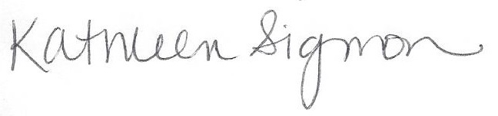
Kathleen Sigmon
Umuhuzabikorwa mu mugambi
NC Infant Toddler Assistive Technology Program
Terefone: (828) 438-6502
CC: | EISC name |  | EISC | name of CDSA |  | CDSA
 | name of AT Contact |  | AT Contact | name of CDSA |  | CDSA

