Newsletter Copy (content and graphics)
In this document, please a find a newsletter description and two (2) headers/graphic options with information pertaining to senior food assistance and other resources to help with common expenses such as phone, internet, and utilities. The content includes a link that directs seniors to an NCDHHS senior-specific webpage where they can learn more about food assistance and other programs that they may be eligible for, as well as information on deductions and how seniors can maximize their allotments. Please feel free to utilize these resources in any newsletters or push-media your organization sends out to promote these programs for seniors.

Newsletter Content:

Good nutrition is the foundation for a healthy lifestyle. When you’re eating healthy, you have the energy to stay well and do the things you love.

As grocery prices continue to rise, senior citizens can get help filling their baskets. Individuals age 60+ who are balancing a limited income may be eligible to participate in several North Carolina food benefit programs.

These programs include food assistance such as NC Food and Nutrition Services (FNS), which provides monthly food benefits. The following deductions can be applied to maximize your monthly allotment:
- $193 standard deduction
- 20% earnings deduction
- Medical expense deduction
- Dependent care deduction
- Housing costs when they exceed a certain percent of your income after deductions

In addition to monthly food benefits, participating in FNS can help you qualify to receive financial assistance for additional programs that can help with common expenses such as utilities, phone, and internet.

Learn more about the different types of assistance available to you, as well as how to qualify and apply, at www.NCDHHS.gov/SeniorResources.

Graphic #1:
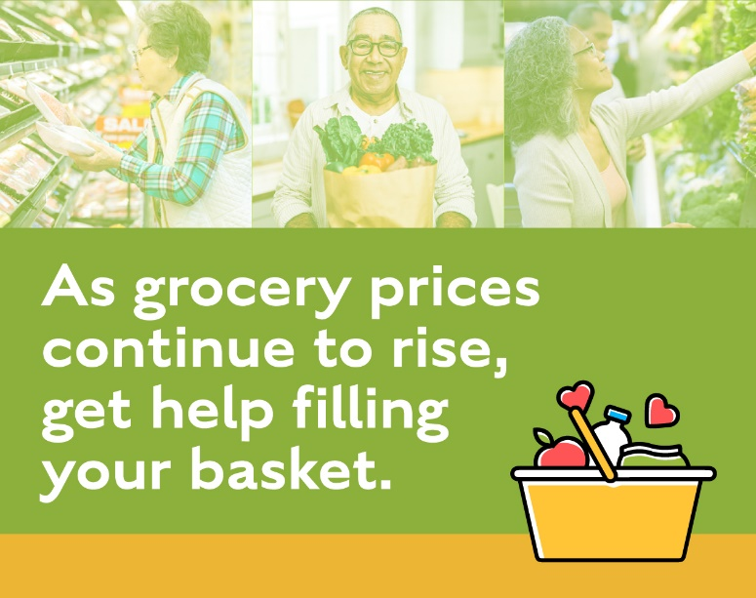

Graphic #2:

