Social Media Images and Captions

In this document, please find three (3) social media images and captions with information pertaining to senior food assistance and other resources to help with everyday expenses such as phone, internet, and utilities. The captions also contain a link to an NCDHHS senior-specific webpage where they can learn more about food assistance and other programs that they may be eligible for.
Additionally, please find three (3) social media images and captions with information specifically pertaining to FNS eligibility and maximizing their benefits. The captions also contain a link to a flyer with additional information on deductions and eligibility criteria.
Partners and community-based organizations are encouraged to utilize these resources when posting to their social media handles.

Social Media Post #1:



Caption: Good nutrition is the foundation for a healthy life. When you’re eating healthy, you have the energy to do the things you love. Seniors may be eligible for food beneﬁt programs that help them buy nutritious food. See if you qualify by visiting NCDHHS.gov/SeniorResources. #NCSeniorResources

Social Media Post #2:
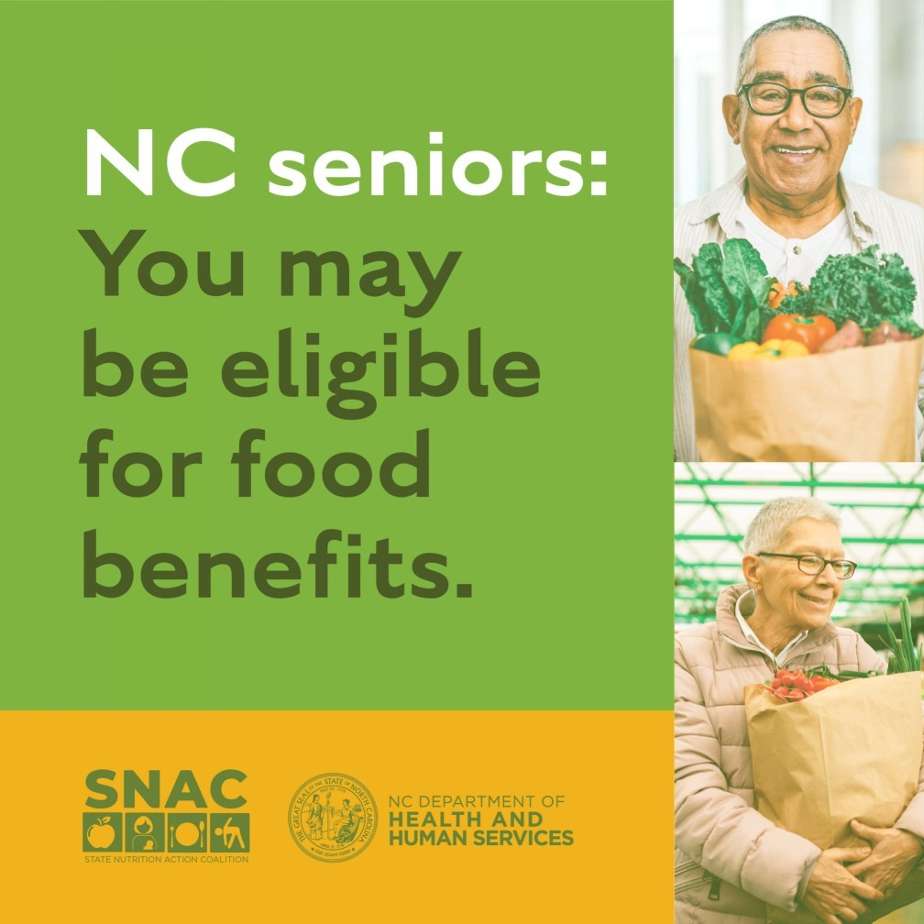
Caption: As grocery prices continue to rise, seniors can get help ﬁlling their baskets. See if you’re eligible for NC food beneﬁt programs that help you buy nutritious food. Learn more at NCDHHS.gov/SeniorResources. #NCSeniorResources

Social Media Post #3:
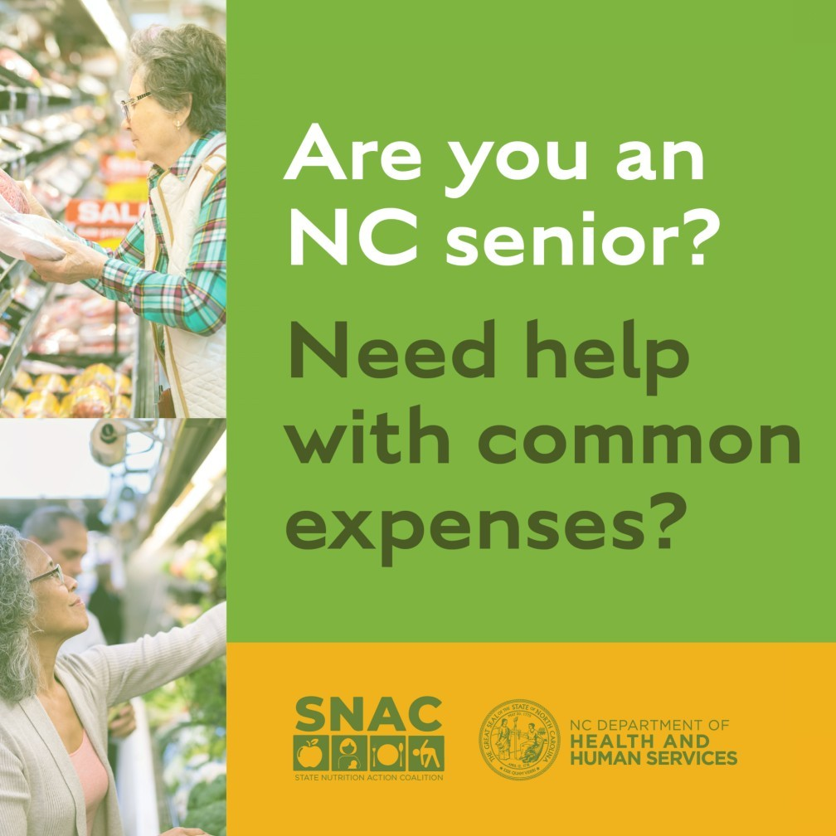
Caption: Senior citizens balancing a limited income may have trouble aﬀording nutritious food and paying their bills. NC beneﬁt programs can help with everyday expenses like food, utilities, phone, and internet. Learn more and see if you’re eligible for assistance at NCDHHS.gov/SeniorResources. #NCSeniorResources
Social Media Post #4:
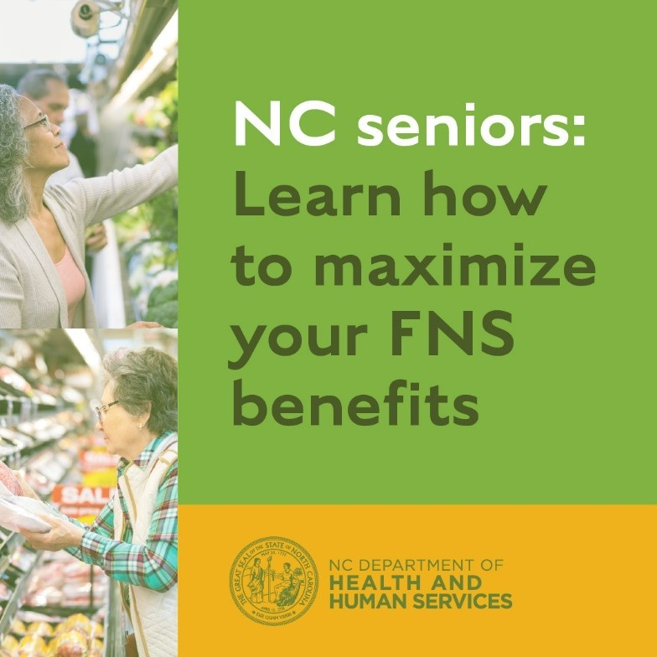
Caption: Did you know you can maximize the benefits you and your family receive? North Carolina allows many everyday expenses to be subtracted from your household’s income, increasing the amount of food assistance you receive. Click here to learn more. #NCSeniorResources

Social Media Post #5:
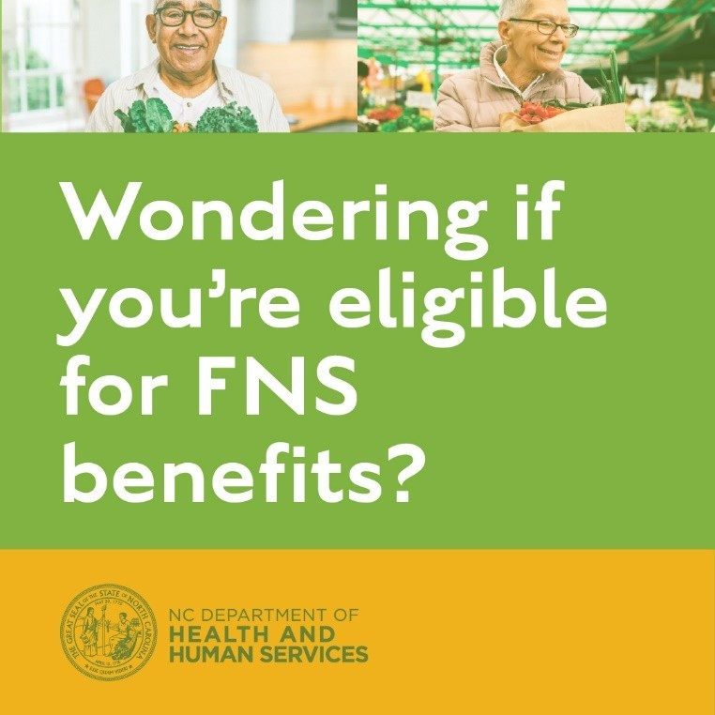
Caption: To get NC FNS benefits, your household’s monthly net income and assets must be at or below a maximum threshold, however, many everyday household expenses can be deducted to help you qualify. Find out if you’re eligible and how to maximize your food benefits by clicking here. #NCSeniorResources
Social Media Post #6:
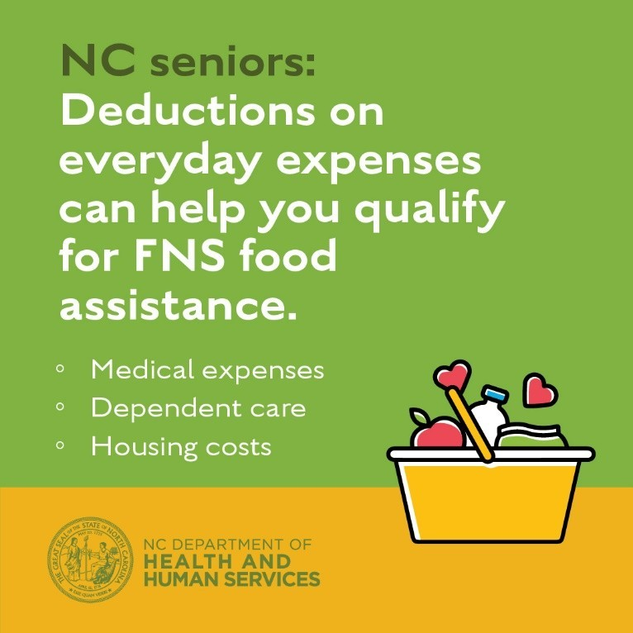
Caption: Your household’s eligibility for FNS benefits is determined by your monthly net income and assets. North Carolina allows many everyday expenses, such as housing and medical expenses and dependent care, to be deducted from your household’s income, increasing the amount of benefits that you can receive. Find out if you’re eligible and how to increase your FNS benefits by clicking here. #NCSeniorResources

