Cultural Competency Awareness
Self-Assessment
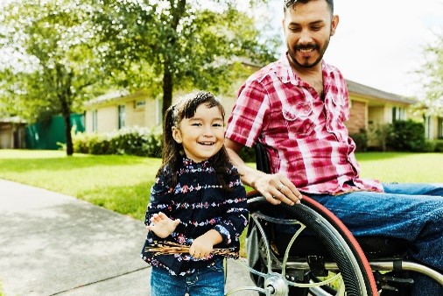

https://nccc.georgetown.edu/curricula/culturalcompetence.html
² https://www.cvims.org/community/cultural-competency/
Community and Partner Engagement Tools for Communities and Partners |  | Background  The North Carolina Department of Health and Human Services (NCDHHS) manages the delivery of health and human-related services for all North Carolinians, especially our most vulnerable citizens – children, elderly, disabled, and low-income families. Our mission is to work collaboratively with partners to improve the health, safety, and well-being of all North Carolinians.  Improving health outcomes requires community, partnership, commitment, collaboration and other factors. A key component to successful community engagements and partnerships includes the involvement of individuals who are culturally competent and display cultural humility.  Key Definitions:  - Cultural Competence: Cultural competence can be defined as the ability of an individual to understand and respect values, attitudes, and beliefs from different cultures and understand how to address differences appropriately in policies, programs, practices, and quality of services. Cultural competence includes gaining the skills that enable effective and equitable services for diverse populations.¹ Cultural competence is an ongoing process of intellectual curiosity, intentional learning, and critical thinking.²  - Community and Partner Engagement: Community and partner engagement can be defined as a mutual and purposeful exchange of lived experience, acquired skills, and genuine trust among partners and communities working together to achieve a common goal (NCDHHS Community & Partner Engagement Guide, page 5).  Purpose: Cultural competence is an ongoing process of intellectual curiosity, intentional learning, and critical thinking.³ This self-assessment is a tool that measures one area of cultural competence: Awareness. This is not a test, but rather a tool to help community-based organizations identify strengths and opportunities for their individual and professional development.  Timing: A quarterly self-assessment is recommended. Individuals can use this as an activity to measure their level of cultural competence.  Objective: This document will help individuals consider their skills, knowledge, and self-awareness in working with others.  Instructions: Read each statement and place an “X” in the column that aligns with you. Remember, cultural competence is a process, and learning occurs on an ongoing basis and over a lifetime. As you complete this assessment, stay in touch with your emotions and remind yourself that learning is a journey.  ³ https://www.cvims.org/community/cultural-competency/  Cultural Competency Awareness Self-Reflection (on next page)
Cultural Competency Resources:
- CLAS, Cultural Competency, and Cultural Humility
- Effective Cross-Cultural Communication Skills (hhs.gov)
- How to Better Understand Different Social Identities (hhs.gov)
- Assess your Organization’s Readiness to Implement and Advance Health Equity. National Council for Mental Wellbeing

Cultural Competency Awareness Self-Reflection
Behaviors | Statement | Never | Sometimes | Often | Always
Support Diversity | I view all cultural differences as positive and a reason to celebrate.
Commitment to Learning | I understand that being culturally competent and having cultural humility involves a commitment to learning over a lifetime. I regularly show my commitment to ongoing learning.
Assumptions | I am aware of the  assumptions that I hold  about people of  cultures different from  my own.
Curiosity | I often put myself in places  where I can learn about  cultural differences and create relationships.
Assessing Behavior | I’m aware that everyone has a “culture” and my “culture” is not to be regarded as the singular or best point of reference to assess which behaviors are appropriate or inappropriate.
Communication | I am aware of my level of active listening and work to listen to understand and learn.
Awareness | I am aware of how others view themselves, how they may view me, and how I view myself and others.
Self-Awareness | I am aware of my behaviors, body language, and actions and actively work to align them to build trust and respect.
Humility | I successfully promote cultural humility when working with others.
 | I am aware of how I am privileged and where I may be marginalized.
 | I successfully have empathy and compassion in working with others.
Reflection
- Once you finish the assessment above, add up the number of X’s in each column (Never, Sometimes, Most of the time, Always).
- Next, for each column, multiply the number of X’s by the numbers below:
Example: If you have 5 X’s in “Never,” you will multiply 5 x 1 to receive a score of 5.
- Never - 1
- Sometimes - 2
- Most of the time - 3
- Always - 4
After multiplying, add up your final score. The more points you have, the more culturally competent you are becoming. The items to which you responded “Never” and “Sometimes” are areas where there may be room to improve your cultural competence.
Next Steps to Consider:
- Goal Setting: Based on your self-assessment results, set three goals to help you become more culturally competent.
  - Goal 1: Develop a short-term goal that you can complete immediately.
  - Goal 2: Develop a medium-term goal that you can complete within a few months.
  - Goal 3: Develop a long-term goal that you can complete over the next year.
- Learning Opportunities: Find learning opportunities through books, professional journal articles, workshops, and training sessions.
- Peer Discussions: Discuss your self-assessment results with colleagues and peers if you are comfortable sharing what you learned through the self-assessment.
- Action Plans: Develop a plan based on your self-assessment results. Outline the steps you can take to enhance cultural competence.
- Engagement: Engage with diverse communities, volunteer, or participate in cultural events, and continue seeking knowledge about various cultures across North Carolina.
- Reflection: Engage in continuous evaluation and self-critique.

For More Information, Visit:
- NCDHHS Office of Health Equity
- Community and Partner Engagement | NCDHHS

