North Carolina Department of Health and Human Services
CPS Assessment in Child Welfare Track Training

Participant’s Workbook
Day Three

October 2024


600 Airport Rd
Lakewood, NJ, 08701-5995
www.pubknow.com

info@pubknow.com
(800) 776-4229

This curriculum was developed by the North Carolina Department of Health and Human Services, Division of Social Services, and revised by Public Knowledge® in 2024.

Copyright © 2024 Public Knowledge®. All rights reserved. No part of this publication may be reproduced, distributed, or transmitted in any form without the written permission of the publisher.
Table of Contents
Instructions 4
Course Themes 4
Training Overview 5
Learning Objectives 7
Day Three Agenda 8
Welcome 9
Interviewing Learning Lab 10
Narrative Interviewing 10
Skills Practice: Narrative Interviewing 10
Interviewing Skills with Children 11
Worksheet: Developmentally Appropriate Child Interview Questions 12
Video: Child Interview: Isabella’s Bruise 14
The Role of Observation in Assessing for Safety 15
Observation Skills 15
Areas to Observe 16
Activity: Factors Influencing Child Vulnerabilities 18
Structured Decision Making: Safety Assessment 19
North Carolina Safety Assessment Tool 19
Activity: Safety Assessment Tool 20
Worksheet: Safety Continuum 22
Assessment Learning Lab 23
Assessing Safety and Risk 23
Worksheet: General Kitchen Assessment 24
Activity: Anchor Family Updates 27
Worksheet: Interview Summaries 27
Worksheet: Case Review Sheet 40
Safety and Danger Indicators 41
Skills Practice: Safety Assessment Practice Parts A and B 42
Harm and Worry Statements 43
Worksheet: Harm and Worry Statements Practice 44
End-of-Day Values Reflection 45
Questions and Reflections 45
Bibliography of References 1
Appendix: Handouts 4
Parent and Child Interaction Guide 5

Instructions
This course was designed to guide child welfare professionals through the knowledge, skills, and behaviors needed to engage with families in need of child protection services. The workbook is structured to help you engage in the lesson through reflection and analysis throughout each week of training. Have this workbook readily available as you go through each session to create a long-lasting resource you can reference in the future.
If you are using this workbook electronically: Workbook pages have text boxes for you to add notes and reflections. Due to formatting, if you are typing in these boxes, blank lines will be “pushed” forward onto the next page. To correct this when you are done typing in the text box, you may use delete to remove extra lines.

Course Themes
The central themes of the CPS Assessment Track Training are divided across several course topics.
- Purpose and Legal Basis for Child Protection Services in North Carolina
- Essential Function: Communicating
- Diversity, Equity, Inclusion, and Belonging
- Trauma-Informed Care
- Family-Centered Practice
- Essential Function: Engaging
- Safety Focused
- Essential Function: Assessing
- Interviewing Learning Lab
- The Role of Observation in Assessing for Safety
- Structured Decision-Making: Safety Assessment
- Assessment Learning Lab
- Safety Planning
- Safety Planning Learning Lab
- Trauma-Informed Practice
- Considerations for Cases Involving Special Circumstances
- Social Worker Safety
- Engaging the Family in Child Protection Services
- Risk Assessment
- Crucial Conversations
- Quality Contacts
- Assessing Family Strengths and Needs
- Secondary Traumatic Stress and Vicarious Traumatization
- Ongoing Assessment
- Family Engagement and Ongoing Assessment Learning Lab
- Documentation
- Well-Being as an Outcome
- Reasonable Efforts and Removals
- Reasonable Efforts and Removals Learning Lab
- Decision-Making
- Decision-Making and Case Closure Learning Lab

Training Overview
Training begins at 9:00 a.m. and ends at 4:00 p.m. If a holiday falls on the Monday of training, the training will begin on Tuesday at 9:00 a.m. This schedule is subject to change if a holiday falls during the training week or other circumstances occur. The time for ending training on Fridays may vary and trainees need to be prepared to stay the entire day.
Attendance is mandatory. If there is an emergency, the trainee must contact the classroom trainer and their supervisor as soon as they realize they will not be able to attend training or if they will be late to training. If a trainee must miss training time in the classroom, it is the trainee’s responsibility to develop a plan to make up missed material.
Pre-Work Online e-Learning Modules
There is required pre-work for the CPS Assessment Track Training in the form of online e-Learning modules. Completion of the e-Learnings is required prior to attendance at the classroom-based training. The following are the online e-Learning modules:
- North Carolina Worker Practice Standards
- Safety Organized Practice
- Understanding and Assessing Safety and Risk
- Understanding and Screening for Trauma
Transfer of Learning
The CPS Assessment Track Training Transfer of Learning (ToL) tool is a comprehensive and collaborative activity for workers and supervisors to work together in identifying worker goals, knowledge gain, and priorities for further development throughout the training process. In four distinct steps, the worker and supervisor will highlight their goals and action plan related to participating in training, reflect on lessons and outstanding questions, and create an action plan to support worker growth. The tool should be started prior to beginning the CPS Assessment Track Training and re-visited on an ongoing basis to assess growth and re-prioritize actions for development.
- Part A: Training Preparation: Prior to completing any eLearning and in-person Track Training sessions, the worker and supervisor should meet to complete Part A: Training Preparation. In this step, the worker and supervisor will discuss their goals for participation in training and develop a plan to meet those goals through pre-work, other opportunities for learning, and support for addressing anticipated barriers.
- Part B: Worker Reflections During Training: The worker will document their thoughts, top takeaways, and outstanding questions regarding each section. This level of reflection serves two purposes. First, the practice of distilling down a full section of training into three takeaways and three remaining questions requires the worker to actively engage with the material, subsequently forming cognitive cues related to the information for future use in case practice. Second, prioritizing takeaways and questions by section allows workers to continually review information to determine if questions are answered in future sessions and supports the development of an action plan by requiring workers to highlight the questions they find most important.
- Part C: Planning for Post-Training Debrief with Supervisor: The worker considers the takeaways and questions they identified in each section and creates a framework to transfer those takeaways and questions into an action plan.
- Part D: Post-Training Debrief with Supervisor: Provides an opportunity for the supervisor and worker to determine a specific plan of action to answer outstanding questions and to further support worker training.
While this ToL is specific to the Track Training in North Carolina, workers and supervisors can review the takeaways and questions highlighted by the worker in each section of training on an ongoing basis, revising action steps when prior actions are completed, and celebrating worker growth and success along the way.
Training Evaluations
At the conclusion of each training, learners will complete a training evaluation tool to measure satisfaction with training content and methods. The training evaluation tool is required to complete the training course. Training evaluations will be evaluated and assessed to determine the need for revisions to the training curriculum.
All matters as stated above are subject to change due to unforeseen circumstances and with approval.

Learning Objectives
Day Three
Interviewing Learning Lab
- Learners will be able to identify strategies to help elicit family voice when conducting interviews.
- Learners will be able to describe the benefit of developing harm and worry statements to communicate concerns related to child maltreatment.
The Role of Observation in Assessing for Safety
- Learners will be able to discuss how their own biases may impact courageous conversations.
- Learners will be able to identify what child and family dynamics must be assessed to make case decisions.
Structured Decision-Making: Safety Assessment
- Learners will be able to describe the purpose of SDM tools used to support assessments.
- Learners will be able to describe how to complete the North Carolina Safety Assessment and when it is used.
Assessment Learning Lab
- Learners will be able to apply the definitions of danger indicators to case examples.
- Learners will be able to formulate harm and worry statements based on scenario information.

Day Three Agenda
CPS Assessment Track Training
Welcome
Interviewing Learning Lab
Narrative Interviewing
Interviewing Skills with Children
The Role of Observation in Assessing for Safety
Observation Skills
Areas to Observe
Structured Decision-Making: Safety Assessment
North Carolina Safety Assessment Tool
Assessment Learning Lab
Assessing Safety and Risk
Safety and Danger Indicators
Harm and Worry Statements
End-of-Day Values Reflection

Welcome
Use this space to record notes from the introduction activity.

Interviewing Learning Lab

Narrative Interviewing

Skills Practice: Narrative Interviewing
Prose Statement: the beginning question or statement of reflection that initiates your narrative interview.
Using the scenario given to you, draft a prose statement. This is the statement you will utilize in your narrative interviewing practice.
Practice Self-Reflection
What is one thing I did well with my practice?
What is one thing I could have done differently to improve my practice?

Interviewing Skills with Children
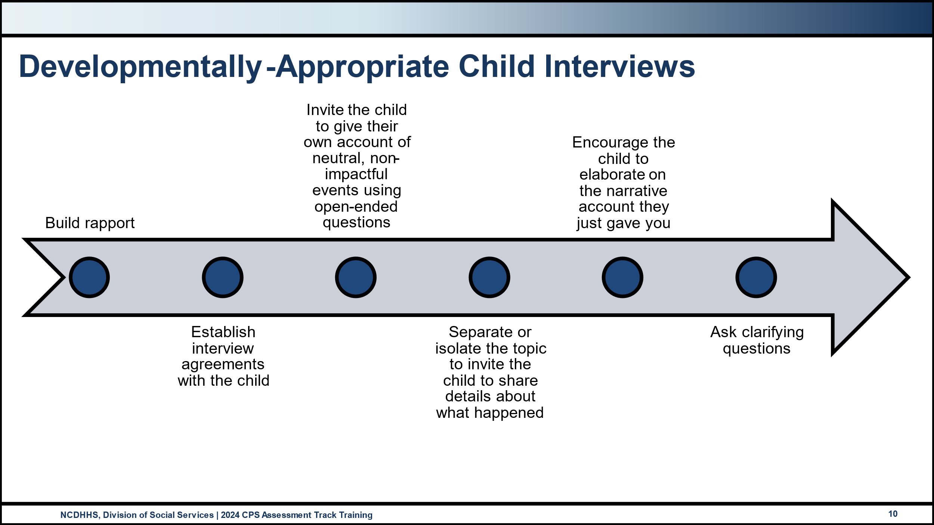
Use this space to record notes.

Worksheet: Developmentally Appropriate Child Interview Questions
For each of the stages below, list a few questions that support the goal of that stage.
Stage One: Build rapport
Stage Two: Establish Interview Agreements with the Child
Stage Three: Invite the child to give you their own account of the neutral, non-impactful events using open-ended questions.

Stage Four: Separate or isolate the topic to invite the child to share details about what happened.
Stage Five: Encourage the child to elaborate on the narrative account they provided.
Stage Six: Ask clarifying questions.

Video: Child Interview: Isabella’s Bruise
https://www.youtube.com/watch?v=DHaepAx8GmQ
Use this space to record notes

The Role of Observation in Assessing for Safety

Observation Skills
Use this space to record notes

Areas to Observe
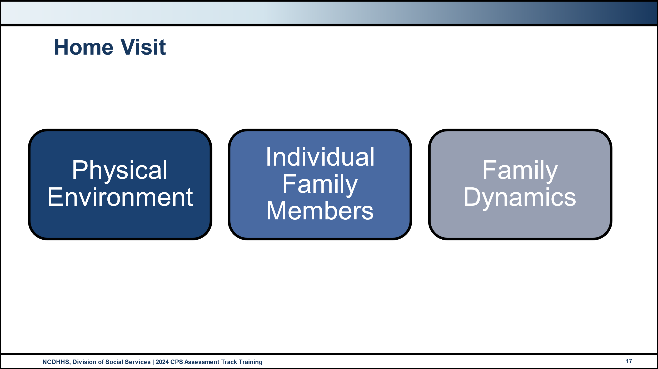
Use this space to record notes

Use this space to record notes

Activity: Factors Influencing Child Vulnerabilities
- Child is aged 0-5. Children ages 0-5 are presumed to be vulnerable in protecting themselves. Evaluate whether any child is able to avoid an abusive or neglectful situation; flee; or seek outside protective resources, such as telling a relative, teacher, etc.
- Child has diagnosed or suspected medical or mental condition, including medically fragile. Any child in the household has a diagnosed medical condition or mental disorder that impairs his/her ability to protect him/herself from harm OR an unconfirmed diagnosis where preliminary indicators are present. Examples may include but are not limited to severe asthma, severe depression, untreated diabetes, and medically fragile (i.e. requires assistive devices to sustain life, etc.).
- Child has limited or no readily accessible support network. Any child in the household is isolated or less visible within the community; or the child does not have adult family or friends who understand the danger indicators; or the child does not have adult family or friends who are willing to take an active role in keeping the child safe.
- Child has diminished mental capacity. Any child in the household has diminished developmental/cognitive capacity, which impacts the child’s ability to communicate verbally or to care for him/herself.
- Child has diminished physical capacity. Any child in the household has a physical condition/disability that impacts his/her ability to protect him/herself from harm (i.e. cannot run away or defend self, cannot get out of the house in an emergency situation if left unattended, cannot care for self, etc.).
Small Group Activity
- Consider your assigned child vulnerability factor
- Generate a list of observable behavioral indicators of this vulnerability
- Create at least one question that further assesses observations of this vulnerability

Structured Decision Making: Safety Assessment

North Carolina Safety Assessment Tool
Use this space to record notes

Activity: Safety Assessment Tool
Your group is responsible for becoming the “expert” of your assigned section of the DSS-5231 Safety Assessment Tool and will respond to the following questions. Utilize DSS-5231ins as a guide.:
What is the purpose of this section?
What key information do you need to complete the section?
What should a worker be mindful of when completing this section?
Who should be involved in completing this section?

Use this space to record notes

Worksheet: Safety Continuum
How do the factors that influence child vulnerability impact safety?
How do you document observations?
What Strengths-based questions might you ask to determine if a situation is out of a parent’s control?
What Strengths-based questions might you ask to determine if a situation is out of a parent’s control?

Assessment Learning Lab

Assessing Safety and Risk
Use this space to record notes

Worksheet: General Kitchen Assessment
Part One
What do you observe? What do you not observe that would be important? Document your observations in bulleted form.
Change your bullets above into a narrative for the record.
Write a paragraph for your report to the court about your General Kitchen Assessment.

Part Two
Document your observations in bullet format. | Write a list of what everyone in the group saw, collectively. | What did you not see that you needed to see? Write a list.

Activity: Anchor Family Updates

Worksheet: Interview Summaries
Interview Summaries
Avilla Chavis Family
- Allegations were discussed during initial contact.
- Parents were contacted prior to initiation.
- Children were seen and interviewed separately within the initiation response timeframe.
- Parents and children were seen and interviewed on the same day as the children.
- Home visit occurred the same day as the victim children were interviewed
Summary of initiation
All household members were initially interviewed together. Subsequent private, individual interviews were conducted.
Regarding the allegations:
- Olivia works part-time as a radiology technician at the local hospital on the second shift, 3 pm-11 pm, and Franklin works as a mechanic at an auto repair shop from 7:30 am-5:45 pm.
- Things have been hard since baby Amelia was born and Olivia has struggled to recover from the birth both physically and emotionally. Olivia’s work changed her to part-time after she returned from maternity leave, which was unexpected and has been a financial difficulty for the family.
- Due to Olivia’s reduced hours and therefore reduced income, the family stopped taking Amelia and Diego to daycare.
- Diego and Amelia are at home with Olivia during the day. Ricardo is in school and goes to after-school childcare at the elementary school on Mondays, Wednesdays, and Fridays and is at home on Tuesdays and Thursdays.
- Leidi watches the younger children from after school when Olivia leaves for work, around 2:45 pm until Franklin returns home from work around 5:45 pm. On the days Olivia does not work, Leidi still watches the children after school because Olivia is tired and goes to her room.
- When Leidi watches the children, she supervises them, feeds and changes Amelia, and makes dinner for the family using the stovetop and oven. She often gives baths to the three youngest and puts Amelia to bed.
- JuanCarlos helps Leidi with the younger children when he is home. He has chorus practice several days a week and often hangs out with his cousin and best friend, Edgar who lives across town.
- The family lives in a manufactured home community. The community consists of three dirt roads that turn off one main road. The family lives on the third road, about ¼ mile from the entrance to the community. Franklin’s sister Martha also lives in the community in the first home on the first road, directly across the main road from the park.
- Leidi often takes the children to the park when babysitting. Leidi brings Amelia in the stroller, and they walk together. It is about ¼ a mile to the park. Everyone is aware that this is happening, and the parents have granted permission.
- Today, Leidi was watching Ricardo, Diego, and Amelia after school while Mom worked. When Leidi was putting Amelia down for a nap, Ricardo decided to take Diego to the park. When Leidi came back into the living room from the bedroom and noticed they were missing, she stepped outside and could see them walking to the park. Since she could see them and the park is right next to Tia Martha’s house, she didn’t see the problem. This is the third time Ricardo has taken Diego to the park. When the neighbor brought them home and scolded her for letting them go to the park, Leidi was shocked.
- Franklin and Olivia have never given permission for Ricardo to take Diego to the park and they were not aware that had happened. They do not feel that this is dangerous and would be okay with it if Tia Martha was home. She was not home today, as she works on Tuesdays.
Individual interview summaries
Observation of Amelia, 6 months old
- Amelia was observed playing on the floor on a blanket, supervised by Leidi. Amelia reached for the toys, putting them into her mouth with both hands. She rolled from her back to her belly while being observed and propped herself up on her elbows to look around.
- In response to Social Worker interaction, Amelia cooed, smiled, and laughed.
Interview with Diego, 3 years old
- Diego was able to tell the social worker his name and held up three fingers when asked how old he was.
- Diego demonstrated an age-typical vocabulary and was able to respond to direct (who, what, and where) questions.
- Diego was observed engaged in a variety of activities during the home visit. He engaged in solo play with trucks on the floor for a few minutes. He grabbed toys from Amelia while she was playing with them to which Leidi grabbed them back and Diego slapped Leidi’s arm. Diego opened the refrigerator multiple times to retrieve apple sauce and cheese sticks which he brought to Ricardo and Leidi to open for him. When Leidi told him no about an additional snack, he stomped his feet, yelled “yes” and got another cheese stick to bring to Ricardo to open.
Interview with Ricardo, 6 years old
- Ricardo provided a tour of his bedroom, shared about his favorite toys, described his favorite movie, Toy Story, and explained how he shares his space with JuanCarlos. Ricardo was observed to respond with age-typical vocabulary and responsiveness.
- When asked about the fact that his bed had no bedding, Ricardo said that Amelia cries at night sometimes so loud that he wakes up, so he started taking his pillow and blanket with him to sleep by her crib, so she doesn’t get so scared.
- He told social worker that one night last week, baby Amelia was sick and vomited in her crib. He tried to wake his mom and dad up but said they wouldn’t wake up, so he woke up Leidi, who changed Amelia’s pajamas and sheets and put her back to bed.
- Ricardo stated that Leidi babysits him sometimes after school until his dad gets home from work. When asked what time his dad gets home, Ricardo said it is dinner time when dad gets home.
- Ricardo said that he likes to go to the park and sometimes he takes Diego with him. When asked about the day that a neighbor walked them home, Ricardo said that the neighbor told him it wasn’t safe for him to babysit Diego, but he said he is really a big boy and he can take good care of them.
- When asked about what he would do if he or Diego got hurt at the park, he said he would get Tia Martha. When asked what he would do if Tia Martha wasn’t home, Ricardo shrugged.
Interview with Leidi, 12 years old
- Leidi provided a tour of her space and shared about her favorite TV show and the book she is reading. Leidi described being a “homebody” meaning she would prefer to be at home than anywhere else.
- Leidi shared that she does have a few friends at school. She has several social media accounts and has made tons of new friends online. She complained about her mom taking her phone away as punishment although states this doesn’t happen often because she is “a really good girl.”
- Leidi talked about being her mom’s “best helper,” and that she does more than JuanCarlos around the house. Leidi said she is expected to do chores around the house such as cleaning the kids’ bathroom, unloading and loading the dishwasher, and vacuuming the hallway plus keeping her bedroom clean, making snacks for the little kids after school, and sometimes babysits when her mom goes to work in the afternoons.
- Leidi explained that her mom leaves for work when she gets off the bus, so she babysits Amelia and Diego until JuanCarlos gets home, if and when he gets home. On Tuesdays and Thursdays, Ricardo also rides the bus home, and only sometimes does she babysit Ricardo, too. She sometimes likes it when Ricardo is home because he plays with Diego so she can focus on Amelia and the housework; sometimes she doesn’t like it because Ricardo and Diego are constantly fighting and don’t listen. She says this can be really stressful and sometimes she doesn’t know what to do.
- Leidi explained that she cooks on the stovetop and in the microwave and that she makes dinner when her mom works or is sleeping. Leidi said that since her mom’s hours at work got cut, she has had to help with babysitting more. She said it’s not just because Diego and Amelia don’t go to daycare, but because her mom is tired and spends a lot of time in her room not helping with the young kids, even when they cry or Diego asks for her. Leidi indicated her mom will come and take over if Leidi asks multiple times, but Leidi doesn’t like to do that because she likes being a helper.
- When asked about emergency plans, Leidi says that she would call her Tia Martha or abuelos if her mom isn’t home. When asked what defines an emergency, Leidi shrugged and said she guesses that if someone got hurt it would be an emergency.
- She says she sees both her parents drink alcohol “a lot” but said she “wasn’t sure” when the social worker asked follow-up questions about the frequency of drinking or the amount consumed.
- When asked about the incident with Amelia throwing up in the middle of the night, Leidi said that Ricardo woke her up and she did change Amelia and the sheets. She said that as she was putting Amelia back down, the baby threw up again and she did wake her mother up. She said her mother seemed annoyed but took Amelia, and Leidi went back to bed so she could get up for school.
Interview with JuanCarlos, 16 years old
- JuanCarlos provided minimal information during the private interview, stating that he had already said “everything I need to say” during the family interview.
- JuanCarlos stated that he is a sophomore in high school, has many friends, and his best friend is also his cousin, Edgar, and doesn’t have very good grades.
- JuanCarlos has been living with the family for two years since his mom, Evangelina got sick with cancer. JuanCarlos misses his mom and feels like people have forgotten her after she died last year.
- JuanCarlos explained that he sings in chorus at school and the choir at church, and singing is something he always did with his mom.
- JuanCarlos stated everything is fine at home. He wishes that Olivia would do more but that Leidi has it “under control” so really, everyone is okay.
Additional Information
Alcohol and Substance Misuse:
- Olivia and Franklin report being “social drinkers,” both stating that they drink alcohol almost every day.
  - Olivia stated that she drinks wine after work “most days” to help her sleep
  - Franklin stated that he drinks a “few” beers when he gets home from work in the evenings.
- Ricardo and Leidi described that Olivia has been “really sleepy” lately, falling asleep on the couch many of the days she does not work, even before putting baby Amelia to sleep for the night. JuanCarlos stated that his stepmom has “passed out” on the couch some nights and that Olivia drinks wine “every day.” Leidi and JuanCarlos stated that they gave Amelia her bath and bedtime bottle and put her to sleep on those nights. When asked where their dad was when this happened, the children talked about how their dad was helping their Tia Martha fix the new house she bought a few blocks away.
Discipline
- The family consistently described that both Olivia and Franklin handle disciplining the children.
- Both parents state that they raise their voices at the children, but do not curse at them. Both parents also utilize grounding, taking away the older children’s cell phones, and spanking to discipline.
- Both parents describe “spanking” as hitting the children’s bottoms with their hands two or three times. Both parents and all the children report no marks are ever left from these spankings.
- When Leidi is babysitting, she smacks Diego and Ricardo’s hands or on the top of their head to stop them from fighting. This doesn’t really work so she yells or tells them to go play outside so they don’t bother Amelia or their mom if she’s home and sleeping.
Family Relationships
- The family reports that adults and older children get along well.
- Ricardo and Diego fight often, frequently pushing, shoving, and hitting each other to the point that they must be physically separated, as they do not respond to verbal prompts. Fighting has occasionally resulted in injuries such as a black eye or scratch marks on arms, neck, or torso. The family indicates that this is expected “boy” behavior and do not find it concerning.
- No concerns noted nor reported regarding family violence.
Mental Health
- Olivia has been involved in therapy in the past. It was not helpful although she reports it was not very consistent due to going back to work after maternity leave.
- She attends a parenting support group at the library twice a week. It started as something to do with the little ones when her hours were cut because they offer babysitting; however, it has been really great. Where she learned about postpartum depression.
- Olivia has a diagnosis of depression by a mental health clinician since her depression is ongoing past birth of her children and has been a long-term issue. She completed the intake and has not engaged in therapy, stating that she doesn’t have time or childcare.
- Olivia started medication three weeks ago, prescribed by her primary care provider. Olivia indicated she cannot tell if it’s working.
- Olivia reports having low energy, lack of desire, and motivation although she does what she needs to get through the day with the children.
Family Supports
- Franklin is close with his family including his parents and sister who both reside in the same community. Franklin’s other sister’s family lives close by and JuanCarlos is close with the son, Edgar. The family provides support and childcare often.
- Olivia’s family is supportive and lives within 15 minutes of the family. They provide financial support as needed and will occasionally watch the children.
- No concerns regarding abuse or neglect within Franklin or Olivia’s families of origin.
Economic/basic needs/access to community resources
- The family has the financial resources to provide for their basic needs.
- When financial strain occurred when Olivia’s hours were reduced, the family accessed support from extended family to cover basic needs.
Physical health
- Franklin is diagnosed with type 2 diabetes and manages with medication.
- Amelia had trouble gaining weight early in her life. She was very small and didn’t eat well. She is better now and doesn’t have to go to the doctor as often.
- No other physical health concerns have been identified for the family
Summary of Collateral Contacts with Neighbor, Tammy Kirby
- Tammy says she has lived two doors down from the Avilla-Chavis family for three years and does not know the family very well. She said Olivia is polite and waves to her if they are both getting home at the same time, but they never really have any conversations.
- Franklin helped her reattach a downspout after a significant rainstorm about 6 months ago, which she appreciated, but she never talks to him and says it seems like he is not around as much.
- Tammy said the children are outside a lot and whenever she sees the younger kids in the yard, they are with Leidi or JuanCarlos.
- She thinks that the parents rely too much on the other kids, especially Leidi, to take care of the children, and has observed Olivia handing Leidi the baby as soon as she gets off the bus, then leaving immediately for work. Tammy says that’s too much responsibility for a kid that age.
- Tammy said she has seen the kids in the park from her window a few times in the afternoons. She says she sees the stroller and Ricardo and Diego running around playing, but it had never occurred to her that they might be unsupervised because you can’t see the bench where most parents sit from her house.
- The day she brought them home she saw Ricardo walking across the street with Diego. She didn’t see anyone else and it occurred to her that they were by themselves.
- Tammy said when she walked the children home, Leidi was polite but not concerned that the younger children had been at the park. She told Leidi it wasn’t ok and said she just shrugged.
- Tammy said the house was “disgusting” from what she saw from the front door, and she is worried that something will happen to the younger kids if this continues. She said it seems like the parents obviously don’t care if they have allowed this to continue.
Collateral with Tia Martha who lives in the community across from the park
- Martha stated that she could not speak for very long, as she was on her way to a meeting.
- Martha explained that she had talked with her brother and knows about the report. She was not home earlier today, as she always is gone on Tuesdays.
- Martha reported that she has seen the children walk together to the park with Leidi pushing Amelia in the stroller, but she didn’t know that Ricardo and Diego had walked to the park alone. She reported that although it’s a long way for them to talk, she feels the neighborhood is fairly safe so isn’t really worried about it.
- Martha indicated that the children come to visit her and hang out but that she doesn’t “babysit” in a scheduled way. Martha stated that she would be willing to look out from her house to watch over the children at the park and would certainly be available if there was an emergency if she is home.
- Martha described the family as a “good family” and that Olivia and Franklin do a good job keeping the children safe. She reports no concerns regarding the children’s safety.

Lewis Family
Interview Summaries
- Allegations were discussed during initial contact.
- Parents were contacted prior to initiation.
- Children were seen and interviewed separately within the initiation response timeframe.
- Parents and children were seen and interviewed on the same day as the children.
- Home visit occurred the same day as victim children were interviewed.
Summary of initiation
All household members were initially interviewed together. Subsequent private, individual interviews were conducted.
Regarding the allegations
- The children have been living with their biological father, George, and George’s husband, William, since their mother, Monica, went to prison a little over a year ago. Before this change, George and William had been consistently involved in the children’s lives, caring for them several days a week and attending school events. George and William have been in a relationship for five years and married for three.
- The family described George as disciplining the children and usually removing privileges for Raymond or grounding Van, meaning they could not leave the house to hang out with friends if they misbehaved.
- William will give directions and reminders of expectations, and when that is not sufficient, he will say, “I’m gonna have to talk to your dad about this,” when he notices behaviors that are not acceptable.
- Van doesn’t get into much trouble.
- Raymond says, “I am always in trouble.” For “bigger stuff,” Raymond gets spankings from George.
- When asked about “bigger stuff,” the family described the following:
  - Van were not home when the incident occurred.
  - When asked about behaviors that result in discipline, George described Yesterday, Raymond told his dad he had finished his homework and logged onto the Xbox.
  - When George went to make dinner, he found the homework lying on the floor, unfinished and covered in juice. The juice container had been left on the counter without a lid and had been knocked over, spilling juice all over the floor.
  - George said that he “snapped” and went to “confront” Raymond. George asked Raymond why he lied, and Raymond said he didn’t lie, he must have forgotten.
  - George indicated that he cannot tolerate this level of disrespect. He “lost it,” meaning he grabbed Raymond and began to “whup” him. Raymond was trying to get away, but George held his arm tightly while hitting his butt with his open hand. At one point, Raymond’s pants fell down, and George continued to hit his unclothed buttocks.
  - Raymond is observed to have purple marks on the soft tissues of his buttocks, primarily on the left side, beginning at the upper region of the buttocks just below the hips and extending to the upper leg, just below the buttocks. The purpleness varies in shade throughout the marked area with flesh-colored linear lines, which could indicate the space between fingers, per account that George whupped Raymond with his hand. Raymond reports that it doesn’t hurt as bad when he sits “to the right” and demonstrated shifting his weight by learning to the right. Raymond said sitting at school is painful.
  - George indicated that he believes that the purple marks on Raymond’s buttocks were a result of his whupping. George said that he doesn’t ever mean to hurt Raymond when he disciplines him, just “teach him a lesson.” In response to an inquiry about how it feels to notice the extent of the bruises, George shrugged and said, “It doesn’t feel good.”
- William and Raymond as being “constantly disrespectful” and “full of attitude.” He went on to say that Raymond would “look right at you and hear what you say, then do the opposite.”
- George commented that Raymond is a “troublemaker” and that “his mama let him get away with all sorts of things that don’t stand at this house.”
- Raymond is diagnosed with ADHD.
  - He takes Adderall every day unless they forget in the rush of the morning to get to school. This happens about once a week.
  - Raymond says that he just gets distracted a lot and needs help remembering to finish things.
  - George, William, and Van gave the following examples of Raymond’s forgetfulness:
    - Raymond leaves his shoes in the hallway and the milk on the counter after making a bowl of cereal.
    - He drops his backpack on the floor and leaves the door open when he comes in from school.
    - He constantly loses something, like a stuffed animal, homework, etc.
  - George indicated that Raymond doesn’t have this level of issue at school, so it’s “obvious that he just doesn’t care and does not respect the household at home.”
  - George says he is “at a loss” for what to do with Raymond and that he “better shape up” because things cannot continue like this. George says that Raymond “makes” him whup him with his bad behavior.
  - George said that the whupping would not have been so bad if Raymond had “just accepted it” and not tried to pull away.
- William indicated that he tries to remind Raymond to clean up, although this often isn’t enough because Raymond just gets distracted again before completing his task.
- William indicated that he would come into the room when George is spanking Raymond, which seems to settle George.
- William said that Raymond is a good kid but doesn’t follow through, which George takes personally. William said he hasn’t spent much time around kids, so he really isn’t sure what is fair.
- Van indicated they try to stay with friends or at school events as often as possible. When asked specifically if there was a reason that they didn’t want to be at home, Van looked at their dad, then looked away and shrugged.
- When information was shared about ADHD and its impact on behaviors, George indicated that this was just an excuse. George shared his thought that “kids today just don’t have discipline” and are not held accountable. George indicated that he was whupped as a child, and he learned not to lie and to see things through, so he believes that Raymond hasn’t learned these things because his mother didn’t discipline him enough.
- When asked about steps to ensure Raymond isn’t injured during discipline, George indicated that DSS was “blowing this all out of proportion” and that DSS involvement was unnecessary; Raymond just needs to “do better.”
Individual interview Summaries
Interview with Raymond:
- Raymond gave a tour of the bedroom he shares with Van. He talked about his favorite superhero, Spider-Man, played video games and explained the rules that keep his stuff out of Van’s things in their shared space.
- When asked if Raymond ever feels scared, Raymond stated he is always scared that his dad is going to “whup” him. Raymond described getting spankings every week and then a “whupping,” like yesterday, about three times since he moved in with his dad.
- Raymond says he thinks about getting whupped “all the time” and that sometimes this makes it hard for him to do things at home because he is afraid he will mess it up.
- Raymond says it doesn’t always hurt as badly as yesterday's, and he doesn’t always get marks. He cannot remember how often that happens.
- Most of all, Raymond hates it when his dad calls him “lazy” or “stupid” or accuses him of lying.
- Raymond says he tries his best to remember to do things, and sometimes he can, but other times he cannot. He said worrying about getting in trouble makes him more forgetful.
- Raymond says he misses his mom because these things never happened when he lived with her.
- Raymond says that William tries to help him remember things, but he can’t always remember.
Interview with Van:
- Van shared about hanging out with their friends, Sam and Henry, after school and their love of basketball.
- Van says that things between their dad and Raymond seem to be getting worse. They are not sure what is going on with their dad, and they think maybe he “can’t handle kids full time.” Van says there have been more whuppings, and they can see that it hurts Raymond.
- Van says that Raymond is so forgetful, and they are annoyed with how much support he needs to get things done. It wasn’t like this when they lived with mom. Van wishes Raymond could “just do better.”
- Van says that they don’t like the constant yelling and nagging, so they stay out of the house whenever they can, but they wonder if they should be there to protect Raymond.
- Van said that when they heard about yesterday, they got really scared that one day their dad was going to “really hurt” Raymond.
Additional Information
Alcohol and Substance Misuse:
- William considers himself a “social drinker,” meaning he has one or two beers each night to “unwind.”
- George does not drink alcohol. George indicated that he had smoked marijuana in the past to “chill.” George said he doesn’t think marijuana is a drug or “that bad,” so he would smoke again if he had access. When smoking, he doesn’t keep marijuana in the house.
- Van and Raymond reported that William “drinks sometimes.”
Family Relationships:
- George and William bicker when problems arise, going back and forth with complaints and making sarcastic comments to one another about areas that they feel the other has deficits, such as William leaving clothes on the floor or his plate on the table or George not putting food on the list when they run out or being “too uptight.”
- Raymond indicated that he had heard George and William yelling in the living room at night and George leaves the house. He heard William crying. This scares Raymond because he doesn’t want George to hurt William.
- George and William indicate they have arguments “like everyone else” and that arguments have never escalated to violence between them. They manage conflict by George taking space to “cool down” and William allowing George to take that space.
- When asked if the presence of the children in the home has increased arguing or tension, George indicated that this hasn’t been the case, while William said, “Now that you mention it,” it does seem to be more frequent now that they are parenting full time.
Supervision:
- Raymond is not allowed to stay home alone. When no parents are available, he will stay with Van for an hour or two. If longer care is needed, he goes to Ms. Rosa's apartment on the first floor, just below the family’s apartment.
- Van can stay home alone for 3-4 hours, which only happens sometimes. Van has a cell phone and identifies that Ms. Rosa and Aunt Michelle are resources in an emergency if their dad and William are unreachable.
- Raymond is allowed to walk to his friend Isabella’s house in the apartment complex. He is required to call from his home phone to report his arrival.
- Van is permitted to skateboard around the apartment complex if they are with a friend and have their cell phone.
Mental Health:
- Van has been struggling with people’s responses to them coming out as non-binary. The teachers at school constantly say their legal name instead of their chosen name. Van says whenever they hear their legal name, or someone calls them “she,” they feel upset. They have another friend who is trans, so the two of them can relate to one another. Van says their family is supportive now that George has “gotten over it.” They are interested in having a different doctor who “gets it,” and when asked about a therapist, they said, “I’m not opposed.”
- Raymond has ADHD, which is managed with medication by a primary care provider. Raymond says that his ADHD makes him forgetful, and sometimes he cannot focus.
- Raymond and Van both say they miss their mom and look forward to her release. Raymond says that sometimes he misses her so badly that he cannot think and cries. This happens most nights, sometimes at school, and when he is in trouble with his dad. Van says they feel similar to Raymond but “don’t cry about it.”
- George and William report that they have no mental health issues.

Economic/basic needs/access to community resources:
- George and William have sufficient financial resources for the household. When the children moved in with them a year ago, things felt “tight,” although they never went without basic needs and many of their desires.
Physical Health:
- George has high blood pressure. There are no current medications or interventions; it “just runs high.
- William has had ongoing issues with his knee. He has had two surgeries in the past and wears a brace at work.
- Van and Raymond are reported to be healthy with no noted medical/physical health concerns.
Collateral Contact with Ms. Rosa, the neighbor who occasionally watches Raymond:
- Ms. Rosa indicated that Raymond is a sweet child who sometimes stays with her if his dad must run an errand. She has gotten him off the bus six or seven times since Raymond moved in with his dad about a year ago.
- Ms. Rosa said that she knows that Raymond worries about being a good kid, as he has told her that he keeps “messing up” with his dad regarding chores and cleaning up after himself.
- Although she sometimes hears George yelling, Ms. Rosa isn’t aware of any spanking or problems.
- Ms. Rosa agreed that if there was ever trouble between George and Raymond, George could send Raymond to her apartment. She is always home after school and on the weekends because she is a “real homebody.”
Phone interview with mother, Monica Lewis, non-resident parent:
- Monica is incarcerated on a two-year sentence after convictions for shoplifting and writing bad checks. She has about ten months left of the sentence. Monica engaged in this criminal behavior after losing her job and could not make ends meet each month.
- Monica never had significant concerns about the children being with George and William. Before going to prison, the children spent every other weekend and at least one weeknight with George.
- Monica has worried about whether things would be okay with George having the children full-time, as he has never had to deal with the day-to-day parenting life.
- Monica described George as being “big on respect.” She described Raymond as needing more support, reminders, and nagging than Van to complete tasks. She indicated that she had to “constantly be on him” for Raymond to complete homework and household tasks. She is not surprised that George would interpret Raymond’s behavior as disrespectful, although she is shocked at the extent of the discipline.
- Monica is worried about the children and whether they will be okay. She worries now that she knows how bad it is that George will take out his embarrassment about DSS being called on Raymond.

Worksheet: Case Review Sheet
For this activity, we will familiarize ourselves with three-column mapping.
The three-column mapping tool is a Safety Organized Practice that supports the organization of your assessment and interviewing activities and findings in a clear, balanced way. Three-column mapping can be utilized for yourself, as we are practicing here, and can be utilized with families, in CFT meetings, or in supervision to promote collaboration and transparency.
The three columns correspond with the three essential questions.
- What are you worried about? captures safety concerns and risk factors.
- What is working well? highlights strengths, protective capacities, and protective factors.
- What needs to happen next? List actions that the family, the social worker, or other safety network or CFT members must take to resolve the concerns.
What are you worried about? | What is working well? | What needs to happen next?

Safety and Danger Indicators
Use this space to record notes

Skills Practice: Safety Assessment Practice Parts A and B
Remaining in your anchor family groups, complete:
- Part A: Factors Influencing Child Vulnerability
- Part B: Current Indicators of Safety
Move into pairs and share your work
- Notice similarities
- Notice differences
Use this space to record notes.
Review as a large group
Use this space to record notes.

Harm and Worry Statements
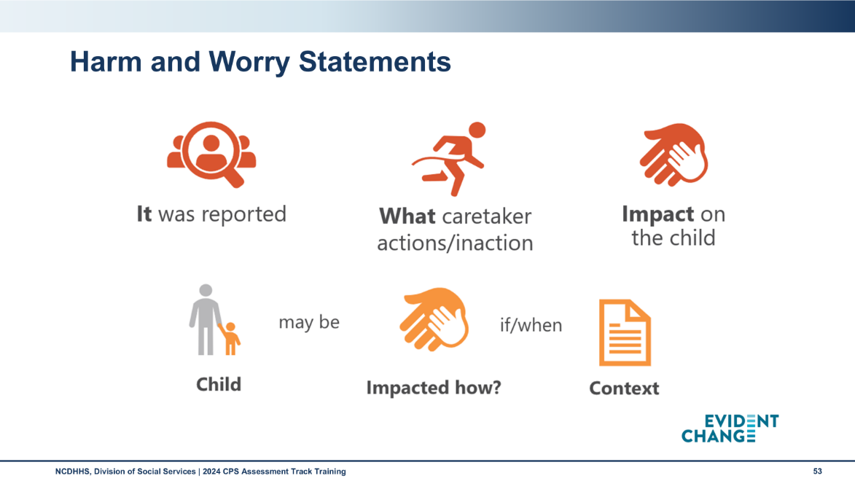
Use this space to record notes

Worksheet: Harm and Worry Statements Practice
Harm Statement
Harm statements include clear, specific statements about the harm or maltreatment that has happened to the child. Harm statements involve what has already happened and why DSS is involved. Provide behaviorally specific details.
Harm Statement Practice
It was reported… | Caregiver action or inaction… | Impact on the child…
Worry Statement
Worry statements are simple behavioral statements about the specific worry DSS has about this child, now and for the future. Worry statements indicate what we continue to be worried about if nothing changes in the future. Two questions answered by the worry statement:
- What is the agency most worried about will happen to the child if nothing changes?
- When or in what context are they most worried this could happen?
Worry Statement Practice
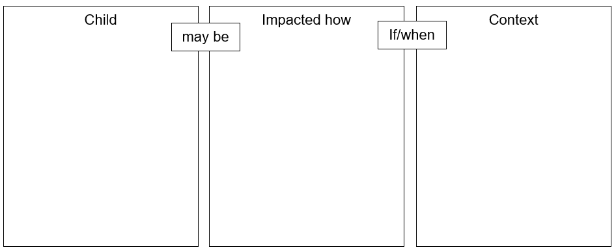

End-of-Day Values Reflection

Questions and Reflections
Use this space to record questions and reflections about what you have learned.

Bibliography of References
Day Three
Adverse childhood experiences study. (2024). Acestudy.org. [Website]. www.acestudy.org
Alberta Home Visitation Network Association. (2009, March). Parent-child interaction: A home visitor’s guide. Leduc, Alberta, Canada: Alberta Home Visitation Network Association. Retrieved from www.socialworkstoolbox.com, https://www.socialworkerstoolbox.com/home-visit-observations-of-parent-child-interactions-questionnaire-checklist/.
Alliance for Child Welfare Excellence. (2020, October 1). Regional Core Training – Interviewing Adults Handouts. Rise with the Alliance. https://risewiththealliance.org/home/regional-core-training-interviewing-adults-handouts/
CalSWEC Online, (2019, April 29) Child Welfare Worker Realistic Job Preview. [Video]. YouTube.com. https://www.youtube.com/watch?v=2aoOYAwgp2o&list=PLNYfSDZN2XUpWQ62KzijZDZ_g2VEjlSGD&index=1
Casey Family Programs, (2019, January 18) Jeremiah Donier: Birth dad winner. [Video]. YouTube.com. https://www.youtube.com/watch?v=yxBeN5-Rq_E&t=249s
Centers for Disease Control and Prevention. (2018, August). Data collection methods for program evaluation: Observation. [Brief]. www.cdc.gov. https://www.cdc.gov/healthyyouth/evaluation/pdf/brief16.pdf
Centre for Investigative Interviewing. (2019, December 8). Child interview: Isabella’s bruise. [Video]. YouTube.com. https://www.youtube.com/watch?v=DHaepAx8GmQ
Child Welfare Information Gateway. (n.d.). Separating poverty from neglect. Washington, DC: U.S. Department of Health and Human Services, Administration for Children and Families, Children's Bureau. https://www.childwelfare.gov/topics/prevention/separating-poverty-neglect/?top=89
Child Welfare Information Gateway. (2020, October) How the Child Welfare system works. Washington, DC: U.S. Department of Health and Human Services, Administration for Children and Families, Children's Bureau. https://www.childwelfare.gov/pubPDFs/cpswork.pdf
Child Welfare Information Gateway. (2021, March). The use of safety and risk assessments in Child Protection cases. Washington, DC: U.S. Department of Health and Human Services, Administration for Children and Families, Administration on Children, Youth, and Families, Children’s Bureau. (March 2021). https://cwig-prod-prod-drupal-s3fs-us-east-1.s3.amazonaws.com/public/documents/safety_risk.pdf?VersionId=ssUjM9eGAF05e9YAiAkm8zjJ_AibAyRS
Child Welfare Information Gateway. (2021). Family engagement: Partnering with families to improve child welfare outcomes. Washington, DC: U.S. Department of Health and Human Services, Administration for Children and Families, Children's Bureau. https://www.childwelfare.gov/pubs/f-fam-engagement/
Child Welfare Information Gateway. (2014, July 23) Child and family services reviews quick reference items list. Washington, DC: U.S. Department of Health and Human Services, Administration for Children and Families, Children’s Bureau. https://www.acf.hhs.gov/sites/default/files/documents/cb/cfsr_quick_reference_list.pdf.
Child Welfare Information Gateway. (2023). Child Welfare Policy Manual. Washington, DC: United States Department of Health and Human Services, Administration for Children and Families, Children’s Bureau. Retrieved from https://www.acf.hhs.gov/ on 12 Nov 2023.
Cleveland Clinic. (2024). Malnutrition. Clevelandclinic.org. https://my.clevelandclinic.org/health/diseases/22987-malnutrition
Efrati, Y. (December 31, 2019). Normal versus abnormal sexual behavior in adolescents. Psychiatric Times, 36(12). https://www.psychiatrictimes.com/view/normal-versus-abnormal-sexual-behavior-adolescents.
Evident Change. (2021). SDM in Practice - Participant Guide: Module 3. Retrieved from https://docs.evidentchange.org/Pages/arkansas/Content/DD/Participant%20Guide%20Mod%203.pdf.
Harborview Center for Sexual Assault & Traumatic Stress & Washington State Criminal Justice Training Commission. (2009, October). Washington State child interview guide. https://depts.washington.edu/uwhatc/PDF/guidelines/WA%20State%20Child%20Interview%20Guide%202009%202010.pdf
Juvenile Code, Article 3 – Screening of Abuse and Neglect. North Carolina Stat. §7B-302. (1979, rev. 2021). https://www.ncleg.net/EnactedLegislation/Statutes/HTML/ByChapter/Chapter_7B.html
Legal Information Institute. (May, 2023). Fourth Amendment. Ithaca, NY: Cornell Law School. https://www.law.cornell.edu/wex/fourth_amendment
Levenson, M. & Rutherford, M. (2022, March 17). Back-to-basics-Safety and risk. [Webinar]. North Carolina County Child Welfare Staff Meeting. https://fcrp.unc.edu/resources/back-to-basics-safety-and-risk-webinar-1-safety-assessment/.
Lund, T.R. & Renne, J. (2009). Child safety: A guide for judges and attorneys. Washington, DC: American Bar Association. https://www.americanbar.org/content/dam/aba/administrative/child_law/child-safety-guide.pdf
Mammen, J.R., Rhee, H., Norton, S.A., & Butz, A.M. (2016, June 23). Perceptions and experiences underlying self-management and reporting of symptoms in teens with asthma. Journal of Asthma 54(2): 143-152. https://www.ncbi.nlm.nih.gov/pmc/articles/PMC5182183/
Maternal, Infant, & Baby Childhood Home Visiting Technical Assistance Resource Center. (n.d.). Parent-child interaction and home visiting. Washington, DC: Health Resources and Services Administration. https://mchb.hrsa.gov/sites/default/files/mchb/programs-impact/parent-child-interaction.pdf
North Carolina Department of Health and Human Services, Division of Social Services. (2002). What is forensic interviewing? Children’s services practice notes 8(2). https://practicenotes.org/vol8_no1/what_is.htm
North Carolina Department of Health and Human Services, Division of Social Services, Child Welfare Services. (2017). DSS-5231: North Carolina safety assessment. https://policies.ncdhhs.gov/wp-content/uploads/dss-5231-ia.pdf
North Carolina Department of Health and Human Services, Division of Social Services, Child Welfare Services. (2017). DSS-5231ins: North Carolina safety assessment instructions. https://policies.ncdhhs.gov/wp-content/uploads/DSS-5231ins.pdf
North Carolina Department of Health and Human Services, Division of Social Services. (2019). Assessing safety and risk. Children’s services practice notes 24(2). https://practicenotes.org/v24n2.htm
North Carolina Department of Health and Human Services, Division of Social Services. (2020, May). CPS Purpose & Philosophy, Legal Basis, Administration: NC Child Welfare manual, 9. https://policies.ncdhhs.gov/wp-content/uploads/purpose.pdf
North Carolina Department of Health and Human Services, Division of Social Services. (2021). North Carolina practice standards worker assessment. https://www.ncdhhs.gov/cw-worker-north-carolina-worker-assessment-all-practice-standards/open
North Carolina Department of Health and Human Services, Division of Social Services. (2021). Worker practice standards desk guide. https://www.ncdhhs.gov/cw-worker-north-carolina-worker-practice-standards-desk-guide/open
North Carolina Department of Health and Human Services, Division of Social Services. (2024, April). Cross function topics: NC Child Welfare manual. https://policies.ncdhhs.gov/wp-content/uploads/In-Home_April-2024_2.pdf
North Carolina Department of Health and Human Services, Division of Social Services. (2024, August). CPS Assessments Policy, Protocol, and Guidance: NC Child Welfare manual. https://policies.ncdhhs.gov/wp-content/uploads/CPS-Assessments-Aug-2024.pdf
North Carolina Department of Health and Human Services, Division of Social Services. (2024, August). CPS Intake Policy, Protocol, and Guidance: NC Child Welfare manual. https://policies.ncdhhs.gov/wp-content/uploads/CPS-Intake_Aug-2024.pdf
Quora. (2023, October 23). How body language is informed by culture. Forbes, Innovation, Consumer Tech. https://www.forbes.com/sites/quora/2023/10/23/how-body-language-is-informed-by-culture/?sh=5139105942ef

Appendix: Handouts
Parent and Child Interaction Guide 5

Parent and Child Interaction Guide
