North Carolina Department of Health and Human Services
CPS Assessment in Child Welfare Track Training

Participant’s Workbook
Day Six

October 2024


600 Airport Rd
Lakewood, NJ, 08701-5995
www.pubknow.com

info@pubknow.com
(800) 776-4229

This curriculum was developed by the North Carolina Department of Health and Human Services, Division of Social Services, and revised by Public Knowledge® in 2024.

Copyright © 2024 Public Knowledge®. All rights reserved. No part of this publication may be reproduced, distributed, or transmitted in any form without the written permission of the publisher.
Table of Contents
Instructions 3
Course Themes 3
Training Overview 4
Learning Objectives 6
Day Six Agenda 7
Welcome 8
Ongoing Assessment 9
Essential Function: Implementing 9
Safety and Risk in Comprehensive Family Assessments 10
Collateral Contacts 13
Handout: Engaging Families in the Safety Network 17
Worksheet: Circles of Safety and Support 19
Activity: Circles of Safety and Support Conversation 20
Formal Evaluations 21
Worksheet: Self-Awareness Check-In 24
Video: Lived Experience: Alexandra’s Story 25
Family Engagement and Ongoing Assessment Learning Lab 26
Activity: Lewis Family Update 26
Worksheet: Case Review Sheet 28
Skills Practice: What’s the Next Question? 29
Skills Practice: Interviewing for Ongoing Assessment 31
Debrief: Family Engagement and Ongoing Assessment 32
Documentation 33
Communication in Documentation 33
Activity: Objective vs. Subjective 35
Activity: Switching Vernaculars: Part One 38
Worksheet: Switching Vernaculars: Part One 40
Worksheet: Switching Vernaculars: Part Two 41
End-of-Day Values Reflections 42
Questions and Reflections 42
Bibliography of References 43
Appendix: Handouts 1
Engaging Families in the Safety Network 2

Instructions
This course was designed to guide child welfare professionals through the knowledge, skills, and behaviors needed to engage with families in need of child protection services. The workbook is structured to help you engage in the lesson through reflection and analysis throughout each week of training. Have this workbook readily available as you go through each session to create a long-lasting resource you can reference in the future.
If you are using this workbook electronically: Workbook pages have text boxes for you to add notes and reflections. Due to formatting, if you are typing in these boxes, blank lines will be “pushed” forward onto the next page. To correct this when you are done typing in the text box, you may use delete to remove extra lines.

Course Themes
The central themes of the CPS Assessment Track Training are divided across several course topics.
- Purpose and Legal Basis for Child Protection Services in North Carolina
- Essential Function: Communicating
- Diversity, Equity, Inclusion, and Belonging
- Trauma-Informed Care
- Family-Centered Practice
- Essential Function: Engaging
- Safety Focused
- Essential Function: Assessing
- Interviewing Learning Lab
- The Role of Observation in Assessing for Safety
- Structured Decision-Making: Safety Assessment
- Assessment Learning Lab
- Safety Planning
- Safety Planning Learning Lab
- Trauma-Informed Practice
- Considerations for Cases Involving Special Circumstances
- Social Worker Safety
- Engaging the Family in Child Protection Services
- Risk Assessment
- Crucial Conversations
- Quality Contacts
- Assessing Family Strengths and Needs
- Secondary Traumatic Stress and Vicarious Traumatization
- Ongoing Assessment
- Family Engagement and Ongoing Assessment Learning Lab
- Documentation
- Well-Being as an Outcome
- Reasonable Efforts and Removals
- Reasonable Efforts and Removals Learning Lab
- Decision-Making
- Decision-Making and Case Closure Learning Lab

Training Overview
Training begins at 9:00 a.m. and ends at 4:00 p.m. If a holiday falls on the Monday of training, the training will begin on Tuesday at 9:00 a.m. This schedule is subject to change if a holiday falls during the training week or other circumstances occur. The time for ending training on Fridays may vary and trainees need to be prepared to stay the entire day.
Attendance is mandatory. If there is an emergency, the trainee must contact the classroom trainer and their supervisor as soon as they realize they will not be able to attend training or if they will be late to training. If a trainee must miss training time in the classroom, it is the trainee’s responsibility to develop a plan to make up missed material.
Pre-Work Online e-Learning Modules
There is required pre-work for the CPS Assessment Track Training in the form of online e-Learning modules. Completion of the e-Learnings is required prior to attendance at the classroom-based training. The following are the online e-Learning modules:
- North Carolina Worker Practice Standards
- Safety Organized Practice
- Understanding and Assessing Safety and Risk
- Understanding and Screening for Trauma
Transfer of Learning
The CPS Assessment Track Training Transfer of Learning (ToL) tool is a comprehensive and collaborative activity for workers and supervisors to work together in identifying worker goals, knowledge gain, and priorities for further development throughout the training process. In four distinct steps, the worker and supervisor will highlight their goals and action plan related to participating in training, reflect on lessons and outstanding questions, and create an action plan to support worker growth. The tool should be started prior to beginning the CPS Assessment Track Training and re-visited on an ongoing basis to assess growth and re-prioritize actions for development.
- Part A: Training Preparation: Prior to completing any eLearning and in-person Track Training sessions, the worker and supervisor should meet to complete Part A: Training Preparation. In this step, the worker and supervisor will discuss their goals for participation in training and develop a plan to meet those goals through pre-work, other opportunities for learning, and support for addressing anticipated barriers.
- Part B: Worker Reflections During Training: The worker will document their thoughts, top takeaways, and outstanding questions regarding each section. This level of reflection serves two purposes. First, the practice of distilling down a full section of training into three takeaways and three remaining questions requires the worker to actively engage with the material, subsequently forming cognitive cues related to the information for future use in case practice. Second, prioritizing takeaways and questions by section allows workers to continually review information to determine if questions are answered in future sessions and supports the development of an action plan by requiring workers to highlight the questions they find most important.
- Part C: Planning for Post-Training Debrief with Supervisor: The worker considers the takeaways and questions they identified in each section and creates a framework to transfer those takeaways and questions into an action plan.
- Part D: Post-Training Debrief with Supervisor: Provides an opportunity for the supervisor and worker to determine a specific plan of action to answer outstanding questions and to further support worker training.
While this ToL is specific to the Track Training in North Carolina, workers and supervisors can review the takeaways and questions highlighted by the worker in each section of training on an ongoing basis, revising action steps when prior actions are completed, and celebrating worker growth and success along the way.
Training Evaluations
At the conclusion of each training, learners will complete a training evaluation tool to measure satisfaction with training content and methods. The training evaluation tool is required to complete the training course. Training evaluations will be evaluated and assessed to determine the need for revisions to the training curriculum.
All matters as stated above are subject to change due to unforeseen circumstances and with approval.

Learning Objectives
Day Six
Ongoing Assessment
- Learners will be able to collaborate with law enforcement, medical, educational, and behavioral health community partners to meet child and family needs during assessments.
- Learners will understand when and how to refer a child for a forensic interview.
- Learners will be able to explain and recognize the importance of engaging collateral contacts in working with families.
- Learners will be able to describe the importance of incorporating collateral contact information into ongoing assessments and case planning.
- Learners will be able to explain and recognize the importance of engaging collateral contacts in working with families.
- Learners will be able to describe the importance of incorporating collateral contact information into ongoing assessments and case planning.
Family Engagement and Ongoing Assessment Learning Lab
- Learners will be able to describe the skills needed to engage all family members in identifying strengths and needs in the assessment process.
- Learners will be able to demonstrate strategies for engaging children and families in the assessment of strengths and needs.
Documentation
- Learners will be able to explain the importance of clear, concise, and accurate documentation.
- Learners will be able to identify the importance of objectivity and the use of facts in documentation.
- The learner will be able to demonstrate the components of documentation.
- The learner will be able to differentiate between objectivity and subjectivity in documentation.

Day Six Agenda
CPS Assessment Track Training
Welcome
Ongoing Assessment
Essential Function: Implementing
Safety and Risk in Comprehensive Family Assessments
Collateral Contacts
Formal Evaluations
Family Engagement and Ongoing Assessment Learning Lab
Documentation
Communication in Documentation
End-of-Day Values Reflection

Welcome
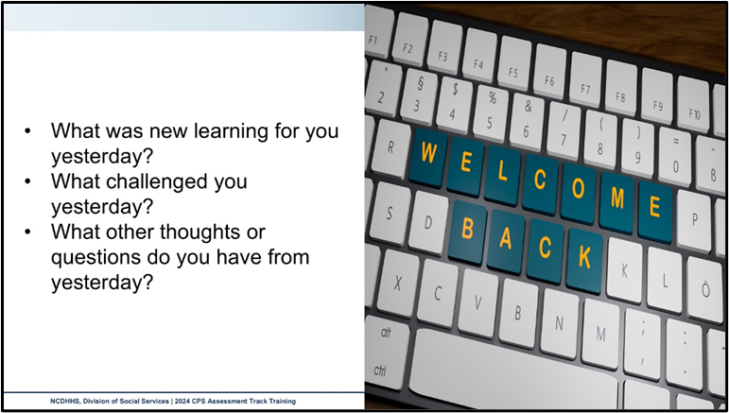
Use this outlined space to record notes from the introduction activity.

Ongoing Assessment

Essential Function: Implementing
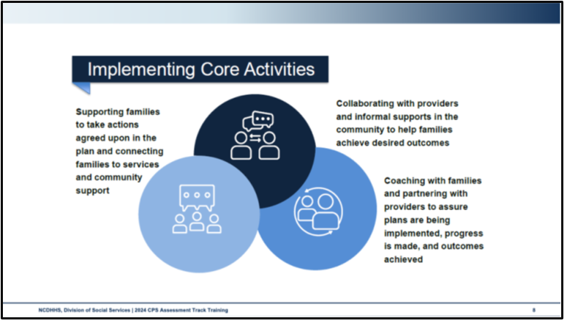
Use this space to record notes.

Safety and Risk in Comprehensive Family Assessments
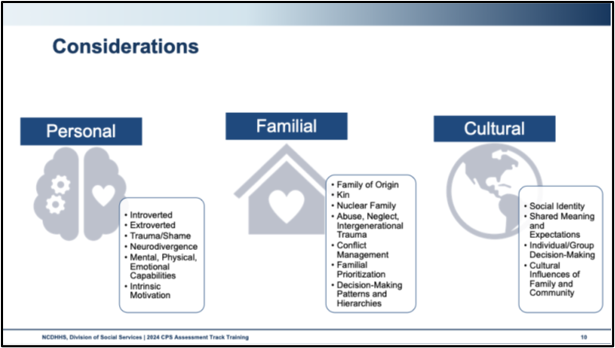
Use this space to record notes.

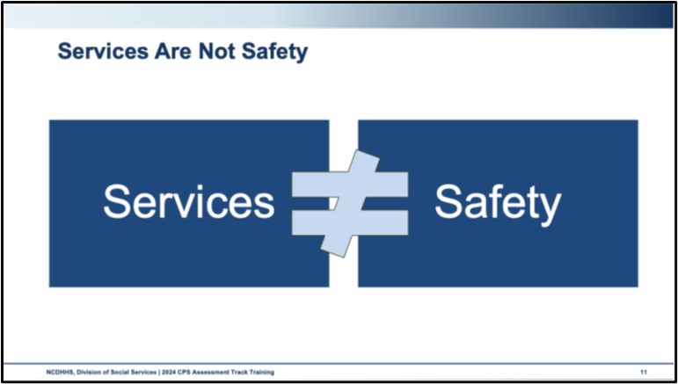
Use this space to record notes.

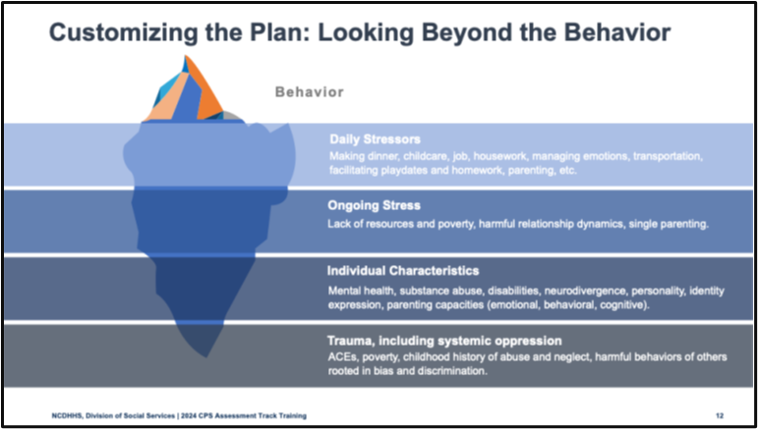
Use this space to record notes.

Collateral Contacts
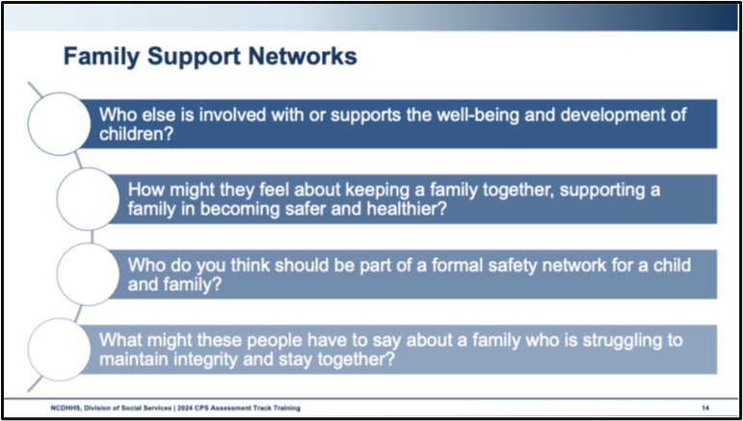
When you think about all the people who were involved in your life when you were being raised and all the people who are engaged in raising the next generation, beyond just parents:
Who else is involved with or supports the well-being and development of children?
How might they feel about keeping a family together, and supporting a family in becoming safer and healthier?

Who on this list do you think should be part of a formal safety network for a child and family?
What might the people on this list have to say about a family who is struggling to maintain integrity and stay together?

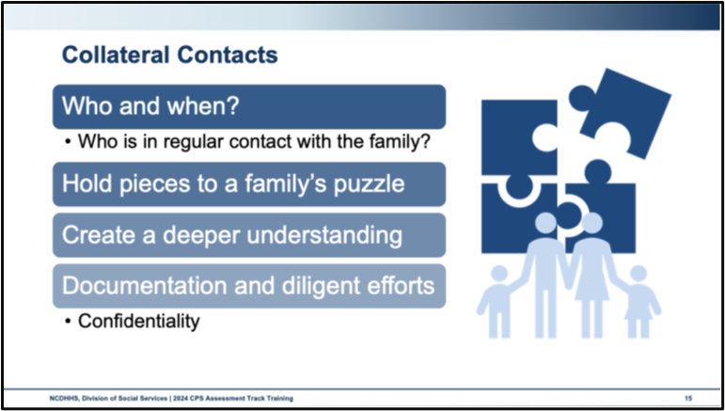
Use this space to record notes.

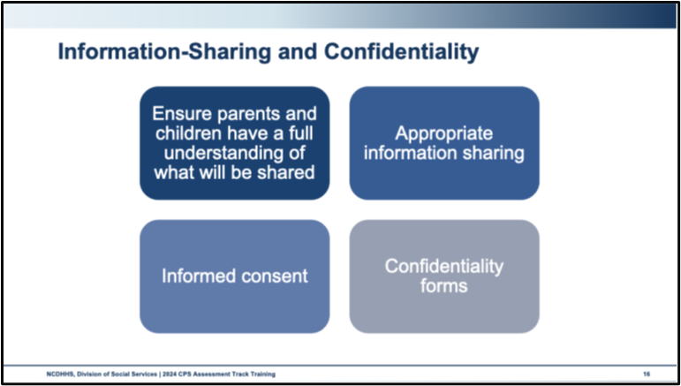
Use this space to record notes.

Handout: Engaging Families in the Safety Network
Circles of Safety and Support
Safety-Organized Practice tool used to support families in identifying people in their network. This tool can be used with adults, youth, and children. The Circles of Safety and Support tool can be used on the very first visit with a family or at the point when you are starting to talk with family about the importance of involving a network of family and friends and involved professionals. Circles of Safety and Support helps workers to introduce and explore the idea of involving a network.
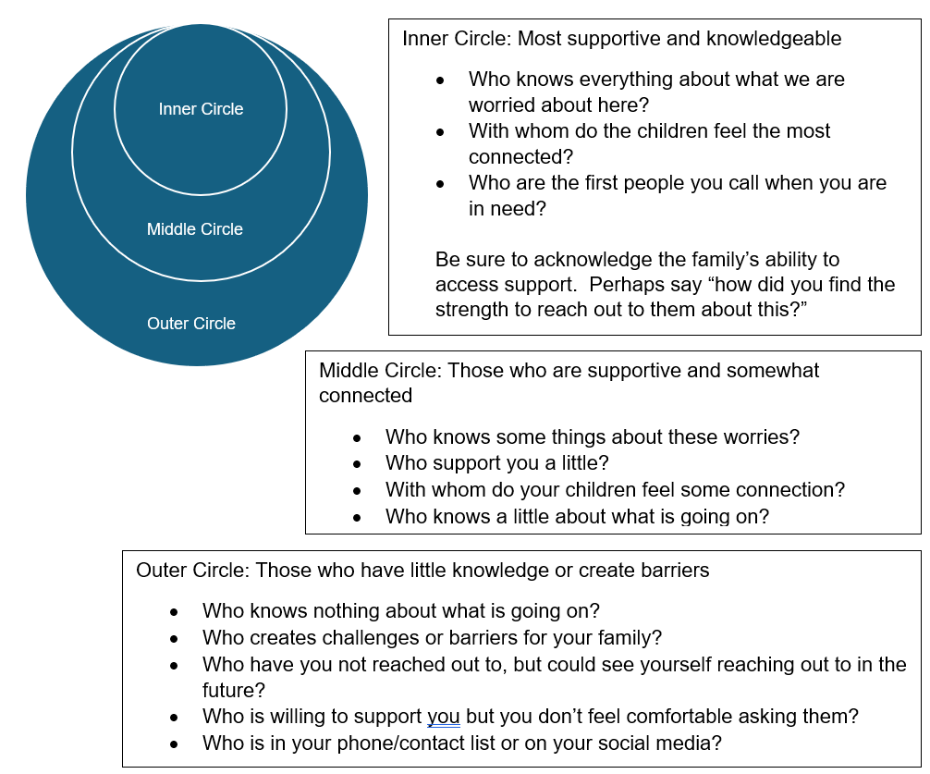
Engaging parents/caregivers using the Circles of Safety and Support tool is a good first step to helping them understand what a safety network is and who needs to be a part of the safety planning process. Share with parents that the network is built by them and can include family, tribes, friends, neighbors, service providers, and others that they believe will be beneficial.
If the family struggles to identify support, consider the following:
- If you were in an accident and were taken to the hospital, who would you call to pick up your children from school?
- If your house was on fire and burned to the ground, who would you call?
- If you won the lottery, who would be the first person you call?
- Who would your children say they want to spend the night with if you needed to go out of town and couldn’t take them with you?
- If you died tomorrow, who would you want to take your children in and care for them until they are adults?
- Who is someone who has shown a lot of interest and support to your children now or in the past? (teacher, neighbor, counselor, church member, someone you work with?)
- Who can help you move closer to your goals? (Boss, co-worker, counselor, neighbor, friend of a friend)
- Do you belong to a church, club, support group, or sports team? If so, who are some people who have been there for you and your children?
- Who do you look up to? Who encourages you when you are having a bad day?
- Has there ever been a time you felt no one cared about you and your feelings? Who is someone who stepped up and made you feel better?
- Tell me about a time when things were working well for your family, what did that look like and who helped you and your children at that time?
- Who in your life has had a tragedy and you helped them through that difficult time?
- Create a family tree with the parent/caretaker and ask about the communication and location of these individuals.
Source: Using Circles of Safety and Support to Build Safety Networks with Families, Child Welfare Practice Manual Resources (December 2021). https://policies.ncdhhs.gov/wp-content/uploads/Resource_Using-Circles-of-Safety-and-Support-to-Build-Safety-Networks_June2024.pdf

Worksheet: Circles of Safety and Support
Use the space below to capture the Circles of Safety and Support for Olivia and Franklin based on the interview.
- Consider designating people who feel safe and secure with a circle.
- Consider designating people moving from one circle to the next with an arrow.

Activity: Circles of Safety and Support Conversation
When exploring with families about expanding their safety network, the following questions can be useful:
- What would it take to move someone from the outer circle to the inner circle?
- Who needs to move to an inner circle?
- Who would grandma/the children/the social worker want to see move to the inner circle?
- Is there anyone you thought of telling but just haven’t reached out to yet?
In pairs, role play engaging one of the parents, Olivia or Franklin, in a discussion about:
Moving people from the outer and middle circles to the inner circle.
Inviting people from the inner circle to be a part of the safety network and safety planning process.

Formal Evaluations
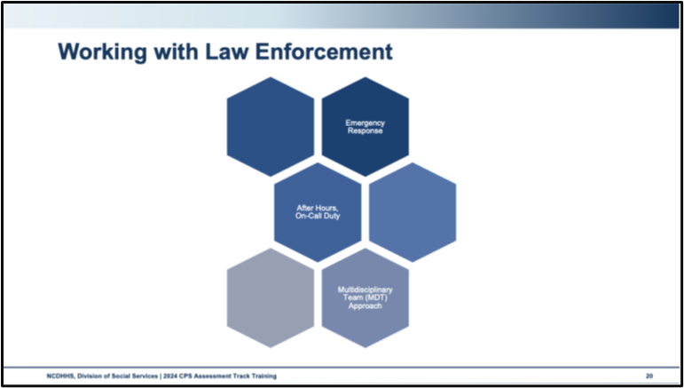
Use this space to record notes.

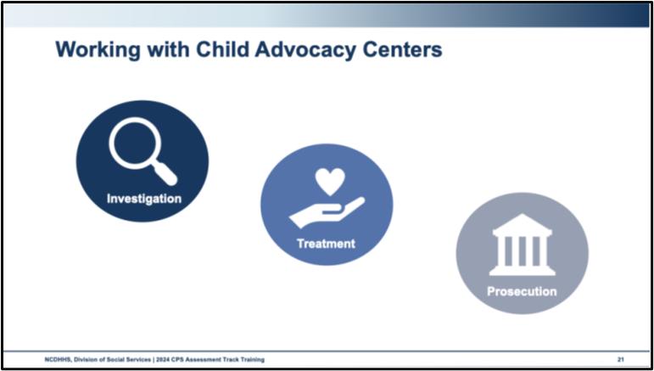
Use this space to record notes.

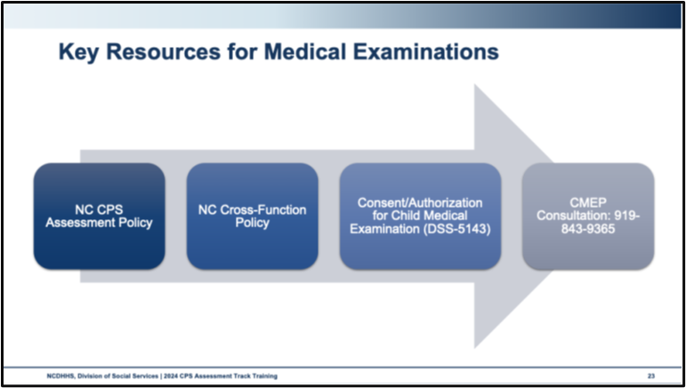
Use this space to record notes.

Worksheet: Self-Awareness Check-In
Emotional responses to the material we have covered may be a sign that you are experiencing bias and might be vulnerable to vicarious trauma. Slowing down and contemplating your own experience is an important step in managing bias and mitigating the effects of trauma.
Spend a few minutes reflecting on how you feel about assessing a family who is experiencing some of the situations that require child welfare intervention such as involvement of CMEP, a forensic interview, or a criminal investigation.
How do you feel at this moment?
What thoughts came up during this section that are worth exploring further?
What is one thing you can do to feel more settled and calmer in this moment?

Video: Lived Experience: Alexandra’s Story
https://youtu.be/F6m_WaSFPkM
Use this space to record notes.

Family Engagement and Ongoing Assessment Learning Lab

Activity: Lewis Family Update
On Saturday, five days after the initial report was initiated, DSS received a new report.
The report was made by Law Enforcement.
Report alleges that 911 was called by Rosa Ward. Around 8:30 pm Rosa had heard glass break upstairs in the family’s apartment and the father yelling and heavy footsteps. Raymond and Van arrived at her apartment at 9:00 pm scared and upset. Raymond’s back was swollen and red with bruises starting to form along his spine; Raymond was having trouble walking and complained of his back hurting.
Law Enforcement arrived on the scene. From information gathered by the officers, George whupped Raymond for breaking some glass dishes. Raymond has swelling and bruising along his back. George is being arrested for misdemeanor child abuse. DSS is requested to assess the situation for the children.
Report was screened in as abuse, Investigative Assessment, immediate response.
Summary of New Report Initiation
On-call responded immediately.
The On-call Social Worker briefly met with George before Law Enforcement escorted him to jail. Interviews were completed with Van, Raymond, and Ms. Rosa. William had a family emergency and was out of state.
Information Gathered in Interviews
- Raymond had been trying to “be good” all week and was cleaning the kitchen. He stacked up all the dirty dishes from dinner on the counter and went to play Xbox. George had come in and when he opened the dishwasher, the pile of dishes that was unsteady fell, breaking all the glass dishes. George went into Raymond’s room, grabbed his arm, and “whupped” him on the back, butt, and upper legs. Van told their dad to stop and that they would take Raymond to Ms. Rosa. This got George’s attention, but he wouldn’t let Raymond go. Raymond pulled away. Raymond and Van ran to Ms. Rosa’s house.
- Ms. Rosa had no idea of the extent of what was going on. She was very concerned for the children. Ms. Rosa said that when she saw Raymond’s back, she knew she had to call for help.
- Raymond was observed to have purplish marks and swelling right side, extending from his mid back down to his buttock to the upper right leg, just under the buttock. The purpleness varies in shade throughout the marked region with flesh-colored linear lines which could be indicative of the space between fingers, per the account that George whupped Raymond with his hand.
- Raymond reports pain on the right side when he breathes in and pain in his buttocks and leg.
- George was arrested for misdemeanor child abuse. Due to this occurring on a Saturday, his first court appearance would not occur until the following Monday.
- Ms. Rosa said that George’s yelling and mean behavior scared her. She was glad she could intervene today, but she isn’t in a place to stay involved. She had to think about her own health.
Custody
Due to George’s arrest and the timing of the events, George will not be released before Monday at his first appearance in court. While several attempts were made to locate a Temporary Safety Provider, no options were available. The Department filed a petition alleging abuse, neglect, and dependency and a non-secure custody order, bringing Van and Raymond into foster care.

Worksheet: Case Review Sheet
For this activity, we will familiarize ourselves with three-column mapping.
The three-column mapping tool is a Safety Organized Practice that supports the organization of your assessment and interviewing activities and findings in a clear, balanced way. Three-column mapping can be utilized for yourself, as we are practicing here, and can be utilized with families, in CFT meetings, or in supervision to promote collaboration and transparency.
The three columns correspond with the three essential questions.
- What are you worried about? captures safety concerns and risk factors.
- What is working well? highlights strengths, protective capacities, and protective factors.
- What needs to happen next? List actions that the family, the social worker, or other safety network or CFT members must take to resolve the concerns.
What are you worried about? | What is working well? | What needs to happen next?

Skills Practice: What’s the Next Question?
Imagine you are the social worker interviewing members of the Avilla Chavis family.
- Listen as the statement or scenario is read
- As the interviewing social worker, consider how you would follow up on this statement
- Write down your response including the next question you would ask
- Be prepared to share your response with the group
Scenario One
Response
Notes, thoughts, or other ideas based on group discussion

Scenario Two
Response
Notes, thoughts, or other ideas based on group discussion

Skills Practice: Interviewing for Ongoing Assessment
The trainer will provide a scenario and observation form.
As the Social Worker, your goal is to use family-centered strategies as you practice your interview. During this time, you need to meet legal standards, engage the interviewee, gather information about how they are keeping the Safety Plan, and explore any new information the interviewee might share. You are to demonstrate engagement and interviewing strategies to understand this family’s strengths and needs. Remember that you must assess for safety and risk, as well as behavioral changes that provide ongoing safety.
As the interviewee, your goal is to respond as you believe your scenario interviewee might and to seek understanding through questions. If the interviewer engages you and asks open-ended questions, share more detailed information with them.
As the observer, your goal is to support your peers in their skills development by making note of and sharing strengths-based observations. Please use the CPS Assessments Peer Observation form for this task, as you will give your written feedback to the interviewing volunteer when the practice is done.
What did you learn from this skills practice?
What will you remember to do when you are next knocking on a family’s door?

Debrief: Family Engagement and Ongoing Assessment
How are we feeling about the safety of the Avilla Chavis children at this point?
If safety threats had been identified, how would we have addressed them with the family?

Documentation

Communication in Documentation
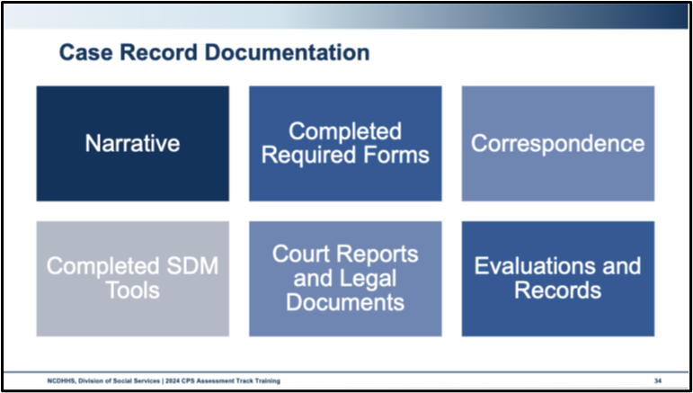
Use this space to record notes.

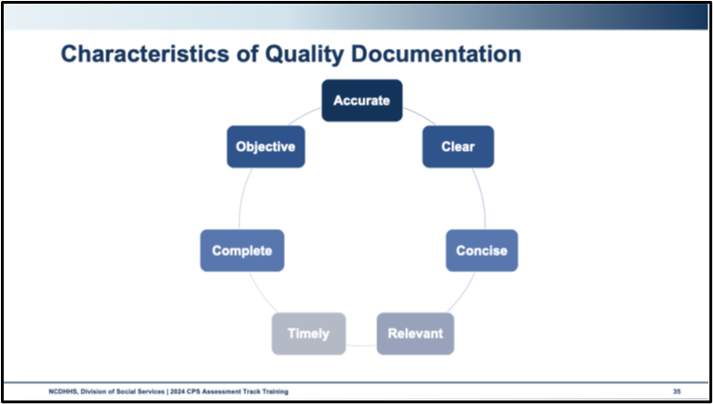
Overall, our documentation should:
- Be Accurate: Statements, conclusions, and opinions must be based on facts that are clearly described.
- Be Clear: Jargon should be avoided, and the descriptions of circumstances should be written using behavioral descriptors based on observations and specific statements of involved parties.
- Be Concise: Records should only contain information that is relevant and necessary to the Assessment.
- Be Relevant: Document decisions with respect to risk and safety assessments, and other information gathered during the Assessment process.
- Be Timely: Documentation, including narrative, must be current within seven days of every activity or action.
- Be Complete: Documentation contains all the information needed to take action, for example, contact names, dates, times, and locations.
- Be Objective: Documentation reflects unbiased facts.
Use this space to record notes.

Activity: Objective vs. Subjective
Review the statements to identify if they are objective or subjective. If you identify that the statement is subjective, use the space below to re-write the statement using more objective language.
- Mom prefers abusing drugs and alcohol over spending her time looking for gainful employment.
☐Objective Statement | ☐Subjective Statement

- Dad whupped Son leaving marks and bruises on his arm, lower back, and buttocks.
☐Objective Statement | ☐Subjective Statement

- Son is prescribed Adderall to treat ADHD symptoms.
☐Objective Statement | ☐Subjective Statement

- A 12-year-old is not a good babysitting option.
☐Objective Statement | ☐Subjective Statement

- Grandma is crazy and the apple doesn’t fall far from the tree.
☐Objective Statement | ☐Subjective Statement

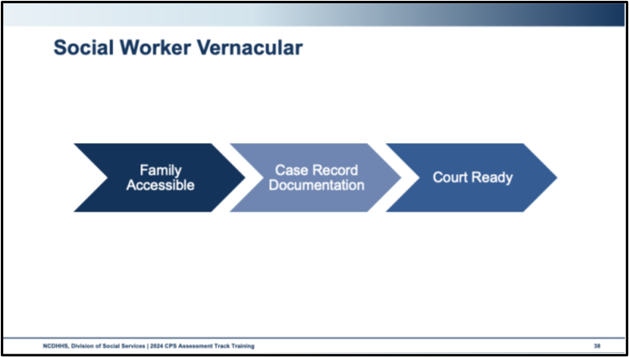
Use this space to record notes.

Activity: Switching Vernaculars: Part One
- Work in trios
- Each trio member will summarize the scenario for their assigned audience:
  - Parents
  - Supervisor
  - Case Decision Documentation
- Work silently and do not share your work with your group members
Anchor Family Scenario
There are concerns about the supervision of the Avilla Chavis children. Ricardo and Diego walked to the park unsupervised and were returned home by a neighbor who is not close to the family. At the time, it didn’t seem like a big deal to the family that Ricardo was responsible for Diego at the park.
Olivia is diagnosed with depression. Olivia is exhausted and caring for the children during the day is taxing. Amelia and Deigo used to go to daycare and now they are home with Olivia. Amelia is young and is about to become mobile. Diego is also young and may have some communication issues. There is concern about the children being at home with her all day when she is so depressed. There is no information to indicate that the children are going without their needs met during the day when with Olivia.
Leidi typically babysits the younger children a few days a week. When the family first came to the attention of DSS with this report, Leidi was caring for the children on her own at least two days a week and several days a week with Olivia home although sleeping in the bedroom. At initiation, Leidi didn’t seem able to identify an emergency or know who to call if there was an emergency. Leidi didn’t seem like she could handle the fighting between Diego and Ricardo.
The collaterals have concerns about the children being cared for by Leidi. They worry that it’s too big a responsibility for someone Leidi’s age and the needs of the children she is watching. Leidi says she likes watching her siblings, being the “big helper” and contributing to her family. School reports indicate that she excels at school.
The family had another report 2 years ago for unsafe supervision that was deemed an isolated incident.
She is going to therapy and has started medication. She attends a mother’s group for support.
Franklin works during the day and checks in on the family before going to his sister's house to do home repairs. This is important to Franklin.
Since DSS became involved, it seems the family has followed the safety plan. The children report changes to the expectations for when Leidi is caring for them. JuanCarlos has started watching the children as well. Franklin was responsive to the incident where the food burned by adding a no cooking on the stovetop rule when Leidi is home alone watching the children. There is no information to say Ricardo and Deigo have left the house unsupervised.
Franklin said it is important that the older children care for the younger children. His preference would be not to have people outside the family watching the children. There are neighbors and extended family members willing to watch the children.
JuanCarlos has been helping out more. There is worry that he is experiencing grief after the death of his mother and may need support handling the dynamics of the family.
The house has consistently been messy with food and trash in the kitchen and living room. There has not been any indication of pests or health hazards. Amelia will be mobile soon so it is concerning that the house isn’t cleaner. When the report was initiated, there were items in Amelia's bed making her sleep space hazardous. The family seems to have changed this since there wasn’t anything in the bed at the last home visit.
At initiation, there was concern about Olivia and Franklin’s alcohol use although not enough to include in the safety plan. No additional information was provided that would indicate that alcohol use negatively impacts children. It is concerning that they drink daily since Olivia’s depression since she is already exhausted.
You are preparing to staff the case with your supervisor, follow up with the family, and begin drafting the case decision summary.

Worksheet: Switching Vernaculars: Part One
- In your triad, decide the audience for each member.
- Working independently, summarize the information above for documentation to your audience.
Your assigned audience:
Scenario Summary:

Worksheet: Switching Vernaculars: Part Two
- Share your summary with your trio.
- Notice the following:
  - Did you highlight the same elements of the scenario?
  - Do you notice a different feeling or quality of the documentation for different audiences?
  - Why do you think you did or did not have differences in what is highlighted or the feeling of the documentation?
Notes and observations

End-of-Day Values Reflections

Questions and Reflections
Use this space to record reflections and questions about what you have learned today.

Bibliography of References
Day Six
Barbee, A., Purdy, L., & Cunningham, M. (2023, September). Secondary traumatic stress: definitions, measures, predictors and interventions. Quality Improvement Center for Workforce Development. https://digitalcommons.unl.edu/qicwdproducts/149/
CalSWEC Online, (2019, April 29) Child Welfare worker realistic job preview. [Video]. YouTube.com. https://www.youtube.com/watch?v=2aoOYAwgp2o&list=PLNYfSDZN2XUpWQ62KzijZDZ_g2VEjlSGD&index=1
Capacity Building Center for States. (n.d.). Defining quality contacts. [Brief]. Washington, DC: U.S. Department of Health and Human Services, Administration for Children and Families, Children’s Bureau. https://capacity.childwelfare.gov/states/resources/defining-quality-contacts#:~:text=Quality%20contacts%2C%20also%20referred%20to,assessment%20and%20case%20planning%20processes.
Capacity Building Center for States. (n.d.). Protective capacities and protective factors: Common ground for protecting children and strengthening families. [Infographic]. Washington, DC: U.S. Department of Health and Human Services, Administration for Children and Families, Children’s Bureau. https://capacity.childwelfare.gov/sites/default/files/media_pdf/protective-factors-capacities-cp-00052.pdf
Casey Family Programs, (2019, January 18) Jeremiah Donier: Birth dad winner. [Video]. YouTube.com. https://www.youtube.com/watch?v=yxBeN5-Rq_E&t=249s
Center for Leadership Education in Maternal & Child Public Health. (2024, July). Mental health and well-being ecological model. Minneapolis, MN: University of Minnesota School of Public Health. https://mch.umn.edu/resources/mhecomodel/
Center for the Study of Social Policy. (n.d.). Parental resilience: Protective and promotive factors. Washington, DC: Center for the Study of Social Policy. https://cssp.org/wp-content/uploads/2019/01/Research-Briefs-and-Action-Sheets-SF-CW.pdf
Child Welfare Information Gateway. (n.d.) Co-occurring factors. Washington, DC: U.S. Department of Health and Human Services, Administration for Children and Families, Children’s Bureau. https://www.childwelfare.gov/topics/casework-practice/co-occurring-factors/?top=293.
Child Welfare Information Gateway. (2014, July 23) Child and family services reviews quick reference items list. Washington, DC: U.S. Department of Health and Human Services, Administration for Children and Families, Children’s Bureau. https://www.acf.hhs.gov/sites/default/files/documents/cb/cfsr_quick_reference_list.pdf.
Child Welfare Information Gateway. (2020, October) How the Child Welfare system works. Washington, DC: U.S. Department of Health and Human Services, Administration for Children and Families, Children’s Bureau. https://www.childwelfare.gov/pubPDFs/cpswork.pdf
Child Welfare Information Gateway. (2023). Child Welfare policy manual. Washington, DC: United States Department of Health and Human Services, Administration for Children and Families, Children’s Bureau. Retrieved from https://www.acf.hhs.gov/ on 12 Nov 2023.
Child Welfare Information Gateway. (2023). Separating poverty from neglect in child welfare. Washington, DC: U.S. Department of Health and Human Services, Administration for Children and Families, Children's Bureau. https://www.childwelfare.gov/pubs/bulletins-povertyneglect.
Child Welfare Information Gateway. (2023). Forensic interviewing: A primer for Child Welfare professionals. Washington, DC: U.S. Department of Health and Human Services, Administration for Children and Families, Children’s Bureau. https://www.childwelfare.gov/resources/forensic-interviewing-primer-child-welfare-professionals/#:~:text=Forensic%20interviewing%20is%20a%20means%20of%20gathering%20information,key%20component%20of%20many%20child%20protective%20services%20investigations.
Hunt, D., & McNeill, H. (2014, December 9). Handouts for the webinar, Documentation in Child Welfare: Effective practices for county DSS agencies. [Webinar]. University of North Carolina, Chapel Hill School of Social Work, Family and Children’s Resource Program, Jordan Institute for Families. https://fcrp.unc.edu/wp-content/uploads/2022/11/documentation_webinar.pdf
Newlin, C., Cordisco Steele, L., Chamberlin, A., Anderson, J., Kenniston, J., Russell, A., Stewart, H., & Vaughan-Eden, V. (2015). Child forensic interviewing: Best practices. (2015). Retrieved from https://www.ojjdp.gov/pubs/248749.pdf on 30 January 2024.
NC Child Medical Evaluation Program. (2024). Contact CMEP. University of North Carolina School of Medicine, Chapel Hill Department of Pediatrics. https://www.med.unc.edu/pediatrics/cmep/contact-cmep/
North Carolina Department of Health and Human Services, Division of Social Services, Child Welfare Services. (2017). DSS-5231: North Carolina safety assessment. https://policies.ncdhhs.gov/wp-content/uploads/dss-5231-ia.pdf
North Carolina Department of Health and Human Services, Division of Social Services, Child Welfare Services. (2017). DSS-5231ins: North Carolina safety assessment. instructions. https://policies.ncdhhs.gov/wp-content/uploads/DSS-5231ins.pdf
North Carolina Department of Health and Human Services, Division of Social Services, Child Welfare Services. (2017). NC Domestic violence policy and best practice in Child Welfare. https://www.ncdhhs.gov/documents/files/dss/training/domestic-violence-workbook/download
North Carolina Department of Health and Human Services, Division of Social Services, Child Welfare Services. (2018). DSS-5229: North Carolina strengths & needs assessment. https://policies.ncdhhs.gov/wp-content/uploads/dss-5229-ia.pdf
North Carolina Department of Health and Human Services, Division of Social Services. (2019). Assessing safety and risk. Children’s services practice notes 24(2). https://practicenotes.org/v24n2.htm
North Carolina Department of Health and Human Services, Division of Social Services. (2020, October). Consent/authorization form for child medical & child/family evaluations. https://policies.ncdhhs.gov/wp-content/uploads/dss-5143-ia.pdf
North Carolina Department of Health and Human Services, Division of Social Services. (2020, May). CPS purpose & philosophy, Legal basis, administration: NC Child Welfare manual. https://policies.ncdhhs.gov/wp-content/uploads/purpose.pdf
North Carolina Department of Health and Human Services, Division of Social Services. (2021). North Carolina practice standards worker assessment. https://www.ncdhhs.gov/cw-worker-north-carolina-worker-assessment-all-practice-standards/open
North Carolina Department of Health and Human Services, Division of Social Services. (2021). Worker practice standards desk guide. https://www.ncdhhs.gov/cw-worker-north-carolina-worker-practice-standards-desk-guide/open
North Carolina Department of Health and Human Services, Division of Social Services. (2021, December). Child Welfare policy manual resources: Using safety circles to build safety networks with families. https://policies-uat.ncdhhs.gov/wp-content/uploads/using-safety-circles-to-build-safety-networks-december-2021.pdf
North Carolina Department of Health and Human Services, Division of Social Services. (2022). DSS-6191 – North Carolina division of social services plan of safe care. https://policies.ncdhhs.gov/wp-content/uploads/DSS-6191.pdf
North Carolina Department of Health and Human Services, Division of Social Services. (2024, April). Cross function topics: NC Child Welfare manual. https://policies.ncdhhs.gov/wp-content/uploads/In-Home_April-2024_2.pdf
North Carolina Department of Health and Human Services, Division of Social Services. (2024, August). CPS assessments policy, protocol, and guidance: NC Child Welfare manual. https://policies.ncdhhs.gov/wp-content/uploads/CPS-Assessments-Aug-2024.pdf
Northern California Training Academy. (n.d.).Safety organized practice quick guide: Behaviorally-based case plans. https://oercommons.s3.amazonaws.com/media/editor/92375/Behaviorally-Based_Case_Plans_-_SOP_Quick_Guide_2018-10-24.pdf.
Office of Juvenile Justice and Delinquency Prevention. (n.d.). Children’s advocacy centers. Washington, DC: U.S. Department of Justice, Office of Justice Programs. https://ojjdp.ojp.gov/programs/childrens-advocacy-centers
Parker, S. (n.d.). Circles of safety & support: A tool to help parents identify people for their family’s safety & support network. https://cog-aap.s3-ap-southeast-2.amazonaws.com/n/350/2020/Mar/08/T7NTJkFW6kEnPYDIA2KZ.pdf
Public Knowledge. (2022, November 2). Family integrity and justice works lived expertise story: Alexandra. [Video]. YouTube.com. https://www.youtube.com/watch?v=F6m_WaSFPkM.
Yamasaki, P. (2023, August 17). “Objective” vs. “subjective”: What’s the difference? [Blog]. Grammarly.com. https://www.grammarly.com/blog/objective-vs-subjective/#:~:text=What%20do%20objective%20and%20subjective,feelings%2C%20opinions%2C%20or%20emotions.
Yates, J.F. & de Oliveira, S. (2016). Culture and decision making. Organizational Behavior and Human Decision Processes, 136: 106-118. https://doi.org/10.1016/j.obhdp.2016.05.003.

Appendix: Handouts
Engaging Families into the Safety Network 2

Engaging Families in the Safety Network
Circles of Safety and Support
Safety-Organized Practice tool used to support families in identifying people in their network. This tool can be used with adults, youth, and children. The Circles of Safety and Support tool can be used on the very first visit with a family or at the point when you are starting to talk with family about the importance of involving a network of family and friends and involved professionals. Circles of Safety and Support helps workers to introduce and explore the idea of involving a network.
Engaging parents/caregivers using the Circles of Safety and Support tool is a good first step to helping them understand what a safety network is and who needs to be a part of the safety planning process. Share with parents that the network is built by them and can include family, tribes, friends, neighbors, service providers, and others that they believe will be beneficial.
If the family struggles to identify support, consider the following:
- If you were in an accident and were taken to the hospital, who would you call to pick up your children from school?
- If your house was on fire and burned to the ground, who would you call?
- If you won the lottery, who would be the first person you call?
- Who would your children say they want to spend the night with if you needed to go out of town and couldn’t take them with you?
- If you died tomorrow, who would you want to take your children in and care for them until they are adults?
- Who is someone who has shown a lot of interest and support to your children now or in the past? (teacher, neighbor, counselor, church member, someone you work with?)
- Who can help you move closer to your goals? (Boss, co-worker, counselor, neighbor, friend of a friend)
- Do you belong to a church, club, support group, or sports team? If so, who are some people who have been there for you and your children?
- Who do you look up to? Who encourages you when you are having a bad day?
- Has there ever been a time you felt no one cared about you and your feelings? Who is someone who stepped up and made you feel better?
- Tell me about a time when things were working well for your family, what did that look like and who helped you and your children at that time?
- Who in your life has had a tragedy and you helped them through that difficult time?
- Create a family tree with the parent/caretaker and ask about the communication and location of these individuals.
Source: Using Circles of Safety and Support to Build Safety Networks with Families, Child Welfare Practice Manual Resources (December 2021). https://policies.ncdhhs.gov/wp-content/uploads/Resource_Using-Circles-of-Safety-and-Support-to-Build-Safety-Networks_June2024.pdf

