North Carolina Department of Health and Human Services
CPS Assessment in Child Welfare Track Training

Participant’s Workbook
Day Eight

October 2024


600 Airport Rd
Lakewood, NJ, 08701-5995
www.pubknow.com

info@pubknow.com
(800) 776-4229

This curriculum was developed by the North Carolina Department of Health and Human Services, Division of Social Services, and revised by Public Knowledge® in 2024.

Copyright © 2024 Public Knowledge®. All rights reserved. No part of this publication may be reproduced, distributed, or transmitted in any form without the written permission of the publisher.
Table of Contents
Instructions 4
Course Themes 4
Training Overview 5
Learning Objectives 7
Day Eight Agenda 9
Welcome 10
Decision-Making 11
Case Decision Process 11
Video: The Science of Neglect 12
Skills Practice: Describing Impact 13
Handout: The Science of Neglect 18
Decision-Making Tools 20
Worksheet: CPS Assessment Decision-Making 20
Decision-Making and Critical Thinking 21
Worksheet: Values 21
Activity: Personal Considerations 22
Supervisory Support 24
Skills Practice: Two-Level Decision-Making: Supervisory Consultation 25
Case Decision 31
Case Transfer 34
Handout: Guide for Conducting Case Transfers 34
Case Closure 37
Activity: Addressing Worry and Risk 38
Case Closure Notification 39
Decision-Making and Case Closure Learning Lab 40
Skills Practice: Decision-Making 40
Case Transfer Learning Lab 41
Skills Practice: Case Transfer 41
Worker Safety 43
Worker Well-Being 43
Worksheet: Self-Care Strategies 46
Considerations for After Hours and On-Call Duty Hours 47
Self-Reflection Training Wrap-Up 48
Worksheet: Post-Self-Assessment 49
Bibliography of References 50
Appendix: Handouts 1
The Science of Neglect 2
Guide for Conducting Case Transfers 4
Self-Care Strategies 6

Instructions
This course was designed to guide child welfare professionals through the knowledge, skills, and behaviors needed to engage with families in need of child protection services. The workbook is structured to help you engage in the lesson through reflection and analysis throughout each week of training. Have this workbook readily available as you go through each session to create a long-lasting resource you can reference in the future.
If you are using this workbook electronically: Workbook pages have text boxes for you to add notes and reflections. Due to formatting, if you are typing in these boxes, blank lines will be “pushed” forward onto the next page. To correct this when you are done typing in the text box, you may use delete to remove extra lines.

Course Themes
The central themes of the CPS Assessment Track Training are divided across several course topics.
- Purpose and Legal Basis for Child Protection Services in North Carolina
- Essential Function: Communicating
- Diversity, Equity, Inclusion, and Belonging
- Trauma-Informed Care
- Family-Centered Practice
- Essential Function: Engaging
- Safety Focused
- Essential Function: Assessing
- Interviewing Learning Lab
- The Role of Observation in Assessing for Safety
- Structured Decision-Making: Safety Assessment
- Assessment Learning Lab
- Safety Planning
- Safety Planning Learning Lab
- Trauma-Informed Practice
- Considerations for Cases Involving Special Circumstances
- Social Worker Safety
- Engaging the Family in Child Protection Services
- Risk Assessment
- Crucial Conversations
- Quality Contacts
- Assessing Family Strengths and Needs
- Secondary Traumatic Stress and Vicarious Traumatization
- Ongoing Assessment
- Family Engagement and Ongoing Assessment Learning Lab
- Documentation
- Well-Being as an Outcome
- Reasonable Efforts and Removals
- Reasonable Efforts and Removals Learning Lab
- Decision-Making
- Decision-Making and Case Closure Learning Lab

Training Overview
Training begins at 9:00 a.m. and ends at 4:00 p.m. If a holiday falls on the Monday of training, the training will begin on Tuesday at 9:00 a.m. This schedule is subject to change if a holiday falls during the training week or other circumstances occur. The time for ending training on Fridays may vary and trainees need to be prepared to stay the entire day.
Attendance is mandatory. If there is an emergency, the trainee must contact the classroom trainer and their supervisor as soon as they realize they will not be able to attend training or if they will be late to training. If a trainee must miss training time in the classroom, it is the trainee’s responsibility to develop a plan to make up missed material.
Pre-Work Online e-Learning Modules
There is required pre-work for the CPS Assessment Track Training in the form of online e-Learning modules. Completion of the e-Learnings is required prior to attendance at the classroom-based training. The following are the online e-Learning modules:
- North Carolina Worker Practice Standards
- Safety Organized Practice
- Understanding and Assessing Safety and Risk
- Understanding and Screening for Trauma
Transfer of Learning
The CPS Assessment Track Training Transfer of Learning (ToL) tool is a comprehensive and collaborative activity for workers and supervisors to work together in identifying worker goals, knowledge gain, and priorities for further development throughout the training process. In four distinct steps, the worker and supervisor will highlight their goals and action plan related to participating in training, reflect on lessons and outstanding questions, and create an action plan to support worker growth. The tool should be started prior to beginning the CPS Assessment Track Training and re-visited on an ongoing basis to assess growth and re-prioritize actions for development.
- Part A: Training Preparation: Prior to completing any eLearning and in-person Track Training sessions, the worker and supervisor should meet to complete Part A: Training Preparation. In this step, the worker and supervisor will discuss their goals for participation in training and develop a plan to meet those goals through pre-work, other opportunities for learning, and support for addressing anticipated barriers.
- Part B: Worker Reflections During Training: The worker will document their thoughts, top takeaways, and outstanding questions regarding each section. This level of reflection serves two purposes. First, the practice of distilling down a full section of training into three takeaways and three remaining questions requires the worker to actively engage with the material, subsequently forming cognitive cues related to the information for future use in case practice. Second, prioritizing takeaways and questions by section allows workers to continually review information to determine if questions are answered in future sessions and supports the development of an action plan by requiring workers to highlight the questions they find most important.
- Part C: Planning for Post-Training Debrief with Supervisor: The worker considers the takeaways and questions they identified in each section and creates a framework to transfer those takeaways and questions into an action plan.
- Part D: Post-Training Debrief with Supervisor: Provides an opportunity for the supervisor and worker to determine a specific plan of action to answer outstanding questions and to further support worker training.
While this ToL is specific to the Track Training in North Carolina, workers and supervisors can review the takeaways and questions highlighted by the worker in each section of training on an ongoing basis, revising action steps when prior actions are completed, and celebrating worker growth and success along the way.
Training Evaluations
At the conclusion of each training, learners will complete a training evaluation tool to measure satisfaction with training content and methods. The training evaluation tool is required to complete the training course. Training evaluations will be evaluated and assessed to determine the need for revisions to the training curriculum.
All matters as stated above are subject to change due to unforeseen circumstances and with approval.

Learning Objectives
Day Eight
Decision-Making
- Learners will be able to describe how caregiver behavior impacts child safety.
- Learners will be able to describe how to incorporate all safety and risk factors into the comprehensive family assessment.
- Learners will be able to develop strategies to adequately address safety and risk factors within ongoing case planning activities.
- Learners will be able to distinguish between safety and risk when considering instances of abuse and neglect.
- Learners will be able to identify and describe danger indicators and risk factors when working with children and families.
- Learners will be able to explain the importance of engaging families in the decision-making process.
- Learners will be able to outline the process for case decision making, including case closure.
- Learners will be able to discuss information needed to make informed case decisions.
- Learners will be able to describe strategies for preparing for staffing meetings with supervisors.
- Learners will be able to outline required notifications and associated timeframes at the conclusion of an assessment.
- Learners will be able to describe the requirements and process for adding an individual to the RIL.
- Learners will be able to describe the requirements and process for adding an individual to the central registry.
- Learners will be able to discuss case dynamics related to domestic violence and how they factor into case closure decisions and ongoing planning.
- Learners will be able to identify and apply policy requirements related to cases involving domestic violence.
- Learners will be able to discuss case dynamics related to domestic violence and how they factor into case closure decisions and ongoing planning.
- Learners will be able to identify and apply policy requirements related to cases involving domestic violence.
- Learners will be able to identify and demonstrate strategies for communicating case decisions to children and families.
- Learners will be able to provide examples of appropriate ongoing support for families after case closure.
Decision-Making and Case Closure Learning Lab
- Learners will be able to explain how to use the NC Family Strengths and Needs Assessment in case planning activities.
- Learners will be able to identify policies and protocols for case transfer from assessment to in-home or permanency planning services.
- Learners will be able to describe best practices to support the family during case transfer.
- Learners will be able to identify and demonstrate strategies for communicating case decisions to children and families.
Worker Safety
- Learners will identify, discuss, and apply strategies to promote their physical, psychological, and emotional safety and well-being.
- Learners will be able to discuss strategies that promote their physical, psychological, and emotional safety.
- Learners will be able to discuss their self-care plan with an accountability partner and seek out support when needed.
- Learners will recognize at least three signs of danger and at least three methods of avoiding or mitigating danger when conducting after-hours or on-call tasks.

Day Eight Agenda
CPS Assessment Track Training
Welcome
Decision-Making
Case Decision Process
Decision-Making Tools
Decision-Making and Critical Thinking
Supervisory Support
Case Decision
Case Transfer
Case Closure
Case Closure Notification
Decision-Making and Case Closure Learning Lab
Case Transfer Learning Lab
Worker Safety
Worker Well-Being
Considerations for After Hours and On-Call Hours
Self-Reflection Training Wrap-Up

Welcome
Use this outlined space to record notes from the introduction activity.

Decision-Making

Case Decision Process
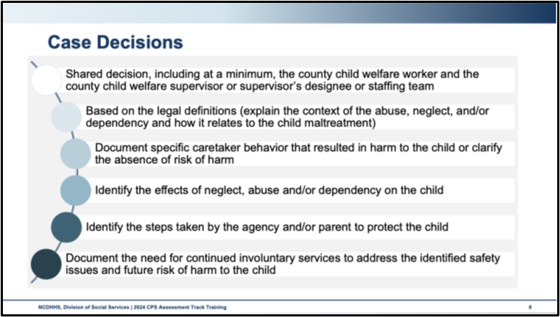
Use this space to record notes.

Video: The Science of Neglect
https://www.youtube.com/watch?v=bF3j5UVCSCA
Use this space to record reflections on your own social work practice and the impact of stress or trauma on children.
What are your reflections, thoughts, and feelings after watching this video?
How does this information impact the work you’re doing today?

Skills Practice: Describing Impact
Impact is when a parent’s behavior, attitudes, emotions, intent, or circumstances create conditions that fall beyond the mere risk of maltreatment and have become an actual imminent threat to a child’s safety.
Step One: State the indications of impact. Place one concern in each left-hand column. Indications of impact can be generated from the following:
Information from interviews or observations that prompt concern that the child may be negatively impacted by parental actions.
Concerns based on child welfare knowledge base, such as child development, trauma, mental health, etc.
Step Two: Consider the type of Maltreatment. Use the definition as outlined in the Intake Policy, Protocol, and Guidance.
For the concern listed in the Indications of Impact column, consider the type of maltreatment category in which your concern falls.
Step Three: Does the impact rise to the statutory definition of abuse, neglect, or dependency? Consider the maltreatment screening tools as a guide for specific types of maltreatment that require further nuance and guidance.
Assigned Child:

Indication of Impact | Type of Maltreatment | Rise to the level of Abuse, Neglect, or Dependency? If yes, describe
Indication of Impact | Type of Maltreatment | Rise to the level of Abuse, Neglect, or Dependency? If yes, describe
Indication of Impact | Type of Maltreatment | Rise to the level of Abuse, Neglect, or Dependency? If yes, describe

Handout: The Science of Neglect
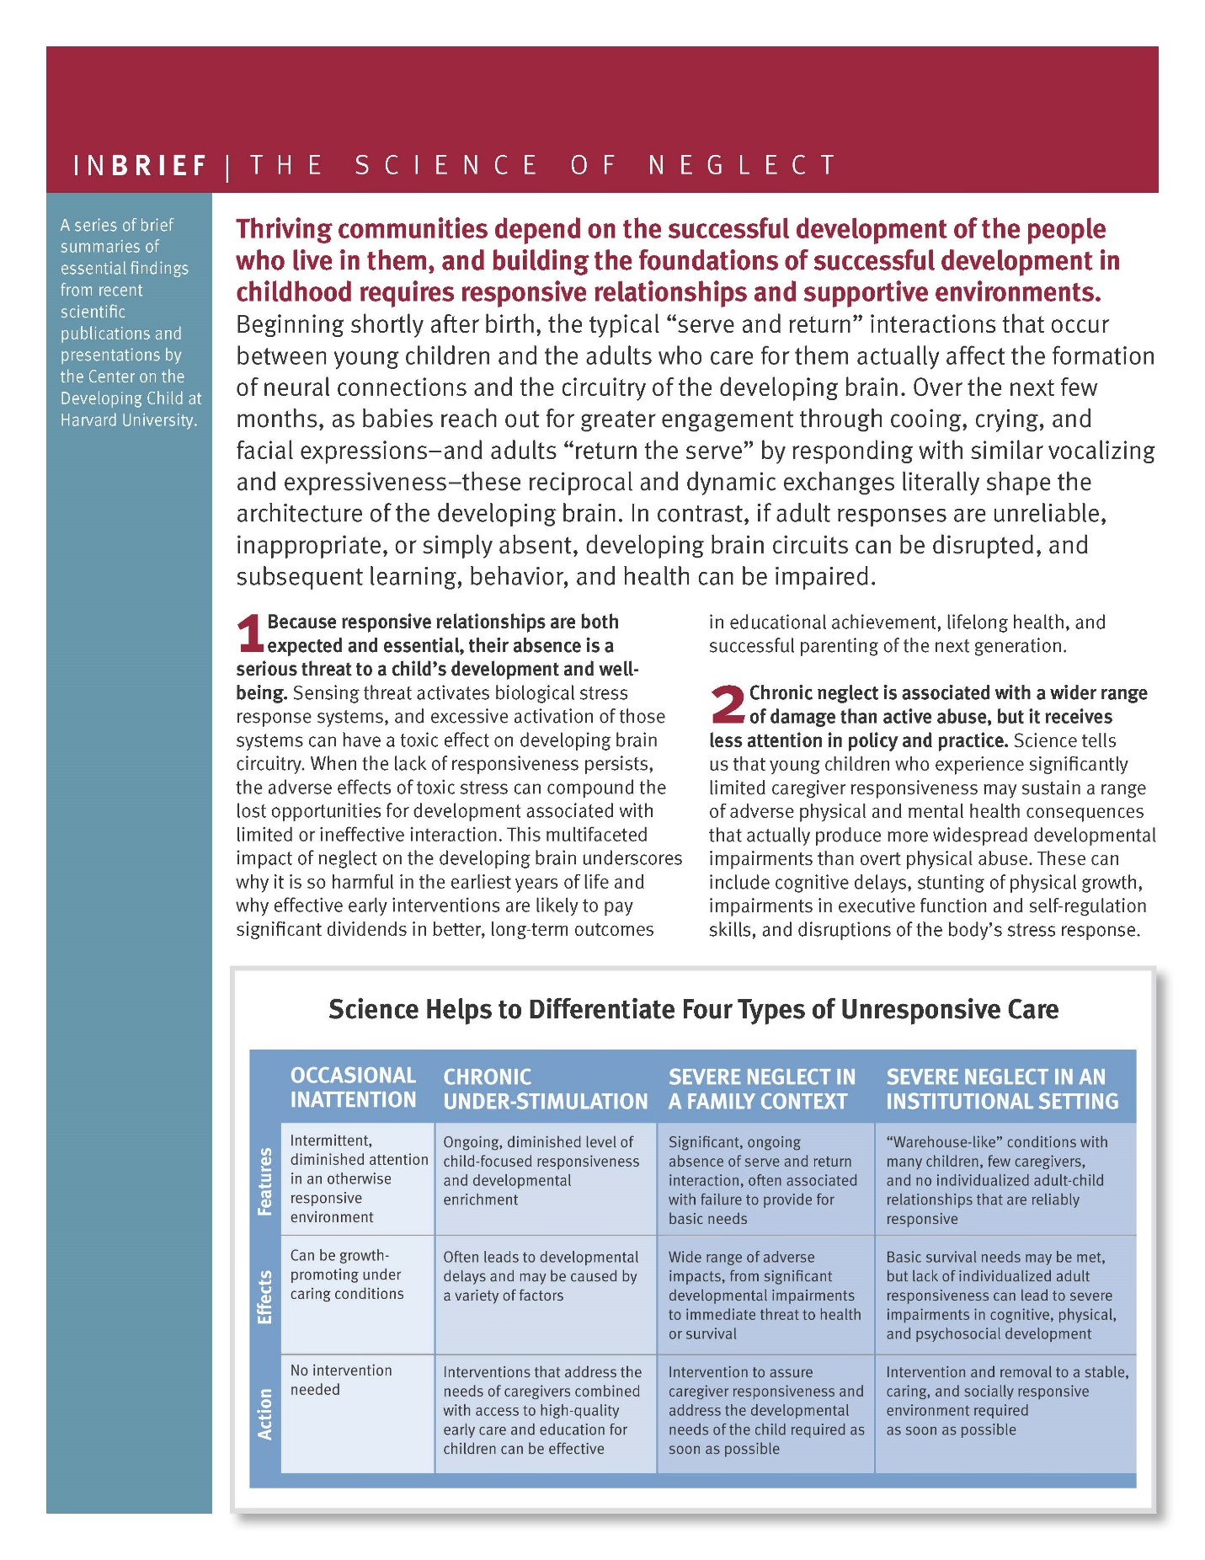

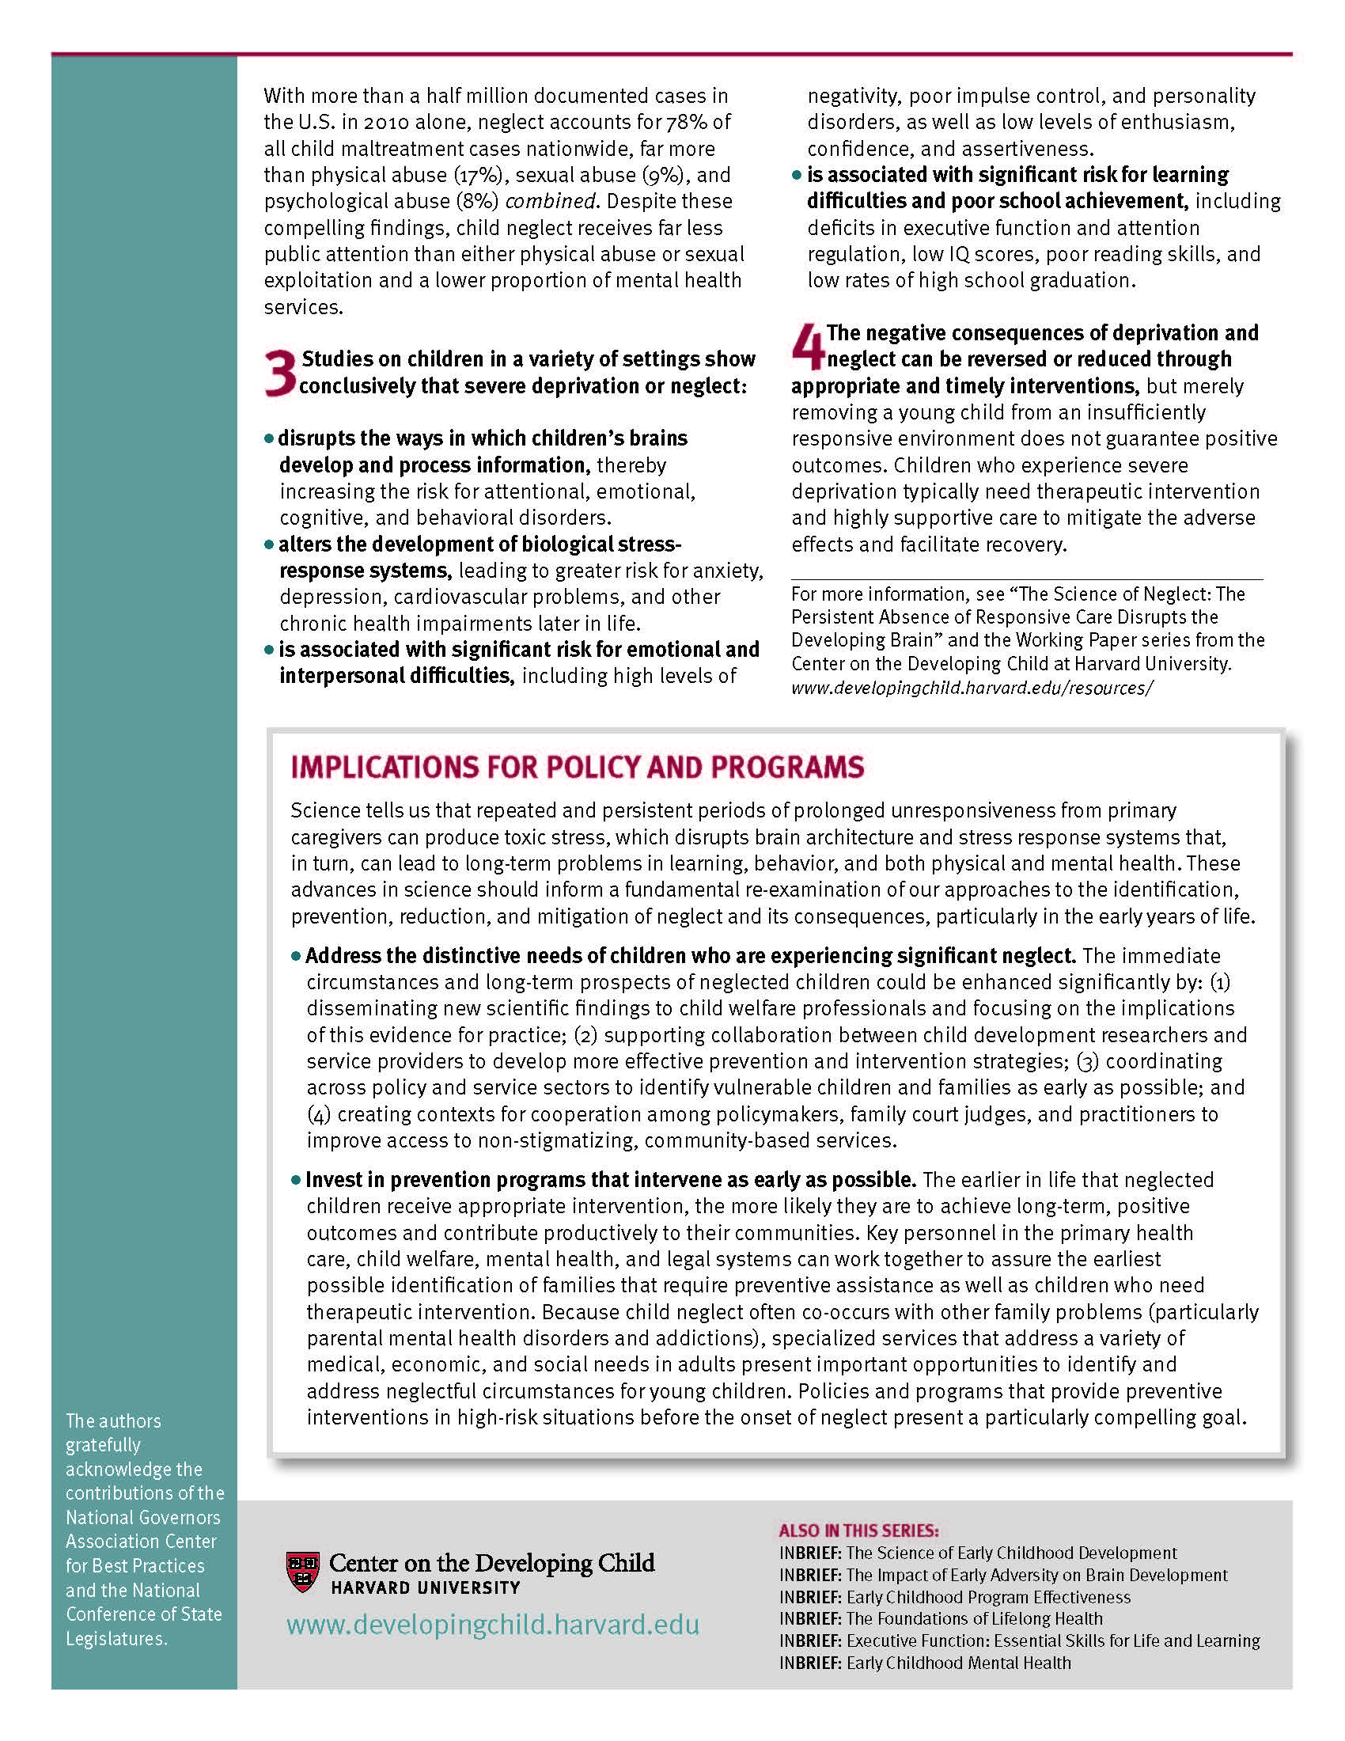

Decision-Making Tools

Worksheet: CPS Assessment Decision-Making
Family and Investigative Assessments
Similarities | Differences
How will you remember the different steps for family and investigative assessment decision-making?

Decision-Making and Critical Thinking

Worksheet: Values
Values are beliefs that are grounded by the principles most of us live by each day. Consider the values below.
Adaptability  Achievement  Ambition  Authenticity  Acceptance  Accomplishment  Bravery  Beauty  Balance  Caring  Certain  Control  Courage  Community  Compassion  Creativity  Dependability  Dignity | Diversity  Devotion  Empathy  Energy  Equality  Fairness  Forgiveness  Friendship  Fun  Giving  Growth  Happiness  Hard work  Health  Independence  Integrity  Intelligence  Justice | Knowledge  Leadership  Love  Loyalty  Maturity  Obedience  Openness  Passion  Purpose  Recognition  Respect  Security  Spirituality  Strength  Success  Teamwork  Wealth  Wisdom
Use this space to record notes.

Activity: Personal Considerations
From the group-generated list of emotions that impact our work with families, select three emotions to personally explore the ways these emotions may impact your behavior and decision-making with families.
Use the spaces below to record your thoughts.
Emotion:
Emotion:
Emotion:

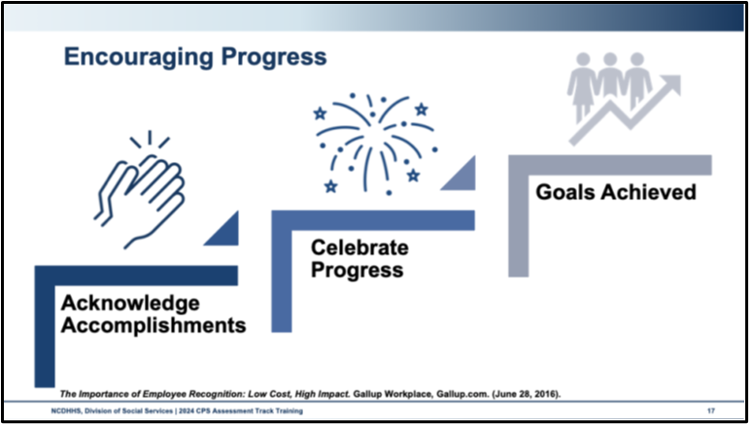
Use this space to record notes:

Supervisory Support
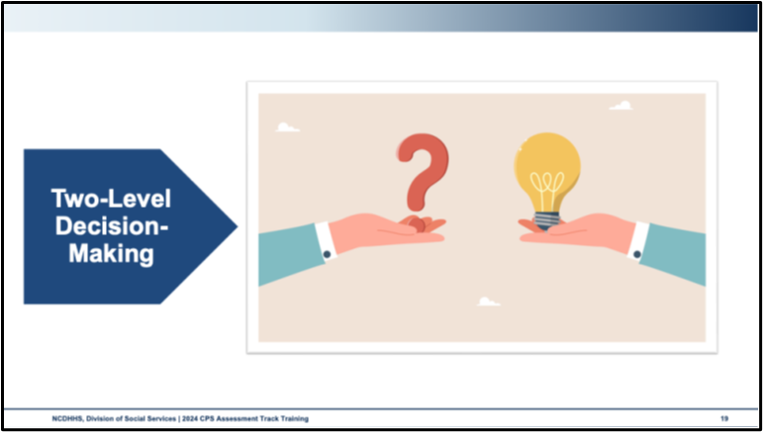
Use this space to record notes:

Skills Practice: Two-Level Decision-Making: Supervisory Consultation
Review the example coaching session. Respond to the questions.
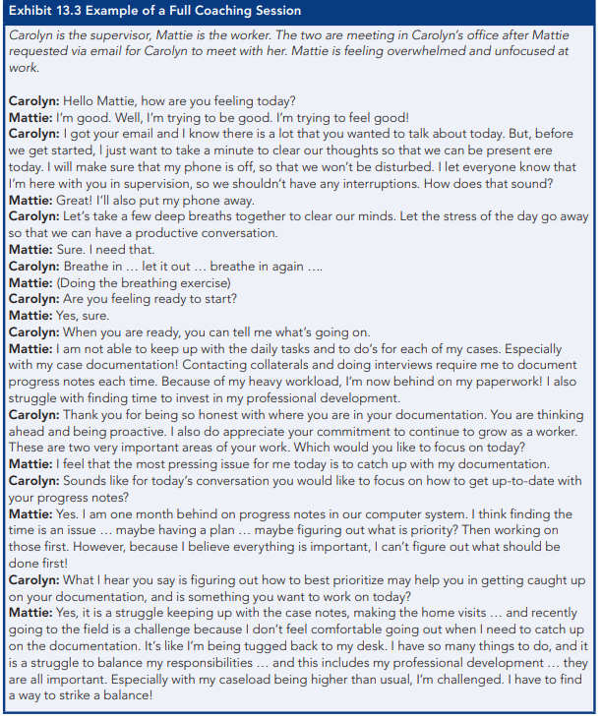

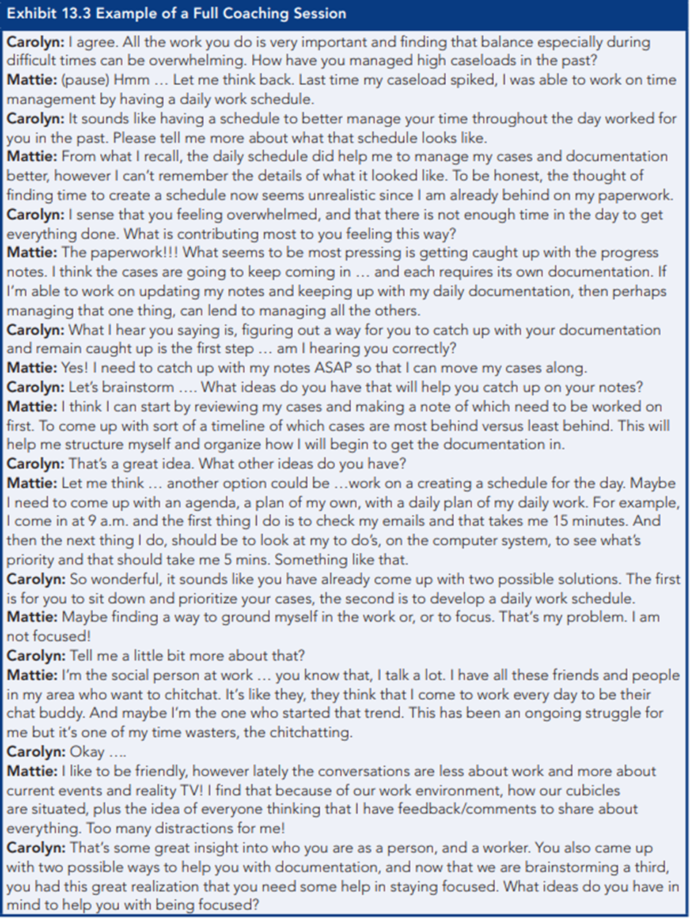
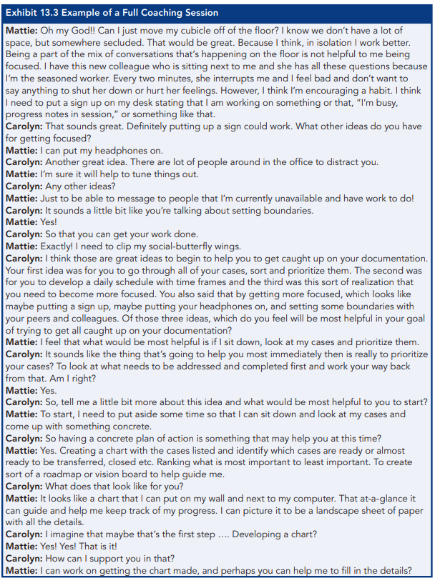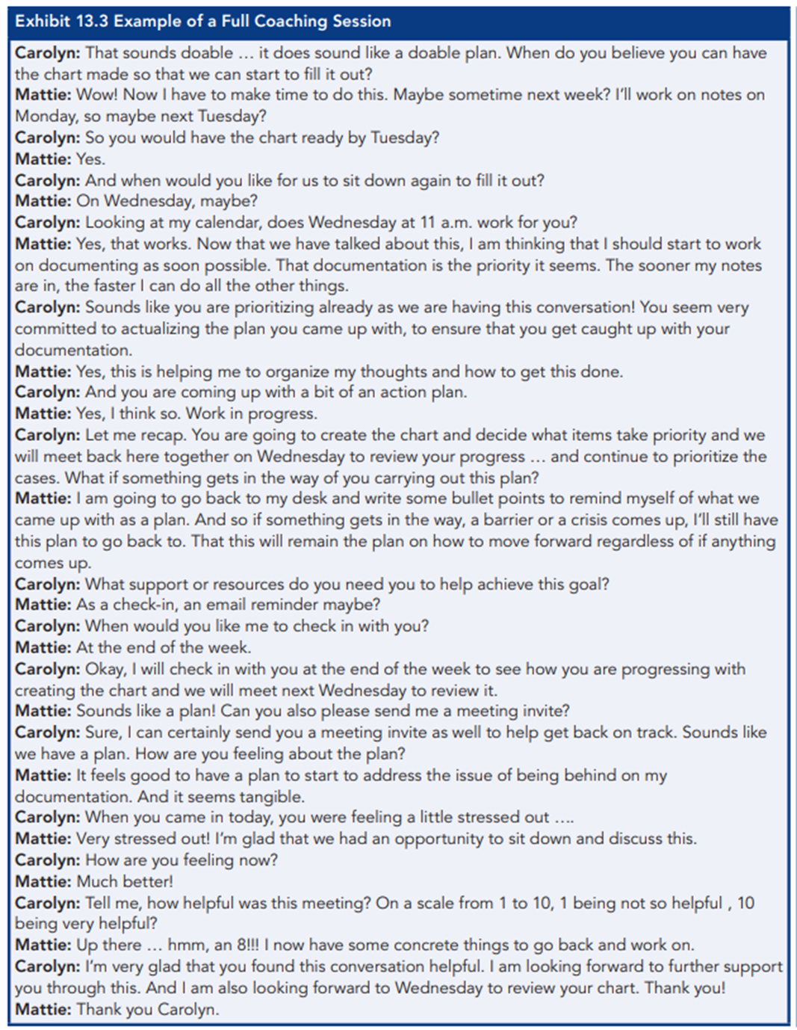
Discussion Questions
What did the supervisor say or do to support the child welfare social worker?
What impact does supervisory coaching have on critical thinking?
How will you prepare for coaching with your supervisor?
What do you need from your supervisory sessions to develop your skills?
What do you recommend the next steps should be in this scenario?
Reflections and Notes
Source material pgs. 152-155: Child Protective Services: A Guide for Caseworkers 2018 (childwelfare.gov)

Case Decision
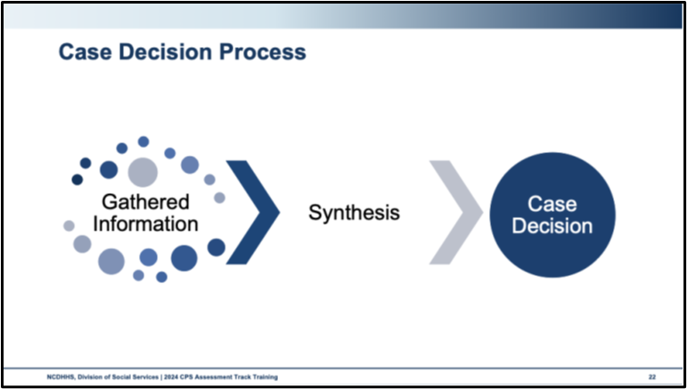
Use this space to record notes:
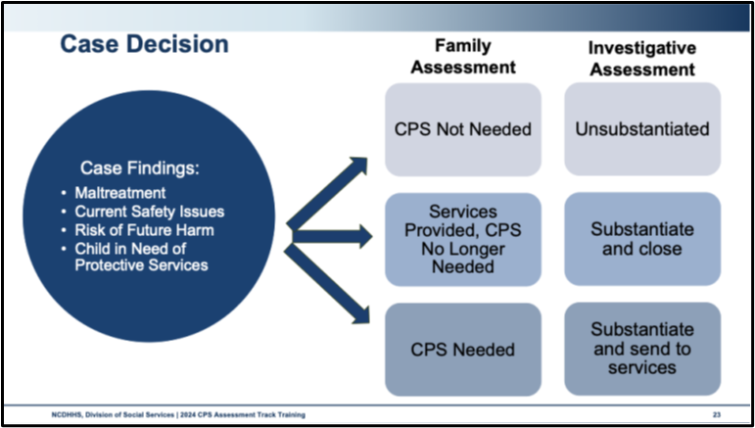
Use this space to record notes:

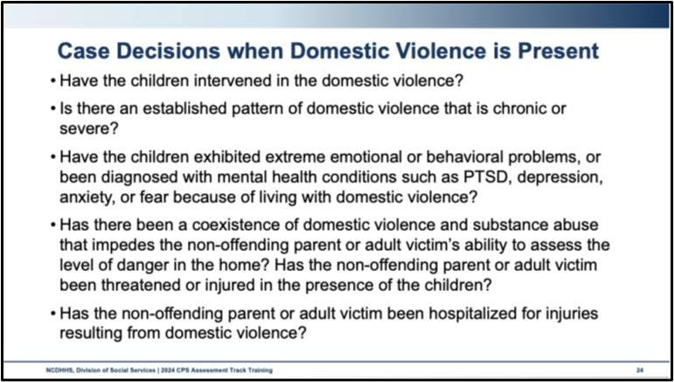
Use this space to record notes:

Case Transfer

Handout: Guide for Conducting Case Transfers
Guide for Conducting Case Transfers
Social Workers can use the following guide to structure case transfer meetings.
Suggested Participants:
- Transferring Social Worker
- Transferring Supervisor
- Newly Assigned Social Worker
- Newly Assigned Supervisor
- Family Team Members (Parents, child, family support, etc.)
- Placement Provider
Suggested Agenda:
- Introductions
  - All attendees introduce themselves, their role, and their relationship with the family
    - Newly assigned social worker and supervisor should provide the family with their contact information
  - Transferring Social Worker reviews the purpose of the meeting and facilitates the development of group agreements. To facilitate, Transferring Social Worker might ask “What do group members need in order to make this a safe and respectful place for our discussion?”
    - Group agreements might include
      - Make space for everyone on the team to contribute.
      - One person talks at a time; everyone will have a chance to share their thoughts
      - Respect confidentiality.
      - All ideas are valid.
      - Respect the perspective of everyone in the room, even if your perspective does not align with theirs.
      - Stay strengths-based and result-driven
- Child Welfare Involvement
  - Review of why child welfare is involved with the family
  - Review North Carolina Safety Assessment Tool and North Carolina Risk Assessment Tool
  - Discuss interventions that have been used to prevent removal and the outcomes of those interventions
- Family Strengths
  - Review Family Assessment of Strengths and Needs Tool
  - Discuss the parental protective factors identified during the assessment
  - Ask family members and other supports present at the meeting to identify additional strengths the family possesses
- Family Supports
  - Identify existing supports, including family, informal, and formal supports
  - Explore additional supports, including additional options for relative or fictive kin placements if the child is not already placed in a relative or fictive kin setting
  - Discuss options for how to include additional family and informal support in current or future planning
- Family Needs
  - Review Family Assessment of Strengths and Needs Tool
  - Discuss steps to address needs with family, informal, or formal support options
  - Ask family members and other supports present if other needs are present and/or if they have any questions or concerns regarding the needs identified in the Family Assessment of Strengths and Needs Tool
- Next Steps
  - Discuss Continuing Needs and Safety Requirements (DSS-5010a) to review ongoing family needs and activities to address identified safety concerns
  - Review upcoming important dates (i.e. court hearings, and other team meetings)
  - Newly assigned social worker schedules the next home visit
Other Helpful Tips:
- When transferring from CPS Assessment or In-Home Services to Permanency Planning, contacts with the family must be made within seven days of the case decision (CPS Assessment) or out-of-home placement.
  - This initial contact with the CPS Assessment or In-Home Services social worker can be in addition to a formal case transfer meeting, giving the family another opportunity to meet and engage with the Permanency Planning social worker prior to terminating their professional relationship with the CPS Assessment/In-Home Services social worker.
- Be sure to use clear, concise language that all team members can understand. Avoid jargon and acronyms and define the terms that you use that may not be commonly understood outside of a child welfare space.
- It is important that both social workers, the parents, and children all participate in the case transfer meeting to ensure that the relationship established between the transferring social worker and the family is transitioned to the newly assigned social worker.

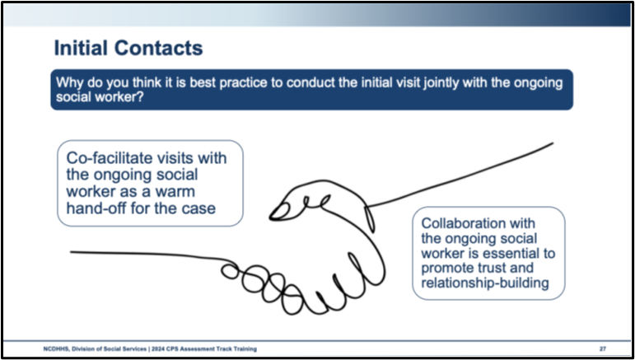
Use this space to record notes:

Case Closure
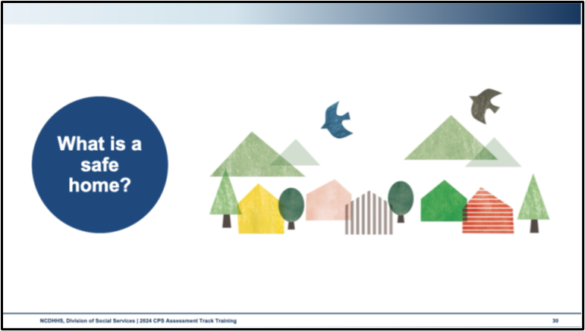
Use this space to record notes:

Activity: Addressing Worry and Risk
Work with your partner to create a list of ways in which you address your own worry or non-imminent risk.
Use this space to record notes.

Case Closure Notification
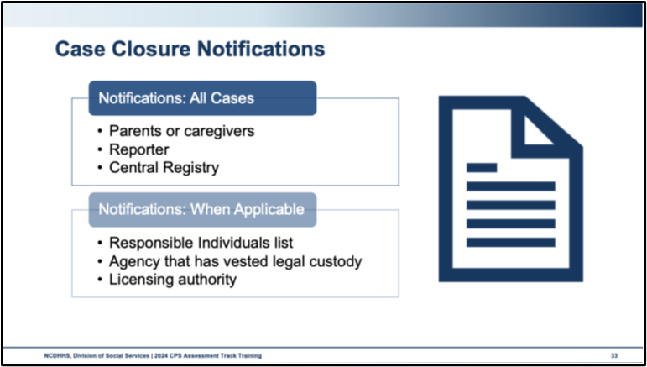
Use this space to record notes.

Decision-Making and Case Closure Learning Lab

Skills Practice: Decision-Making
Part One:
- With your group, consider the information you have gathered over the course of this eight-day track training on the Avilla Chavis family.
- Use this information to complete the SDM Tools.
- Each small group will complete a case completion Safety Assessment and a Family Assessment of Strengths and Needs (DSS-5229) for the family.
- You will need at least two people to complete these forms.
Part Two:
- Each group will staff their case with a supervisor.
- In your groups, please choose a volunteer to act as the supervisor.
- That person will staff the case with you, focusing on asking open-ended questions that determine if you have met reasonable or active efforts to preserve family integrity and whether you have met all of the case procedures.
What reflections do you have from this exercise?
What will you remember to do in the field when you are making case decisions?

Case Transfer Learning Lab

Skills Practice: Case Transfer
The trainer will provide worksheets for each case family member for this activity.
Because we will be filing a non-secure custody order and juvenile petition in juvenile court, the Lewis family case will be transferring to Permanency Planning Services.
- Each small group will hold a simulated case transfer meeting with the CPS Assessment social worker, the permanency planning social worker, a supervisor, and the parents, George and Monica.
- The process for case transfer differs in each county. For this practice, the focus will be on introducing the new social worker, ensuring there is a shared awareness of the reasons the case moved to custody, the purpose of permanency planning services, and the next steps.
- Decide who will play each role and hand out role sheets to corresponding team members.
- Consider the following agenda for the transfer team meeting:
- Introductions
- Ground Rules
- Purpose of the meeting
- Overview of permanency planning services
- Next steps
- Closing
What reflections do you have on case transfer meetings?
What stood out to you during your meeting?
What helped to support continuity of care for the family?
What will you take with you into case transfer in the future?

Worker Safety

Worker Well-Being
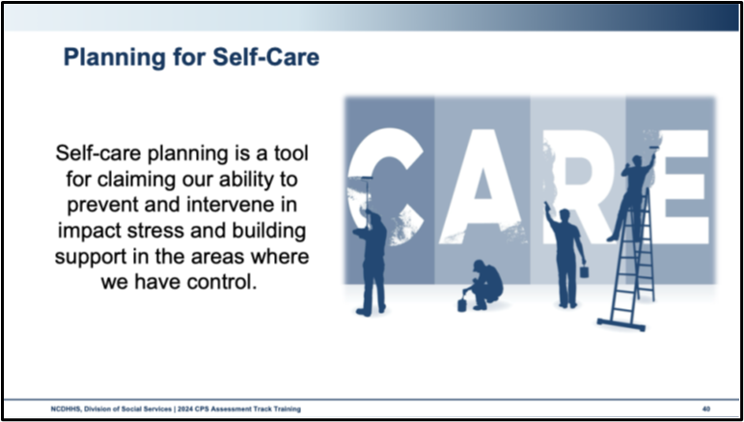
Use this space to record notes.

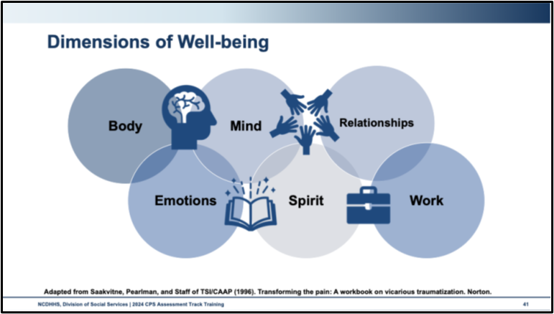
How well is your Self-Care Plan working for you today?
Where are you successful?
Where do you need support?
What are the barriers? Focus on addressing barriers if any exist and identifying supports to assist you.
How was this experience similar to what parents or caregivers might feel when we talk with them about self-care or well-being?
How does this experience inform your conversations with families about balancing work and life responsibilities?
What will you commit to doing differently to care for yourself in the future?

Worksheet: Self-Care Strategies
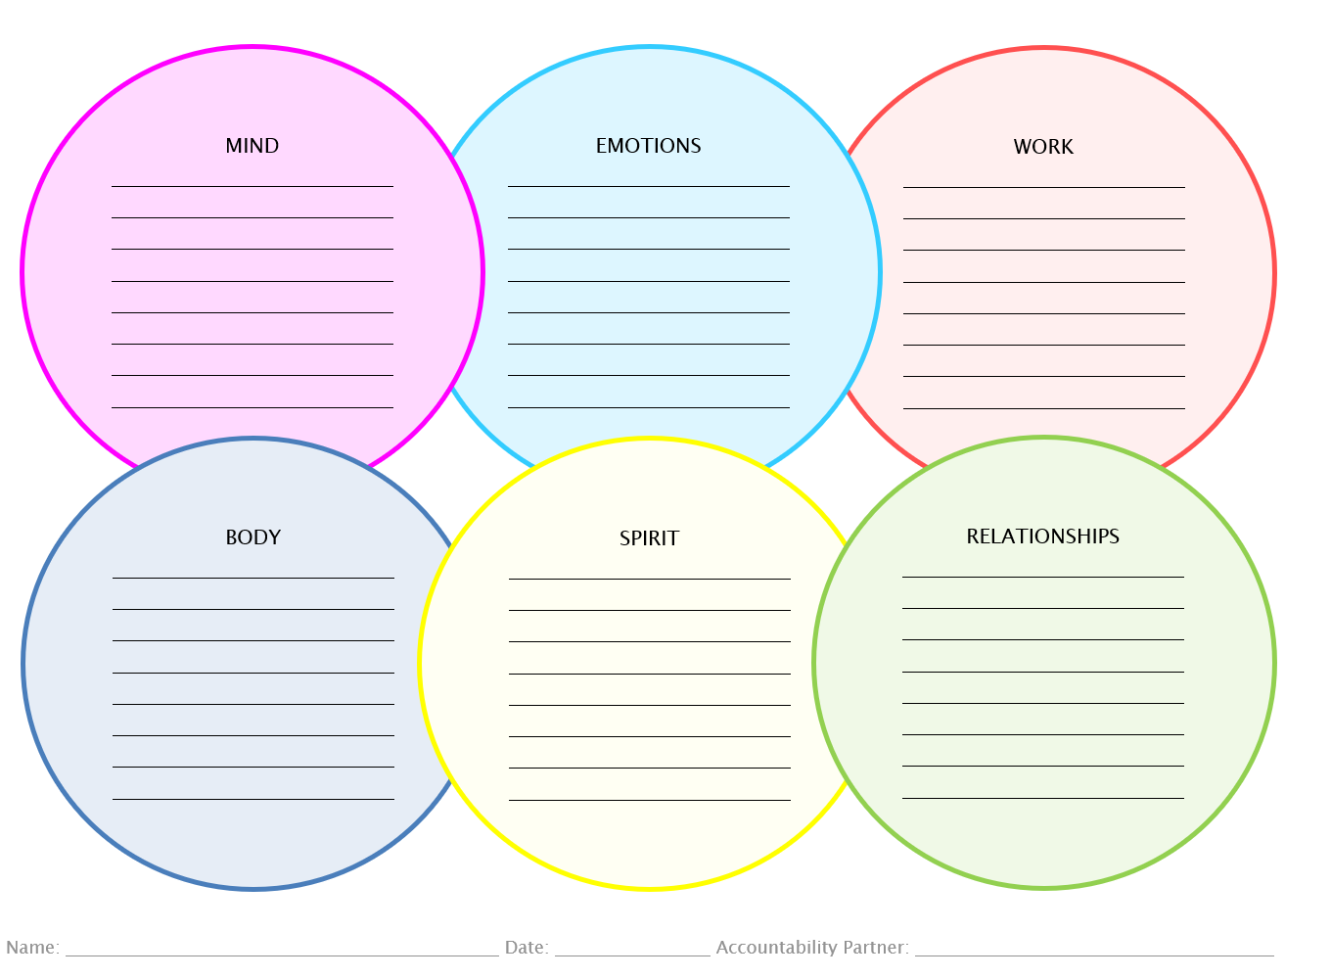

Considerations for After Hours and On-Call Duty Hours
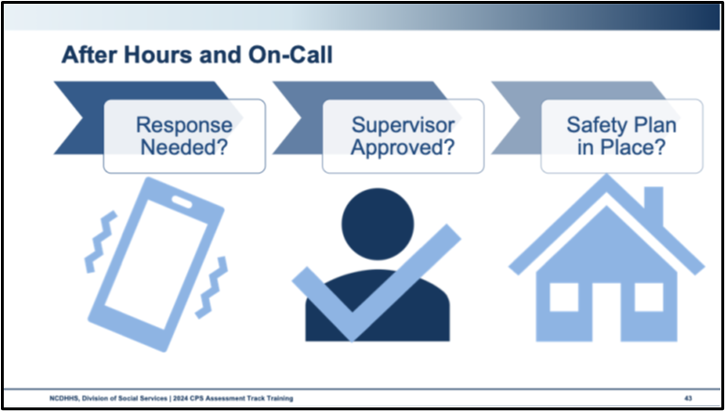
Use this space to record notes.

Self-Reflection Training Wrap-Up
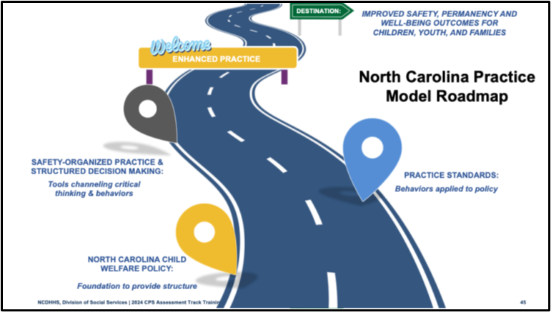
Use this space to record notes.

Worksheet: Post-Self-Assessment
Did you discover any new areas of strength? Maybe you received some positive feedback from a peer that you never recognized in yourself.
Have you identified any new areas for growth?
Did you learn and build a skill that will help you continue to grow in the areas you identified?
List any professional development action steps you would like to take based on this training.

Bibliography of References
Day Eight
Barbee, A., Purdy, L., & Cunningham, M. (2023, September). Secondary traumatic stress: definitions, measures, predictors and interventions. Quality Improvement Center for Workforce Development. https://digitalcommons.unl.edu/qicwdproducts/149/
Center on the Developing Child at Harvard University (CDCHU). (Oct. 31, 2013). In review: the science of neglect. Harvard University. https://harvardcenter.wpenginepowered.com/wp-content/uploads/2015/05/InBrief-The-Science-of-Neglect-3.pdf
Center on the Developing Child at Harvard University (CDCHU). (Oct. 31, 2013). In review: the science of neglect. [Video]. YouTube.com. Harvard University. https://www.youtube.com/watch?v=bF3j5UVCSCA
Child Welfare Information Gateway. (2014, July 23) Child and family services reviews quick reference items list. Washington, DC: U.S. Department of Health and Human Services, Administration for Children and Families, Children’s Bureau. https://www.acf.hhs.gov/sites/default/files/documents/cb/cfsr_quick_reference_list.pdf
Child Welfare Information Gateway. (2020, October) How the Child Welfare system works. Washington, DC: U.S. Department of Health and Human Services, Administration for Children and Families, Children’s Bureau. https://www.childwelfare.gov/pubPDFs/cpswork.pdf
Child Welfare Information Gateway. (2020). Reasonable efforts to preserve or reunify families and achieve permanency for children. Washington, DC: U.S. Department of Health and Human Services, Administration for Children and Families, Children’s Bureau. https://www. childwelfare.gov/topics/systemwide/laws-policies/statutes/reunify/
DePanfilis, Diane. (2018). Chapter 13: Supervision, Child Protective Services: a guide for caseworkers. Washington, DC: U.S. Department of Health and Human Services, Administration for Children and Families, Children’s Bureau. https://capacity.childwelfare.gov/sites/default/files/media_pdf/cps2018.pdf
Gallup Workplace. (2016, June 28). The importance of employee recognition: low cost, high impact. [Blog]. Gallup.com. https://www.gallup.com/workplace/236441/employee-recognition-low-cost-high-impact.aspx
George, J.M., & Dane, E. (2016). Affect, emotion, and decision making. Organizational behavior and human decision processes, 136: 47–55. https://www.sciencedirect.com/science/article/abs/pii/S074959781630365X
George, J.M. & Dane, E. (2016). Mood swing: the hidden role of emotion in decision making. Rice Business, Jones Graduate School of Business. https://business.rice.edu/wisdom/peer-reviewed-research/hidden-role-emotion-decision- making#:~:text=Decision%2Dmakers%20who%20feel%20more,prone%20to%20take%20greater%20risks.
Hellman, C.M., Robinson-Keilig, R.A., Dubriwny, N.M., Hamill, C., & Kraft, A. (2018). Hope as a coping resource among parents at risk for child maltreatment. Journal of family social work, 21(4-5). https://doi.org/10.1080/10522158.2018.1469559
The National Child Traumatic Stress Network. (2011). Secondary traumatic stress: a fact sheet for child-serving professionals. [Brief]. www.nctsn.org. https://www.nctsn.org/resources/secondary-traumatic-stress-fact-sheet-child-serving-professionals
North Carolina Department of Health and Human Services, Division of Social Services, Child Welfare Services. (2017). DSS-5231: North Carolina safety assessment. https://policies.ncdhhs.gov/wp-content/uploads/dss-5231-ia.pdf
North Carolina Department of Health and Human Services, Division of Social Services, Child Welfare Services. (2017). DSS-5231ins: North Carolina safety assessment. instructions. https://policies.ncdhhs.gov/wp-content/uploads/DSS-5231ins.pdf
North Carolina Department of Health and Human Services, Division of Social Services, Child Welfare Services. (2017). NC Domestic violence policy and best practice in Child Welfare. https://www.ncdhhs.gov/documents/files/dss/training/domestic-violence-workbook/download
North Carolina Department of Health and Human Services, Division of Social Services, Child Welfare Services. (2018). DSS-5229: North Carolina strengths & needs assessment. https://policies.ncdhhs.gov/wp-content/uploads/dss-5229-ia.pdf
North Carolina Department of Health and Human Services, Division of Social Services. (2019). Assessing safety and risk. Children’s services practice notes 24(2). https://practicenotes.org/v24n2.htm
North Carolina Department of Health and Human Services, Division of Social Services. (2019). NC DSS Best Practice for Social Worker Well-Being: North Carolina Child Welfare manual. https://policies.ncdhhs.gov/wp-content/uploads/appendix-6-best-practice-for-social-worker-well-being.pdf
North Carolina Department of Health and Human Services, Division of Social Services. (2020, October). Consent/authorization form for child medical & child/family evaluations. https://policies.ncdhhs.gov/wp-content/uploads/dss-5143-ia.pdf
North Carolina Department of Health and Human Services, Division of Social Services. (2020, May). CPS purpose & philosophy, Legal basis, administration: NC Child Welfare manual. https://policies.ncdhhs.gov/wp-content/uploads/purpose.pdf
North Carolina Department of Health and Human Services, Division of Social Services. (2021). North Carolina practice standards worker assessment. https://www.ncdhhs.gov/cw-worker-north-carolina-worker-assessment-all-practice-standards/open
North Carolina Department of Health and Human Services, Division of Social Services. (2021). Worker practice standards desk guide. https://www.ncdhhs.gov/cw-worker-north-carolina-worker-practice-standards-desk-guide/open
North Carolina Department of Health and Human Services, Division of Social Services. (2021, December). Child Welfare policy manual resources: Using safety circles to build safety networks with families. https://policies-uat.ncdhhs.gov/wp-content/uploads/using-safety-circles-to-build-safety-networks-december-2021.pdf
North Carolina Department of Health and Human Services, Division of Social Services. (2022). DSS-6191 – North Carolina division of social services plan of safe care. https://policies.ncdhhs.gov/wp-content/uploads/DSS-6191.pdf
North Carolina Department of Health and Human Services, Division of Social Services. (2023, December 18). The youth perspective. [Video]. North Carolina Lived Experience Video Dropbox. https://www.dropbox.com/scl/fo/wu4s22b7ouc96gyvtmmik/h?e=2&preview=12_18_23_the_youth_perspective+(720p).mp4&rlkey=wrxfiviurth20lg80pv1d3b9l&dl=0
North Carolina Department of Health and Human Services, Division of Social Services. (2024, April). Cross function topics: NC Child Welfare manual. https://policies.ncdhhs.gov/wp-content/uploads/In-Home_April-2024_2.pdf
North Carolina Department of Health and Human Services, Division of Social Services. (April 2024). In-home Services policy, protocol, and guidance: NC Child Welfare manual. https://policies.ncdhhs.gov/wp-content/uploads/In-Home_April-2024_2.pdf
North Carolina Department of Health and Human Services, Division of Social Services. (April 2024). Permanency planning services policy, protocol, and guidance: NC child welfare manual. https://policies.ncdhhs.gov/wp-content/uploads/Permanency-Planning-April-2024.pdf
North Carolina Department of Health and Human Services, Division of Social Services. (2024, August). CPS assessments policy, protocol, and guidance: NC Child Welfare manual. https://policies.ncdhhs.gov/wp-content/uploads/CPS-Assessments-Aug-2024.pdf
TherapistAid, LLC. (2021). The Cognitive Triangle. [Infographic]. TherapistAid.com. https://www.therapistaid.com/worksheets/cbt-triangle

Appendix: Handouts
The Science of Neglect 2
Guide for Conducting Case Transfers 4
Self-Care Strategies 6

The Science of Neglect

Guide for Conducting Case Transfers
Guide for Conducting Case Transfers
Social Workers can use the following guide to structure case transfer meetings.
Suggested Participants:
- Transferring Social Worker
- Transferring Supervisor
- Newly Assigned Social Worker
- Newly Assigned Supervisor
- Family Team Members (Parents, child, family support, etc.)
- Placement Provider
Suggested Agenda:
- Introductions
  - All attendees introduce themselves, their role, and their relationship with the family
    - Newly assigned social worker and supervisor should provide the family with their contact information
  - Transferring Social Worker reviews the purpose of the meeting and facilitates the development of group agreements. To facilitate, Transferring Social Worker might ask “What do group members need in order to make this a safe and respectful place for our discussion?”
    - Group agreements might include
      - Make space for everyone on the team to contribute.
      - One person talks at a time; everyone will have a chance to share their thoughts
      - Respect confidentiality.
      - All ideas are valid.
      - Respect the perspective of everyone in the room, even if your perspective does not align with theirs.
      - Stay strengths-based and result-driven
- Child Welfare Involvement
  - Review of why child welfare is involved with the family
  - Review North Carolina Safety Assessment Tool and North Carolina Risk Assessment Tool
  - Discuss interventions that have been used to prevent removal and the outcomes of those interventions
- Family Strengths
  - Review Family Assessment of Strengths and Needs Tool
  - Discuss the parental protective factors identified during the assessment
  - Ask family members and other supports present at the meeting to identify additional strengths the family possesses
- Family Supports
  - Identify existing supports, including family, informal, and formal supports
  - Explore additional supports, including additional options for relative or fictive kin placements if the child is not already placed in a relative or fictive kin setting
  - Discuss options for how to include additional family and informal support in current or future planning
- Family Needs
  - Review Family Assessment of Strengths and Needs Tool
  - Discuss steps to address needs with family, informal, or formal support options
  - Ask family members and other supports present if other needs are present and/or if they have any questions or concerns regarding the needs identified in the Family Assessment of Strengths and Needs Tool
- Next Steps
  - Discuss Continuing Needs and Safety Requirements (DSS-5010a) to review ongoing family needs and activities to address identified safety concerns
  - Review upcoming important dates (i.e. court hearings, and other team meetings)
  - Newly assigned social worker schedules the next home visit
Other Helpful Tips:
- When transferring from CPS Assessment or In-Home Services to Permanency Planning, contacts with the family must be made within seven days of the case decision (CPS Assessment) or out-of-home placement.
  - This initial contact with the CPS Assessment or In-Home Services social worker can be in addition to a formal case transfer meeting, giving the family another opportunity to meet and engage with the Permanency Planning social worker prior to terminating their professional relationship with the CPS Assessment/In-Home Services social worker.
- Be sure to use clear, concise language that all team members can understand. Avoid jargon and acronyms and define the terms that you use that may not be commonly understood outside of a child welfare space.
- It is important that both social workers, the parents, and children all participate in the case transfer meeting to ensure that the relationship established between the transferring social worker and the family is transitioned to the newly assigned social worker.

Self-Care Strategies

