Kev Hloov Me Nyuam Thaum Ntxov
hauv North Carolina
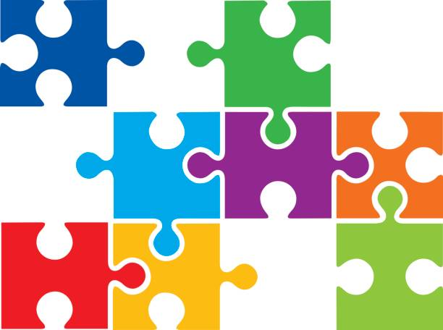
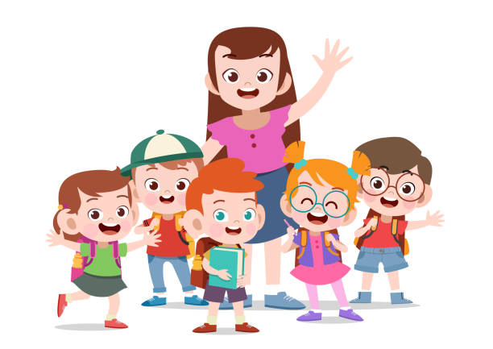
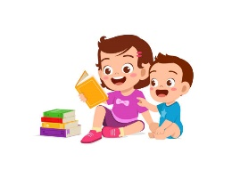
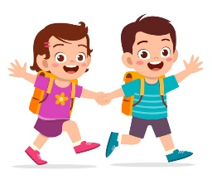
Ib qho piv txwv ntawm
Me Nyuam mos, Me Nyuam,
thiab
Preschool Chaw rau Niam Txiv

Nyob zoo niam txiv,
Koj tus menyuam tau ua haujlwm zoo hauv North Carolina Infant-Toddler Qhov kev pab cuam (ITP), thiab peb xav ua kev zoo siab rau koj.Daim ntawv no tau muab rau koj kom koj tuaj yeem yog tus neeg koom tes hauv kev npaj rau koj tus menyuam txoj kev koom tes yav tom ntej hauv Preschool Qhov kev pab cuam lossis lwm yam kev pabcuam hauv zej zog, tom qab nws kawm tiav los ntawm Infant-Toddler Program.
Thaum txoj kev hloov pauv tau ua raws li cov txheej txheem ib txwm ua, cov no yog tsim los hloov kho kom tau raws li qhov xav tau ntawm txhua tsev neeg.Peb lees paub tias txhua tus niam txiv muaj lawv tus kheej txoj kev nyiam, sijhawm, thiab kev ua phooj ywg thaum nws los txog rau tsev neeg sib sau.Koj qhov kev koom tes hauv kev hloov pauv yog nyob ntawm koj.
Peb lees paub tias tus kheej cov kev paub dhau los, kev xav, thiab cov lus teb tau zoo ib yam li cov lus, kab lis kev cai, thiab keeb kwm.Cov chaw muab kev pabcuam ntawm koj tus menyuam pab pawg npaj kev hloov pauv yuav hwm koj tsev neeg txoj kev coj noj coj ua thiab qhov tseem ceeb.
Peb kuj lees paub tias muaj ntau hom lus thiab hom kev sib txuas lus hauv tsev neeg thiab cov niam txiv xav tau kev nkag mus rau cov peev txheej uas pab lawv txiav txim siab.Txoj kev no yuav coj mus rau hauv tus account ntau yam lus hais hauv tsev los ntawm cov menyuam yaus.Koj raug tso cai mus nrhiav kev pab ntawm cov neeg tawm tswv yim thiab cov kws kho kev coj noj coj ua, nrog rau kev pabcuam lus thiab kev txhais lus.
Koj cov neeg muab kev pabcuam yuav coj koj los ntawm txoj kev hloov pauv, piav qhia txog qhov yuav tsum tau muaj thiab muab kev xaiv rau koj los ua thiab ntsuas kev hloov pauv.Koj yuav tsum tso siab rau koj cov neeg muab kev pabcuam thiab txaus siab rau cov txiaj ntsig.Koj muaj kev tiv thaiv kev cai lij choj thiab kev xaiv los txiav txim siab tshaj plaws rau koj thiab koj tus menyuam.
Thov tham nrog cov tswv cuab ntawm koj tus menyuam txoj kev hloov pauv yog tias koj muaj lus nug lossis kev txhawj xeeb txog ib yam dab tsi hauv phau ntawv no lossis koj tus menyuam txoj kev hloov.
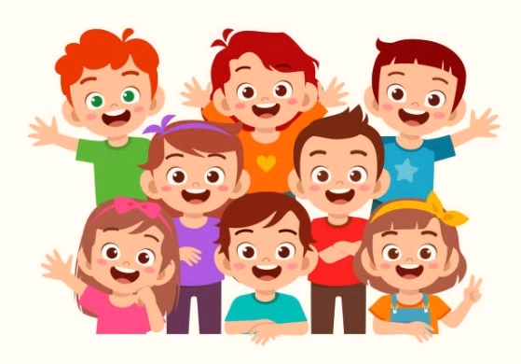

Kev Hloov Me Nyuam Thaum Ntxov hauv North Carolina
Cov ntaub ntawv

Taw qhia 1
Cov Kev Pabcuam rau Cov Menyuam mos, Cov menyuam me thiab cov menyuam kawm preschoolers hauv North Carolina: Kev Sib Piv 2
IDEA Part B Cov Kev Pab Cuam Me
Koj Cov Cai thiab Lub Luag Haujlwm Ua Niam Txiv lossis Tus Saib Xyuas 6
Cov txheej txheem hloov mus rau Preschool Qhov kev pab cuam Kev pabcuam 7
Cov lus qhia ua kom qhov hloov tau yooj yim dua 12
Daim ntawv teev kev hloov pauv 13
Qhia Txog Kuv Tus Me Nyuam 14
Koj Cov Kev Pabcuam Zej Zog 15
Cov ntawv luv & Cov ntawv luv siv los ntawm koj cov peev txheej hauv zej zog 16
Cov ntsiab lus ntawm Jargon 18
Cov ntsiab lus ntxiv 22
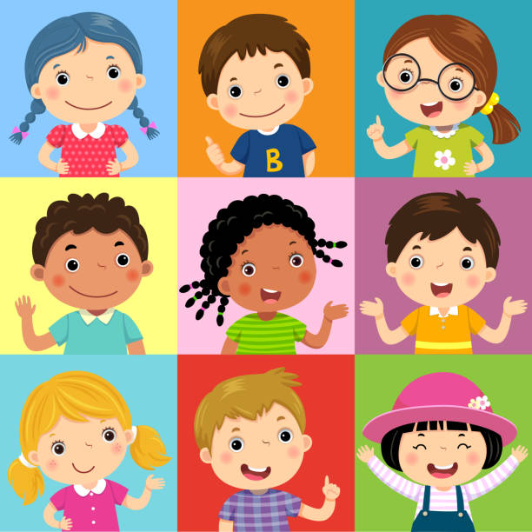
Kev lees paub 23

Taw qhia
Yuav tsum nyob rau hauv kev hloov pauv yog nyob rau hauv lub xeev ntawm transformation.Nws tshwm sim hauv ntau hom thoob plaws txhua tus neeg lub neej.Muaj cov ntawm peb txais tos kev hloov pauv thiab peb cov uas ntshai nws.Kev hloov pauv yog yam tsis muaj nyob hauv ob qho tib si.
Lo lus kev hloov pauv yog hais txog cov txheej txheem ntawm kev hloov ntawm ib qho kev pabcuam thaum ntxov mus rau lwm qhov, xws li:
- los ntawm chav xwm txheej ceev mus rau koj lub tsev,
- los ntawm kev zov me nyuam rau cov me nyuam mos thiab cov me nyuam me mus rau kev zov me nyuam rau cov me nyuam kawm ntawv preschool, los yog
- los ntawm kev saib xyuas me nyuam mus rau kev kawm qib kindergarten.
Cov no tuaj yeem yog qhov pib ntawm kev hloov pauv, qee qhov yuav tshwm sim hauv chav kawm.Lawv cim qhov kev hloov ntawm ib qho kev pabcuam mus rau lwm qhov.
Ua ntej koj tus menyuam muaj peb xyoos, koj thiab koj tus menyuam Tus Thawj Saib Xyuas Kev Pabcuam Thaum Ntxov (EISC) yuav pib tham txog thiab npaj rau kev hloov pauv.Thaum koj tus menyuam muaj peb xyoos, nws yuav tau hloov kho rau cov neeg saib xyuas tshiab, tsev kawm ntawv tshiab, thiab cov txheej txheem nyiaj txiag tshiab rau nws cov kev pabcuam.Cov haujlwm hauv kev npaj hloov pauv muaj xws li:
- kev tso chaw hauv zej zog, kev pabcuam, thiab kev txhawb nqa kev sib tham thiab sau cov ntaub ntawv;
- txhawb nqa thaum koj thiab koj tus menyuam hloov kho rau cov kev pabcuam tshiab; thiab
- koom tes nrog lwm tus neeg muab kev pabcuam los qhia cov ntaub ntawv hais txog koj tus menyuam (nrog rau cov ntaub ntawv ntsuam xyuas thiab kev sojntsuam thiab Cov Kev Pabcuam Rau Tsev Neeg Tus Kheej) nrog koj daim ntawv tso cai.
Koj paub koj tus menyuam zoo dua lwm tus.Kev txiav txim siab txog koj tus menyuam cov kev pabcuam thiab cov kev pabcuam yuav raug txiav nrog koj cov tswv yim ua ib feem ntawm txoj kev hloov pauv.Lub hom phiaj ntawm qhov kev qhia no yog los pab koj los ntawm cov txheej txheem hloov mus rau ib kauj ruam.Tej zaum koj yuav muab koj daim ntawv qhia no rau lwm tus niam txiv lossis tus txheeb ze ntawm ib tug me nyuam me nyob rau yav tom ntej.Yog tias koj muaj hmoo, tus neeg tshiab no tseem yuav tau txais txiaj ntsig los ntawm kev hnov ​​txog koj cov dab neeg hloov pauv tau zoo.
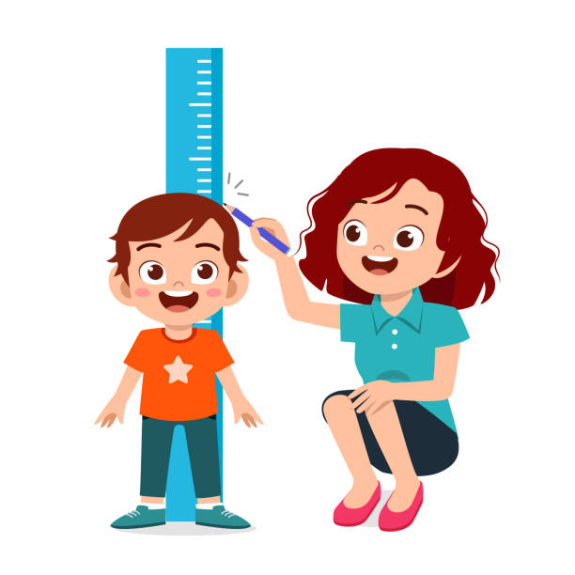
Txheeb xyuas Preschool and Infant-Toddler Cov
kev pab cuam hauv North Carolina
Ob Qhov Kev Pab Cuam Me (Part C ntawm Txoj Cai Kev Kawm Rau Cov Neeg Tsis Muaj Peev Xwm [IDEA]) thiab Cov Kev Pab Cuam Me (Part B ntawm IDEA) muaj qhov sib piv thiab qhov sib txawv.Ob daim ntawv thov yog luv sib piv hauv qab no.Tham nrog Early Intervention Service Coordinator (EISC) los yog Preschool Coordinator ntawm koj cheeb tsam tsev kawm ntawv yog tias koj muaj lus nug ntxiv.

 |  | North Carolina Infant-Toddler Qhov kev pab cuam (Tshooj C) | North Carolina Preschool Program  (Tshooj B)
 | Lub Xeev Tus Thawj Coj | Kev Pabcuam Thaum Ntxov, Lub Tsev Haujlwm Saib Xyuas Kev Noj Qab Haus Huv thiab Tib Neeg, Chaw Haujlwm Saib Xyuas Menyuam Yaus thiab Tsev Neeg | Xeev North Carolina, Chaw Ua Haujlwm rau Cov Menyuam Tshwj Xeeb, Lub Tsev Haujlwm Saib Xyuas Kev Qhia Pej Xeem
 | Lub Koom Haum  Saib Xyuas Hauv Zos | Txoj Cai Tswjfwm rau Cov Menyuam Tsis Taus (CDSA) | Lub Tsev Kawm Ntawv Pej Xeem (PSU) tseem hu ua Lub Chaw Saib Xyuas Kev Kawm Hauv Zos (LEA), lub tsev kawm ntawv hauv zos
 | Sijhawm Ua Haujlwm | Cov menyuam yaus uas muaj kev tsis taus, txij thaum yug mus txog peb xyoos. | Cov menyuam yaus uas muaj hnub nyoog peb thiab tsib xyoos.Qhov Kev Pab Cuam Preschool tsis txais cov menyuam hnub nyoog 5 xyoos uas laus txaus mus kawm qib kindergarten.
 | Kev tsim nyog | Kev ntsuam xyuas thiab kuaj cov txiaj ntsig txiav txim siab kev tsim nyog.Ib tug hluas poob rau hauv ib qho ntawm ob pawg rau kev tsim nyog:  Cov menyuam yaus uas muaj kev qeeb hauv ib qho ntawm tsib lub ntsiab ntawm kev loj hlob (kev txawj ntse, kev sib txuas lus, lub cev, kev xav-kev xav, lossis kev yoog raws) raug kuaj pom tias muaj kev loj hlob qeeb.  Cov xwm txheej twb paub tias ua rau qeeb hauv lub hnub nyoog loj hlob Ib tug me nyuam tau hais tias muaj ib qho uas twb paub lawm ua rau kev loj hlob qeeb.Kev puas tsuaj ntawm cov noob los yog lub paj hlwb, kev yug me nyuam heev, tsis pom kev lossis hnov lus, thiab kev puas siab puas ntsws yog tag nrho cov piv txwv. | Cov qauv tsim nyog tau txiav txim los ntawm kev tshuaj ntsuam thiab kev ntsuas.Cov ntaub ntawv raug muab faib rau pawg IEP. IEP yog hais txog tus menyuam kawm ntawv txoj kev npaj qhia ntawv tus kheej.Koj muaj lub luag haujlwm tseem ceeb los ua si hauv pab pawg no.Cov qeb kev tsim nyog muaj xws li:  - Kev loj hlob qeeb  - Autism spectrum teeb meem  - Lag ntseg-Qhov muag tsis pom kev  - Lag ntseg  - Kev hnov lus tsis zoo (tsis hnov lus nyuaj)  - Lwm yam kev puas tsuaj  - Orthopedic kev puas tsuaj  - Kev hais lus lossis lus tsis zoo  - Qhov muag tsis pom kev, nrog rau qhov muag tsis pom kev  - Qhov muag tsis pom kev  - Mob hlwb raug mob  - Kev Tsis Muaj Peev Xwm Loj  - Ntau Qhov Kev Tsis Taus  - Kev tsis taus kev txawj ntse

 |  | North Carolina Infant-Toddler Qhov kev pab cuam (Tshooj C) | North Carolina Preschool Program  (Tshooj B)
 | Ua kom pom tseeb | Qhov Kev Pab Cuam Me Nyuam Yaus hauv North Carolina yog tsim los ua kom haum rau koj tsev neeg cov cai.Cov menyuam yaus uas muaj kev xav tau tshwj xeeb txij thaum yug txog rau hnub nyoog peb xyoos tuaj yeem siv tau ntau yam kev pabcuam thaum ntxov los ntawm Kev Pabcuam Menyuam mos-Me nyuam mos.Lub hom phiaj ntawm Qhov Kev Pabcuam Menyuam Yaus-Me Nyuam Yaus yog qhia cov niam txiv kom muab kev saib xyuas zoo tshaj plaws rau lawv cov menyuam. | North Carolina Preschool Program tau tsim los nrog koj tus menyuam txoj kev loj hlob ntawm kev kawm hauv siab.Cov menyuam yaus hauv North Carolina uas muaj hnub nyoog ntawm peb thiab tsib xyoos tuaj yeem ua kom zoo dua ntawm ntau cov kev pabcuam los ntawm lub xeev txoj haujlwm preschool.Lub hom phiaj ntawm cov ntaub ntawv kawm preschool yog npaj tus me nyuam rau yav tom ntej kev vam meej hauv kev ua ub no uas muaj kev loj hlob thiab / lossis hnub nyoog tsim nyog rau nws.
 | Cov peev txheej  siv tau | Cov menyuam yaus thiab lawv tsev neeg uas tsim nyog rau Qhov Kev Pab Cuam Me tuaj yeem tau txais nws cov txiaj ntsig.Txhua qhov kev pabcuam yuav tsum tau muab tso rau hauv qhov chaw sab nraud.  Cov kev pabcuam uas muaj los ntawm Infant-Toddler Qhov kev pab cuamm uaj xws li:  - Cov kev pab cuam technology thiab cov cuab yeej siv  - Cov kev pab cuam kho mob  - Kev sib koom tes  - Kev cob qhia tsev neeg, kev sab laj, thiab mus ntsib tsev  - Kev pab kho mob  - Kev kho mob  - Cov kev pab tu neeg mob  - Khoom noj khoom haus  - Kev kho mob ua haujlwm  - Kev kho lub cev  - Cov kev pabcuam puas siab puas ntsws  - Cov kev pabcuam so  - Cov lus kos npe thiab cov kev pabcuam hais lus  - Kev pabcuam kev ua haujlwm  - Kev Qhia Tshwj Xeeb (tseem hu ua cov kev pabcuam kho mob hauv zej zog)  - Kev Hais Lus-Kev Kho Lus  - Kev thauj mus los  - Cov kev pab cuam pom kev | Cov Kev Kawm Tshwj Xeeb thiab Cov Kev Pab cuam ntsig txog Preschool Program muaj rau cov menyuam yaus uas tsim nyog tau txais kev kawm tshwj xeeb thiab cov kev pab cuam tshuam raws li qhov tsim nyog.Cov kev pabcuam yuav tsum tau muab rau hauv qhov chaw txwv tsawg kawg nkaus (LRE) raws li tus menyuam qhov kev xav tau tshwj xeeb.  Cov kev pabcuam Preschool Program tuaj yeem suav nrog:  - Kev qhia tshwj xeeb-Tsim kev qhia hauv thaj chaw uas xav tau.  - Cov kev pabcuam cuam tshuam xws li:  - Audioology  - Kev sab laj  - Txhais lus  - Cov kev pab kho mob rau kev ntsuam xyuas  - Kev kho mob ua haujlwm  - Kev taw qhia thiab kev txav mus los  - Kev kho lub cev  - Tsev kawm ntawv tus nais maum  - Kev ua haujlwm  - Kev Hais Lus-Kev Kho Lus  - Kev thauj mus los
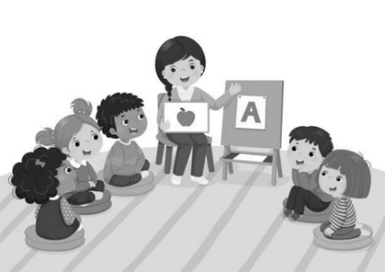

 |  | North Carolina Infant-Toddler Qhov kev pab cuam (Tshooj C) | North Carolina Preschool Program  (Tshooj B)
 | Hom tswv yim | Qhov Kev Pabcuam Me Nyuam Me hauv North Carolina siv Individualized Family Service Plan (IFSP).Koj yuav yog ib feem ntawm pab pawg IFSP uas txiav txim siab seb IFSP cov txiaj ntsig tau los ua ntej.  Hauv luv, IFSP yuav:  - hwm cov kev xav tau, kev txwv, thiab qhov tseem ceeb ntawm koj cov neeg koj hlub;  - cov hom phiaj rau koj tus menyuam thiab koj tsev neeg cov kev xav tau ua haujlwm;  - thov piav qhia txog kev txhawb nqa koj tus menyuam thiab tsev neeg yuav tau txais txiaj ntsig los ntawm kev thiaj li ua tiav cov txiaj ntsig xav tau;  - tham lus thiab sau ntawv siv cov lus thiab style uas nyiam tshaj plaws rau koj tsev neeg;  - yuav tsum xeem dhau muster nrog tsev neeg ua ntej;  - txhawb nqa koj tsev neeg lub hom phiaj; thiab  - yuav tsum saib txhua rau lub hlis tsawg kawg nkaus. | Ib qho IEP (Individualized Education Program) yuav raug tsim los ntawm PSU.Pab Pawg Preschool IEP, uas koj yog ib feem, yuav xaiv cov hom phiaj rau IEP cov tub ntxhais kawm txoj kev kawm.  Ib qho IEP yuav:  - lub hom phiaj txhua xyoo uas suav nrog koj tus menyuam txoj kev kawm, kev loj hlob, thiab kev xav tau;  - thov piav qhia txog lub sijhawm thiab zaus ntawm cov kev pabcuam uas koj tus menyuam yuav tau txais;  - muab kev txhawb nqa hauv qhov hu ua Least Restrictive Environment (LRE), uas rau cov menyuam kawm ntawv preschool suav nrog sab nraum zoov  - tau tsim nrog ib xyoos hauv siab, hloov kho thiab hloov kho txhua xyoo.
 | Hom Kev Muab Kev  Pabcuam | Qhov Kev Pabcuam Me Nyuam Me hauv North Carolina yog ib qho kev xaiv hauv.  Koj Tus Kws Saib Xyuas Kev Pabcuam Thaum Ntxov (EISC) ntawm Lub Chaw Pabcuam Kev Loj Hlob Me Nyuam (CDSA) yuav yog koj qhov tseem ceeb ntawm kev tiv tauj rau kev pab.  IFSP yog npaj rau ob qho tib si ua ntej thiab thaum nws tsim.Cov kev pabcuam twg xav tau, leej twg yuav muab rau lawv, thiab qhov twg lawv yuav muab yog txhua qhov kev txiav txim siab uas koj, koj EISC, thiab lwm tus neeg muab kev pabcuam hauv koj pab pawg IFSP ua ke.  Kev pab tuaj yeem nrhiav tau los ntawm ntau qhov chaw hauv zos, nrog rau cov kev pab cuam thiab cov kws tshaj lij.Cov no tuaj yeem nyob hauv tsev, hauv zej zog, lossis lwm qhov chaw uas feem ntau tsim cov menyuam yaus dai tawm.Cov zej zog muaj kev pabcuam yuav txawv. | Cov menyuam yaus hauv North Carolina tuaj yeem xaiv seb puas yuav tso npe rau hauv qhov kev pabcuam preschool.  Lub tsev kawm ntawv tus kws pab tswv yim lossis tus kws qhia ntawv tshwj xeeb hauv koj tus menyuam lub tsev kawm ntawv yuav yog koj qhov tseem ceeb ntawm kev sib cuag rau kev pabcuam.  Lub Rooj Sib Tham Kev Kawm Rau Tus Kheej (IEP) yog qhov chaw koj yuav ua tiav feem ntau ntawm koj txoj kev npaj.  PSU tswj xyuas kev kawm tshwj xeeb thiab cov kev pabcuam cuam tshuam.  Cov hom phiaj txhua xyoo yog tsim los ntawm lub rooj sib tham IEP siv cov ntaub ntawv sau los ntawm ntau qhov chaw, suav nrog tus menyuam qhov kev ntsuam xyuas thiab kev ua haujlwm tam sim no.  Pab neeg tom qab ntawd txiav txim siab qhov twg thiab ntev npaum li cas cov kev pabcuam yuav muab tau tom qab tsim cov hom phiaj.

 |  | North Carolina Infant-Toddler Qhov kev pab cuam (Tshooj C) | North Carolina Preschool Program  (Tshooj B)
 | Hom Kev Muab  Kev Pabcuam (txuas ntxiv) | Thaum tus menyuam muaj hnub nyoog peb xyoos, nws yuav tsum tawm hauv North Carolina Infant-Toddler Qhov kev pab cuam.Koj tus menyuam Tus Thawj Saib Xyuas Kev Pabcuam Thaum Ntxov (EISC) yuav koom tes nrog koj kom muaj kev hloov pauv mus rau cov haujlwm tsim nyog thiab kev txhawb nqa.Lub Tsev Kawm Ntawv Nroog Xees Phos (PSU) tuaj yeem muab kev pabcuam rau Preschool Program rau koj tus menyuam.  Thaum lub sij hawm txoj kev npaj hloov pauv, koj thiab cov neeg ua haujlwm yuav tshuaj xyuas lwm cov kev pab cuam uas koj tus menyuam yuav tsim nyog tau txais, xws li Head Start, ib txwm kawm preschool, thiab lwm yam.  Yog tias koj xav tau kev pab npaj cov kev pabcuam rau koj thiab koj tus menyuam dhau ntawm qhov Kev Pabcuam Menyuam Yaus-Me Nyuam Yaus, Txoj Haujlwm Saib Xyuas Kev Nyab Xeeb rau Cov Menyuam Yaus (CMARC) ntawm koj lub chaw saib xyuas kev noj qab haus huv hauv nroog yuav tuaj yeem pab tau.Koj EISC yog ib tug neeg zoo los tham txog qhov no. | Cov menyuam yaus uas ua tau raws li qhov yuav tsum tau nkag mus rau PSU-khiav Preschool Qhov kev pab cuam thaum lawv muaj peb xyoos.  PSU yuav muab ntau yam kev pabcuam kom tau raws li koj tus menyuam qhov kev xav tau.Cov kev pabcuam tuaj yeem muab rau hauv tsev, tom tsev kawm ntawv, lossis los ntawm cov xibfwb qhia ntawv.  Koj tus menyuam tus kws qhia ntawv yuav yog lub hauv paus ntawm kev tiv tauj rau kev tswj xyuas cov kev pabcuam lossis thov kom hloov cov kev pabcuam.  Koj tus menyuam tuaj yeem tsim nyog tau txais kev pabcuam tshwj xeeb hauv nws lub xyoo kawm ntawv yog tias nws muaj kev tsis taus.  Pab neeg IEP ua txhua yam kev txiav txim siab txog kev pabcuam.Koj tau txais los ua ib pab neeg ua si.
 | Cov Nqi Kev Pabcuam | Qee tus kws kho mob yuav siv tus nqi swb los them cov niam txiv.Koj qhov EISC tuaj yeem muab cov ntsiab lus qhia txog kev them nyiaj rau cov kev pabcuam koj tau txais li cas.  Kev txheeb xyuas tus me nyuam thiab kev tshuaj ntsuam xyuas, kev sib koom ua haujlwm, kev ntsuam xyuas kev  loj hlob thiab kev ntsuam xyuas, IFSP kev txhim kho thiab kev tshuaj xyuas, thiab cov dej num txuas los xyuas kom meej koj cov cai muaj kev nyab xeeb yuav tsum tau muab pub dawb raws li ib feem ntawm Qhov Kev Pab Cuam Me Me. | Tsev neeg yuav tsis muaj teeb meem nyiaj txiag vim tau txais cov kev pab cuam IEP.Qhov no yog hu ua FAPE raws li tsoomfwv txoj cai lij choj: Pub dawb, kawm ntawv qib siab zoo rau txhua tus.
Tus me nyuam nrhiav: Qhov Kev Pabcuam Menyuam Yaus-Me Nyuam Yaus yuav tsum muab cov neeg ua haujlwm hauv tsev kawm ntawv pej xeem lub luag haujlwm rau menyuam nrhiav nrog cov ntaub ntawv txwv (koj tus menyuam lub npe, hnub yug, thiab hnub tso npe rau kev pabcuam thaum ntxov, nrog rau koj tsev neeg lub npe, chaw nyob, thiab tus xovtooj) yog tias peb xav tias koj tus menyuam muaj kev tsis taus.Koj tus menyuam hnub yug thib ob yog lub sijhawm zoo los xa cov ntaub ntawv no.Kev tsim nyog tau txais kev pabcuam Preschool Program yog txiav txim siab los ntawm pab pawg IEP nkaus xwb.
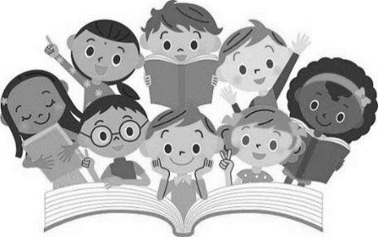

IDEA Part B Cov Kev Pab Cuam Me Me:
Koj Cov Cai thiab Lub Luag Haujlwm Ua Niam Txiv lossis
Tus Saib Xyuas
Raws li ib tug niam txiv lossis tus neeg saib xyuas ntawm tus menyuam muaj kev tsis taus, koj muaj cai tshwj xeeb raws li Txoj Cai Kev Kawm Rau Ib Tus Neeg Nrog Kev Xiam Oob Qhab (IDEA 2004) hais txog kev nyab xeeb thiab kev pabcuam rau koj tus menyuam.Koj kuj tseem txaus siab rau ntau qhov kev tiv thaiv tib yam raws li Kev Pabcuam Me Nyuam Me Me (IDEA-Part C), uas yog hais, ntau ntawm lawv.Lub rooj sib tham hloov pauv yuav raug teem rau cov tsev neeg uas tau txais kev pabcuam los ntawm Infant Toddler Qhov kev pab cuam tsis pub dhau 90 hnub ua ntej tus menyuam hnub yug thib peb.
Koj cov cai raws li Part B ntawm IDEA yog, luv luv:
Kev ntsuam xyuas
Koj tus menyuam tuaj yeem raug soj ntsuam dawb yog tias koj xav tias nws muaj kev tsis taus thiab xav paub seb koj puas tsim nyog tau txais kev pabcuam.
Daim Ntawv Pom Zoo Hauv Kev Sau Ntawv
Ua ntej koj tus menyuam tuaj yeem raug soj ntsuam thiab / lossis pib tau txais kev pabcuam kev kawm tshwj xeeb, koj yuav tsum tau sau ntawv tso cai.
Daim Ntawv Ceeb Toom hauv Kev Sau Ntawv
Txhua qhov kev txiav txim siab uas tuaj yeem cuam tshuam koj tus menyuam txoj kev kawm lossis IEP yuav tsum tau sau ntawv rau koj ua ntej.
COV NTAUB NTAWV TSIS TXAUS SIAB
PSU yuav tiv thaiv koj tus menyuam txoj kev ceev ntiag tug thiab ua rau nws cov ntaub ntawv khaws tseg rau koj thaum thov.Family Educational Rights and Privacy Act (FERPA) ntawm 1974 tswj kev khaws cia thiab nthuav tawm cov ntaub ntawv no.
Kev Txiav Txim Siab
PSU lub hom phiaj yog muab kev saib xyuas rau koj tus menyuam uas lawv xav tau thiab daws txhua qhov kev tsis sib haum xeeb ntawm qhov chaw.Txawm li cas los xij, koj tuaj yeem nrhiav cov ntaub ntawv tiv tauj rau koj tus PSU Tus Thawj Coj ntawm Cov Menyuam Tshwj Xeeb ntawm https://www.dpi.nc.gov/districts-schools/classroom-resources/exceptional-children#LEAECDirectors-3207 yog tias koj muaj kev txhawj xeeb txog koj tus menyuam qhov kev txheeb xyuas, kev ntsuam xyuas, lossis kev kho mob.*Niam txiv lossis tus neeg saib xyuas yuav muab ib daim qauv ntawm Niam Txiv Txoj Cai thiab Lub Luag Haujlwm hauv Kev Kawm Tshwj Xeeb, uas qhia meej txog kev tiv thaiv koj muaj cai raws li txoj cai lij choj hais txog koj tus menyuam txoj kev kawm.

Qhov Kev Pabcuam Preschool mus rau Infant-Toddler Qhov kev pab cuam: Cov kauj ruam rau kev hloov ntawm qhov Kev Pabcuam Menyuam mos-Me nyuam mos
Koj tus menyuam cov kev pabcuam thaum ntxov thiab kev txhawb nqa yuav tsum tsis txhob cuam tshuam vim tias tsis muaj kev sib tham thaum muaj hnub nyoog ob thiab peb xyoos.
Kauj ruam 1
Ua Kev Npaj rau Kev Hloov
Koj thiab koj tus menyuam Tus Thawj Saib Xyuas Kev Pabcuam Thaum Ntxov (EISC) yuav pib npaj txoj kev hloov pauv thaum koj tus menyuam muaj ob xyoos.
PSU tau ceeb toom thiab xa mus
Kev tsim nyog rau Preschool Program tuaj yeem txiav txim siab ntxov li cuaj lub hlis ua ntej tus menyuam hnub yug thib peb, yog tias Qhov Kev Pabcuam Menyuam Yaus-Me Nyuam Yaus ceeb toom rau PSU rau Kev Kawm Tshwj Xeeb thiab Cov Kev Pabcuam Hauv Kev Pabcuam Preschool.PSU yuav xa ib daim qauv ntawm Cov Niam Txiv Txoj Cai thiab Lub Luag Haujlwm tam sim no rau hauv cov ntaub ntawv Kev Kawm Tshwj Xeeb sai li sai tau thaum lawv tau txais koj daim ntawv ceeb toom.Yog tias koj muaj menyuam yaus peb xyoos lossis laus dua thiab koj xav tias nws yuav muaj kev tsis taus, koj tuaj yeem coj lawv mus rau PSU tam sim ntawd.
Tsis yog ua kom tus menyuam paub txog Lub Tsev Kawm Ntawv Hauv Tsev Kawm Ntawv, ib qho kev xa mus yuav tsum tau sau ntawv tso cai los ntawm niam txiv.PSU yuav muab ib daim ntawv luam ntawm Niam Txiv Txoj Cai thiab Lub Luag Haujlwm tam sim no rau hauv cov ntaub ntawv Kev Kawm Tshwj Xeeb sai li sai tau thaum lawv tau txais cov lus pom zoo.
Txhawm rau tiv tauj ib tus neeg los ntawm PSU Preschool Qhov kev pab cuam, mus saib: https://www.dpi.nc.gov/districts-schools/classroom-resources/exceptional-children#LEAECDirectors-3207.
Kuv PSU yog ________________________.
Kauj ruam 2
Lub rooj sib tham los sib tham txog cov phiaj xwm rau yav tom ntej
Lub rooj sib tham txog kev hloov pauv yuav muaj nrog koj, koj li EISC, cov chaw muab kev pabcuam tam sim no, thiab lwm tus uas yuav ua haujlwm nrog koj tus menyuam thiab tsev neeg tomqab lawv muaj peb xyoos txog cuaj lub hlis ua ntej lawv hnub yug thib peb txog peb lub hlis (90 hnub) ua ntej lawv lub hnub yug thib peb.
Part B Preschool Qhov kev pab cuam cov neeg koom nrog uas nws cov menyuam tuaj yeem tsim nyog rau Kev Kawm Tshwj Xeeb thiab cov kev pabcuam cuam tshuam yuav muaj tus neeg sawv cev PSU caw tuaj koom lub rooj sib tham.
Koj thiab koj tus menyuam pab neeg yuav tham txog ntau yam kev xaiv uas muaj rau koj thiab koj tus menyuam thaum nws muaj hnub nyoog peb xyoos, suav nrog Txoj Haujlwm B Preschool (saib nplooj 11, "Yuav Ua Li Cas Xaiv Koj Yuav Tsum Xav?"), thiab tshuaj xyuas IFSP cov txiaj ntsig, xws li kev npaj hloov pauv, rau koj tus menyuam.Thaum tus menyuam muaj hnub nyoog peb xyoos, lawv niam lawv txiv yuav raug thov kev tso cai kom lawv soj ntsuam lossis soj ntsuam los ntawm tsev kawm ntawv lossis lwm tus neeg ua haujlwm hauv lub koomhaum txhawm rau txiav txim siab tias lawv tsim nyog rau ntau yam kev pabcuam thiab cov kev pabcuam cuam tshuam.

Kauj ruam 3
Kev Ntsuam Xyuas Kev Tsis Muaj Peev Xwm Ua Tau
Koj tus menyuam yuav tau txais kev soj ntsuam ntau yam kev qhuab qhia tshwj xeeb hauv nws thawj hom lus ua ntej PSU tuaj yeem tsim kev tsim nyog.Qhov kev ntsuam xyuas dav no tuaj yeem pab txiav txim siab seb koj tus menyuam puas muaj teeb meem kev kawm.Rau pab pawg IEP los txiav txim siab zoo raws li cov ntaub ntawv ntsuas uas twb muaj lawm, cov ntaub ntawv ntawd yuav tsum yog ob qho tib si tshiab thiab siv tau.Yog tias koj muaj lus qhia txog koj tus menyuam txoj kev noj qab haus huv, tsev kawm ntawv, lossis kev ua neej nyob, thov qhia rau lawv.Yog tias koj tsis muaj daim ntawv theej ntawm cov ntawv tsim nyog ntawm tes, PSU tuaj yeem hais kom koj kos npe tso cai tso tawm cov ntaub ntawv.Ua ntej peb lub rooj sib tham, kuv yuav txaus siab rau nws yog tias koj tuaj yeem xa cov ntaub ntawv tseem ceeb.
Ib pawg kws tshaj lij hauv lawv txoj haujlwm yuav ua ib qho kev xeem uas lawv pom tias tsim nyog rau koj tus menyuam.
Txhawm rau txiav txim siab koj tus menyuam qhov kev tsim nyog thiab kev pabcuam, peb yuav tsum sau cov ntaub ntawv siv ntau yam kev ntsuas sib txawv, cov tswv yim, thiab cov txheej txheem.
Koj yuav tau txais ib tsab ntawv ceeb toom tom qab kev ntsuam xyuas tiav.Cov kev ntsuam xyuas kev tshawb pom thiab cov lus qhia yuav qhia meej hauv daim ntawv qhia uas koj tuaj yeem nkag siab yooj yim.
Kauj ruam 4
Kev txiav txim siab ntawm Kev Tsim Nyog rau Ntu B
Yog tias koj tus menyuam ua tau raws li cov txheej txheem rau Kev Kawm Tshwj Xeeb thiab Cov Kev Pabcuam ntsig txog hauv Preschool Qhov kev pab cuam, IEP Team lub rooj sib tham yuav raug teeb tsa tom qab kev ntsuam xyuas tiav.Pab neeg IEP, uas koj yog ib feem, yuav hu koj los teem sijhawm lub rooj sib tham.
Koj tus menyuam yuav tau txais Kev Pabcuam Kev Kawm Rau Tus Kheej (IEP) thiab kev txiav txim siab qhov chaw kawm raws li lawv qhov kev tsim nyog rau Kev Kawm Tshwj Xeeb thiab Cov Kev Pabcuam Hauv Kev Kawm Preschool.Txawm li cas los xij, yog tias koj tus menyuam muaj peb xyoos dhau lub caij ntuj sov lossis lwm lub sijhawm thaum lub tsev kawm ntawv tsis nyob hauv kev sib tham, cov kev pabcuam yuav tsis pib mus txog rau xyoo kawm ntawv tom ntej.
Pab neeg IEP tuaj yeem pom zoo rau lwm qhov chaw pabcuam yog tias koj tus menyuam tsis raug txiav txim siab tsim nyog rau Kev Kawm Tshwj Xeeb thiab Cov Kev Pabcuam Muaj Feem Xyuam hauv Preschool Program.
Nyob rau lub rooj sib tham IEP no, Leej twg yuav tuaj?
Koj qhov kev muaj nyob ntawm lub rooj sib tham IEP yuav tsum yog vim koj yog ib tug tswv cuab tseem ceeb ntawm pab pawg IEP.Muaj cov neeg yuav tsum tau koom, tab sis lwm tus neeg muab kev pabcuam raug txais tos tuaj koom thiab.
Cov neeg koom xav tau ntawm pab pawg IEP:
    - ib tug neeg los ntawm PSU nrog txoj cai los tswj lossis saib xyuas kev kawm tshwj xeeb thiab cog lus nyiaj txiag; tus neeg no tuaj yeem yog tus saib xyuas menyuam kawm ntawv preschool, lub hauv paus ntsiab lus, lossis lwm tus neeg sawv cev;
    - ib tug kws tshwj xeeb hauv kev kawm thaum yau, tus kws tshaj lij hauv kev kawm tshwj xeeb, thiab tus kws qhia ntawv thaum yau;
    - tus kws tshaj lij uas tuaj yeem pab cov tub ntxhais kawm txog cov kev xav tau tshwj xeeb; thiab
    - ib tug neeg uas paub txog kev soj ntsuam kev tshawb pom (tej zaum yog tus kws qhia ntawv tshwj xeeb lossis tus thawj coj).
Lwm tus tuaj yeem koom tau:
    - Rau cov menyuam yaus uas tsis pom kev lossis hnov ​​lus tsis zoo, ib tus neeg sawv cev ntawm Lub Chaw Haujlwm Saib Xyuas Kev Kawm yuav raug caw tuaj koom, nrog rau cov tswvcuab ntawm EISC lossis lub chaw haujlwm pom zoo, tus menyuam tus kws qhia ntawv, thiab tus kws pabcuam tam sim no.
    - Lub tsev kawm ntawv muaj txoj cai txuas ntxiv kev caw mus rau lwm tus neeg muaj feem cuam tshuam nws pom tau tias muaj feem cuam tshuam.Ib tug neeg uas tam sim no pab koj tus menyuam tuaj yeem poob rau hauv pawg no.Koj muaj cai paub leej twg ntawm lub tsev kawm ntawv tau raug caw tuaj koom lub rooj sib tham.
    - Raws li niam txiv, koj muaj kev xaiv caw lwm tus, xws li tus me nyuam tus kws kho mob, ib tug phooj ywg uas muaj siab hlub, los yog lwm tus neeg hauv tsev neeg.
Cov txheej txheem rau kev sib tham
- Yog tias koj tseem tsis tau ua li ntawd, txiav txim siab txog koj tus menyuam qhov kev tsim nyog tau txais Kev Pabcuam Preschool Txoj Kev Kawm Tshwj Xeeb thiab Kev Pabcuam (IEP yuav tsum tau sau ua ntej 30 hnub tom qab koj tus menyuam tau txais kev pabcuam tshwjxeeb thiab lwm yam kev pabcuam).
- Npaj koj tus menyuam qhov Kev Pabcuam Kev Kawm Ib Tus Kheej (IEP), uas yuav suav nrog kev txiav txim siab tso npe kawm, kom siv tau rau lawv lub hnub yug thib peb.
Sau daim IEP
Koj tus menyuam cov hom phiaj yuav raug tham thiab tsim los ntawm pab pawg IEP.Raws li tus neeg xav tau kev pab ntawm tus menyuam, pab pawg no yuav txiav txim siab seb hom kev kawm tshwj xeeb thiab cov kev pabcuam cuam tshuam dab tsi.
Tag nrho cov hauv qab no yuav tsum muaj nyob rau hauv Ib Txoj Kev Kawm Rau Tus Kheej IEP:
- koj tus menyuam qhov kev ua tau zoo tam sim no, suav nrog nws qhov muaj zog thiab qhov tsis muaj zog;
- lub hom phiaj txhua xyoo kom tshem tawm cov sijhawm tos;
- ntau npaum li cas, ntev npaum li cas, thiab qhov twg muaj kev kawm tshwj xeeb thiab cov kev pab cuam cuam tshuam (xws li teev, feeb, thiab hnub);
- ntau npaum li cas koj tus menyuam yuav raug suav nrog hauv cov chav kawm preschool ib txwm ntawm cov menyuam yaus uas tsis muaj kev xav tau tshwj xeeb;
- txhua yam uas koj tus menyuam xav tau hauv txoj kev pabcuam pabcuam, kev pabcuam, kev hloov kho, thiab / lossis kev pabcuam;
- sijhawm sijhawm ntawm cov kev pabcuam yuav muaj;
- koj tus menyuam txoj kev vam meej yuav raug saib xyuas li cas thiab ntau npaum li cas koj yuav raug hloov kho ntawm nws txoj kev vam meej mus rau lub hom phiaj txhua xyoo; thiab
- cov ntaub ntawv kev tuaj koom rau Pab Pawg Kev Kawm Rau Tus Kheej (IEP).
Ua ntej ntawm Lub Rooj Sab Laj
Cov niam txiv yuav tau txais txiaj ntsig zoo los nug cov ntawv luam ntawm tag nrho cov ntaub ntawv ntsuam xyuas ntxiv rau thawj IEP.Khaws ib phau ntawv uas muaj cov ntaub ntawv tseem ceeb yog ib qho kev coj ua ntawm cov niam txiv.Koj tus menyuam, koj, thiab cov neeg ua haujlwm hauv tsev kawm ntawv yuav tau txais txiaj ntsig los ntawm cov ntaub ntawv uas koj xaiv rau hauv phau ntawv no rau lub rooj sib tham IEP.Cov khoom uas tej zaum yuav muaj nyob rau hauv xws li phau ntawv sau muaj xws li:
- cov ntaub ntawv ntawm kev kho mob tau txais, tshwj xeeb (tshaj yog hais) txog kev txhaj tshuaj;
- cov duab, daim ntawv yug me nyuam, daim npav Medicaid, thiab lwm yam ntaub ntawv tsim nyog; thiab
- Cov ntaub ntawv txheeb xyuas qhov Kev Pab Cuam Me Me Me Me thiab Me Nyuam Yaus Cov Kev Pabcuam Tib Neeg (IFSP) tam sim no.
Xav ua kom tiav cov hauv qab no ua ntej lub rooj sib tham IEP ntxiv rau kev khaws ib phau ntawv rau koj tus menyuam cov ntaub ntawv:
- Xav txog seb koj txoj cai li cas ntawm niam txiv lossis tus saib xyuas yog hais txog koj tus menyuam txoj kev kawm.
- Sau koj cov kev xav txog koj tus menyuam cov ntsiab lus zoo thiab lawv qhov tsis muaj zog.
- Tsim ib daim ntawv teev cov kev txawj thiab kev txawj ntse uas yuav pab tau rau koj tus menyuam tam sim no thiab yav tom ntej.
Lub rooj sib tham ntawm IEP
Nws yog ib qho tseem ceeb uas koj koom rau hauv txoj kev IEP uas yog niam txiv lossis tus saib xyuas.Koj tuaj yeem pab tib neeg nrog kev paub thiab kev pom koj muaj.Thov ua li ntawd ntawm lub rooj sib tham IEP:
- Muab koj cov tswv yim rau koj tus menyuam qhov Kev Pabcuam Kev Kawm Rau Tus Kheej (IEP).
- Yog tias muaj dab tsi hais txog lub rooj sib tham lossis IEP uas koj tsis nkag siab, nco ntsoov nug cov lus nug.
- Koj tus menyuam txoj kev kawm tshwj xeeb thiab cov kev pabcuam cuam tshuam yuav tsum tau tham kom meej ua ntej koj txiav txim siab txog qhov chaw rau koj tus menyuam.
Tom qab lub rooj sib tham IEP
Thaum lub rooj sib tham IEP tiav lawm, koj yuav tau txais ib daim qauv ntawm koj tus menyuam txoj kev npaj IEP. Qhov Kev Pabcuam Kev Kawm Ib Tus Kheej (IEP) rau koj tus menyuam yuav yog ib qho chaw muaj txiaj ntsig rau kev saib xyuas thiab txhawb nqa koj tus menyuam txoj kev loj hlob hauv tsev.
Nws yog ib qho tseem ceeb uas koj yuav tsum sib txuas lus nrog tsev kawm ntawv tom qab lub rooj sib tham IEP xaus.Nov yog qee cov tswv yim los txhim kho koj txoj kev sib raug zoo nrog koj tus menyuam tus kws qhia ntawv:
- Nug txog cov niam txiv kev koom tes hauv koj tus menyuam lub tsev kawm ntawv.
- Tswj kev sib txuas lus zoo ib yam nrog tus kws qhia ntawv ntawm koj tus menyuam.
- Thov koj xav tiv tauj rau lub koom haum nrog txhua yam lus nug.
Xa mus rau ntu "Cov Txheej Txheem Kev Nyab Xeeb" ntawm Niam Txiv Txoj Cai thiab Lub Luag Haujlwm hauv Kev Kawm Tshwj Xeeb yog tias koj thiab PSU tuaj yeem tsis tuaj yeem pom zoo txog koj tus menyuam cov kev xav tau kev kawm.
Nkag mus rau Preschool
Cov lus piav qhia ntxaws txog koj tus menyuam qhov chaw kawm tshwj xeeb thiab cov kev pabcuam cuam tshuam yuav muab rau koj.
Daim ntawv "Kev Pom Zoo rau Kev Pabcuam" yuav tsum tau kos npe ua ntej PSU tuaj yeem muab kev kawm tshwj xeeb rau koj tus menyuam lossis cov kev pabcuam cuam tshuam.
Tshwj tsis yog tias koj tus menyuam lub hnub yug thib peb poob rau ib hnub uas tsis muaj tsev kawm ntawv, PSU yuav pib muab kev kawm tshwj xeeb thiab cov kev pabcuam cuam tshuam rau koj tus menyuam uas tsim nyog rau lawv.Yog tias koj tus menyuam lub hnub yug poob rau lub caij ntuj sov, nws yuav tsis tsim nyog tau txais kev pabcuam txog thaum pib xyoo kawm ntawv tom ntej.
Yog tias koj tus menyuam tsis tsim nyog tau txais kev kawm tshwj xeeb thiab cov kev pabcuam cuam tshuam los ntawm PSU preschool program, koj puas muaj lwm txoj kev xaiv?
Koj Tus Thawj Saib Xyuas Kev Pabcuam Thaum Ntxov (EISC) los ntawm Qhov Kev Pabcuam Menyuam Yaus-Me Nyuam Yaus yuav txuas koj nrog cov kev pabcuam hauv zej zog uas yuav zoo dua rau koj tsev neeg cov kev xav tau tomqab koj tus menyuam muaj peb xyoos ua ib feem ntawm txoj kev npaj hloov pauv.Cov kev xaiv tuaj yeem suav nrog qee yam hauv qab no:
- Lub taub hau pib
- Community preschools thiab chaw zov me nyuam
- Cov kev pab cuam ua si hauv zej zog
- Chav nyeem zaj dab neeg teev
- Niam cov kev pab cuam thaum sawv ntxov
- Koom tes ua si pawg
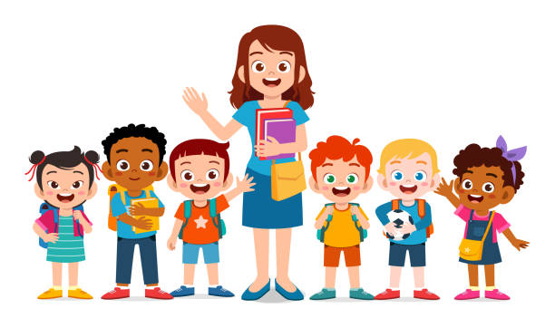
- Care Management for At-Risk Children (CMARC) qhov kev pab cuam (Lub Tsev Haujlwm Saib Xyuas Kev Noj Qab Haus Huv)
Cov lus qhia ua kom qhov hloov tau yooj yim dua
Yuav kom ua tiav qhov kev hloov pauv, koj yuav tsum tau sib txuas lus nrog thiab koom tes nrog lwm tus hauv koj qhov chaw tam sim ntawd.Cov tsev neeg ua qhov kev txav mus los hauv North Carolina tau pom cov kev tawm dag zog hauv qab no thiab cov lus qhia muaj txiaj ntsig:
    - Pib lub taub hau thiab nco ntsoov nug ntau cov lus nug.Kev hloov pauv yog ib yam uas yuav tsum pib sai li sai tau.Sau koj tus menyuam txoj kev loj hlob, kev nyiam ua, thiab kev ua tiav hauv phau ntawv teev npe yooj yim, xws li digital lossis sau ntawv.Cov ntawv txheeb xyuas yav dhau los thiab cov ntaub ntawv kho mob yuav tsum suav tias yog qhov tseem ceeb.Thaum lub sijhawm hloov pauv no, koj tus menyuam tus kws pabcuam tuaj yeem tau txais cov ntaub ntawv lawv xav tau los ntawm phau ntawv no.Koj yuav tsum siv thawj ob peb xyoos kom paub koj tus kheej nrog cov peev txheej hauv zos.
    - Nws yog ib lub tswv yim zoo los mus xyuas cov tsev kawm ntawv uas koj tus menyuam yuav tuaj koom ua ntej thiab tom qab tso npe rau lawv.
    - Xyuas kom lub tsev kawm ntawv koj tus menyuam tuaj koom muaj cov chaw siv tau, xws li cov chav kawm nkag tau thiab chav dej.Npaj los tham txog koj tus menyuam qhov kev nyiam, kev tsis nyiam, kev nyiam ntawm kev sib txuas lus, thiab txhua lub tswv yim uas tau ua pov thawj tiav hauv koj tsev neeg.
    - Koom tes nrog koj tus menyuam tus kws qhia ntawv tshiab los tsim kom muaj kev hloov pauv mus rau tsev kawm ntawv, uas tej zaum yuav muaj xws li tsim cov txheej txheem thaum sawv ntxov lossis koom nrog lwm yam dej num.
    - Xyuas kom koj tus menyuam tus kws qhia paub yuav tiv tauj koj li cas yog lawv muaj lus nug.
    - Nws yog ib qho tseem ceeb kom muaj kev sib txuas lus qhib ntawm koj tus menyuam tus kws kho mob thiab cov neeg ua haujlwm hauv tsev kawm ntawv.
    - Txiav txim siab txog koj qhov kev koom tes (qhib tsev mus ntsib, teem sijhawm soj ntsuam, thiab lwm yam) hauv Preschool Qhov kev pab cuam qhov muab rau cov tsev neeg tshiab.
    - Koj yuav tsum paub ntau npaum li cas ntawm koj tus menyuam lub tsev kawm ntawv cov neeg ua haujlwm ntau npaum li qhov ua tau (xws li tus thawj xibfwb, xibfwb, tus tsav tsheb npav, thiab tus saib xyuas).
    - Npaj rau qee lub sijhawm thaum xyoo koj thiab koj tus menyuam tus kws qhia ntawv tshiab tuaj yeem ntsib thiab tham.Ua ib lub tswv yim rau txoj kev sib cuag li niaj zaus, xws li phau ntawv qhia sib tham, sib tham hauv xov tooj, lossis xa ntawv hluav taws xob.
    - Nug txog cov kev pab cuam rau tsev neeg hauv zos (xws li niam txiv-rau-niam txiv pab pawg, Family Resource Center, cov chaw saib xyuas kev noj qab haus huv, thiab Cooperative Extension Services) kom paub ntau ntxiv txog seb koj tuaj yeem txuas nrog lwm tsev neeg hauv koj cheeb tsam li cas.
    - Nug seb puas muaj kev thauj mus los.
    - Sib cuag nrog lwm cov niam txiv uas lawv cov menyuam twb tau mus kawm rau hauv qhov kev pab cuam preschool.
    - Family Support Network (FSN) tuaj yeem hu rau ntawm (800) 852-0042, thiab Exceptional Children's Assistance Center (ECAC) tuaj yeem hu rau ntawm (800) 962-6817 yog tias tsis muaj pab pawg txhawb nqa hauv zos.
    - Koom nrog Parent Teacher Association (PTA) lossis Parent Teacher Organization (PTO) sib sau ua ke.
Hloov los ntawm Cov Me Nyuam, Cov Hluas, thiab Cov Txheej Txheem Hloov Tsev Kawm NtawvDaim ntawv xaj thawj zaug,
Kentucky Transition Txoj haujlwm rau Cov Me Nyuam Yaus
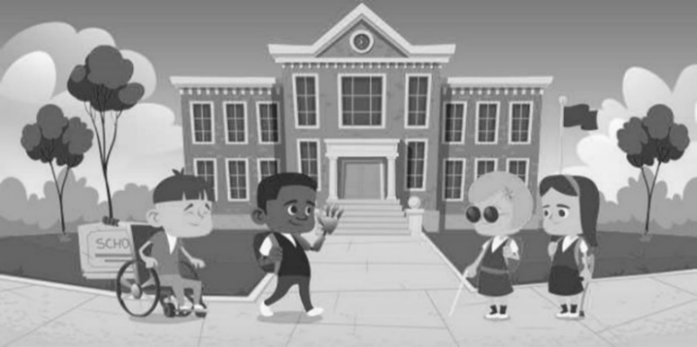
Daim ntawv teev kev hloov pauv
Siv daim ntawv txheeb xyuas no los tswj cov tab ntawm qhov kev vam meej koj tau ua.
1. Kuv tus PSU tau raug ceeb toom txog kuv tus menyuam qhov kev tsim nyog tau txais (thaum lub hnub nyoog thoob ntiaj teb ob xyoos thiab peb lub hlis).
2. Daim phiaj xwm Hloov pauv thiab ncua sij hawm ntawm cov xwm txheej tau raug tsim los tom qab Lub Rooj Sib Tham Hloov Pauv Hloov Pauv.
3. Kuv tus menyuam tau raug pom zoo rau Preschool Part B Qhov kev pab cuam, thiab kuv pom zoo rau qhov no.
4. Kuv tus menyuam tau dhau los ntawm tag nrho cov kev kuaj mob uas tsim nyog thiab kev ntsuam xyuas.
5. Kuv tus menyuam ua tau raws li cov txheej txheem rau kev kawm tshwj xeeb, thiab peb yuav tau txais lawv.
6. Kuv tau pab sau cov ntawv luam ntawm cov ntaub ntawv hauv qab no rau kuv PSU:
- Daim ntawv pov thawj hnub yug
- Pov thawj ntawm qhov chaw nyob
- Kev kuaj lub cev
- Cov ntaub ntawv txhaj tshuaj tiv thaiv
- Medicaid card (yog muaj)
- Kev tiv tauj thaum muaj xwm ceev (cov neeg hauv tsev neeg, kws kho mob, cov lus qhia tshwj xeeb thaum muaj xwm ceev)
- Cov ntaub ntawv teev tseg txog Kev Pab Cuam Me Me-Me Nyuam Yaus
- Lwm cov ntaub ntawv teev npe kawm preschool
- Tsev kho mob, tsev kho mob, lossis cov ntaub ntawv kho mob (yog tias tsim nyog)
    - Kuv tus menyuam Tus Thawj Saib Xyuas Kev Pabcuam Thaum Ntxov thiab/lossis pab pawg IFSP/IEP tau hais txog peb cov kev xaiv yog tias kuv tus menyuam tsis pom tias tsim nyog tau txais kev pabcuam tshwjxeeb los ntawm kuv tus PSU.
    - Kuv tau tshawb fawb txog cov kev xaiv kawm preschool uas muaj los ntawm kuv lub PSU thiab lwm cov kev pabcuam hauv zej zog kom pom tias kuv tus menyuam puas tsim nyog rau lawv.
    - Kuv tau tham txog tej kev hloov pauv hauv kuv tus menyuam cov chaw zov me nyuam thaum nws mus txog hnub nyoog peb xyoos.
    - Kuv tus menyuam qhov Kev Pabcuam Kev Kawm Rau Tus Kheej (IEP) tau tshwm sim, thiab cov hom phiaj txhua xyoo tau tsim
(tej zaum yuav ua tiav 30 hnub ua ntej hnub nyoog 3 xyoos).
    - Kuv tus menyuam qhov kev tso kawm tau raug txiav txim siab raws li Txoj Haujlwm Kev Kawm Rau Tus Kheej (IEP).
    - Cov txheej txheem ntawm kev xa khoom tau tsim muaj yog tias xav tau.
    - Kuv twb tau tham nrog kuv tus menyuam cov kws kho mob tshiab thiab cov kws qhia ntawv.

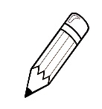
Qhia Txog Kuv Tus Me Nyuam
Tus Menyuam Lub Npe:_____________________________ Hnub tim:___________________
(Siv qhov no los ua ib qho cuab yeej los pab koj npaj koj cov kev xav ntawm koj tus menyuam qhov kev txaus siab, kev txhawj xeeb, thiab kev daws teeb meem ua ntej koj mus rau lub rooj sib tham hloov pauv.Nqa nrog koj mus rau lub rooj sib tham.)

Tej yam uas ua rau kuv tus menyuam tshwj xeeb: | Qhov kuv tus me nyuam ua tau zoo yog cov hauv qab no: | Kuv tus me nyuam yeej hlub cov no:
Qhov kuv txhawj xeeb tshaj plaws tam sim no yog: | Kuv vam tias yuav pab txhawb rau kuv tus menyuam txoj haujlwm los ntawm kev ua cov hauv qab no: | Kuv tus menyuam yaus tau txais kev kawm ntau dua thaum:
Kuv ntseeg tias kuv tus menyuam tuaj yeem tau txais txiaj ntsig los ntawm cov haujlwm no vim tias: | Peb kuj tuaj yeem xav tau qee qhov kev pab nrog: | Yav tom ntej, kuv vam tias kuv tus menyuam yuav ua tej yam no:

Hloov los ntawm Cov Me Nyuam, Cov Hluas, thiab Cov Txheej Txheem Hloov Tsev Kawm NtawvDaim ntawv xaj thawj zaug
Kentucky Transition Txoj haujlwm rau Cov Me Nyuam Yaus

Koj Cov Kev Pabcuam Zej Zog
Thov siv qhov chaw no los tshaj tawm cov peev txheej hauv zos.

Lub npe chaw ua haujlwm thiab chaw nyob |  | Xov tooj |  | Tus neeg tiv tauj

Cov ntawv luv luv & Cov ntawv luv luv siv los ntawm koj cov peev txheej hauv zej zog
ADA | Cov neeg Amelikas uas xiam oob qhab ua haujlwm |  | ECAC | Exceptional Children's Assistance Center (ECAC)
ADD | Kev saib xyuas tsis txaus ntseeg |  | ECATS | Txhua tus menyuam lub luag haujlwm & kev taug qab qhov system
ADHD | Mob siab rau hyperactivity tsis meej |  | ECE | Kev kawm thaum yau
AIDS | Tau txais kev tiv thaiv kab mob tsis txaus ntseeg |  | ECSE | Kev kawm tshwj xeeb thaum yau
Arc | Lub Arc  (yav tas los koom nrog rau cov pej xeem rov qab) |  | ECTA | Kev pab rau menyuam yaus thaum yau
ASHA | Lub koom haum American hais lus hnov lus |  | EHS | Lub taub hau pib thaum ntxov
ASL | Lus Asmesliskas |  | EI | Kev cuam tshuam thaum ntxov
AT | Kev pabcuam technology |  | ED | Kev xav tsis taus
AU | Autism |  | EISC | Tus neeg saib xyuas kev pab cuam thaum ntxov
BIA | Chaw ua haujlwm ntawm Indian kev ua haujlwm |  | ESY | Lub xyoo kawm ntawv txuas ntxiv
CA | Lub hnub nyoog chronological |  | FAPE | Pub dawb, kawm ntawv qib siab zoo rau txhua tus
CEC | Council rau tshwj xeeb cov me nyuam |  | FERPA | Tsev neeg txoj cai kev kawm thiab kev ceev ntiag tug
CDSA | Txoj Cai Tswjfwm rau Cov Menyuam Tsis Taus |  | FSN | Kev txhawb pab tsev neeg network
CNS | Central lub paj hlwb |  | HI | Kev tsis hnov lus suav nrog kev lag ntseg
CP | Lub paj hlwb |  | HS | Lub taub hau pib
CMARC | Kev saib xyuas rau cov me nyuam muaj kev pheej hmoo |  | ICC | Kev sib koom tes sib koom tes pawg sab laj
COSF | Daim ntawv qhia txog menyuam cov txiaj ntsig |  | I/DD | Kev txawj ntse/kev loj hlob tsis taus (mob me, nruab nrab, lossis hnyav)
CSHS | Cov kev pabcuam tshwj xeeb rau menyuam yaus |  | IDEA | Cov tib neeg muaj kev xiam oob khab kev kawm txoj cai
DA | Kev loj hlob muaj hnub nyoog |  | IEP | Kev kawm ntawv tus kheej
DAP | Kev tsim kho kom tsim nyog |  | IFSP | Txoj kev npaj pab tsev neeg tus kheej
dB | decibel |  | LEA | Lag ntseg / dig muag
D/B | Lag ntseg / dig muag |  | LICC | Hauv zos Kev sib koom tes sib koom tes pawg sab laj
DCFW | Department of Family thiab Child Services |  | LRE | Tsawg kawg ib puag ncig
DD | Kev loj hlob tsis taus lossis kev loj hlob qeeb |  | MA | Lub hnub nyoog puas hlwb
DDC | Kev loj hlob hnub center |  | MD | Kev Tsis Muaj Peev Xwm Loj
DHHS | Department of Health thiab Human Services |  | MDE | Kev ntsuam xyuas ntau yam
DPI | Department ntawm kev qhia rau pej xeem |  | MTSS | Multi-tier system ntawm kev them nyiaj yug
EC | Cov menyuam yaus tshwj xeeb |  | NAEYC | National koom haum rau kev kawm ntawv ntawm cov me nyuam yaus

NC ICC | North Carolina kev sib tham tswj pawg tswj hwm |  | SC | Kev pabcuam kev pabcuam  lossis kev pabcuam pabcuam
NC  Pre-K | North Carolina Pre-Kindergarten |  | SDI | Kev qhia tshwj xeeb tsim
NICU | Neonatal intensive kev kho mob |  | SEA | Lub koom haum qhia ntawv hauv xeev
OCR | Chaw ua haujlwm ntawm pej xeem cov cai |  | Tshooj 504 | Ib feem ntawm Txoj Cai Kho Kom Zoo Dua Tshiab Xyoo 1973, raws li tau hloov kho
OI | Orthopedic kev puas tsuaj |  | Tshooj 619 | IDEA sub feem cuam tshuam tshwj xeeb nrog kev kawm preschool.
OT | Cov Kev Qhia Txog Kev Ua Haujlwm thiab Kev Kho Mob |  | SEE | Kos npe rau Lus Askiv
Tshooj B | Cov kev pabcuam kev kawm rau cov menyuam yaus uas muaj hnub nyoog peb xyoos txog nees nkaum-ib xyoos yog tswj hwm los ntawm ntu no ntawm IDEA |  | SI | Kev hais lus lossis lus tsis zoo
Tshooj C | Txoj Cai Tswjfwm Saib Xyuas Kev Xiam Oob Qhab (IDEA) tswj kev pabcuam tshwj xeeb rau cov menyuam mos thiab menyuam yaus txog li 36 lub hlis |  | S/L | Hais lus thiab lus
PL | Kev cai lij choj pej xeem |  | SLD | Kev tsis taus kev txawj ntse
PL  94-142 | Txoj Cai Kev Kawm Rau Cov Neeg Tsis Muaj Peev Xwm, lossis IDEA |  | SLP | Tus kws kho mob hais lus
PL  99-457 | Lub npe tam sim no rau kev hloov kho rau PL94-142 lub npe hu ua IDEA, uas tau tso cai rau cov kev pab cuam preschool rau cov menyuam hnub nyoog peb txog tsib xyoos thiab tau tso cai rau kev cuam tshuam ntxov rau cov menyuam mos thiab cov menyuam me uas muaj kev puas tsuaj |  | SLT | Kev hais lus thiab kev kho lus  lossis tus kws kho lus hais lus
 |  |  | SSI | Cov nyiaj tau los ruaj ntseg ntxiv
PSSP | Kev Pabcuam Tsev Kawm Ntawv Tus Kheej |  | ST | Kev hais lus kho mob lossis kws kho hais lus
PSU | Lub Tsev Kawm Ntawv Pej Xeem |  | TBI | Qhov muag tsis pom kev
PT | Kev kho lub cev los yog tus kws kho mob lub cev |  | TDD | Xov tooj cua rau cov lag ntseg
PWN | Daim Ntawv Ceeb Toom Ua Ntej |  | TSG | Qhia tswv yim kub
RN | Sau npe tus neeg saib mob |  | VI | Qhov muag tsis pom kev, nrog rau qhov muag tsis pom kev
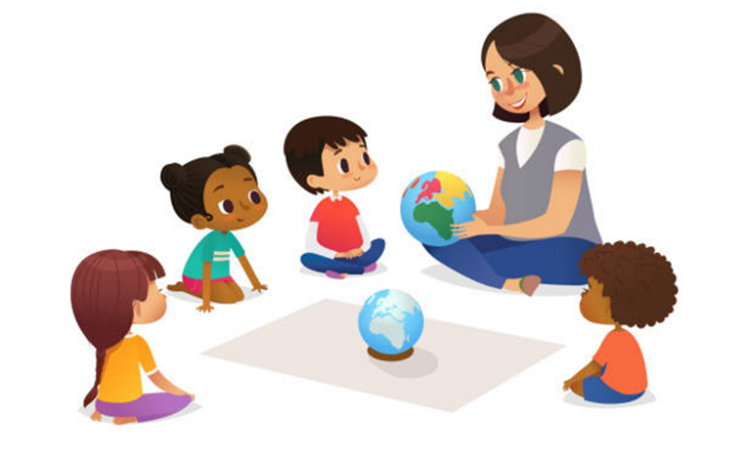

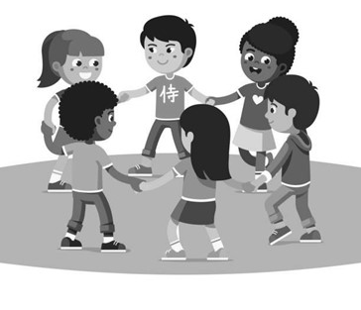
Cov lus txhais ntawm cov lus
Cov kws qhia kev qhia cev nqaij daim tawv uas tseem muaj ntawv pov thawj hauv kev kawm lub cev hloov pauv (CAPE) muab cov tub ntxhais kawm-chav kawm txuas ntxiv ntawm kev npaj tshwj xeeb rau kev kawm lub cev rau APE. Kev txav mus los, kev txawj tsav tsheb, thiab kev ua si lub cev tsis tau qhia meej meej hauv cov menyuam kawm ntawv preschool, tab sis lawv suav nrog hauv Lub Hauv Paus rau Kev Kawm Thaum Ntxov thiab Kev Loj Hlob.Raws li kev kawm lub cev tsis tu ncua tsis raug cai rau txhua tus menyuam kawm ntawv preschools uas tsis muaj kev puas tsuaj, cov kev kawm preschool tsis muaj lub luag haujlwm los muab kev pabcuam APE rau txhua tus menyuam kawm ntawv.Txawm li cas los xij, raws li tau hais hauv tsab ntawv los ntawm (Lub Chaw Haujlwm Saib Xyuas Kev Kawm Tshwj Xeeb thiab Kev Kho Mob [OSERS] mus rau Tymeson (2013), cov tsev kawm ntawv tsis raug tshem tawm ntawm 'ub luag haujlwm los muab kev kawm lub cev rau cov tub ntxhais kawm uas muaj qhov tshwj xeeb xav tau kev kawm lub cev' ua ib feem. ntawm tus menyuam kawm ntawv txoj kev kawm tshwj xeeb thiab cov kev pabcuam cuam tshuam.Pab neeg IEP txiav txim siab seb tus menyuam puas tsim nyog tau txais kev kawm lub cev zoo ib yam li lawv txiav txim siab seb tus menyuam puas xav tau kev qhia tshwj xeeb hauv lwm yam kev kawm.
Kev tawm tswv yim hais txog kev nqis tes ua kom lav tias koj thiab koj tus menyuam tau txais kev pabcuam zoo.Koj tuaj yeem ua rau koj tus menyuam ntau dua li lwm tus ua tau.Koj yog tus kws tshaj lij ntawm koj tus menyuam.
Tus me nyuam qhov kev ua tau zoo thiab / lossis kev loj hlob tuaj yeem raug ntsuas raws li tus kheej.Tus me nyuam qhov profile tshwj xeeb zoo li no tuaj yeem pab nrog kev qhia thiab kev cuam tshuam kev tsim qauv.Cov chav kawm tshwj xeeb thiab cov kev pab txhawb nqa tej zaum yuav los sis tsis raug muab coj los ua raws li qhov kev npaj ua.
Txhua yam khoom, cov khoom siv, lossis cov khoom siv uas siv los ua kom muaj zog, tswj, lossis txhim kho tus menyuam muaj kev xiam oob khab kev ua haujlwm tuaj yeem suav hais tias yog cov cuab yeej siv thev naus laus zis, txawm tias nws tau yuav los ntawm txee, hloov kho, lossis ua raws li kev cai.Ib qho khoom siv kho mob phais lossis nws qhov kev hloov pauv tsis suav nrog hauv cov ntsiab lus no.
Ib tug menyuam yaus uas xiam oob khab tuaj yeem tau txais txiaj ntsig los ntawm kev pabcuam thev naus laus zis yog tias lawv pab tus menyuam xaiv, tau txais, lossis siv cov cuab yeej tsim nyog.Lub ntsiab lus txhais:
(a) Tus txheej txheem ntawm kev txiav txim siab seb yuav ua li cas thiaj ua tau raws li qhov yuav tsum tau muaj ntawm tus menyuam uas muaj kev tsis taus, uas tuaj yeem cuam tshuam nrog kev ntsuas kev ua haujlwm ntawm tus menyuam hauv nws qhov chaw.
(b) Pab cov tsev neeg uas muaj menyuam xiam oob khab los ntawm kev them nyiaj rau kev yuav khoom, xauj tsev, lossis muab cov cuab yeej pabcuam.
(c) Xaiv cov cuab yeej pab tsim nyog thiab tom qab ntawd muab nws haum, hloov kho, siv, tuav, kho, lossis hloov yog tias tsim nyog.
(d) Kev koom ua ke ntawm cov phiaj xwm kev kawm thiab kev kho kom rov zoo uas twb muaj lawm, nrog rau lwm yam kev kho mob, kev cuam tshuam, thiab kev pabcuam, nrog cov cuab yeej siv thev naus laus zis.
(e) Ib tug menyuam yaus uas muaj kev tsis taus, lossis nws tsev neeg, yuav tau txais txiaj ntsig los ntawm kev cob qhia lossis kev txhawb nqa.
(f) Cov kws tshaj lij (xws li cov neeg ua haujlwm hauv kev kawm lossis kev kho mob), cov chaw ua haujlwm, thiab lwm tus uas muaj kev koom tes tseem ceeb hauv tus menyuam lub neej niaj hnub los ntawm kev muab kev pabcuam, kev ua haujlwm, lossis lwm yam kev pabcuam yuav tau txais txiaj ntsig los ntawm kev cob qhia lossis kev pabcuam.(Kev cai: 20-U.S.C 1401(2); 34 CFR 300.6)

Kev xiam oob khab uas tsim nyog rau tus menyuam hnub nyoog nruab nrab ntawm peb thiab nees nkaum ib xyoos rau kev pabcuam kev kawm tshwj xeeb raws li Tshooj B ntawm IDEA
Rau txhua tus menyuam kawm ntawv hauv ITP lossis txiav txim siab tsim nyog rau ITP uas muaj hnub nyoog tsawg kawg yog nees nkaum xya lub hlis, yuav tsum tau xa tsab ntawv ceeb toom rau cov neeg ua haujlwm hauv tsev kawm ntawv lub luag haujlwm rau menyuam nrhiav, suav nrog cov ntaub ntawv txwv suav nrog: tus menyuam lub npe, hnub yug , thiab hnub tso npe rau kev cuam tshuam ntxov, nrog rau koj tsev neeg lub npe, chaw nyob, thiab tus xov tooj.
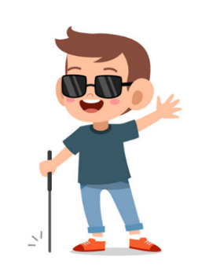
Lub tuam tsev saib xyuas kev noj qab haus huv hauv nroog muaj ib txoj haujlwm hu ua CMARC (Kev Tswj Xyuas Kev Kho Mob rau Cov Menyuam Uas Muaj Teeb Meem) los pab cov tsev neeg uas cov menyuam yaus raug txheeb xyuas tias muaj kev pheej hmoo rau, lossis cov uas tau raug kuaj mob, kev loj hlob tsis taus, teeb meem kev sib raug zoo lossis kev xav, thiab mob ntev.
Kev cob qhia yog ib hom kev kawm rau cov neeg laus uas pab cov niam txiv thiab lwm tus neeg saib xyuas nthuav dav lawv cov kev txawj ntse, kawm cov tswv yim tshiab, thiab tau txais kev nkag siab ntau dua ntawm cov ntsiab lus uas lawv tau ua haujlwm.
Kev txawj ntse yog hais txog kev puas siab puas ntsws uas tshwm sim hauv lub hlwb thaum xav txog.
Kev loj hlob yog hais txog ib tug neeg txoj kev puas siab puas ntsws, lub cev nqaij daim tawv, thiab kev hloov hauv kev sib raug zoo.
Ib tug menyuam yaus muaj txoj cai raws li txoj cai, uas yog hais txog cov kev cai lij choj uas tuaj yeem coj los tiv thaiv nws txoj cai.
Tus Thawj Saib Xyuas Kev Pabcuam Thaum Ntxov (EISC) yog lub luag haujlwm los xyuas kom meej tias txhua tus menyuam mos thiab menyuam yaus uas tau kawm hauv North Carolina Infant-Toddler Program tau txais kev pabcuam thaumntxov thiab tsim nyog.
Txhawm rau txiav txim siab seb tus menyuam puas muaj kev xiam oob khab, kev loj hlob qeeb, lossis lwm yam xwm txheej uas tau lees paub kev kawm tshwj xeeb, yuav tsum muaj kev ntsuam xyuas.Kev ntsuam xyuas raug cai thiab tsis raug cai, nrog rau cov ntawv ceeb toom los ntawm cov niam txiv thiab cov kws qhia ntawv, tuaj yeem siv rau hauv cov txheej txheem no.
Kom ntseeg tau tias txhua tus menyuam yaus uas muaj kev tsis taus, txij li peb xyoos txog rau nees nkaum-ib xyoos, tau txais kev kawm pub dawb uas tsim nyog rau pej xeem uas tau hais txog kev kawm tshwj xeeb thiab cov kev pabcuam cuam tshuam raws li lawv tus kheej xav tau thiab pab lawv dhau los ua kev kawm, tau txais kev ua haujlwm zoo, thiab cov neeg laus muaj nyiaj txiag ywj pheej, tseem hwv tsoomfwv tau pab nyiaj rau Exceptional Children Program.
Txoj Kev Kawm Txuj Ci Kev Kawm Txuj Ci muab cov tub ntxhais kawm xiam oob qhab nkag mus rau tib cov qauv kev kawm uas tsim los ntawm lawv lub xeev rau qib uas lawv tau cuv npe.North Carolina Foundations rau Kev Kawm Thaum Ntxov thiab Kev Loj Hlob yog cov qauv kev kawm rau cov menyuam kawm preschool hauv lub xeev.
Cov lus qhia rau kev kawm tshwj xeeb rau cov menyuam yaus uas muaj kev xiam oob qhab txij thaum yug los txog rau hnub nyoog nees nkaum-ib xyoos tau teev tseg nyob rau hauv Txoj Cai Kev Kawm Rau Ib Tus Neeg Nrog Kev Xiam Oob Qhab (IDEA), uas yog tsoomfwv txoj cai lij choj.Cov kev pabcuam rau cov menyuam hnub nyoog 3-21 xyoos tau piav qhia hauv Tshooj B, thiab cov kev pabcuam rau cov menyuam mos thiab menyuam yaus tau piav qhia hauv Tshooj C.
Ib tug menyuam yaus raug txiav txim siab kom muaj Qhov Kev Pabcuam Kev Kawm Rau Tus Kheej (IEP) yog tias lawv muaj daim ntawv qhia kev kawm uas hais txog lawv cov kev xav tau tshwj xeeb hauv kev kawm tshwj xeeb thiab cov kev pabcuam cuam tshuam.
Kev npaj tsim ua sau ntawv los ua kom tiav cov kev xav tau ntawm tus me nyuam mos los yog me nyuam me thiab nws tsev neeg. Kuj tseem hu ua Individualized Family Service Plan (IFSP).
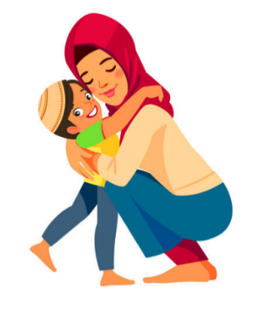
Kev nkag mus rau cov kev pab cuam hauv zej zog thiab cov kev pabcuam uas qhib rau cov menyuam yaus thiab tsis muaj kev xiam oob qhab.
Thaum tus me nyuam muaj kev tsis taus los yog muaj kev pheej hmoo kom tau txais kev xiam oob khab, muaj kev cuam tshuam los pab kev loj hlob ntawm lub peev xwm tsim nyog rau tus menyuam kom koom nrog hauv tsev neeg niaj hnub thiab zej zog kev ua ub no hauv tus menyuam qhov chaw ib puag ncig.
Cov tsev kawm ntawv pej xeem thiab cov tsev kawm ntawv charter zoo ib yam poob rau hauv kev saib xyuas ntawm Lub Chaw Haujlwm Saib Xyuas Kev Kawm Hauv Zos (LEA), tseem hu ua Public School Unit (PSU).
IDEA tau txib kom cov tub ntxhais kawm uas muaj kev tsis taus nkag mus rau hauv chav kawm tsis tu ncua nyob qhov twg los tau, hu ua Teem ceeb tshaj plaws (LRE).
Muaj kev qhuab qhia ntau yamary yog hais txog ib pab pawg neeg txoj kev kuaj mob thiab kev kho mob.Cov kws tshaj lij hauv kab lus hais lus, kev xav, thiab kev kawm tshwj xeeb koom tes los ntsuam xyuas thiab pab tsev neeg nrog lawv cov menyuam.
Ib puag ncig ntuj yog hais txog ib puag ncig uas zoo rau cov menyuam yaus hnub nyoog tib yam uas tsis muaj kev xav tau tshwj xeeb.
Cov Kev Npaj Pabcuam Rau Tsev Neeg Tus Kheej yog qhov chaw cov tsev neeg thiab cov kws tshaj lij ua haujlwm ua ke los piav qhia txog lawv cov txiaj ntsig xav tau rau lawv cov menyuam thiab lawv tus kheej vim tias tau txais cov kev pabcuam thaum ntxov Part C.
IDEA's Procedural Safeguards tiv thaiv txoj cai raug cai ntawm niam txiv thiab tus menyuam tsis taus.
Thaum tus me nyuam xav tias muaj kev tsis taus thiab nws tau txiav txim siab seb tus me nyuam puas xav tau kev kawm tshwj xeeb thiab cov kev pab cuam cuam tshuam, kev xa mus yog sau rau hauv PSU.
Lo lus Cov Kev Pabcuam Sib Txuas yog hais txog cov kev pabcuam ntxiv uas cov menyuam yaus uas muaj kev xiam oob qhab xav tau los ua kom tau txais txiaj ntsig zoo tshaj plaws ntawm lawv qhov kev kawm tshwj xeeb.Txhawm rau kom tau txais kev pabcuam, tus menyuam yuav tsum raug lees txais rau hauv qhov kev kawm tshwj xeeb.Kev kho lub cev, kev ua haujlwm kho mob, kev pabcuam hais lus hais lus, kev ua si, kev pabcuam sablaj, kev pabcuam niam txiv thiab kev cob qhia, kev pabcuam audiology, thiab kev thauj mus los yog tag nrho cov piv txwv ntawm cov kev pabcuam cuam tshuam los ntawm Tshooj B.
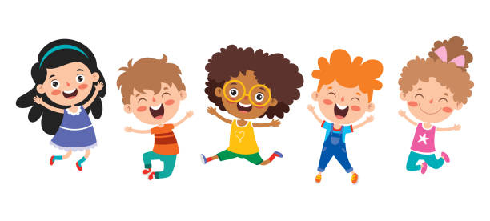
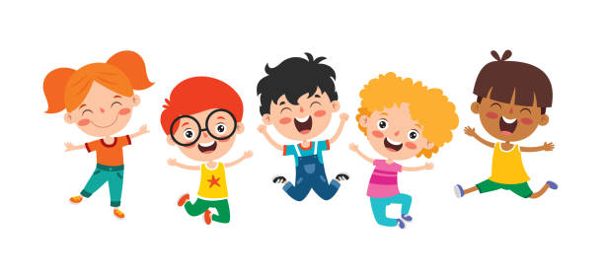
Kev tshuaj ntsuam yog hais txog tus txheej txheem ntawm kev ntsuas tus menyuam txoj kev loj hlob thiab kev loj hlob.Thaum muaj lus nug txog tus me nyuam txoj kev loj hlob, kev tshuaj ntsuam xyuas yuav pab nrhiav seb cov me nyuam xav tau kev saib xyuas ntau dua.

Cov txheej txheem uas tus menyuam yuav tau txais kev pabcuam thaum ntxov, kev kawm tshwj xeeb, thiab cov kev pabcuam cuam tshuam.
Kev kawm tshwj xeeb yog ib hom kev pab nyiaj rau pej xeem, kev kawm tus kheej rau cov me nyuam tsis taus.
Kev kho mob yog ib qho kev pabcuam tsim tshwj xeeb kom ua tau raws li qhov xav tau ntawm cov menyuam yaus.Feem ntau hom kev kho mob muab los ntawm cov tsev kawm ntawv pej xeem raws li ib feem ntawm nws cov kev pabcuam cuam tshuam yog:
Cov tub ntxhais kawm tuaj yeem tau txais kev pabcuam ua haujlwm kho mob los ntawm ib tus kws kho mob ua haujlwm (OT) lossis tus kws pabcuam ua haujlwm pabcuam (OT Assistant saib xyuas).Cov kev pab cuam no pab cov tub ntxhais kawm koom nrog thiab tau txais kev kawm tshwj xeeb los ntawm kev muab lawv cov txiaj ntsig thiab / lossis kev ua haujlwm tseem ceeb.Cov tub ntxhais kawm lub luag haujlwm thiab kev sib cuam tshuam, kev kawm thiab cov txheej txheem, kev saib xyuas tus kheej, kev lom zem thiab kev ua si, kev sib txuas lus sau ntawv, kev sib koom ua ke hauv zej zog, thiab kev ua haujlwm yog txhua yam piv txwv ntawm txoj haujlwm ua tau.
Kev txhim kho hauv kev txav mus los, kev koom tes, thiab kev ywj pheej tuaj yeem ua tiav los ntawm kev kho lub cev, uas yog ib (PT) feem ntawm kev txuas ntxiv ntawm cov tub ntxhais kawm cov (PT) kev pabcuam xa los ntawm lub xeev-tso cai kho lub cev (PT lossis PT Assistant saib xyuas) kws kho mob.Raws li ib feem ntawm lawv lub luag haujlwm, PT cov kws tshaj lij txhawb kev noj qab haus huv thiab kev nyab xeeb ntawm lawv cov neeg siv khoom.Cov kws kho lub cev ua haujlwm ua ke nrog lwm tus neeg ua haujlwm hauv tsev kawm kom paub tseeb tias tus menyuam kawm ntawv lub cev tsis muaj peev xwm kawm, ua si, thiab koom nrog txhua yam hauv tsev kawm ntawv lub neej.
Kev sib txuas lus tsis zoo, xws li teeb meem nrog kev txawj ntse, kev hais lus, lus, lossis lub suab, tuaj yeem cuam tshuam tsis zoo rau tus menyuam txoj kev kawm. Tus kws kho mob hais lus muaj ntawv tso cai tuaj yeem soj ntsuam thiab cuam tshuam hauv cov cheeb tsam no.Muaj ntau lwm yam lus los xav txog, xws li nws txoj haujlwm, nws cov ntsiab lus, thiab nws daim ntawv.
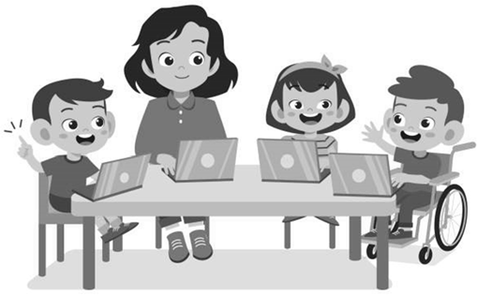
Thaum ib yam xaus thiab lwm qhov pib, qhov ntawd yog hu ua kev hloov pauv.Thaum muaj hnub nyoog 3 xyoos, cov me nyuam uas muaj kev tsis taus uas tsim nyog tau txais kev pab cuam Part B yuav hloov los ntawm cov kev pab cuam Part C.
Cov ntsiab lus ntxiv
Peb cia siab tias phau ntawv qhia no yuav pab tau koj heev.Peb cia siab tias yuav pab tau koj ua cov niam txiv thiab cov kws tshaj lij hauv kev pabcuam kev hloov pauv zoo nyob rau xyoo no.Thov tiv tauj nrog ib qho ntawm cov hauv qab no yog tias koj muaj teeb meem ntxiv lossis lus nug:
- Hais txog cov kev pabcuam uas muab los ntawm Qhov Kev Pabcuam Menyuam mos-Me nyuam mos:
Hu rau Children's Developmental Service Agency (CDSA) hauv koj cheeb tsam hauv xov tooj lossis xa ntawv; los yog
North Carolina Infant-Toddler Program Part C Program Coordinator
Division of Child and Family Well-Being, Early Intervention Section
North Carolina Department of Health and Human Services
1916 Mail Service Center, Raleigh, N.C. 27699-1919
(919) 707-5520, lub vev xaib: https://www.ncdhhs.gov/divisions/child-and-family-well-being/north-carolina-infant-toddler-program-nc-itp/find-your-childrens-developmental-service-agency-cdsa
- Hais txog Part B Preschool Program cov kev pabcuam muab rau peb tus menyuam:
Hu lossis sau koj lub Tsev Kawm Ntawv Hauv Pej Xeem (PSU) lossis tus saib xyuas menyuam kawm ntawv preschool,
Office of Early Learning, North Carolina Department of Public Instruction
2075 Mail Service Center, Raleigh, N.C.27699-2075
(984) 236-2100, lub vev xaib:
https://www.dpi.nc.gov/districts-schools/classroom-resources/office-early-learning-oel
- Kev tswj hwm cov teeb meem:
Hu rau koj tus PSU lossis tus kws pab tswv yim kom pab daws teeb meem,
Office of Exceptional Children, North Carolina Department of Public Instruction
6356 Mail Service Center, Raleigh, N.C.27699-6356
(984) 236-2100, lub vev xaib:
https://www.dpi.nc.gov/districts-schools/classroom-resources/exceptional-children/parent-resources#dispute-resolution
- Hais txog lwm yam kev pab
Exceptional Children's Assistance Center (ECAC)
(800) 962-6817, email: ecac@ecacmail.org, lub vev xaib: www.ecac-parentcenter.org
Family Support Network ntawm NC.
(800) 852-0042, lub vev xaib: https://beearly.nc.gov/index.php/contact/cdsa
North Carolina pawg sab laj txog kev xiam oob qhab
(800) 357-6916, email: info@nccdd.org, lub vev xaib: https://nccdd.org
North Carolina cov menyuam yaus thiab cov hluas uas muaj kev kho mob tshwj xeeb xav tau kev pabcuam
(800) 737-3028, email: CYSHCH.Helpline@dhhs.nc.gov

Lub hom phiaj ntawm phau ntawv qhia no yog los qhia cov niam txiv txog cov kauj ruam uas koom nrog hauv kev tso npe lawv tus menyuam hauv Preschool Program tom qab ua tiav Qhov Kev Pabcuam Menyuam mos-Me nyuam mos.
Zoo siab txais tos koj tuaj yeem luam tawm txhua ntu ntawm phau ntawv qhia no.Cov ntaub ntawv hauv zos tuaj yeem hloov pauv.
Peb cia siab tias phau ntawv qhia no yuav muaj kev pab rau koj. Transition Committee, North Carolina Interagency Coordinating Council, 1916 Mail Service Center, Raleigh, N.C. 27699-1916 zoo siab txais tos txhua qhov kev hloov kho lossis kevkho uas koj yuav muaj.Xov tooj: (919) 707-5520.

Kev lees paub
Cov haujlwm hauv qab no tau txais kev tshoov siab rau phau ntawv qhia no:
- Tsev Neeg thiab Txoj Kev Hloov Pauv: Txoj Kev Hloov Mus Rau Menyuam Yaus Thaum Ntxov hauv Kentucky, Thawj Hom, 1995.
- Xyoo 1995, Daim Ntawv Qhia Txog Kev Pabcuam Menyuam mos thiab Menyuam yaus tau tshaj tawm.
- Kev hloov pauv: Lub sijhawm rau kev txhim kho ntawm lub sijhawm hloov pauv Family Outreach Center for Special Needs Education, Inc., 1994.
- Kev ua thawj zaug: Missouri State Department of Elementary and Secondary Education, Hloov mus rau Kev Kawm Tshwj Xeeb rau Cov Menyuam Yaus (1993).
- Pennsylvania Txoj Haujlwm Pabcuam Thaum Ntxov: Niam Txiv Txoj Kev Qhia, 1st ed., Instructional Support System of Pennsylvania, 1998.
Cov qhab nia
2022 Chaw Ua Haujlwm Ntawm Cov Me Nyuam Tshwj Xeeb,
North Carolina chav haujlwm ntawm kev qhia pej xeem
ntawm
Kev Pabcuam Thaum Ntxov,
epartment of Family thiab Child Services,
Human Services Department ntawm North Carolina
Rau cov ntawv luam ntxiv, rub tawm los ntawm https://ncdhhs.gov/itp-beearly

Xeev North Carolina

North Carolina chav haujlwm ntawm kev qhia pej xeem
Chaw Ua Haujlwm Ntawm Cov Menyuam Tshwj Xeeb
https://www.dpi.nc.gov/districts-schools/classroom-resources/exceptional-children

North Carolina Department of Health ntawm Human Services
Division of Child and Family Well-Being
Kev Pabcuam Thaum Ntxov
https://ncdhhs.gov/itp-beearly
https://www.ncdhhs.gov
https://www.ncdhhs.gov/divisions/division-child-and-family-well-being

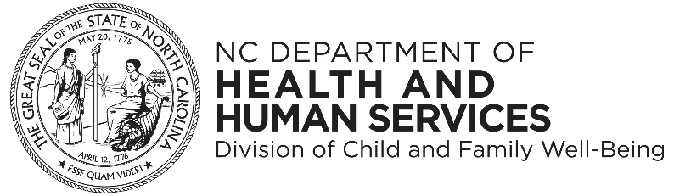

Koj tuaj yeem luam qhov no thiab faib tawm dawb.
Cuaj hlis 2007 | Cuaj hlis 2015 | Cuaj hlis 2022
Ob lub North Carolina Lub Tsev Haujlwm Saib Xyuas Kev Qhia Pej Xeem thiab North Carolina Lub Tsev Haujlwm Saib Xyuas Kev Noj Qab Haus Huv thiab Tib Neeg tau cog lus los muab kev ua haujlwm sib luag thiab kev pabcuam rau tib neeg ntawm txhua haiv neeg, xim, keeb kwm ntawm lub tebchaws, poj niam txiv neej, kev ntseeg, hnub nyoog, thiab lub peev xwm.

