NC DEPARTMENT OF HEALTH AND HUMAN SERVICES

Division of Employment and Independence for People with Disabilities

JOBSEEKER SERVICES

We help eligible clients overcome barriers to getting a job, keeping a job, and advancing professionally.

APPLY FOR SERVICES

If you have a disability or a chronic condition that prevents you from achieving success on the job, we can help! Click here to find your local EIPD office and schedule a virtual or in-person appointment to apply for services.

ELIGIBILITY

Once you apply, we determine if you are eligible for services. It can take 60 days or more to review your educational, work, and disability records. If you receive Social Security benefits, you are presumed eligible.

INDIVIDUALIZED PLANNING

In partnership with a vocational rehabilitation counselor, you’ll identify an employment goal and create a customized plan of services and supports you need to reach your goal.

PARTICIPATE IN SERVICES

Services may include counseling, treatment, training, education, job placement assistance, internships, assistive technology, and more, depending on what each client needs.

BENEFITS COUNSELING

Expert counselors will provide guidance to help you understand how earned income from working will impact your benefits and resources available to help protect your benefits while you pursue your path to employment.

ACHIEVE YOUR GOAL

When you’re ready, we help you ﬁnd jobs that match your goal. We’ll help you with applications, resumes, and interview prep. After you’re hired, we’ll work with the employer to provide accommodations or additional services as needed.

ONGOING SUPPORT

We’ll follow your progress for 90 days after you are hired to make sure the job remains a good ﬁt for you and the employer.

LONG-TERM SERVICES

We partner with other service providers to ensure that jobseekers who need longer-term supports keep receiving those services to stay employed after EIPD closes your case.

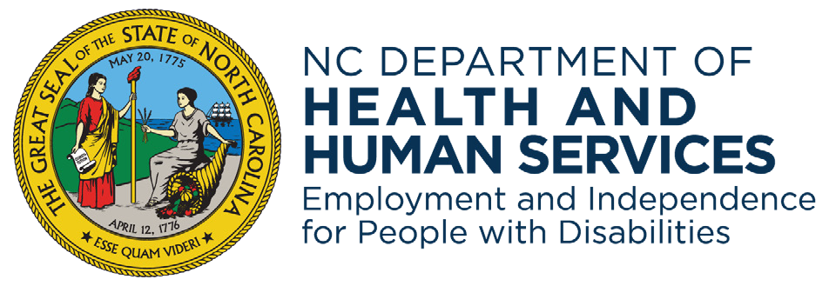Learn more: ncdhhs.gov/eipd

NCDHHS is an equal opportunity employer and provider.