LIVE HEALTHIER TO BE THERE for the holidays– Social Media Toolkit
The NCDHHS Office of Health Equity’s Live Healthier To Be There social media toolkit is a collection of materials and resources designed to help people or organizations share a message consistently and effectively across social media platforms using images of populations of focus (African American, Latinx, People who are Disabled, etc.). The toolkit is designed to share health promotional messages across social media platforms and to be used as a free health education initiative to ensure that our community partners can post about respiratory health promotion with on-brand content directly from the NCDHHS Office of Health Equity.
Thank you for joining us in spreading the word about the importance of staying healthy this holiday season.

Suggested Instructions for our partners for Using the "LIVE HEALTHIER TO BE THERE for the holidays" Social Media Toolkit:
1. Get Familiar with the Toolkit - Review the toolkit materials, including sample posts, images, hashtags, and messaging guidelines. Identify which materials resonate most with the communities you serve.
2. Tailor the Content to Your Audience - Feel free to include information about local vaccination clinics, healthcare providers, or other resources to make posts more relevant.
3. Choose your Platforms - Share posts on platforms your audience uses most (e.g., Facebook, Instagram, X – formerly Twitter, Bluesky or LinkedIn)
4. Timing is Everything - Maximize audience engagement. Post during peak activity hours (e.g., mornings, lunch breaks, and early evenings).
5. Use the Suggested Hashtags - Include the hashtags (example - #LiveHealthierToBeThere or #COVID19vaccines). Add any local or organization-specific hashtags to broaden your reach.
6. Leverage Visuals - Use the toolkit’s pre-made visuals that reflect the diversity of the populations you serve. Ensure all visuals have accompanying alt-text descriptions for users with visual impairments.
7. Share Stories and Engage - Respond to comments and questions on your posts to foster trust and engagement.
8. Monitor and Measure Impact - Track how well your posts are performing (e.g., likes, shares, comments, and reach). Share feedback and success stories with us! This helps us refine future campaigns and celebrate your impact.
9. Collaborate and Spread the Word - Share the toolkit with other organizations, partners, or influencers in your network.

By working together, we can ensure every family in North Carolina has the opportunity to celebrate the holidays safely and healthily. If you have any questions or need additional support, don’t hesitate to reach out. Thank you for your partnership!
URL for use in posts: Vaccine Information | NC COVID-19: covid19.ncdhhs.gov/vaccines
Population of Focus | Facebook/Instagram or Twitter (X) Post Copy | Social Media Graphic and ALT Text
African American | Facebook/Instagram:  The holidays are a time for family, friends, and celebration. But did you know that Black communities in North Carolina have higher rates of severe illness from flu, COVID-19, and RSV? Let’s change that. Getting vaccinated cuts your chances of getting COVID-19 in half and prevents you from getting sick. Find out how to get covered and get vaccinated: covid19.ncdhhs.gov/vaccines  #LiveHealthierToBeThere #GetVaccinated #FluShots #COVID19vaccines #RSV  Twitter (x):  The holidays are here! But so is flu season. As we gather to celebrate, it’s a great time to protect our loved ones with flu, COVID-19, & RSV vaccines. Let’s prioritize health so we can #LiveHealthierToBeThere for the Holidays! Go to covid19.ncdhhs.gov/vaccines  #GetVaccinated #FluShots #COVID19vaccines #RSV | 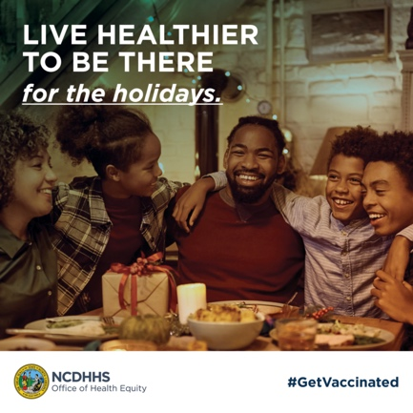  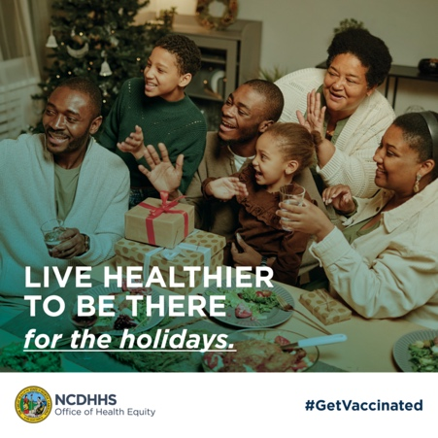  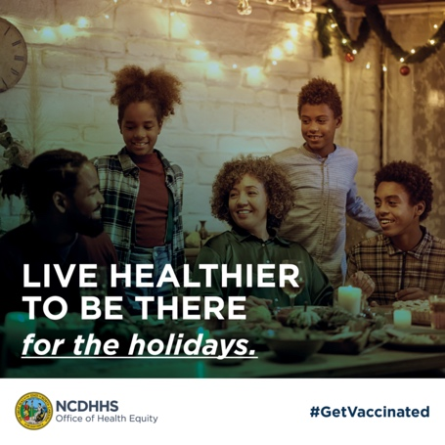  Alt Text: LIVE HEALTHIER TO BE THERE for the holidays.
Latinx | Facebook/Instagram:  ¡Protégete para estar presente en estas fiestas!  Since the start of the pandemic, Latinx communities in North Carolina have been hit hard by COVID-19. Even though we make up only 1 in 10 North Carolinians, we represented more than half of all early COVID-19 cases and continue to be at risk of serious health complications.  The good news? COVID-19 vaccine remains the safest, most effective way to protect yourself from severe illness, hospitalization, and even death.  Now is the time to get vaccinated so you can stay healthy for the holidays.  #LiveHealthierToBeThere #GetVaccinated #FluShots, #COVID19vaccines #RSV #SaludYBienestar  Twitter (x):  ¡Protégete para estar presente en las fiestas! Latino communities in NC have been hit hardest by COVID-19. The vaccine cuts your risk of severe illness in half, but only 1 in 10 Hispanic adults got the 2023-2024 vaccine.  Get vaccinated today and stay healthy this season! Go to covid19.ncdhhs.gov/vaccines for more.  #GetVaccinated #FluShots #COVID19vaccines #RSV  #SaludYBienestar | 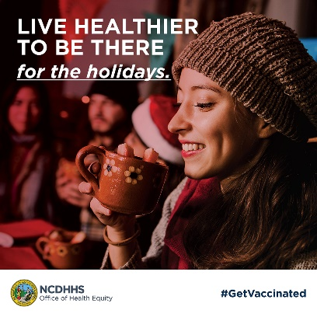  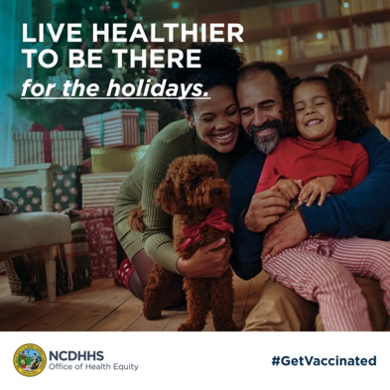  Alt Text: LIVE HEALTHIER TO BE THERE for the holidays.
LGBTQIA+ | Facebook/Instagram:  The holidays are about being there for the moments that matter. According to the 2024 NCDHHS Health Disparities Analysis Report, LGBTQIA+ individuals often avoid or delay healthcare due to past negative experiences or fear of discrimination. This can lead to lower vaccination rates and missed opportunities for early intervention. This season let’s change that. Protect yourself and your loved ones. Talk to an affirming health care provider and get vaccinated today.  ncdhhs.gov/2024-health-disparities-analysis-report/download?attachment  #LiveHealthierToBeThere #GetVaccinated #FluShots #COVID19vaccines #RSV  Twitter (x):  The holidays are for moments that matter. LGBTQIA+ folks face higher risks of severe illness from flu, COVID-19 & RSV due to chronic conditions and missed opportunities for early intervention. Protect yourself this holiday season.  Talk to an affirming health care provider and get vaccinated today.  covid19.ncdhhs.gov/vaccines  #LiveHealthierToBeThere #GetVaccinated #FluShots #COVID19vaccines #RSV | 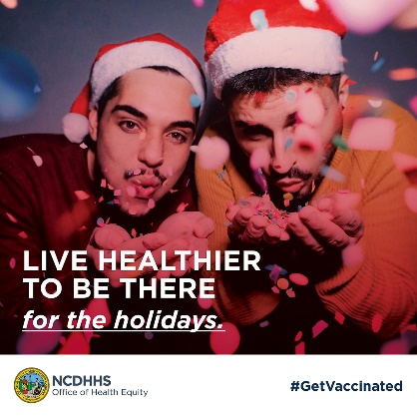  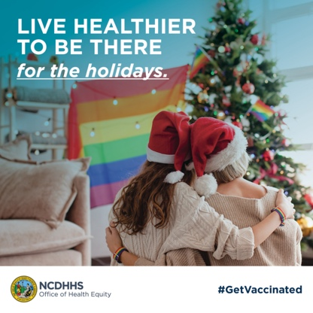  Alt Text: LIVE HEALTHIER TO BE THERE for the holidays.
Children (Infant) | Facebook/Instagram:  This holiday season, let’s protect the youngest members of our community. RSV is a leading cause of hospitalization for infants and young children, especially those under 5 or with underlying health conditions or preterm birth. Every child deserves a healthy holiday season. Talk to your pediatrician about getting vaccinated to help keep your family safe and healthy this year.  covid19.ncdhhs.gov/vaccines  #LiveHealthierToBeThere #GetVaccinated #FluShots #COVID19vaccines #RSV  Twitter (x):  Every child deserves a healthy holiday season! RSV, flu, and COVID-19 can lead to serious complications for kids under 5, especially with asthma or those with health conditions like preterm birth. Let’s close gaps in care—get your child vaccinated today.  covid19.ncdhhs.gov/vaccines  #LiveHealthierToBeThere #GetVaccinated #FluShots #COVID19vaccines #RSV | 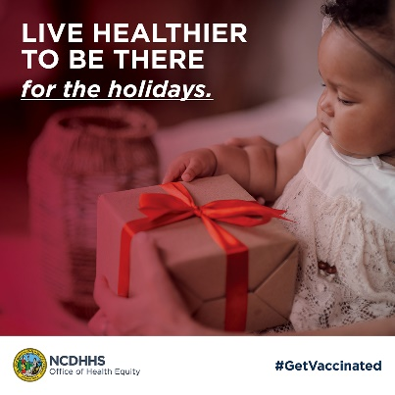  Alt Text: LIVE HEALTHIER TO BE THERE for the holidays.
Back to School | Facebook/Instagram:  Heading back to school? Keep the flu and COVID-19 at bay by keeping immunizations up to date! It’s not too late. Visit your local pharmacy, doctor’s office or community health center and protect yourself and those around you. Learn more at covid19.ncdhhs.gov  #LiveHealthierToBeThere #GetVaccinated #FluShots #COVID19vaccines #RSV  Twitter (x):  It’s getting colder. Keep kids and classrooms safe from COVID-19 and flu. Get vaccinated over the winter break. Available at most local pharmacies, doctors’ offices, and community health centers. Visit covid19.ncdhhs.gov for more.  #LiveHealthierToBeThere #GetVaccinated #FluShots #COVID19vaccines #RSV | 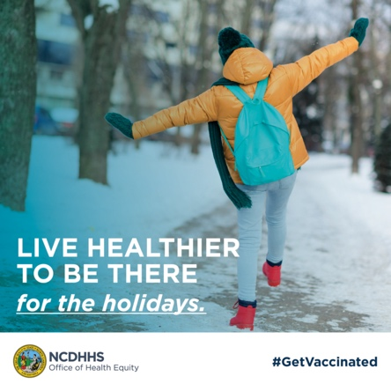  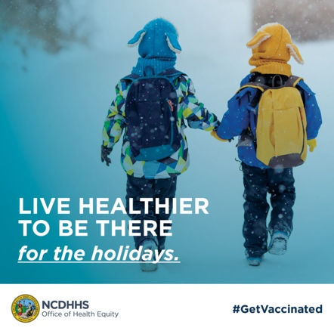  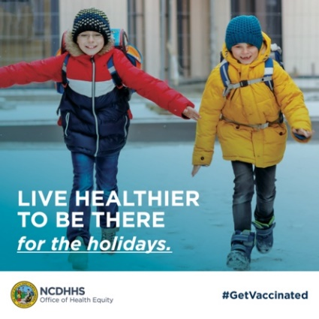  Alt Text: LIVE HEALTHIER TO BE THERE for the holidays.
Aging Adults | Facebook/Instagram:  Did you know that RSV is a leading cause of respiratory hospitalizations for adults over 65 – and that Black and Latinx individuals in North Carolina are at greater risk? Protect your loved ones by staying up-to-date on vaccines. This holiday season, let’s prioritize health so we can truly be there for one another.  Learn more: covid19.ncdhhs.gov/vaccines  #LiveHealthierToBeThere #GetVaccinated #FluShots  #COVID19vaccines #RSV  Twitter (x):  RSV affects older adults and hits Black and Latinx communities in NC harder. Stay healthy this holiday season by getting vaccinated.  covid19.ncdhhs.gov/vaccines  #LiveHealthierToBeThere #GetVaccinated #FluShots #COVID19vaccines #RSV | 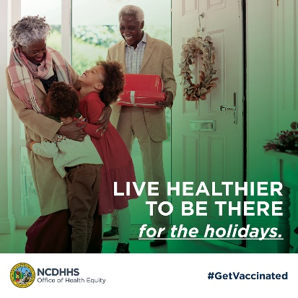  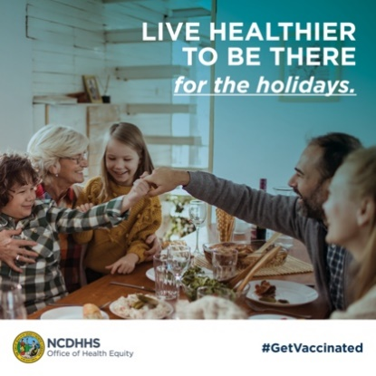  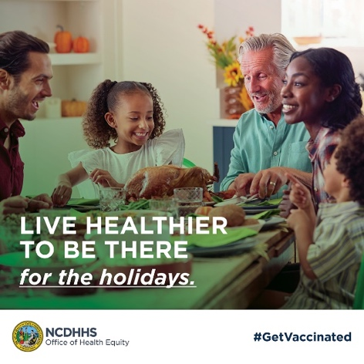  Alt Text: LIVE HEALTHIER TO BE THERE for the holidays.
American (Indian) Native | This season let’s honor the strength of our traditions and communities by prioritizing our health. COVID-19, RSV, flu, and pneumonia can affect anyone, but staying up to date on vaccinations can protect us and those we care about most. Taking steps to safeguard your health ensures you can fully celebrate the holidays and preserve cherished traditions.  Live healthier to be there for every moment. Learn more:  covid19.ncdhhs.gov/vaccines  #LiveHealthierToBeThere #GetVaccinated #FluShots #COVID19vaccines #RSV  Twitter (x):  Honor traditions by protecting your health this holiday season. COVID-19, RSV, flu, & pneumonia vaccines help keep our celebrations safe. Live healthier to be there for every cherished moment all winter long. Get vaccinated today!  covid19.ncdhhs.gov/vaccines  #LiveHealthierToBeThere #GetVaccinated #FluShots #COVID19vaccines #RSV | 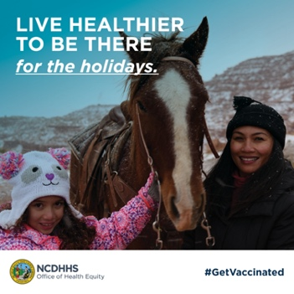  Alt Text: LIVE HEALTHIER TO BE THERE for the holidays.
AANHPI | This season let’s honor the strength of our traditions and communities by prioritizing our health. COVID-19, RSV, flu, and pneumonia can affect anyone, but staying up to date on vaccinations can protect us and those we care about most. Taking steps to safeguard your health ensures you can fully celebrate the holidays and preserve cherished traditions.  Live healthier to be there for every moment. Learn more:  covid19.ncdhhs.gov/vaccines  #LiveHealthierToBeThere #GetVaccinated #FluShots #COVID19vaccines #RSV  Twitter (x):  Honor traditions by protecting your health this holiday season. COVID-19, RSV, flu, & pneumonia vaccines help keep our celebrations safe.  Live healthier to be there for every cherished moment all winter long. Get vaccinated today!  covid19.ncdhhs.gov/vaccines  #LiveHealthierToBeThere #GetVaccinated #FluShots #COVID19vaccines #RSV | 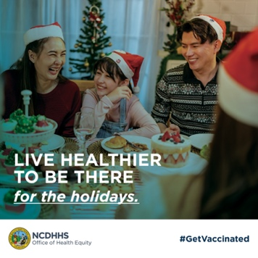  Alt Text: LIVE HEALTHIER TO BE THERE for the holidays
People with Disabilities | This holiday season, let’s prioritize health and inclusion for our communities. COVID-19, RSV, flu, and pneumonia can pose greater risks to individuals with disabilities, especially those with underlying health conditions, including physical, functional or communication challenges. Vaccines remain the best way to protect yourself and ensure you can safely celebrate with loved ones. Live healthier to be there for every holiday moment that matters. Talk to your healthcare provider about getting vaccinated today!  covid19.ncdhhs.gov/vaccines  #LiveHealthierToBeThere #GetVaccinated #FluShots #COVID19vaccines #RSV  Twitter (x):  Protect your health this holiday season! COVID-19, RSV, flu, & pneumonia vaccines are vital for people with disabilities, especially those at higher risk.  Live healthier to be there for every special moment. Get vaccinated today!  covid19.ncdhhs.gov/vaccines  #LiveHealthierToBeThere #GetVaccinated #FluShots #COVID19vaccines #RSV | 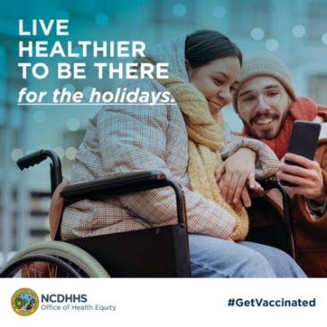  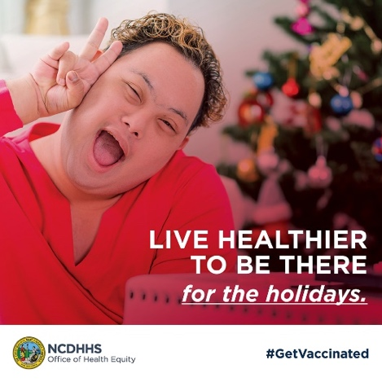  Alt Text: LIVE HEALTHIER TO BE THERE for the holidays.
Veterans | This holiday season, we salute our veterans and encourage you to prioritize your health. COVID-19, RSV, flu, and pneumonia can pose serious risks, especially as we age or manage chronic health conditions. Vaccines remain the best way to protect yourself and your loved ones.  Stay strong, stay healthy, and be there for the celebrations that matter most. Talk to your health care provider or local VA about getting vaccinated today!  covid19.ncdhhs.gov/vaccines  #LiveHealthierToBeThere #GetVaccinated #FluShots #COVID19vaccines #RSV  Twitter (x):  Veterans, protect your health this holiday season! COVID-19, RSV, flu, & pneumonia vaccines are your best defense against severe illness.  Stay strong, stay healthy, and celebrate with loved ones. Talk to your local VA about vaccines today!  covid19.ncdhhs.gov/vaccines  #LiveHealthierToBeThere #GetVaccinated #FluShots #COVID19vaccines #RSV | 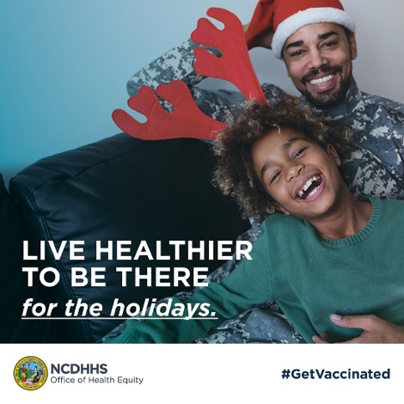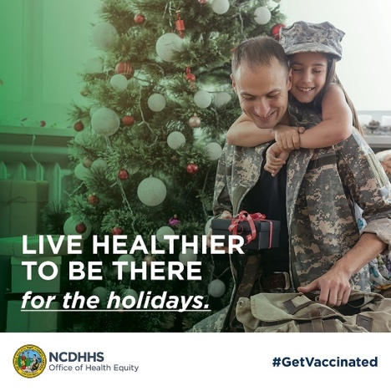  Alt Text: LIVE HEALTHIER TO BE THERE for the holidays.
Multi-faith Holiday:  Jewish Faith | This holiday season, let’s come together to protect our health and our communities. Whether you’re celebrating Hanukkah, gathering for the 15th of Shevat, or for Shabbat, staying healthy ensures we can share these cherished moments with loved ones. COVID-19, flu, RSV and pneumonia pose risks to everyone, but vaccines remain the best way to prevent severe illness. Protect yourself, your family, and your community by getting vaccinated today.  Let’s live healthier to be there for the celebrations that matter most.  covid19.ncdhhs.gov/vaccines  #LiveHealthierToBeThere #GetVaccinated #FluShots #COVID19vaccines #RSV  Twitter (x):  Protect your health this holiday season! Whether you gather for the Tu Bishvat, Hanukkah, or Shabbat Shirah, staying healthy ensures we can gather with loved ones.  COVID-19, flu, RSV & pneumonia vaccines help prevent severe illness. Get vaccinated today to keep your community safe.  covid19.ncdhhs.gov/vaccines  #LiveHealthierToBeThere #GetVaccinated #FluShots #COVID19vaccines #RSV | 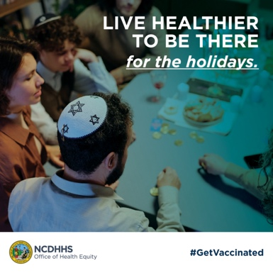  Alt Text: LIVE HEALTHIER TO BE THERE for the holidays.
Muslim Faith | This holiday season let’s prioritize health and well-being for ourselves and our loved ones. For gatherings during Jumu'ah or Rabi’ al-Akhir and Jumada al-Awwal Observances, staying healthy ensures we can fully participate in the moments that matter. COVID-19, flu, RSV and pneumonia vaccines are your best defense against severe illness. Protect yourself and your family by staying up-to-date on vaccinations. Let’s live healthier to be there for the celebrations that bring us together. Get vaccinated today!  covid19.ncdhhs.gov/vaccines  #LiveHealthierToBeThere #StayHealthyTogether #VaccinesSaveLives  Twitter (x):  This holiday season, protect yourself & loved ones. Whether gathering for Jumu'ah or family events, staying healthy ensures we can share these special moments.  Vaccines for COVID-19, flu, & pneumonia help prevent severe illness. Get vaccinated today!  covid19.ncdhhs.gov/vaccines  #LiveHealthierToBeThere #GetVaccinated #FluShots #COVID19vaccines #RSV | 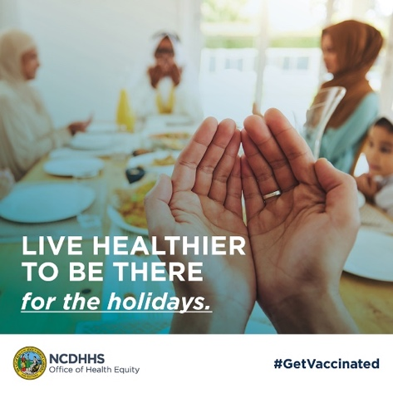  Alt Text: LIVE HEALTHIER TO BE THERE for the holidays.
13. Kwanza | This Kwanzaa, let’s honor the principles of unity and collective responsibility by prioritizing our health. COVID-19, RSV, flu, and pneumonia pose risks to our families and communities, but vaccines are a powerful way to protect ourselves and those we love. Staying up-to-date with our vaccines ensures we can gather in joy and health to celebrate the traditions that bring us together.  Live healthier to be there for every moment this holiday season. Get vaccinated today!  covid19.ncdhhs.gov/vaccines  #LiveHealthierToBeThere #GetVaccinated #FluShots #COVID19vaccines #RSV  Twitter (x):  Celebrate Kwanzaa in health & unity! COVID-19, RSV, flu, & pneumonia vaccines help protect you & your loved ones this season.  Live healthier to be there for every special moment. Get vaccinated today!  covid19.ncdhhs.gov/vaccines  #LiveHealthierToBeThere #GetVaccinated #FluShots #COVID19vaccines #RSV  #LiveHealthierToBeThere #VaccinesSaveLives #Kwanzaa2024 | 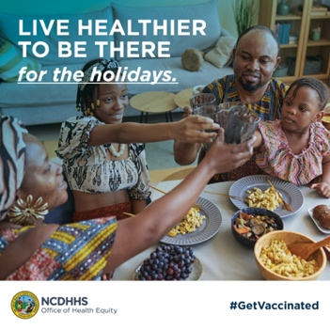  Alt Text: LIVE HEALTHIER TO BE THERE for the holidays.  .

