North Carolina Local Interagency Coordinating Council Handbook



March 2026
North Carolina Interagency Coordinating Council
Dear LICC member,
Welcome to your Local Interagency Coordinating Council (LICC). As a member of your LICC, you offer a valuable contribution to children with disabilities and their families. The LICC is composed of both professional and non-professional volunteers and everyone who attends meetings brings a valuable perspective to the table. While serving on the LICC you will have many important roles and responsibilities. In this handbook, we outline what the LICC is, how it is related to the bigger picture, your responsibilities, and other helpful information.
Within this handbook, you will find many useful resources and explanations. We start by defining how the state-level NC-ICC and local-level LICCs are related and work together. We then go into detail on the interworking of the LICC and how to make your LICC more effective.
This handbook also outlines the important role of families of children with disabilities to the LICCs. You will see the importance of the caregiver role and how other LICC members can best support them as they serve on the LICC. We hope that you find this handbook useful and encouraging. If you have any questions or comments, please contact Deputy Director of Early Intervention and Part C Coordinator, Brian Deese, at brian.deese@dhhs.nc.gov or Director of Comprehensive System of Personnel Development, Angie Phipps at Angie.Phipps@dhhs.nc.gov.
Your involvement with the LICC is very much appreciated and will not be taken for granted. We count it as an honor that you would join us in our pursuit to reach all families of children with special needs. Whether you have just begun your work on the LICC or have been a member for a while, we thank you for your commitment to your Local Interagency Coordinating Council.

Sincerely,
The LICC Support Committee
NC Interagency Coordinating Council

WELCOME!

NC Local Interagency Coordinating Council Handbook

Table of Contents
Section 1: The Local ICCs 1
Section 2: The NC ICC 4
Section 3: Becoming an Effective LICC 6
Section 4: Family Partner Participation in the LICC 16
Section 5: Appendices 22
Appendix A: Important Abbreviations & Acronyms 23
Appendix B: Family Partner Dictionary 26
Appendix C: LICC Mini Grants 37
Appendix D: LICC Child Find Activities Report 38
Appendix E: Sample Family Partner Letter from LICC 40
Appendix F: Sample LICC By-Law 41



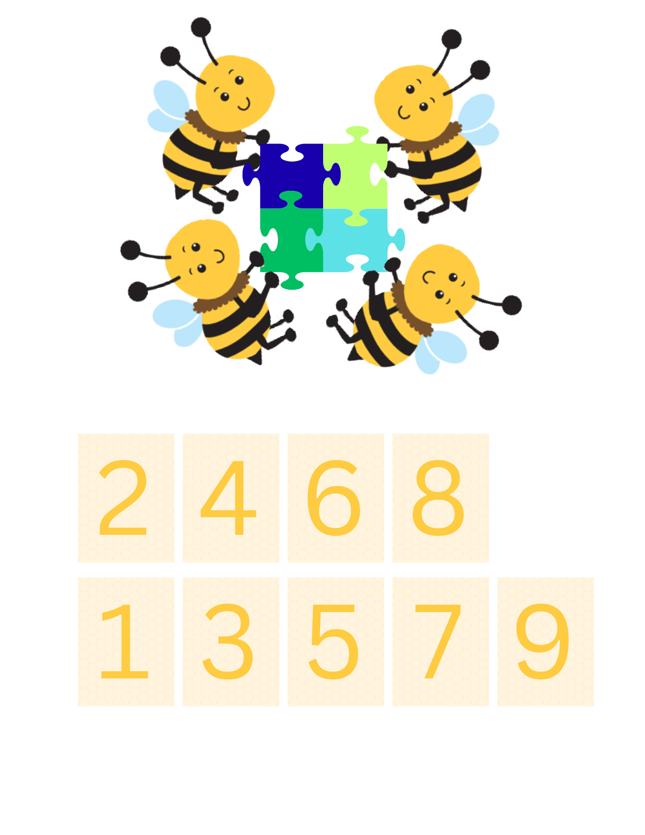
Section 1: The Local ICCs

What are the Local Interagency Coordinating Councils?
Local Interagency Coordinating Councils (LICCs) are community-based advisory groups focused on the implementation of a birth-to-five interagency system of early intervention services. Local Interagency Coordinating Councils provide opportunities for service providers to be involved in activities such as child find and public awareness, community needs assessment, system evaluation, and professional development. It is recommended that a Local Interagency Coordinating Council be organized for each county to support collaboration among agencies, to provide space for family involvement and voice, and to effectively function as a local engine of Child Find at the community level.

What is Child Find?

At its Core, Child Find is a federally mandated requirement under the Individuals with Disabilities Education Act (IDEA) that ensures all children from birth through age 21 who may have developmental delays or disabilities are identified, located, and evaluated as early as possible. In North Carolina, Child Find is implemented as a comprehensive, coordinated system that includes public awareness, outreach, referral, screening, and evaluation. The goal is to ensure that all children – especially those not yet connected to services – have timely access to early intervention and support.
Local Interagency Coordinating Councils (LICCs) play a critical role in advancing Child Find at the community level. While not responsible for conducting evaluations, LICCs support the system by leading or coordinating public awareness efforts, strengthening referral pathways, and fostering partnerships across agencies such as health care providers, early childhood programs, schools, and community organizations. Examples of Child Find activities at the local level include distributing educational materials, hosting outreach or screening events, engaging underserved communities, and using local data to identify and address gaps in referrals. Through these efforts, LICCs help ensure that no child “falls through the cracks” and that families can access services as early as possible.
LICCs support and strengthen each step through coordination, partnerships, and community engagement. Think of Child Find as a pipeline – from awareness to services – and LICCs help make sure that pipeline is strong, connected, and reaching every child in their communities.

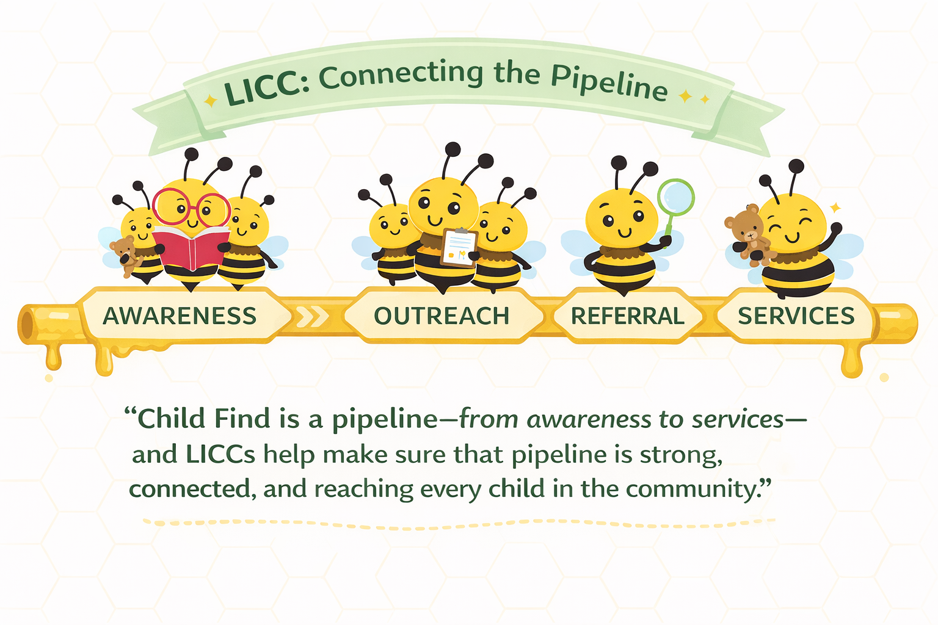

The Members of LICCs
Membership of a Local Interagency Coordinating Council should include, but not be limited to:
- representatives (mid-level to upper-level managers recommended) of agencies providing services for children with special needs, birth to five years. These may include the Children’s Developmental Services Agency, county Department of Social Services, local Health Department, Mental Health Local Management Entity-Managed Care Organization, Local Education Agency Preschool Program, Head Start/Early Head Start, private providers such as specialized therapists, and home health agencies;
- families and parents of children with special needs – often referred to as family partners;
- family support and advocacy groups;
- civic groups that provide supportive services to children with special needs and their families, including churches, Civitans, Junior Women's League, Lions Club and Shriners;
- community leaders, including county commissioners, city managers, health and mental health board members, business leaders, staff from parks and recreation; and
- early childhood groups or organizations, including Smart Start, Child Resource and Referral agencies, county Day Care Associations, or a local affiliate of the North Carolina Association for the Education of Young Children, N.C. Pre-K.

What are the responsibilities of the LICCs?
The role of the Local Interagency Coordinating Council (LICC) is to:
- develop and disseminate county specific public awareness and child find materials;
- foster interagency collaboration and communication;
- promote parent and family involvement in all community activities; and
- encourage community efforts to include children with special needs and their families.
Sub-committees may be appointed as the need arises for such issues as travel reimbursement for parents, public awareness, or child find, as well as handling specific tasks of the LICC. Because LICC meetings are public meetings, a specific child or family must be discussed in such a way which protects the confidentiality of the child and family.
It is strongly recommended that LICCs write by-laws and other operating procedures (see Appendix F). Such procedures would include the mission of the Local Interagency Coordinating Council; goals and objectives; meeting times and places; election of officers; and selection of committee members.
Additionally, an LICC Resource Padlet is available on the Statewide Interagency Coordinating Council website. On the Resource Padlet you can find LICC contacts by county along with important documents for LICC work, including Child Find mini grant application directions and documents. You can also post questions and share ideas with other LICCs using this tool.

Section 2: The NC ICC

What is the NC Interagency Coordinating Council?
The North Carolina Interagency Council (NC ICC) is responsible for advising and working with the state to assist children enrolled in both the NC Infant-Toddler Program (NC ITP) or children ages birth to three and the NC Preschool Program for children ages three to five who have developmental disabilities, delays, or established health conditions that lead to developmental delay.
The NC ICC receives its federal authority and charge through the Individuals with Disabilities Education Act (IDEA) under Public Law 108-446 and its state authority through NC General Statute 143B-179.5.

What are the duties and roles of the NC ICC?
- To advise and assist in making policy related to early intervention services
- To assist with evaluation of services
- To support interagency agreements
- To identify services that are right for infants, toddlers, and preschoolers
- To support and guide the Local Interagency Coordinating Councils (LICCs)

The Members of the NC ICC
The Governor of North Carolina appoints members for two-year terms so that half the membership rotates off the Council every year. A Council member can be reappointed for an additional two-year term. The Parent Co-chairperson is a parent of a child with a disability under the age of twelve (12) years and the Professional Co-chairperson is a professional working in the field of early intervention. To view the list of other members specified in federal and state law, see Lead Agency Policy at https://www.ncdhhs.gov/itp-beearly. Other information about the NC ICC may be obtained by contacting:
The Early Intervention Section
Toll Free Telephone: 1-855-NC-EARLY (1-855-623-2759)
Telephone: 919-707-5520
Fax: 919-870-4834

Website: Councils | NCDHHS

Visit the North Carolina Early Intervention Birth to Five website:
https://www.ncdhhs.gov/itp-beearly

The Department of Public Instruction Early Childhood Exceptional Children (ECEC) Section:
https://www.dpi.nc.gov/districts-schools/classroom-resources/exceptional-children/programs-services

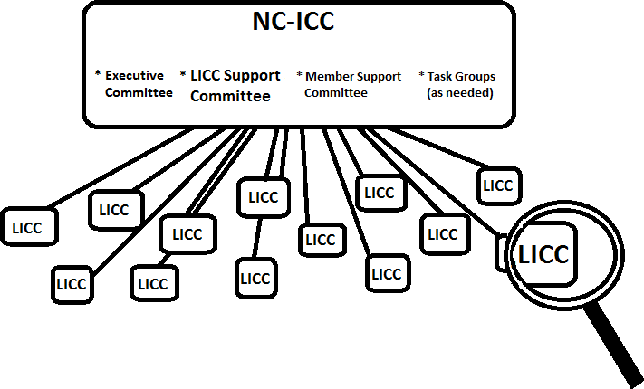
How are the NC ICC and the LICCs different?

STATE COUNCIL | LOCAL COUNCILS
NC Interagency Coordinating Council  (NC-ICC) | Local Interagency Coordinating Council  (LICC)
Purpose: Planning partner with the Division of Child and Family Wellbeing and Department of Public Instruction to ensure the development and implementation of a coordinated interagency service system for infants, toddlers, and preschoolers with disabilities or developmental delays and their families and to serve as the major state level advisory  board for early intervention and preschool services. | Purpose: Provide opportunities for community partners to be involved in local activities such as child find and public awareness, community needs assessment, system evaluation, and professional development.
Identifies services that are right for infants, toddlers, and preschoolers | Develop and disseminate county specific public awareness and child find materials
Advise and assist in making policy related to early intervention services | Foster interagency collaboration and information sharing
Assist with evaluation of services | Promote parent and family involvement in all community activities
Support interagency agreements | Encourage community efforts supporting inclusion of children with special needs and their families
Support and guide LICCs | Provide awareness for local needs

Section 3: Becoming an Effective LICC

10 COMPONENTS OF AN EFFECTIVE LICC
It is important for LICCs to develop a model of organization and structure, to establish the identity of the LICC and promote its credibility within the community. There are 10 basic components that all LICCs should incorporate to keep it functioning effectively.
- Core Membership
LICCs with full, active memberships have the most successful mission and goals. Core early intervention proponents are generally found in all counties in NC.
- Regular Meetings
The regularity of meetings helps instill commitment in your LICC membership. It also validates and reinforces their time and participation. Consider varying the time of meetings to avoid scheduling conflicts.
- Clear Meeting Agendas
Agendas help plan and facilitate discussions, outline the meeting purpose, and validate the time commitment of participants.
- Dissemination of Meeting Minutes
LICC meeting minutes document discussions and decisions made by members, therefore they
  - serve as an important reference
  - remind people what they have agreed to do
  - can be used to track and document LICC activities or events
- Committed, Effective Leaders
Effective leadership can:
  - keep the group focused and grounded around the LICC purpose
  - keep the group motivated and invested in the LICC activities
Responsibilities should be rotated to allow all members opportunities for group leadership.
LICCs should have co-chairpersons at a minimum, with other officers added as needed.

- Child Find Activities Report
The LICCs are a vital link in supporting the NC early intervention system in meeting federal requirements, such as the child find activities report (see Appendix D).
  - The child find activities report is a statewide report that captures the rich and diverse activities occurring in local communities and promotes awareness of the NC early intervention system in local communities.
  - Child find activities include, but are not limited to, participating in local annual community fairs/festivals/parades, NICU activities, screenings, leaving brochures with day cares and pediatrician offices, social media promotion, developing partnerships with local agencies such as Mothers of Preschoolers (MOPS), churches, colleges and universities, and support groups. These partnerships improve collaboration, perspective, and awareness.
- Mission/Vision Statement
A mission/vision statement should:
  - Describe a desired future based on the LICC and the early intervention system’s values and philosophy.
  - Be broader than what any one agency can achieve, therefore supports collaboration.
  - Describe the LICCs reason for existence and state its role in reaching its vision.
- Council By-Laws
By-laws help identify approved policies and procedures for the LICC, define the responsibilities of the LICC and its members, and support the working structure of the LICC.
By-laws are generally organized by main headings, called articles, which are subdivided into sections. Appendix F contains a sample template that LICCs can use to develop their own by-laws by following this outline, filling-in-the-blanks, and answering the questions. In this manner, the by-laws will more closely match the needs of your community as you define them.
Information in by-laws includes, but is not limited to:
  - responsibilities of members for attendance and participation
  - procedure for defining and replacing non-contributing or inactive members
  - time limits for serving on the LICC
  - representative membership and suggested number of members
  - selection criteria or considerations for membership
  - officers and their responsibilities
  - procedure for how decisions will be made (e.g., majority rules, consensus)
  - procedure for resolving disagreements
  - committee planning and evaluation procedures
  - procedure for reporting committee activities
  - subcommittee function, structuring, and information exchange
- Priority Driven
The LICC must first know the needs of its community and the priorities in meeting those needs. Child find is a universal priority across all counties. Based on the community, other needs related to the early intervention system may be identified.
  - Explore existing efforts used to identify community needs (e.g., Smart Start plans, health department community assessments).
  - Host a brainstorming session to determine if the LICC has a broad base of community representatives. If the LICC is not broad-based, it may be necessary to do a needs assessment. Survey respondents should include agency administrators and staff, parents of young children, current agency clients with young children, and other interested individuals or civic groups.
  - Conduct focus group discussions with service providers and consumers. In focus groups, representatives are asked an agreed-upon list of questions.
    - Be sure to establish the LICC priorities through group consensus. It is important that priorities be established by consensus so that each member supports the priorities and is assured that his/her need will be addressed by the group as soon as possible.
Once the needs and priorities of the LICC are established, it is important that this step be repeated on a regular basis. The needs of the community will change over time, and the LICC needs to respond to these changing needs.
- Action Plans
The action plan gives the LICC a concrete written plan for how to:
  - address the identified priorities
  - identify activities to reach specific outcomes
  - track the group’s work and evaluate results
Action plans may be developed by the entire group or may be delegated to a committee or task group based on input from the entire LICC. An Action Planning template can be found on the LICC Resource Padlet.


Developing an Action Plan for the LICC

What is an action plan?
The following 6 steps are used when developing the action plan:
- Identify the problem, the degree of impact that change will create, and the priority of the problem.
- Identify the source or level of the problem.
- Identify the personnel who can implement the change.
- Identify the actions or tasks required to make the change.
- Identify the forces and the strength of the forces both in favor of and in opposition to the change.
- Identify the timelines of the change and the probability that it can occur.

Guidelines and Suggestions for Developing an Action Plan
The proposed format for action plan has five distinct elements. They are:

Goal statements
Goals attempt to capture the broad and long-term intentions of the LICC. They should relate to its basic mission and reasons for being. The LICC has and will continue to periodically set goals for itself as part of its ongoing planning and development. These goals are likely to drive the priorities and the agenda of tasks and activities that make up the work of the LICC. The action plan should begin with and be guided by the agreed upon goals of the LICC.

Intended outcomes
Intended outcomes are worded somewhat differently than traditional objectives. You can phrase statements in the future perfect tense, by using ‘will have’ rather than the more traditional infinitive phrase ‘to.’ This wording assures that this phase of the action plan process deals with determining true outcomes and not simply turning activities into outcome statements.

Strategies/timelines
After intended outcomes have been identified, the next planning question is:
  - What set of tasks and activities, if successfully carried out, would likely achieve the intended outcomes and within what time frame would those tasks and activities need to be carried out to be successful?
A description of these tasks and activities constitutes the strategies/timelines of the action plan.

Responsibilities/resources
Based on the strategies/timelines developed, the next planning question is:
  - Who must do what by when to carry out the strategies and what resources will be required to implement the strategies?
Probably the most important resource to explore during this phase is the time commitment necessary for those responsible for carrying out the action plan. Realities of time limits could require that strategies/timelines be modified, and intended outcomes be reconsidered. Some strategies may require the preparation of a proposed budget to support the tasks and activities being planned.

Evaluation Plans
The LICC will want to know how the work is progressing while it is in process, and how successful it has been in helping to accomplish the stated goals of the LICC. Getting such feedback clearly and in a timely fashion must also be planned. The best time to do evaluation planning is as the action plan itself is being developed. Evaluations generally have one of two purposes or a combination of both. They are:
  - to examine what has been done to make decisions about plan changes or to guide future planning, and
  - to examine what has been done to determine its value.


LICC Members and Stakeholders
Member | Responsibilities
1. Family Partners | - Represent 20% of total LICC membership  - Provide family perspective as it pertains to early intervention services and system in region  - Solicit input on early intervention from other parents/family members of children in early intervention and convey to LICC  - Assist LICC and CDSA in maintaining a family- centered approach to early intervention service delivery  - Provide information, input, and feedback regarding the activities of the LICC (child find, monitoring, service system, personnel  development, and coordination/communication)
2. Coordinator or representative of Preschool Disabilities Program | - Represent the local preschool/exceptional children’s program serving children ages three to five  - Inform LICC of child find, monitoring, and other activities  - Inform LICC of specific activities and obtain input from LICC  - Assist/participate in local child find/public awareness activities and document on child find tool provided by NC ICC  - Identify service needs and training needs of the  preschool disabilities program as applicable
3. CDSA director or representative | - Represent the local Infant-Toddler Program serving children, ages birth to three  - Inform LICC of child find, monitoring, and other activities  - Inform LICC of specific activities and obtain input from LICC  - Assist/participate in local child find/public awareness activities and provide any available data to complete child find tool provided by NC ICC  - Identify service needs and training needs of the early intervention program, as applicable

Member | Responsibilities
4. Family Support Network (FSN) representative OR members from a local family-led organization OR family leaders | - Provide input regarding family support needs and activities in CDSA area  - Inform families of LICC activities and local FSN early intervention plan  - Identify and convey family support needs to LICC  - Represent FSN groups in region, if applicable
5. Local Management Entity- Managed Care Organizations (LME-MCO)(local mental health government agency) | - Represent LME-MCO in LICC area regarding needs relative to early intervention, including training and monitoring  - Ensure LME planning for young children with special needs is integrated and coordinated with that of LICC
6. Local Health Department (LHD) | - Represent needs of LHD relative to early intervention  - Inform LHD of LICC plan and activities  - Ensure needs of children eligible for early intervention and who have special health care needs are addressed in any LICC planning efforts
7. Smart Start Partnership executive director or representative | - Represent needs and activities of Smart Start partnership as related to early intervention  - Assist LICC in development or planning activities relative to early intervention planning efforts
8. Department of Social Services (DSS) | - Represent DSS and share with LICC all needs and activities of DSS related to early intervention  - Assist CDSA and LICC in identifying early intervention needs of such children and in developing services to address those needs  - Assist LICC in identifying training needs of early  intervention staff relative to above population
9. Medical community | - Represent medical community and inform LICC of activities related to early intervention.  - Assist LICC in developing early intervention referral process with others in medical community  - Assist LICC with public awareness and child find  activities within medical community

Member | Responsibilities
10. Head Start and/or Early Head Start | - Represent respective Head Start/Early Head Start/Migrant Program and inform LICC of their early intervention needs  - Participate in and represent other Head Start  programs in monitoring activities
11. Child care community and Childcare resource and referral agencies | - Represent local child care programs and the larger childcare community  - Inform LICC of the needs of providers in the area to support inclusion  - Assist LICC with public awareness and child find activities within the child care community
12. Department of Public Instruction representatives from the Early Learning Sensory Support programs (formerly the Governor Morehead School for the Visually Impaired and Early Intervention Program for Children who are Deaf & Hard  of Hearing*) | - Represent children with visual impairments and children who are deaf or hard of hearing to inform LICC of their early intervention needs  - Work collaboratively with LICC to identify and address service and training needs as related to early intervention staff and children with visual impairments and auditory impairments
14. Military early intervention Programs* | - Represent military early intervention on LICC  - Assist LICC in identifying and addressing service and training needs of military families in early intervention
15. Treatment and Education of Autistic and Related Communication Handicapped Children (TEACCH)* | - Represent children with autism and family needs in early intervention  - Inform LICC of early intervention needs of children with autism  - Assist LICC in any planning or development activities related to early intervention  - Early intervention services, especially as it pertains to children with autism spectrum  Disorders
*Denotes special population services provided in most counties. Agency representation is strongly recommended.

Member | Responsibilities
16. Other public or private early intervention providers | - Represent constituency of early intervention providers  - Inform LICC of needs of early intervention providers as related to training and monitoring activities  - Work with LICC on any development or planning  activities related to early intervention

Other community stakeholders to consider include:
- Business community
- Civic groups
- Community clinics
- Community advocates for special populations
  - families in prevention and treatment of domestic violence shelters
  - families who are homeless
- Elected officials
- Hospitals/Neonatal Intensive Care Units (NICUs)
- Infant-Toddler specialists
- Local community college/ universities
- NC Pre-K
- Parent support groups
- Institutions of worship
- Private therapists

To become an effective LICC, officers must be elected, and responsibilities carried out. Below is a general list of some of the LICC officer responsibilities.

What do LICC Chair and/or Co-chairs do?
- Convene meetings
- Develop agenda and facilitate meetings
- Develop child find and public awareness activities with assistance from other LICC members
- Oversee activities supported by the LICC award
- Participate in any training offered by the NC ICC
- Prepare annual child find activity report and submit to NC ICC
- Provide fiscal oversight for mini-grant funds

What does the LICC Vice-chair do?
- Assist chair with duties as needed
- Develop and implement parent recruitment plan to increase parent membership on LICC with assistance of other LICC members
- Serve as or identify LICC members to mentor parent members during initial 6-month membership period
- With chair and/or membership, develop parent orientation materials, if LICC is not using the materials developed by NC ICC
- Substitute for chair in circumstances when chair has conflict of schedule for meetings

What does the LICC Secretary do?
- Take minutes and record attendance at LICC meetings
- Disseminate minutes once approved by membership
- Perform duties as agreed upon by LICC membership

Section 4: Family Partner Participation in the LICC

How Can Family Partners Participate in the LICC?
Parents have a unique and extremely important role in the LICC. This role is to offer a perspective of a parent who has a child with special needs and to use that perspective to meet the needs of those children and families within your community.

Family Partner duties during LICC meetings

Speak up
You can prompt constructive discussion on issues when you offer your perspective as a parent with a child who has special needs. Your perspective may help others to see broader possibilities because you have shared your opinions and experiences.

Offer suggestions
Offer suggestions that may be helpful for others receiving similar services as your child. You may be able to help improve someone’s services by doing so.

Express satisfaction and opportunities for growth
Make sure to always mention things that are WORKING or have worked for your family along your early intervention journey. A little praise goes a long way.

LICC member duties during meetings

Provide networking opportunities
Offer opportunities for parents to meet representatives from state and local agencies such as the local school system, as well as private service providers and professionals.

Provide partnerships
The LICC will introduce parents to LICC members (parents and/or professionals) who can offer information and support.

Provide parent compensation
Some LICCs choose to use mini-grant funds to provide parents with stipends for their travel and child care expenses when applicable. This is an approved use of mini-grant funding. LICCs may be able to offer child care at meetings or offer appropriate referrals for child care providers.
Refer to Appendix E for a sample letter to send to parent

What roles can a Family Partner serve on the LICC?
- Family Partner co-chair of the LICC
- Public and parent education
- Participant in LICC projects and committee work
- Family voice in LICC issues, discussions, and activities
- Resource, advisor, liaison, and representative of the LICC for families of children with special needs

How can I, as a Family Partner, best support my LICC?
You can best support your LICC by sharing your perspective. Talk about what is working and help others understand the family experience. When families are involved:
✔ Services better reflect real needs
✔ Communities become more family-friendly
✔ Other families feel less alone

Why Is Family Involvement Important to LICCs?
- Family involvement is critical because it increases the effectiveness of early intervention service delivery.
- Families benefit the LICC by providing consumer experience. Oftentimes, they can provide a new framework of thinking based on their experience as a parent.
- Family partners also enhance the two-way exchange of information throughout the community (through formal or casual parenting networks).

What are the principles of family/professional collaboration?
To work effectively, families and professionals need to form an equal partnership which is mutually respectful of the education and expertise of both partners. Principles of family/professional collaboration must include:
- Promoting a relationship in which family members and professionals work together to ensure the best services for the child and the family.
- Recognizing and respecting the knowledge, skills, and experience that families and professionals bring to the relationship.
- Acknowledging that the development of trust is an integral part of a collaborative relationship.
- Facilitating open communication so that families and professionals feel free to express themselves.
- Creating an atmosphere in which the cultural traditions, values, and diversity of families are acknowledged and honored.
- Recognizing that negotiation is essential in a collaborative relationship.
- Bringing to the relationship the mutual commitment of families, professionals, and communities to meet the needs of children with special needs and their families.

What are the responsibilities of the LICC to parent representatives?
- Support family partner participation in the LICC in addition to recognizing parents as necessary team members based on their field of expertise (i.e., firsthand encounters of the life experiences that professionals are trained for). LICCs can also provide more tangible and necessary support to parents.
- Include the Family Partner Representative in all LICC activities and treat the Family Partner Representative as an equal team member and valuable consumer consultant.
- Remember that being a family partner on the LICC may not benefit that parent’s child and in some cases may be a hardship for the family.
The involvement necessary for family partners of children with disabilities is often beyond the role of typical parenting and therefore not part of the ‘job.’ Therefore, serving on the LICC is indeed just that – serving – and that involves sacrifice and time. Make family partners’ time and involvement worthwhile and provide feedback regularly.

What can LICCs do to enable effective family partner representation?
- Provide a stipend to compensate family partners for their time and to cover their travel and childcare expenses. Identify a staff person to be primary contact for reimbursement and who understands that timeliness is essential.
- Provide child care at the meeting site or referrals for appropriate child-care providers.
- Provide transportation if needed.
- Schedule the LICC meetings at convenient times for the parent representative, adjusting the regular schedule as necessary.
- Provide personal orientation before the family partner’s first LICC meeting including a copy of the LICC Handbook and other orientation materials in the families’ preferred language. Recognize that some family members may require more support than others.

- Offer to match veteran parents with new parents. The veteran parents may accompany the new member to their first LICC meeting which ensures that new members feel supported in their roles as advisors and can share their ideas.
- During and after meetings, specifically recognize the value of family participation.
- Wear name tags and repeat introductions frequently for the benefit of all new members of the LICC.
- Provide ongoing education and information regarding available programs and resources.
- Provide scholarships and other financial support for parents to attend state or regional workshops.
- Include family representatives in specific projects in significant ways, remembering to balance membership on committees between families and professionals. Committees should be encouraged to have more than one family member.
- Encourage several family partners to become members of the LICC either at the same time or on a rotating basis. This helps cover family emergencies and prevents the perception of being “the token parent” on the LICC. It will also give families the opportunity to share ideas and impressions with other parents.
- Ensure diversity among the membership by recruiting broadly from the community and the population the programs serve.
- Broaden the prospective pool of family partners to include caregivers of children who have already graduated from early intervention (e.g., parents of children with disabilities aged 12 years or younger).

What are some strategies for working with families who speak languages other than English?
- Identify someone who shares the family’s cultural background and speaks the family’s language to facilitate family participation.
- Provide explicit instructions about what the family will be expected to do.
- Ask the family if they want an interpreter and involve them in the selection of interpreters. Strive to offer interpreters for all the program’s activities, not just at special times. Use the same interpreter at each meeting so that a new interpersonal relationship does not have to be established each time. Identify interpreters who understand the subject matter being discussed.
- Invite a bilingual family member who has served on the LICC to sit with a new family participant to translate and offer support during and after the meeting.
- Provide all written materials in the family’s preferred language. Check https://www.ncdhhs.gov/itp-beearlyfor materials in various languages.
- With families’ permission, record sessions and meetings in addition to keeping minutes; some families may not be literate in their own language.

What are some tips for recruiting families?
- Ask other families who are already involved with the LICC if they have a friend who might be interested.
- Ask providers to identify families and talk with families about participating on the LICC.
- Ask key people in the community who are knowledgeable about children with special needs and may be a link to other families and family groups.
- Contact local or statewide parent-to-parent organizations.
- Ask families who participate in parent and support gatherings.
- Develop radio and TV public service announcements in the language of the communities you are trying to reach.
- Place a story in the community newspaper.
- Develop posters and place them in community locations such as:
  - recreational and social service programs serving children and families
  - child care facilities
  - physician offices, community health clinics
  - libraries

What are some reliable resources where I can find more tips on Family Engagement?
- Early Childhood Technical Assistance Center. (n.d.). Practice guides for families.
- Division for Early Childhood. (2014). Recommended practices.
- Office of Head Start. (2018). Parent, family, and community engagement framework.

Items to consider for involving families on LICCs
Which of the following is your LICC doing well? Which of the following items does your LICC need to improve? Use the following list of items to evaluate your LICC and develop new strategies to reach out to your community or expand on any current activities. Check all that apply.
- We recognize and respect the expertise of families as LICC members.
- We are vigilant about seeking opportunities to involve families in LICC activities.
- We seek to involve families who reflect the racial, ethnic, cultural, and socioeconomic diversity of families currently served in the community.
- We use a variety of strategies to identify and recruit families to serve on the LICC.
- We demonstrate appreciation for the contributions families make to the LICC.
- We have developed both short-term and long-term roles for families.
- We create opportunities for families to participate that are consistent with their cultural practices and individual personalities.
- We have developed a range of ways for families to participate as members including:
  - participating as trainers in staff orientation and in-service programs
  - developing and reviewing public awareness and educational materials developed by the LICC for families
  - conducting evaluation activities
  - holding focus groups
  - serving as members of committees and task forces
  - reviewing grants
- We support families who serve on the LICC by:
  - reimbursing their travel and child care expenses
  - offering a stipend or honorarium for their participation
  - providing mentors
  - offering training programs and workshops
  - providing administrative support
  - facilitating networking opportunities with other families
  - being aware of parental burnout
- We provide training to staff on working collaboratively with families.
Adapted from: Essential Allies – Families as Advisors, E. Jeppson & J. Thomas, Institute for Family- Centered Care, December, 1995

Section 5: Appendices


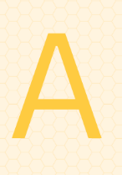
Appendix A: Important Abbreviations & Acronyms
ADA | Americans with Disabilities Act
ADD | Attention Deficit Disorder
ADHD | Attention Deficit Hyperactivity Disorder
AIDS | Acquired Immune Deficiency Syndrome
Arc | The Arc
ASHA | American Speech-Language-Hearing Association
ASL | American Sign Language
AT | Assistive Technology
AU | Autism
BIA | Bureau of Indian Affairs (federal level)
CA | Chronological Age
CAP-C | Community Alternatives Program for Children
CBRS | Community Based Rehabilitative Services (previously known as Special  Instruction/Developmental Therapy)
CC4C | Care Coordination for Children
CDSA | Children's Developmental Services Agency
CEC | Council for Exceptional Children
CNS | Central Nervous System
CP | Cerebral Palsy
D/B | Deaf/Blind
DA | Developmental Age
DAP | Developmentally Appropriate Practice
dB | Decibel
DCFW | Division of Child and Family Well-Being
DD | Developmental Disability or Developmental Delay
DHHS | Department of Health and Human Services (NC state office)
DPI | Department of Public Instruction (NC state office)
EC | Exceptional Children
ECAC | Exceptional Children's Assistance Center
ECE | Early Childhood Education
ECMH | Early Childhood Mental Health
ECSE | Early Childhood Special Education
ECTA | Early Childhood Technical Assistance Center
EI | Early Intervention

EISC | Early Intervention Service Coordinator
ESY | Extended School Year
FAPE | Free Appropriate Public Education
FERPA | Family Educational Rights and Privacy Act
FSN | Family Support Network
HI | Hearing Impairment including Deafness
HS | Head Start
ICC | Interagency Coordinating Council
ID | Intellectual Disability (mild, moderate or severe)
IDEA | Individuals with Disabilities Education Improvement Act
IEP | Individualized Education Program
IFSP | Individualized Family Service Plan
IQ | Intelligence Quotient
LD | Specific Learning Disability
LEA | Local Education Agency
LICC | Local Interagency Coordinating Council
LME-MCO | Local Management Entity-Managed Care Organizations (local mental health  agency)
LRE | Least Restrictive Environment
MA | Mental Age
MD | Multiple Disabilities
MDE | Multidisciplinary Evaluation
NAEYC | National Association for the Education of Young Children
NC-ICC | North Carolina Interagency Coordinating Council
NICCHY | National Dissemination Center for Children with Disabilities
NICU | Neonatal Intensive Care Unit
OCR | Office of Civil Rights
OHI | Other Health Impairment
OI | Orthopedic Impairment
OSEP | Office of Special Education Programs (federal level)
OEL | Office of Early Learning (NC state office)
OT | Occupational Therapy or Occupational Therapist
Part B | Part of IDEA that regulates educational services to children with disabilities ages three through 21
Part C | Part of IDEA that regulates educational services to children with disabilities  ages birth to 36 months
PL | Public Law
PL 94-142 | Education for All Handicapped Children Act, now IDEA

PL 99-457 | Amendment to 94-142 that authorized early intervention for infants and toddlers with disabilities and required preschool services for three- to five-year olds.
PT | Physical Therapy or Physical Therapist
RN | Registered Nurse
S/L | Speech and Language
SC | Service Coordinator or Service Coordination
SEA | State Education Agency
SECTION 504 | Portion of the Rehabilitation Act of 1973, as amended
SECTION 619 | The portion of IDEA that deals solely with the preschool program
SED | Serious Emotional Disability, now referred to as emotional disability
SEE | Signing Exact English
SI | Speech or Language Impairment
SLP | Speech-Language Pathologist
SLT | Speech and Language Therapy or Speech-Language Therapist
SS | Social Security
SSI | Supplemental Security Income
ST | Speech Therapy
TBI | Traumatic Brain Injury
TDD | Telecommunication Device for the Deaf
VI | Visual Impairment, including blindness


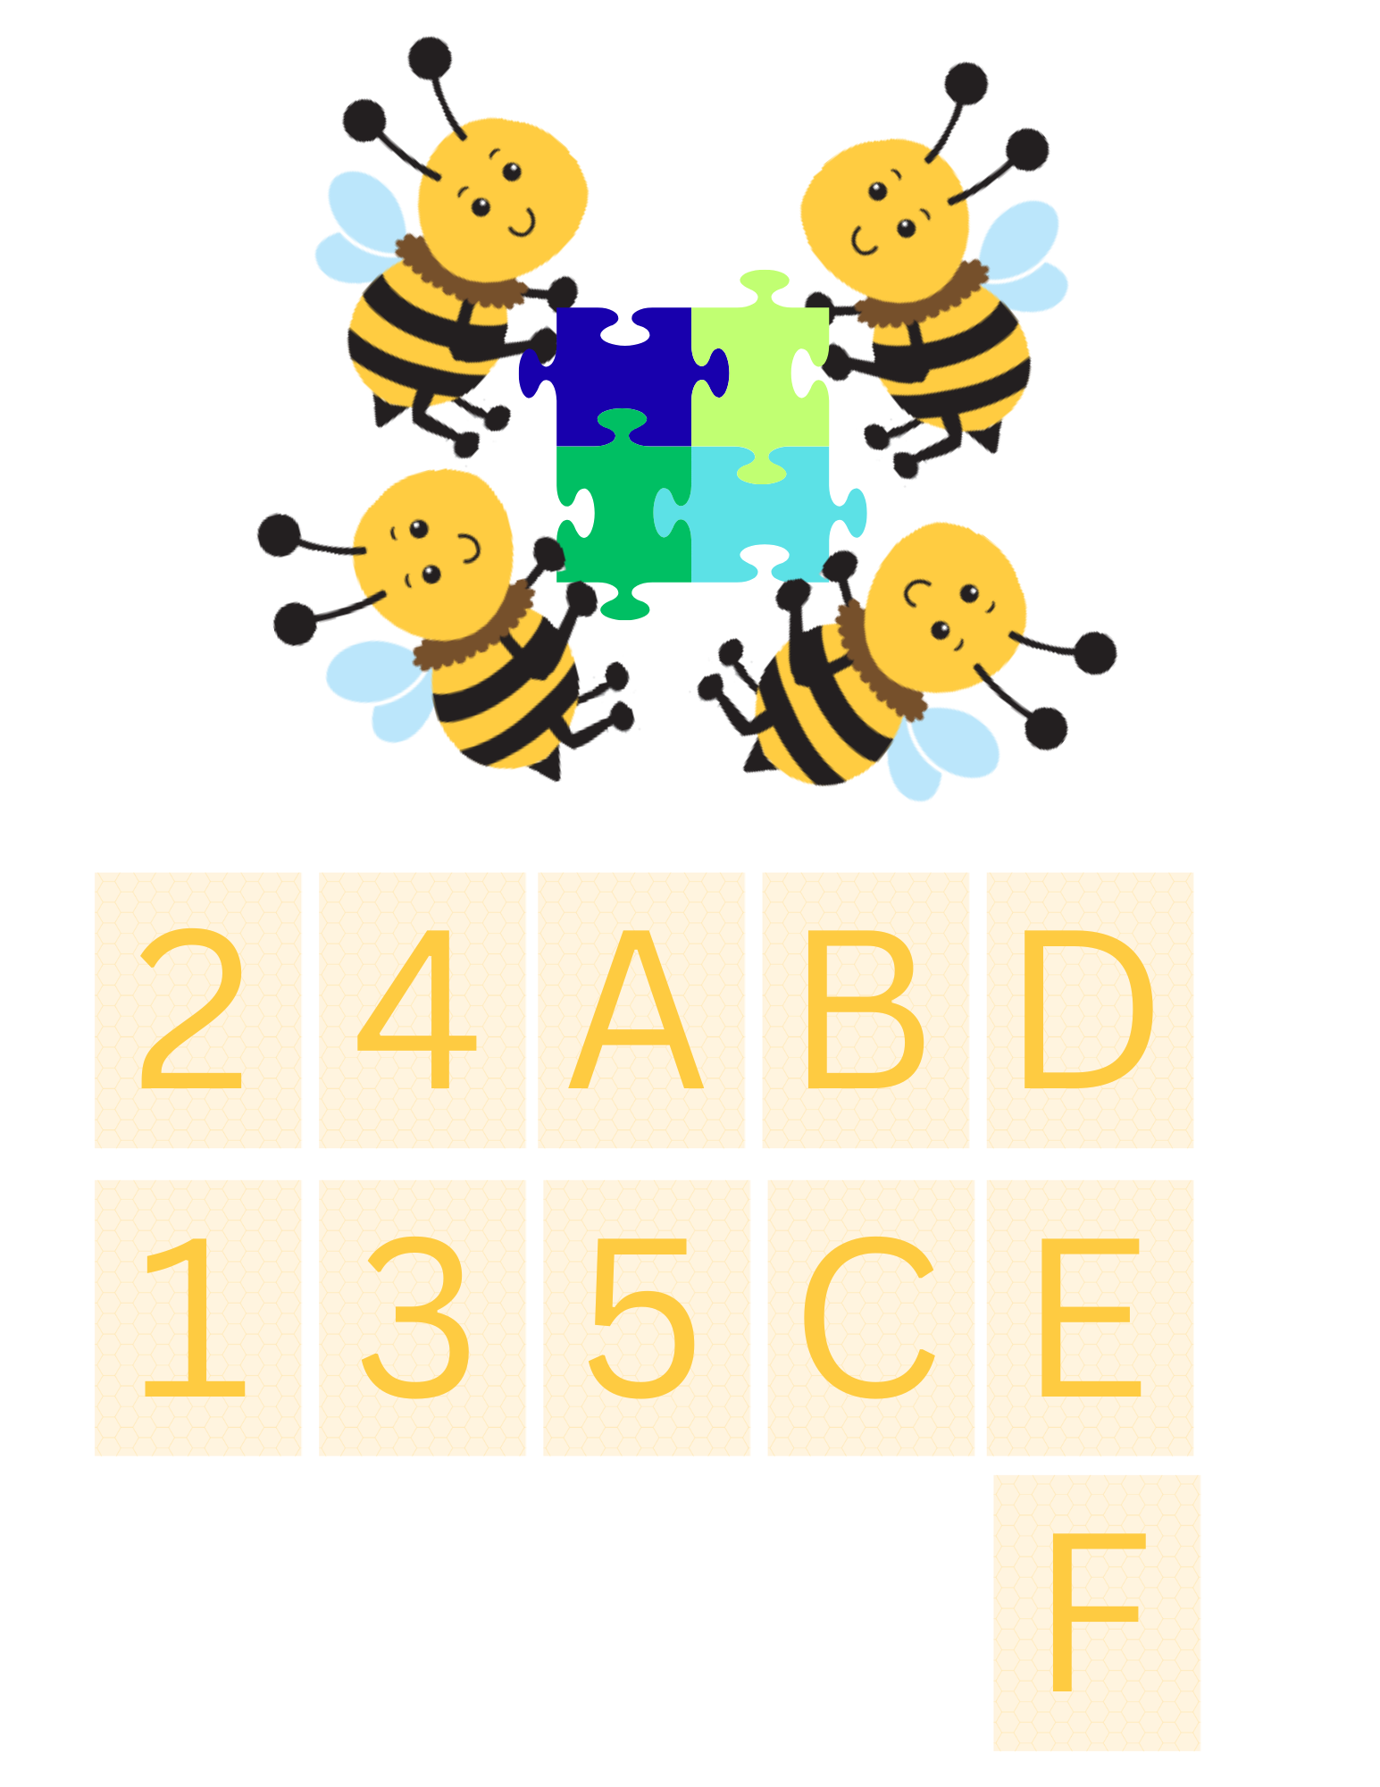
Appendix B: Family Partner Dictionary
Definitions of Early Intervention Words


Definitions given here are very basic and may lack details about what is required under the law. For additional information, talk with your Early Intervention Service Coordinator.

Adaptive Development
Skills that children develop that allow them to take care of themselves and become independent (such as feeding and dressing).

Adjusted Age (AA)
The age of a child, minus the number of weeks the child was born prematurely. For example, if a child was born 10 weeks premature, and currently is 34 weeks old, the child’s adjusted age is 24 weeks.

Administrative Due Process Hearing
A formal process for settling disagreements about Infant-Toddler Program services. An Administrative Hearing Officer, approved by the Early Intervention Section, oversees the process.

Advocacy
The process of speaking for, writing in favor of, supporting, and/or acting on behalf of oneself, another person, or a cause. In obtaining the appropriate educational services for a child, advocacy can be defined as action or intervention in the service system on behalf of a child to ensure or obtain the best possible services for that child.

Assessment
The ongoing process of gathering and using information about how a child is developing and determining areas of strength and need.

Assistive Technology Resource Center (ATRC)
A place where parents and service providers learn how to use special equipment. The ATRCs also loan special equipment and developmental toys to children and families.

The Arc
A national association with state and local chapters that works to encourage programs and activities for people of any age with intellectual and other developmental disabilities.

Augmentative Communication
A collection of techniques, symbols, equipment, and interaction strategies to facilitate communication, which may include sign language, picture boards, electronic communication devices, microcomputers, or a combination of systems.

Autism
A pervasive developmental disorder characterized by a pattern of deficits that include impaired communication skills, failure to develop social relationships, and restricted, repetitive, and atypical behaviors.



BEGINNINGS for Parents of Children Who are Deaf or Hard of Hearing
A non-profit agency providing an impartial approach to meeting the diverse needs of families with children who are deaf or hard of hearing and the professionals who serve them.



Care Coordination for Children (CC4C)

An at-risk population management program that serves children from birth to 5 years of age who meet certain risk criteria, whose main goals are to improve health outcomes and reduce costs for enrolled children. It is a partnership between Community Care of North Carolina (CCNC), the NC Department of Health and Human Services’ Division of Public Health (DPH) and the Division of Medical Assistance (DMA).

Child Development Center
A name used by some child care programs.

Child Development Specialist
See Early Childhood Special Education Teacher.

Child Find
A process developed by each state for identifying children potentially eligible for the Infant- Toddler Program and Preschool Program Services. North Carolina Child find requirements allow referral sources to share the child’s name, date of birth, address, parent’s name and telephone number, and the general fact that the child may be eligible for the program.

Child Outcomes

The benefits experienced by a child receiving early intervention services.

Children’s Developmental Services Agency (CDSA)
The local lead agency for the North Carolina Infant-Toddler Program.

Chronological Age (CA)
The actual age of an individual, which is determined from his or her date of birth. Chronological age can be expressed in years, months, and days.

Cognitive Development
Skills that children develop allowing them to think, learn, problem-solve, and remember.

Communication Development
Skills that children develop that allow them to understand language and tell others what they think, feel, want, or need. Signs, gestures (such as looking and pointing), and talking are all means of communication.

Community Alternatives Program for Children (CAP/C)
Formerly referred to as “Katie Beckett.” A Medicaid program that provides case management and home care services to medically fragile children from birth through age 18 who would otherwise require long-term hospital care or nursing facility care.

Community Alternatives Program for Intellectual/Developmental Disabilities(CAP-I/DD)
A Medicaid waiver program that provides community services and case management to individuals of any age who qualify for care in an intermediate care facility for the mentally retarded (IFC-MR). The focus is to enable individuals to remain in the community instead of residing in an institution.

Community-Based Rehabilitative Services (CBRS)
A service provided to enhance development in infants and toddlers that could include promoting the acquisition of skills in various developmental areas, curriculum planning, and providing families with skills, information and support.

Concerns
Areas that family members identify as needs, issues, or problems they want to address as part of the IFSP.



Department of Health and Human Services (DHHS) also North Carolina Department of Health and Human Services (NCDHHS)
A state agency that is responsible for ensuring the health, safety, and well-being of all North Carolinians. It administers the Division of Public Health, Division of Health Benefits, the Division of Mental Health, Developmental Disabilities, and Substance Abuse Services, the Division of Social Services, and other agencies.

Department of Public Instruction (DPI)
A state agency that is responsible for the administration and oversight of North Carolina’s public schools.

Developmental Age (DA)
The age at which a person is functioning.

Developmental Delay (DD)
When a child’s growth or skill development is slower than that of most other children of the same age.

Developmental Milestones
The skills a child learns at certain times throughout infancy and childhood such as sitting, crawling, or walking.

Disability
An impairment associated with a person’s limitations in everyday activities.

Disability Rights North Carolina (DRNC)
A 501(c)(3) nonprofit organization that provides advocacy and legal services at no charge for people with disabilities across North Carolina.

Division of Child and Family Well-Being
The NCDHHS Division of Child and Family Well-Being works to meet the health, social and emotional needs of children, youth, and families in North Carolina.

Division of Child Development and Early Education (DCDEE)
An NCDHS agency that licenses and monitors all child care programs in the state, administers child care subsidies, promotes professional development of child care providers, and administers Smart Start and the NC Partnership for Children.

Division of Services for the Blind (DSB)
An NCDHHS agency that oversees programs for people who are blind or visually impaired.

Division of Social Services (DSS)
An NCDHHS agency that provides such things as information, referral, follow-up case management, and foster care support. DSS may also refer to a local (county) Department of Social Services.

Due Process
The family’s right to have a formal review of disagreements about services they or their children are eligible to receive by law.




Early Childhood Special Education Teacher
A specialist trained in child development and ways to help children effectively develop and learn needed skills. This person may provide special instruction in a child’s home, or in a center, or may be a teacher in a child care program.

Early Intervention Section
State lead agency for the N.C. Infant-Toddler Program, under the Division of Child and Family Well-Being. The program is governed by the federal Part C of the Individuals with Disabilities Education Act (IDEA).

Early Intervention Services
Generally, services that help families with young children, aged birth to five years, with special needs. These services help young children grow and develop and support their families in caring for them.

Early Intervention Service Coordinator (EISC)
The title given to the providers of service coordination under the North Carolina Infant-Toddler Program.

Early Learning Sensory Support Programs
Programs within the Office of Early Learning in the Department of Public Instruction that administers two programs for infants and toddlers with hearing (Early Intervention Program for the Deaf or Hard of Hearing) and/or visual impairments (Governor Morehead Preschool for the Visually Impaired).

Exceptional Children's Assistance Center (ECAC)
A useful resource for information regarding preschool and school-aged children with disabilities and their rights in the school system in public education.

Exceptional Children’s Preschool Program Services (Part B of the IDEA)
Early intervention services for children ages three and four years, based on an Individualized Education Plan (IEP). In North Carolina, these are provided by, or are under the supervision of, local public-school systems.

Early Intervention Program for Children Who are Deaf or Hard of Hearing
A program that provides early intervention for children from birth to age three who are deaf or hard of hearing.



Family Support Network of North Carolina (FSN-NC)

An agency that provides support and assistance to families of children with special needs through a statewide network of parent-to-parent programs.

Family Outcomes
The benefits experienced by a family as a result of receiving early intervention services. (Also see child outcomes.)

Fee
Charges paid to service providers, based on services provided.

Fine Motor Development
Skills that children develop that rely on their small muscles (such as holding materials, turning knobs, using snaps and buttons).

FERPA
The Family Educational Right and Privacy Act. A federal law that protects the privacy rights of children and families enrolled in the Infant-Toddler Program, students, and parents.



Gross Motor Development
Skills that children develop which rely on their large muscles (such as crawling, sitting, walking).


HIPAA
Health Insurance Portability and Accountability Act of 1996. A federal law that protects the confidentiality of medical records and other personal health information. It limits the use and release of individually identifiable health information, gives patients the right to access their medical records, and restricts most disclosure of health information to the minimum needed for the intended purpose.

Inclusive
Services provided to children with special needs in settings that also serve those children who do not have special needs. These services are typically located in a preschool, child care center, or day care home. When a child is in an inclusive setting, the early intervention professional works with the child in that setting, and provides consultation, training, and support to the staff of the setting. Another name for an inclusive setting is a natural environment.

Individual Child Complaint Resolution
The formal resolution of concerns and disagreement between a parent and the Infant-Toddler Program using mediation and/or an administrative due process hearing.

Individualized Education Program (IEP)
Written document listing the services and resources a child will receive when he or she is eligible to receive his/her education through the public schools at age three.

Individualized Family Service Plan (IFSP)
A process to plan services for a child and his/her family, and a written document of that process. The process involves a joint planning effort between parents and specialists. The written document lists the services a child needs to grow and develop, and the services the family needs to help their child grow.

Individuals with Disabilities Education Act (IDEA)
A federal law that requires special services for children birth to age 21 years with special needs. Part B provides for children aged three to 21. Part C provides for children from birth to age three.

Infant-Toddler Program (Part C of IDEA)
The North Carolina early intervention program for children younger than age three with disabilities and their families.

In Loco Parentis
A person, other than a natural or adoptive parent or legal guardian, who has assumed the status and obligation of a parent without being awarded legal custody by a court.

Interagency Coordinating Council (ICC)
An advisory group for the implementation of an interagency system of services. There are two interagency councils associated with the Infant-Toddler Program: the North Carolina Interagency Coordinating Council (NC-ICC), and the Local Interagency Coordinating Councils (LICCs).




Least Restrictive Environment (LRE)
An educational setting or program that provides a child with special needs opportunities to work and learn to the best of his or her ability. It also provides the child with as much contact as possible with children without disabilities, while meeting all the child’s learning needs and physical requirements.

Local Education Agency (LEA)
A term used to describe the local public school system.

Local Interagency Coordinating Council (LICC)
A community group of people that includes early intervention agencies, parents, and other interested parties that are committed to young children with disabilities and their families. This group works to support local early intervention efforts.



Mediation
Procedures to resolve disputes involving matters under the Infant-Toddler Program. The mediation process is conducted by a qualified and impartial mediator who is knowledgeable in laws and regulations relating to the provision of early intervention services and trained in effective mediation techniques.



Native Language
When used with reference to people of limited English proficiency, this means the language or mode of communication normally used by the person.

Natural Environments
Early Intervention service settings, to the maximum extent appropriate to the needs of the child that are natural or normal for the child’s age peers who have no disability.

Neonatal Intensive Care Unit (NICU)
The unit in the hospital that cares for premature infants and very ill babies until they are transferred to the regular nursery.



Outcomes (or goals as related to the IFSP)
Statements of expectations or changes that families want for themselves and their children as a result of early intervention services, written in Individualized Family Service Plans.



Parent
A parent is…
- A biological or adoptive parent of a child
- A foster parent (unless contractual obligations with a State or local entity prohibit a foster parent from acting as a parent)
- A guardian generally authorized to act as the child’s parent, or authorized to make early intervention, educational, health or developmental decisions for the child (but not the State if the child is a ward of the State)
- An individual acting in the place of a biological or adoptive parent (including a grandparent, stepparent, or other relative) with whom the child lives, or an individual who is legally responsible for the child's welfare
- Or a surrogate parent

Pediatric Intensive Care Unit (PICU)
The unit in the hospital that cares for babies and children who are seriously ill or injured until they are transferred to the pediatric unit.

Personally Identifiable Information
Any information that identifies or might enable a person to contact or locate the person to whom such information pertains.

Physical Development
Moving, seeing, and hearing abilities.

Priorities
A family’s choice as to how early intervention will be integrated into the family’s life; what is most important to the family.

Procedural Safeguards
Rules and procedures that protect rights specified by IDEA. Often referred to as Child and Family Rights.

Provider
A public or private agency or a professional that receives public funds to provide early intervention services for an eligible child and the child’s family.



Recommended Services
Early intervention services believed to help children to grow and develop, but which are not required to be available to all children and their families who are eligible for the Infant-Toddler Program.

Referral to Early Intervention
Contacting the Children’s Developmental Services Agency (CDSA) in your area due to concerns for a child’s development or physical abilities. Parents, medical professionals, or anyone in the community can make referrals.

Required Services
Services that must be made available to all North Carolina children and their families eligible for and enrolled in the Infant-Toddler Program, if these services are listed on the Individualized Family Service Plan.

Resources
The strengths, abilities, and supports that a family can use to meet its needs.



Sliding Fee Scale
A method for determining payment for certain services, based on a family’s income and size.

Smart Start
A group in your community that provides funding to local programs to help young children get ready for school. Smart Start provides funding for services such as quality child care and health care for children. The Smart Start group may be referred to as the local Partnership.

Social-Emotional Development
Skills that children develop that allow them to interact with others (playing, responding to adults and other children) as well as to express their emotions (laughing, crying, talking about feelings).

Special Needs
The term used to refer to children who have developmental delays or an established condition which has a high probability of resulting in a developmental delay.

Supplemental Security Income (SSI)
A federal program that provides financial assistance for eligible children under 18 who are blind or have a severe disability or chronic illness. It also provides financial assistance to people aged 65 or older who are blind or disabled, and who have little or no other resources and income.

Supports
People or activities in a child’s and family’s life that enhance his or her everyday functioning. Supports may be formal or informal.

Surrogate Parent
A person appointed to protect the rights of a child participating in the Infant-Toddler Program if the parents of the child are not known, cannot be found, or the child is a ward of the State. The surrogate cannot be an employee of the state, and cannot be any person, or employee of a person, providing early intervention services to the child or any family member of the child.



Transition
Transition occurs when children exit the Infant-Toddler Program because they no longer need early intervention services, or they turn three years old and age out of the program. The Infant-Toddler Program is required to ensure a smooth transition for children and families exiting the program and entering the public-school system’s Exceptional Children’s Preschool Program or other appropriate services.

Treatment and Education of Autistic and related Communication Handicapped Children (TEACCH)
A program whose mission is to enable individuals with autism to function in the community as meaningfully and as independently as possible. TEACCH provides services to individuals with autism and their families, and to those who serve and support them.



Ward of the State

A federal phrase that means, in North Carolina, that a county Department of Social Services has been given legal custody of the child and therefore has legal responsibility to make decisions concerning the child even if the natural or adoptive parent is known, available, and interested in representing the child.

Well-Child Care

Generally, medical care given to children during the first six years of their lives. Services include a medical history and complete physical examination, as well as developmental assessment, and immunizations. The American Academy of Pediatrics recommends well- child care visits occur at one month, two months, four months, six months, nine months, 12 months, 15 months, 18 months, 24 months, and yearly thereafter.

Women, Infants and Children (WIC)
Provision of nutrition education, supplemental foods (including formula), breast-feeding promotion and support, and referrals to health care for women, infants, and children. The NCDHHS Division of Child and Family Well-Being administers the WIC program.

Appendix C: LICC Mini-Grants

Quick Guide to Mini-Grants

LICCs are eligible for an $800 mini grant to complete Child Find activities
- The application period for the grant is open from September 1 – September 30
- Application materials and instructions can be found on the LICC Resource Padlet
- Completion of the Child Find activity report is a requirement to be eligible for the next award
- Funds can be used in many ways, the following table includes some examples of previous LICC work with mini grant dollars

Examples of child find activities funded by mini grants
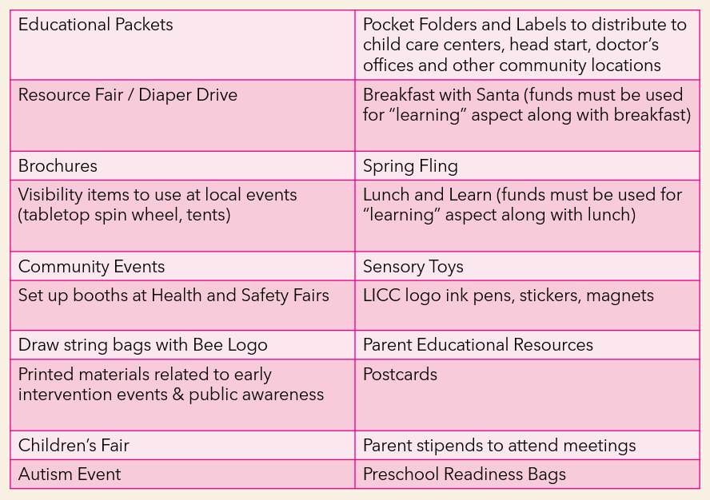

Appendix D: LICC Child Find Activities Report

Additional instructions and materials for Child Find Activities reporting can be found on the LICC Resource Padlet


LICC: Fiscal Year: July 1, - June 30,

Primary Referral Source (Target Audience) | Conducted or Participated in: |  | Distributed Materials |  |  |  | Advertisement
Primary Referral Source (Target Audience) | Community Event | Screening Clinic | Be Early Materials | Parent Handbook | Provider  Resource Packets | Other Materials
1. Hospital(s) (#in LICC region ) | Yes No N/A | Yes No N/A | Yes No N/A | Yes No N/A | Yes No N/A | Yes No N/A | Yes No N/A
2. Physicians & Medical Community | Yes No N/A | Yes No N/A | Yes No N/A | Yes No N/A | Yes No N/A | Yes No N/A | Yes No N/A
3. Parent/Family Caregiver | Yes No N/A | Yes No N/A | Yes No N/A | Yes No N/A | Yes No N/A | Yes No N/A | Yes No N/A
4. Child Care Resource & Referral Agency | Yes No N/A | Yes No N/A | Yes No N/A | Yes No N/A | Yes No N/A | Yes No N/A | Yes No N/A
5. Child Care Programs | Yes No N/A | Yes No N/A | Yes No N/A | Yes No N/A | Yes No N/A | Yes No N/A | Yes No N/A
6. Public Health Department | Yes No N/A | Yes No N/A | Yes No N/A | Yes No N/A | Yes No N/A | Yes No N/A | Yes No N/A
7. Department of Social Services | Yes No N/A | Yes No N/A | Yes No N/A | Yes No N/A | Yes No N/A | Yes No N/A | Yes No N/A
8. Mental Health Agency/Provider | Yes No N/A | Yes No N/A | Yes No N/A | Yes No N/A | Yes No N/A | Yes No N/A | Yes No N/A
9. Early Head Start & Head Start | Yes No N/A | Yes No N/A | Yes No N/A | Yes No N/A | Yes No N/A | Yes No N/A | Yes No N/A
10. Even Start | Yes No N/A | Yes No N/A | Yes No N/A | Yes No N/A | Yes No N/A | Yes No N/A | Yes No N/A
11. Partnerships for  Children/ Smart Start | Yes  No N/A | Yes  No N/A | Yes  No N/A | Yes  No N/A | Yes  No N/A | Yes  No N/A | Yes  No N/A
12. Homeless Family Shelters | Yes  No N/A | Yes  No N/A | Yes  No N/A | Yes  No N/A | Yes  No N/A | Yes  No N/A | Yes  No N/A
13. Domestic Violence Shelters & Agencies | Yes No  N/A | Yes No  N/A | Yes No  N/A | Yes No  N/A | Yes No  N/A | Yes No  N/A | Yes No  N/A
14. Other: | Yes No  N/A | Yes No  N/A | Yes No  N/A | Yes No  N/A | Yes No  N/A | Yes No  N/A | Yes No  N/A

Please describe:
Conducted or Participated in:
- Community Event:
- Screening Clinic:
Distributed Materials:
- Be Early materials:
- Parent Handbook:
- Provider Resource Packets:
- Other materials:

Advertisement: Other:

Instructions for Completing
LOCAL INTERAGENCY COORDINATING COUNCIL CHILD FIND ACTIVITIES REPORT
The Child Find Activities Report is a statewide method to capture the rich, diverse outreach activities promoting community awareness of the NC early intervention system locally. Listed on the report are the primary referral sources for the early intervention system, although they may not all be in your communities.
Activities include explaining the Infant-Toddler and/or the Preschool/Exceptional Children’s early intervention programs regarding:
- Referral process
  - Who, how or why to refer
- Screening and Evaluation process(es)
  - Brief overview of methods used by CDSA and/or Preschool/Exceptional Children’s program
  - Brief overview of how early intervention programs screen/evaluate
- Eligibility categories
  - Overview of categories/conditions leading to eligibility within Infant-Toddler and/or the Preschool/Exceptional Children early intervention programs
What activities or events to include:
- Child Find group activities or events (ex. presentations, forums, community events, screening clinics)
- Distribution of materials (ex. Be Early materials, Act Early materials, Parent Handbook, Provider Resource Packets)
- Mass media/advertisements (ex. website, TV/radio promotions, billboards)
  - Planned Child Find outreach activities sponsored by the LICC or LICC members
  - Do not include ’individual encounters,’ such as one-on-one conversations
Completing the report:
  - Enter Yes or No in each column depending on whether your LICC reached the referral sources/populations during the year. Enter N/A if that referral source/population does not exist in your LICC catchment area.
  - Multiple referral sources/populations may be documented in each topic column.
  - Please be sure to describe your activities, so that this information can be shared with funders and other LICCs as appropriate.
  - Summarize and submit one report for the most recent state fiscal year (July 1 – June 30).
  - Due (date) to the NC-ICC Coordinator:
    - Brian Deese: Brian.deese@dhhs.nc.gov

Appendix E: Sample Family Partner Letter from LICC
Dear Family Partner:
The Local Interagency Coordinating Council (LICC) is composed of professional and non-professional members. Everyone who attends meetings does so voluntarily and brings a valuable point of view to the group. As a parent member, you have a very important contribution to make to the LICC: your opinion. Please do not hesitate to participate in the discussions at LICC meetings.
Think of yourself as a “customer.” After all, you and your family are the recipients of services provided by the state and local agencies. This is an excellent opportunity for you to offer suggestions to improve the services that your child receives. Family Partners have the power to offer suggestions that continually help improve early intervention services. It is also a good time to express your satisfaction if you have had a good experience with a particular service or agency. Praise goes a long way.
By providing the LICC your perspective as a caregiver of a child with special needs, you will be offering a great service to the community. The primary purpose of parent representation on the LICC is to assist professional members by offering ideas to better serve families of children with special needs in the area. Your input is necessary and valuable to ensure that the efforts of the LICC reach families, like yours, who have children with special needs.
We understand that your time is valuable; therefore, your involvement with the LICC is very much appreciated and will not be taken for granted. We consider it an honor that you would take time to join with us in our pursuit to reach all families of children with special needs.
Whether you have just joined the LICC or have been a member for a while, thank you for your commitment to participate on the Local Interagency Coordinating Council.
Sincerely,

Your Local Interagency Coordinating Council Partner

Appendix F: Sample LICC By-Law
County Local Interagency Coordinating Council By-Laws
ARTICLE 1. ORGANIZATION NAME
The name of this organization shall be…
ARTICLE 2. MISSION/VISION STATEMENT

Example 1
The County Local Interagency Coordinating Council (hereinafter referred to as the ‘LICC’) shall serve the community as follows:
- Provide opportunities for service providers to be involved in local activities such as child find and public awareness, community needs assessment, system evaluation and professional development.
- Develop and disseminate county specific public awareness and child find materials.
- Foster interagency collaboration and information sharing.
- Encourage community efforts supporting inclusion of children with special needs and their families.

Example 2
The County Local Interagency Coordinating Council (hereinafter referred to as the LICC) shall serve as the designated group for interagency cooperation regarding service delivery for infants and children with developmental disabilities or delays or established health conditions ages birth five, and their families.

Example 3
The County LICC will develop and maintain a community-based identification and service delivery system within the county for children with special needs from birth through 5 years of age and their families.

Example 4
The community wide vision of the County Local Interagency Coordinating Council is promoting interagency cooperation in supporting children, birth to five, with developmental disabilities or delays or established health conditions ages birth to five and their families so that they may fully participate in healthy development, family, and community lifestyles.
ARTICLE 3. ￼MEMBERSHIP

Section 1: ￼AGENCY REPRESENTATION
Define who the members are. Is there a limit to the number of members? Are the members representing themselves or do they represent their agency if they are employed by an agency?

Example
Representation includes, but is not limited to, the following agencies. Each agency’s director/supervisor will be asked to designate one representative. Each agency will notify the LICC of any changes in representation. [Add location specific services as well.]
- Department of Social Services
- County health department
- County schools
- County Smart Start
- Regional library
- Child care community representative
- Department of Public Instruction (Early Learning Sensory Support Programs)
- Child care resource & referral
- Children’s Developmental Services Agency
- Head Start
- Healthy social behaviors Specialist
- Local hospital
- NC Pre-K
- NC Cooperative Extension Service
- Parent to Parent – Family Support Network

Section 2. MEMBER TERMS
Define the term of the members. Do they serve staggered terms so that at least half of the LICC is always made up of experienced members? Are members restricted to serving a maximum length of time before they are required to rotate off?

Example
Following three consecutive absences without notification, a phone call will be made, or a letter sent to the participating member to ask if they are interested in continued membership on the council.

Section 3. REMOVING A MEMBER
Define procedure for defining and replacing non-contributing or inactive members.

Example
Any member may be removed with cause by a majority of a quorum of Members. Cause will be determined by the Executive Committee and be based upon such action as, not all inclusive, but including behavior and actions contrary to the Mission and Values, illegal activity or actions, breach of confidentiality, immoral activity/actions, or failure to fulfill Member responsibilities.

Section 4. VOTING
Define voting rights of members. Does each agency get one vote? Which agency member gets that vote? Will you allow proxy votes?

Example
- Each agency will be allowed one vote per agency on items; regardless of the number of agency members present.
- Each parent representative will be allowed one vote.

Section 5. VACANCIES
Define procedure for filling member vacancies due to resignation. How do members resign?

Example
- A member shall resign from the LICC in writing to the Co-chairs of the LICC.
- A member may designate an alternate in writing to the Co-chairs of the LICC.

Section 6. MEMBER RESPONSIBILITIES
Define responsibilities of the members, including what to do if the member cannot make a meeting.

Example
- Attendance at regularly scheduled and announced meetings
- Actively participate in the discussions and activities of the LICC
- Positively represent the LICC
ARTICLE 4. OFFICERS

Section 1. OFFICERS
Define who the officers will be for the LICC.

Example
The officers of the LICC shall consist of a Chairperson, or Co-Chairs, a Secretary, and a Treasurer. All officers shall be elected by and for the membership of the LICC based on simple majority held when elections occur.

Section 2. ELECTION
Define how the officers are nominated and elected. When will this be done?

Example
The LICC Chair or Co-chairs shall take nominations from the floor for officers. Elections of officers will be held each May.

Section 3. DUTIES
Define the duties of each officer that are beyond their regular duties as LICC members. For example, who will receive information from the NC-ICC? Who will notify the NC-ICC when chairpersons/contact people change? Will one member serve as a Legislative Contact for the LICC?

Example 1
Each officer should be familiar with the current Infant-Toddler Manual. The designated officers of the LICC and their principle responsibilities shall include:
- Chair or Co-chairs
  - Preside over all scheduled and called meetings of the LICC
  - Establish Committee Task Forces
  - Set the meeting dates for the LICC for the upcoming year through coordination with key members
  - Provide meeting announcements to Members
  - Ensure an LICC representative serves on the Board of Directors of the County Smart Start
  - Maintain and distribute a roster of LICC members
  - Follow up with members on attendance
  - Establish meeting agendas with the support and advice from the executive committee to include matters for open or closed sessions
  - Co-chair will serve as Chair-elect and will assume duties in the Chair’s absence
- Recording Secretary
  - Take minutes at each meeting and distribute to the LICC Members prior to the next scheduled meeting
  - Ensure a record of attendance occurs and that members denote their commitment to maintain confidentiality with their signature
  - Will disseminate information to the LICC members only with the approval from the executive committee
  - Maintain a roster of LICC Members
  - Serve as treasurer
  - Maintain financial accounts and records of the LICC
  - Make monthly reports to the LICC of balances
  - Provide stipend to parent representative(s)

Example 2
- Duties of the Chairperson
  - Preside at LICC meetings
  - Establish agenda for each meeting with input from members
  - Call all emergency or special meetings if needed
- Duties of the Co-Chair (Parent Representative if possible)
  - Perform duties of Chair in his/her absence
  - Carry out other duties as delegated by the Chair
  - Train and support parents in their role in the LICC

- Duties of the Secretary
  - Maintain a membership roster and confidentiality statements
  - Record minutes of LICC meetings
  - Provide minutes to members
- Duties of the Treasurer
  - Provide up-to-date and accurate financial records of the LICC
  - Report financial statements at each LICC meeting
  - Assist with grant writing for LICC funding
  - Maintain the checkbook and related banking information in one central location which assures safety

Section 4. TERMS
Define the terms of each officer.

Example 1
The term of office shall begin on July 1 and conclude on June 30. Officers may be re-elected to no more than three consecutive terms. Vacancies will be filled as needed.

Example 2
Officers shall be elected for a term of two (2) years and may be re-elected for additional terms. Officers must be elected.

Section 5. EXECUTIVE COMMITTEE
Define the roles and who makes up the executive committee.

Example
- The Officers of the LICC shall be the Executive Committee.
- The Executive Committee may conduct business on behalf of the Members when all officers are present.
- Business conducted by the Executive Committee on behalf of the Members must be reported to the Members at the next immediate meeting.

Section 6. FISCAL
Define the roles and who makes up the executive committee.

Example
- The LICC will choose an appropriate organization to act as it fiduciary until such time as it may become a legal incorporated entity.
- The fiduciary will present a quarterly financial report to the LICC
ARTICLE 5. MEETINGS

Section 1. FREQUENCY/ SCHEDULING
Define meeting time, date and place. Time should include the beginning and ending time for the meeting. Define parameters for special “called meetings” as necessary. Who calls for special meetings? For what reasons? How are members notified?

Example 1
The LICC shall meet on a monthly basis on the third Tuesday at 9:00 am unless special circumstances arise; then the executive committee will reschedule. Called meetings are the prerogative of the chairperson and may occur if situations arise which require a response from the LICC outside the context of the regularly scheduled meetings.

Example 2
The general membership of the LICC shall meet quarterly on the third Thursday of March, June, September, and December from 9:00 am to 11:00 am at a designated location, unless otherwise notified.
Special Meetings may be called by the Chairperson or Co-Chair, or by two persons on the LICC, provided notice of the meeting is given five (5) working days in advance of the meeting.

Section 2. CONFIDENTIALITY
Describe how members must keep information confidential. What information does this pertain to?

Example
LICC members must maintain confidentiality with no infractions from discussing/disclosing information pertaining to issues related to children, parents, or agencies to unauthorized and/or uninvolved persons.

Section 3. ADVERSE WEATHER
Define what adverse weather is. What will be the protocol for canceling and rescheduling meetings?

Example
In the case of adverse weather (such as snow, ice, rain, flooding, etc.) LICC meetings will be automatically canceled when County Schools are closed to students.

Section 4. CONFLICT OF INTEREST
Define conflict of interest. How will this relate to the members on the LICC? Describe the LICC process if this becomes a concern.

Example
    - No members should knowingly vote on any matters which directly or indirectly benefit themselves or members of their family.
    - When a member has reason to believe that a member or a guest is, or may be, in violation of the conflict-of-interest policy or is seeking personal gain, the matter will go in front of the executive committee, who will then determine whether or not the topic can be discussed.

Section 5. QUORUM
Define a quorum. Will a quorum be required for the LICC to transact business?

Example
A quorum shall consist of a minimum of three (3) LICC members.

Section 6. MEETING AGENDA
Define how members will develop and receive a meeting agenda. Will the agenda for the next meeting be set at the end of meeting? How will new or late-breaking or time-limited information be handled? Will agendas be mailed in advance of the meeting, or will they be presented by the chairperson at the meeting?

Example 1
The Co-chairs will develop the agenda and send them to members prior to the meetings. Members should submit items they want to be considered for the meeting at least 3 days before the meeting.

Example 2
The secretary or Co-chairs will email pertinent early intervention information to LICC members.
ARTICLE 6. COMMITTEES

Section 1. FORMING SUBCOMMITTEES
Describe which subcommittees will be formed and how.

Example:
There will be two standing subcommittees of the LICC.
- Membership Committee
  - Committee and responsibilities will be developed by the LICC
- Public Awareness/Child Find Committee
  - Committee and responsibilities will be developed by the LICC

Section 2. WORK GROUPS & TASK FORCES
Describe which work groups or task forces will be formed and how.

Example:
Work groups or task forces will be formed from the membership through volunteers to investigate a specific need or problem and make recommendations for action to the larger committee.
ARTICLE 7. AMENDMENTS
Describe how any amendments will be made.

Example 1:
By-laws may be amended or changed by a majority vote of members present at the meeting.

Example 2:
These by-laws may be amended or repealed, and amendments adopted by the affirmative vote of the majority.

State of North Carolina

North Carolina Department of Public Instruction
Office of School Readiness
Exceptional Children Division
https://www.dpi.nc.gov/districts-schools/classroom-resources/exceptional-children



North Carolina Department of Health and Human Services
Division of Child and Family Well-Being
Early Intervention Section
https://www.ncdhhs.gov/itp-beearly



https://www.ncdhhs.gov ● North Carolina Infant-Toddler Program (NC ITP) | NCDHHS

Developed and modified in partnership with the Family Support Network of North Carolina.



Permission to reproduce is granted.
March 2026

The North Carolina Department of Public Instruction and the North Carolina Department of Health and Human Services do not discriminate on the basis of race, color, national origin, sex, religion, age, or disability in employment or the provision of services.

