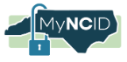

MyNCID
Access to the new IRIS system is restricted to registered users with valid NCID accounts. Please follow the instructions below explicitly for the path that applies to you.
Why is NCID needed for the IRIS system?
- Simplified Login: Streamlines access and automatically populates agency-specific information.
- Automated Notifications: Sends alerts when additional documents, information, or updates are required.
- Linked Reports: Enables information sharing across related reports, automatically prepopulates common fields, and allows reviewers to request additional details in one centralized location.
- Centralized Worklist: Provides users with a clear view of draft reports awaiting submission, outstanding actions, and information needed to finalize and close reports.
- Enhanced Security: Strengthens identity verification and safeguards sensitive information through improved security measures.

______________________________________________________________________________________________________
- Register for new NCID: For users who do not already have an NCID.
Follow the registration instructions, create an account if eligible, and then continue to IRIS – follow from Steps 1 - 5

- Already have an NCID: For providers who use NCID to access NCTracks or other state services.
Sign in with your existing credentials, then verify access to IRIS and complete any required account linking or authorization – follow from Step 5

For any existing account issues like Forgot Username/Forgot Password/Unlock Account for an existing NCID account: goto https://accessproxy.myncid.nc.gov/TroubleSigningIn.html or call NC DIT support desk

1. Register for new NCID account
Open the registration URL and select the account type that applies to you: Individual, Business, State Employee, or Local Government Employee.

Registration URL: https://accessproxy.myncid.nc.gov/NewUserRegistration.html

Providers, please use “Business” type.

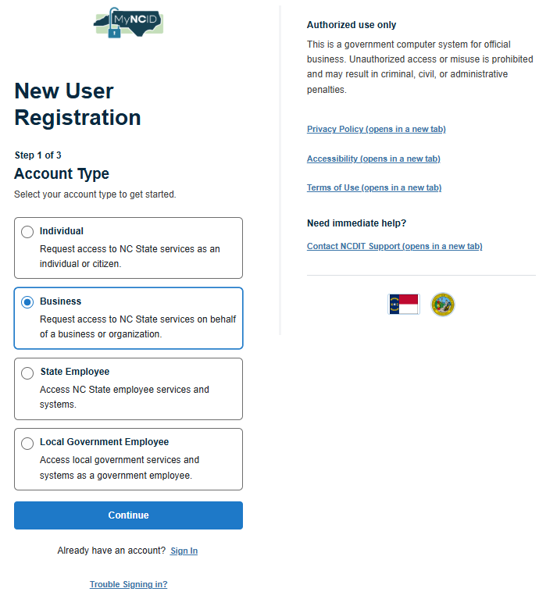
Fig1: Choose the correct account type, then select Continue.

- Enter your first name, last name, username, agency official email address, and any other requested details. Create and confirm a password that meets the on-screen rules, then select Register.

Note: Please use your official or business email address connected with your organization. DO NOT USE PERSONAL EMAIL ADDRESS.
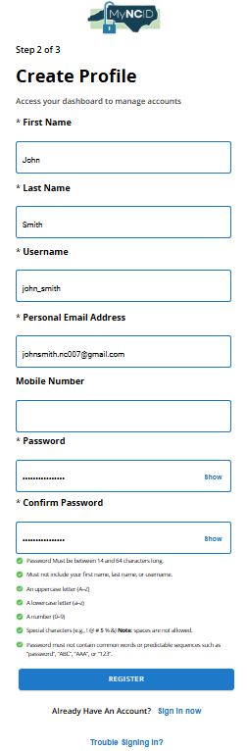
Fig2: Complete the required profile fields.
Note: The username and password you create during this process will be your NCID credentials for accessing North Carolina applications including the IRIS system. Keep your username and password in a secure location and do not share your password with others.

2. Verify your email
- You will be receiving an email from myncid.notifications@nc.gov to verify the email address provided above.
  - Note: Please also look into SPAM folder if you are not able to see the email in your inbox
- Select verify your MyNCID account. If needed, copy the verification link into your browser.
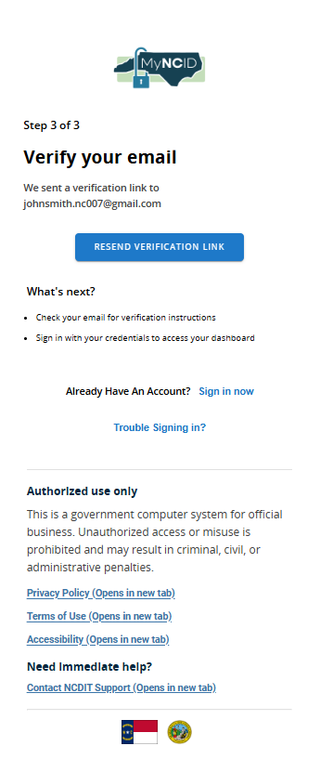
Fig3: MyNCID confirms the email address awaiting verification.

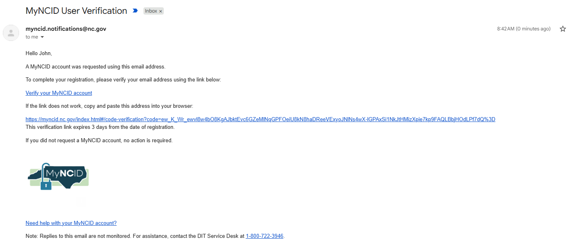
Fig4: Example verification email. The verification link expires after three days.
Can't find the email? Check Spam/Junk or use Resend Verification Link on the verification page.

3. Sign in
- After account creation, select Sign in on the NCID screen. Refer to figure 5.
- Enter your username and password when prompted. If you need help, select Trouble Signing In?
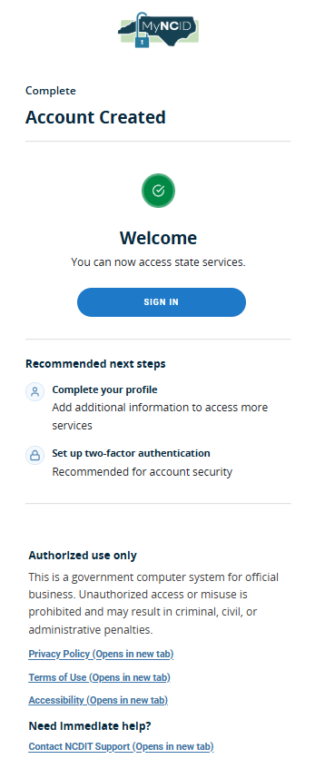
Fig5: Account created confirmation.

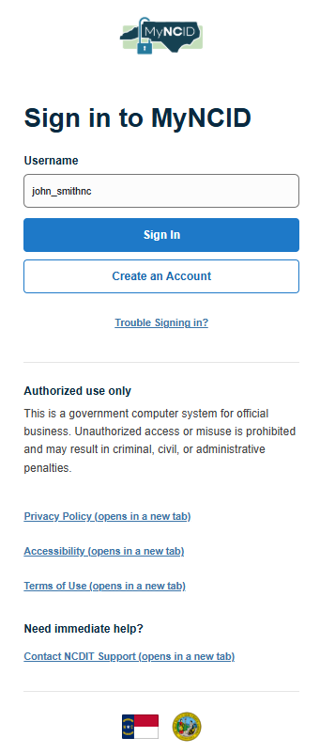  Fig6: Enter your username | 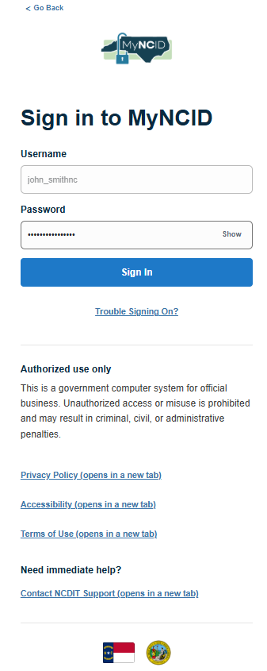  Fig7: Enter your password.

Note: Once you have successfully logged in to the NCID system, you may see different options on your screen. Please follow the instructions below based on the options displayed to complete your Multi-Factor Authentication (MFA) setup.

4. Set up MFA for new IRIS system Single Sign-On

Click on the new IRIS Portal page or copy and paste into your preferred browser https://ncdhhs.prod.simpligov.com/
- Open the portal and sign in with your MyNCID credentials. Enter your username and password created.
- On the MFA Enrollment screen, choose one method: Authenticator, Email, Phone Call, or Text Message.

Note - The below instructions illustrate how to set up MFS with the email address, steps may differ for other methods of setup.

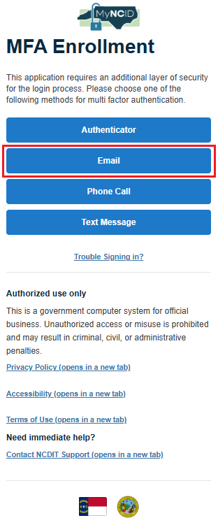
Fig8: Select your preferred MFA method.
Example: Choose Email, then open your inbox and find the “NCID OTP Notification” message from myncid.notifications@nc.gov.
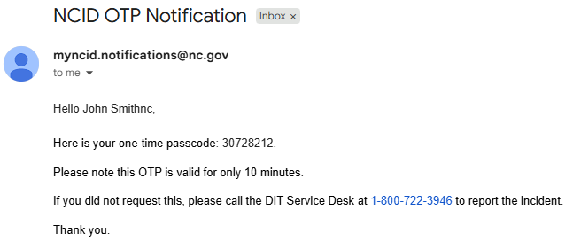
Fig9: one-time passcode email. Use your own current code; never reuse or share the code.

- Enter the OTP on the verification screen and select Submit. The code is valid for 10 minutes.
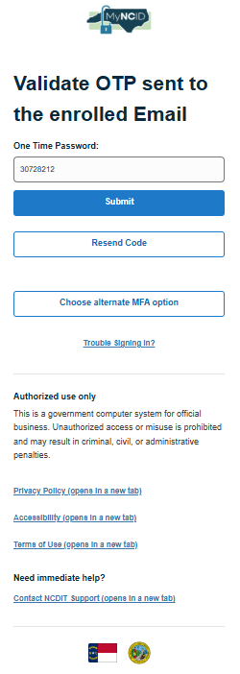
Fig10: Enter the code and select Submit. Use Resend Code if needed.

Other MFA methods: Follow the prompts displayed for Authenticator, Phone Call, or Text Message.

5. Login to new IRIS system with your NCID

Click on the new IRIS Portal page or copy and paste into your preferred browser: https://ncdhhs.prod.simpligov.com/

After you successfully authenticate with your NCID username/password and complete MFA verification, you should be able to log into the new IRIS system. Once logged in, the screen shown below will appear. If you can see this dashboard, your login to the new IRIS system using your NCID was successful. No further action is required at this time. For additional details, you may visit the IRIS Home Page to review the latest updates
NC IRIS Information Page
“Welcome to the New IRIS System!
If you are seeing this message, you have successfully logged in and reached the correct page of the new Incident Response Improvement System (IRIS).
No further action is required at this time.
For additional information and important announcements, please visit the NC IRIS Information Page.
Thank you for your patience and cooperation as we transition to the new IRIS system. “

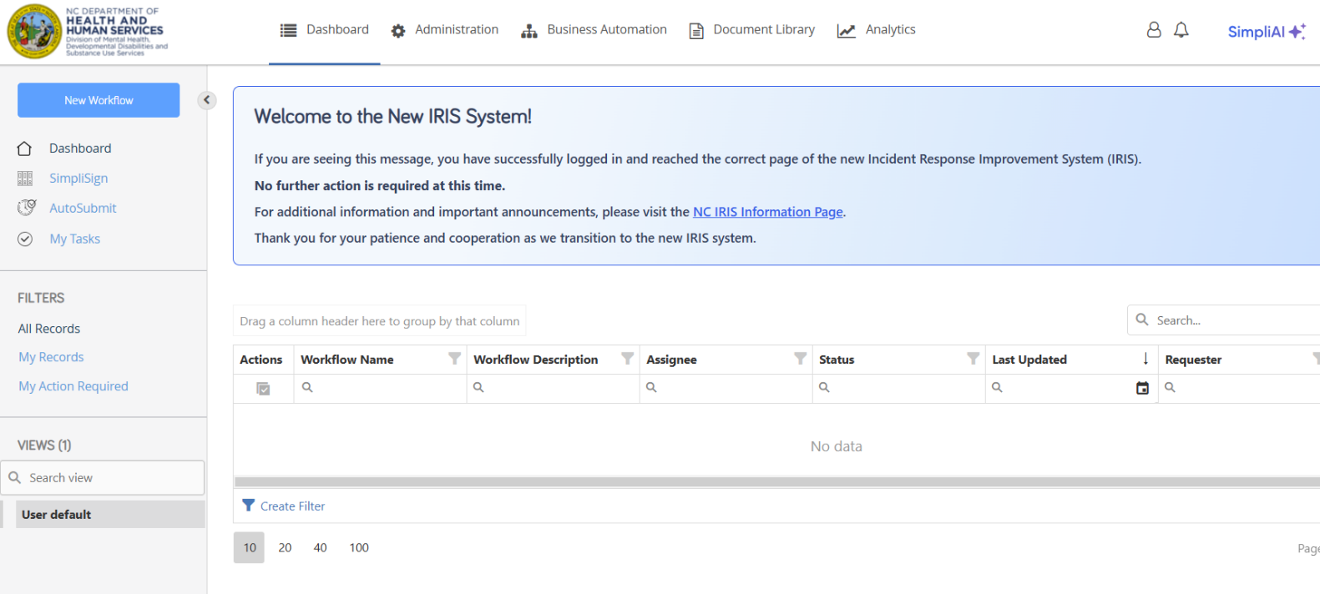
Fig11: New IRIS dashboard page after successful login using NCID

6. If you need help
For any sign-in issues or account unlock or password reset assistance refer to MyNCID support website: https://it.nc.gov/support/accounts/myncid
or contact the NCDIT Service Desk at 800-722-394 or 919-754-6000

If You Have Problems Accessing IRIS
If you have trouble creating your NCID, logging in, or accessing IRIS:
• Verify that your NCID account has been successfully created and activated.
• Confirm that you are using the correct NCID username and password.
• Check your email, including your spam or junk folder, for IRIS communications.
• Contact the IRIS staff at your Health Plan for assistance.
• You may also contact the IRIS staff at contactiris@dhhs.nc.gov with questions regarding the IRIS access process.
Important Reminder
Your NCID credentials are uniquely your own. Do not share your username or password with another individual. Each person who requires IRIS access should obtain and use only their own NCID account.

www.ncdhhs.gov NCDHHS is an equal opportunity employer and provider 11/2027

