North Carolina Senior Community Service

Employment Plan (SCSEP) Stand-Alone State Plan
Two-Year Modification (PY 2026–2027)
Prepared in accordance with TEGL 14-25 Section 4(b)

Executive Summary
This Two-Year Modification reflects a unified statewide Senior Community Service Employment Plan (SCSEP) strategy incorporating aligned input from CWI Works, National Council on Aging (NCOA) NCCBA, Inc., formerly known as the National Center and Caucus on Black Aging and the State of North Carolina SCSEP program. The update strengthens statewide coordination, expands employer engagement, integrates training aligned with labor market needs, enhances rural outreach, and prepares for program modernization such as Additional Training and Supportive Service (ATSS) utilization and federal Prevailing Wage changes.

Integrated Two-Year Plan Update
The SCSEP Two-Year Modification blends statewide and national grantee practices into a
seamless statewide approach. All grantees maintain a shared commitment to serving older North Carolinians with the greatest economic and social need, expanding community service assignments, and developing pathways to unsubsidized employment. This update reflects evolving workforce needs, service gaps, and participant demographics.

Labor Market and Training Alignment
Long-term employment projections across North Carolina indicate continued growth in health care, social assistance, food service, logistics, and administrative support roles. SCSEP
projects statewide—including those operated by CWI Works, NCOA, NCBA, Inc. and the State—align training with these sectors. Training includes digital literacy, employability skills, soft-skills coaching, and Occupational Information Network (O*NET) informed Individual Employment Plans.

Employment Trends by Sector (2024–2025)
Source: NC Labor Market Information Division — Sector Employment Change Analysis (Planning Visualization).

High-Demand Occupations & Training Alignment

Occupation | Training Focus | Credential
Certified Nursing Assistant | Clinical skills; caregiving | CNA License
Home Health Aide | Caregiving; daily living support | HHA Certificate
Food Service Roles | ServSafe; customer service | ServSafe Certification
Admin Support | Industry-recognized cert | Office Skills Certificate
Logistics & Facilities | Warehouse skills; safety

North Carolina’s labor market conditions continue to reflect strong overall economic
performance, with the statewide unemployment rate holding at 3.5 percent in May 2026. While unemployment increased slightly in 70 counties, most remained within a moderate range, and over-the-year trends show broad improvement across most counties. These conditions shape SCSEP service delivery by identifying where older jobseekers may encounter greater barriers such as limited job availability, transportation challenges, or reduced access to training providers. The statewide data supports targeted outreach in counties with consistently higher unemployment—such as Hyde, Edgecombe, Halifax, and Bladen- while reinforcing continued partnership development in counties with stable or improving job markets. This updated narrative replaces the previous heatmap section and provides a streamlined summary that aligns SCSEP statewide planning with documented economic conditions.
North Carolina Department of Commerce — May 2026 County and Area Employment Figures (Local Area Unemployment Statistics)

Employer Engagement Strategy
Employer engagement is a shared priority across SCSEP providers. Approaches include job fairs, weekly job postings, mock interviews, employer presentations, and coordinated outreach.
Employers benefit from reduced hiring risk, job-ready candidates, and support during
onboarding. This coordinated statewide strategy expands employer partnerships in both rural and urban communities.

Coordination with Workforce Partners
All SCSEP providers coordinate with NC Works Career Centers, community colleges, Adult Education, vocational rehabilitation, veterans’ services, faith-based groups, and community
organizations. Participants receive referrals, training, digital skills classes, and support services through these partnerships. Co-enrollment with Workforce Innovation and Opportunity Act (WIOA) Title I programs remain a statewide priority.

Co-Enrollment Workflow Summary

Stage | SCSEP Role | Workforce Partner Role
Intake | Eligibility, orientation,  assessments | NC Works assessment &  registration
Training | CSA training, digital literacy,  OJE | ITA, workshops, skills classes
Placement | Job development & referrals | Employer matching & hiring  support
CSA – Community Service Assignment: Hands-on training at nonprofit or public agencies.
OJE – On-the-Job Experience: Employer-based trial work experience with no hiring obligation.
ITA – Individual Training Account: Training funds used for credentialing, workshops, or occupational skills.

ATSS Waiver and Prevailing Wage Preparation
CWI Works and other SCSEP providers utilize ATSS waivers to expand participant access to training and essential supportive services. This flexibility supports participant re-engagement and training completion. To prepare for the forthcoming federal Prevailing Wage framework, all grantees are aligning job goals and training pathways with O*NET occupational umbrellas to ensure consistency statewide.

Rural Strategy and Participant Support
Rural areas face challenges such as transportation, isolation, limited broadband, and fewer training sites. SCSEP providers respond by partnering with senior centers, food banks,
community nonprofits, tribal organizations, and local governments to expand outreach. Recruitment methods include senior-serving organizations, targeted marketing, PSAs, and referrals from NC Works.
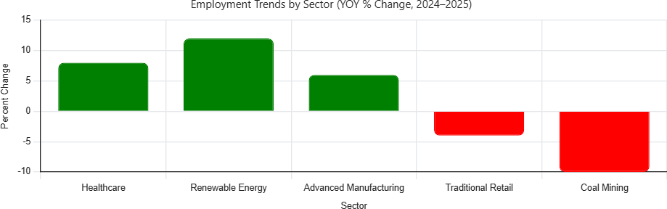

Alignment With TEGL 14-25 §4(a) and TEGL 07-25

Pillar 1: Prepare workers for in-demand careers

Training is aligned with high-growth sectors and O*NET-based Individual Employment Plans. Pillar 2: Advance equity
Targeted outreach for rural, low employment prospects, (LEP) homeless, veterans, and priority individuals.

Pillar 3: Support employers
Consistent statewide employer engagement includes job fairs, presentations, and mock interviews.

Pillar 4: Expand work-based learning
CSA assignments, digital literacy, ATSS-supported training, and OJE opportunities.

Pillar 5: Strengthen system alignment
Co-enrollment, NC Works integration, strong WIOA collaboration.

Compliance With Federal Non-Discrimination Requirements
All SCSEP grantees in North Carolina affirm full compliance with the U.S. Department of Justice guidance for recipients of federal financial assistance issued on July 29, 2025, regarding unlawful discrimination.

Job Projections and Skills Alignment
North Carolina’s long-term occupational projections (2021–2030) indicate substantial growth in service-based, health care, food service, transportation, logistics, and administrative support
roles. SCSEP participants possess skills such as customer service, maintenance, record keeping, and food service experience, which align with these projections.

Minority Older Individual Strategy
North Carolina exceeds service expectations for Black and American Indian older adults but continues outreach to underrepresented Asian American and Hispanic/Latino older adults through multilingual outreach and minority-serving organizations.

Community Services Needed
Most needed services include nutrition programs, transportation, home care, employment services, health services, and digital literacy support.

Performance Improvement Strategy
Performance strategies include quarterly Grantee Performance Management System (GPMS) reviews. corrective action monitoring, employer partnerships, and alignment with OAA Sec. 513 outcomes.

Localities and Populations Most in Need
Populations in need include older adults in rural counties, individuals with disabilities, low employment prospective individuals, veterans, justice-involved individuals, and low-income seniors.

Slot Imbalances and Corrective Actions

Underserved counties:
The underserved counties in the SCSEP Distribution Table include Alleghany, Avery, Bertie, Camden, Caswell, Chowan, Clay, Currituck, Dare, Gates, Graham, Greene, Hertford, Hyde, Jones, Madison, Mitchell, Pamlico, Perquimans, Polk, Swain, Transylvania, Washington and Yancey.

Overserved counties:
The overserved counties are Alamance, Brunswick, Buncombe, Cabarrus, Catawba, Cleveland, Cumberland, Davidson, Durham, Forsyth, Gaston, Guilford, Iredell, Johnston, Mecklenburg, Nash, New Hanover, Onslow, Pitt, Randolph, Robeson, Rowan, Wake and Wayne.
Corrective actions include targeted outreach and host agency diversification.

Equitable Distribution Strategy
NC ensures equitable service distribution through collaboration with national grantees, quarterly review, and adjustments, as needed, in slot allocation.

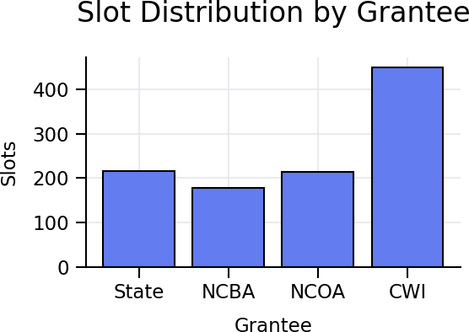

Distribution Ratios
Provider-area ratios reflect eligible individuals across regions, including poverty rates and demographic patterns.

Disruption Avoidance During Redistribution
NC minimizes disruption through participant communication, transfer protocols, and coordinated grantee transitions.

Slot Distribution Table
A. The Table below lists the counties by Providers and their designated slot assignments. *Note the last column reflects changes in the number of positions reflective of the previous year.

Table. NC SCSEP PY 2025

County | State | NCBA | NCOA | CWI | PY 24
Alamance |  | 19
Alexander |  |  |  | 4
Alleghany |  |  |  | 2
Anson | 4
Ashe |  |  |  | 5
Avery |  |  |  | 3
Beaufort |  |  | 8
Bertie |  |  | 3
Bladen | 4 |  |  | 3 | -1 NC
Brunswick |  |  |  | 17
Buncombe | 12 |  |  | 14 | -1 NC -2 CWI
Burke |  |  |  | 13
Cabarrus | 14 |  |  |  | -1 NC
Caldwell |  |  |  | 11
Camden |  |  | 2
Carteret |  |  | 7 |  | -1 CWI
Caswell |  | 3
Catawba |  |  |  | 15 | -1 CWI
Chatham |  | 8
Cherokee |  |  |  | 6

County | State | NCBA | NCOA | CWI | PY 24
Chowan |  |  | 3
Clay |  |  |  | 3
Cleveland | 9 |  |  | 5
Columbus |  |  |  | 9
Craven |  |  | 10 |  | -1 NCOA
Cumberland |  |  |  | 31 | -1 CWI
Currituck |  |  | 2
Dare |  |  | 2
Davidson |  |  |  | 21
Davie |  |  |  | 4
Duplin |  |  | 6
Durham |  | 24
Edgecombe | 8
Forsyth |  |  |  | 38
Franklin |  |  | 6 |  | -1 NCOA
Gaston |  |  |  | 26
Gates |  |  | 2
Graham
Granville |  | 8 |  |  | -1 NCBA
Greene |  |  | 3
Guilford |  | 51
Halifax | 8 |  | 3
Harnett |  | 13
Haywood |  |  |  | 8
Henderson | 4 |  |  | 6 | -1 NC -1 CWI

County | State | NCBA | NCOA | CWI | PY 24
Hertford |  |  | 3
Hoke | 6
Hyde |  |  | 2
Iredell | 14
Jackson |  |  |  | 4
Johnston |  |  | 19
Jones |  |  | 2
Lee |  |  |  | 7
Lenoir |  |  | 9 |  | -1 NCOA
Lincoln |  |  |  | 10
McDowell | 6
Macon |  |  |  | 8
Madison |  |  |  | 3
Martin |  |  | 4
Mecklenburg | 26 |  |  | 42
Mitchell |  |  |  | 3
Montgomery |  | 4
Moore |  |  |  | 8 | -1 CWI
Nash | 9 |  | 5
New Hanover |  |  |  | 21
Northampton | 4
Onslow |  |  |  | 14
Orange |  | 8 |  |  | -1 NCBA
Pamlico |  |  | 3
Pasquotank |  |  | 5

County | State | NCBA | NCOA | CWI | PY 24
Pender |  |  |  | 6
Person |  | 5
Perquimans |  |  | 2
Pitt |  |  | 17
Polk | 3
Randolph |  | 15 |  |  | -1 NCBA
Richmond | 4 |  |  | 3
Robeson | 15 |  |  | 7 | -1 CWI
Rockingham |  | 13 |  |  | -1 NCBA
Rowan | 16
Rutherford | 11
Sampson |  |  | 8
Scotland | 6
Stanly | 8
Stokes |  |  |  | 6 | -1 CWI
Surry |  |  |  | 11
Swain |  |  |  | 2
Transylvania | 3 |  |  |  | -1 NC
Tyrell
Union | 6 |  |  | 5
Vance |  | 6
Wake |  | 6
Warren |  | 4 | 52
Washington |  |  | 3
Watauga |  |  |  | 5

County | State | NCBA | NCOA | CWI | PY 24
Wayne |  |  | 14 |  | -1 NCOA
Wilkes |  |  |  | 9 | -1 CWI
Wilson | 10 |  | 3
Yadkin |  |  |  | 5
Yancey |  |  |  | 3
TOTALS | 210 | 187 | 208 | 426 | -23

