TELEHEALTH: Getting Started Checklist
What is Remote Patient Monitoring? Remote Patient Monitoring (RPM) is the use of a connected electronic tool to record personal health and medical data in one location for review by a provider in another location. This usually includes an actual electronic transfer of data.

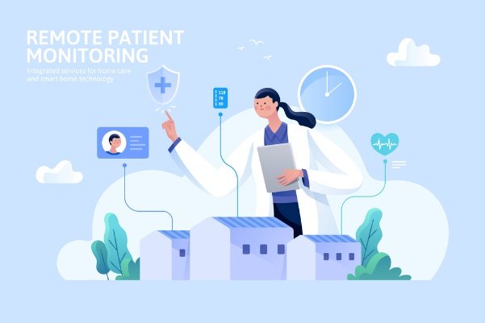
Telehealth remote patient monitoring is beneficial to both providers and patients in several ways:
- Monitoring a patient’s weight and chronic illness such as diabetes and hypertension.
- Tracking a patient’s blood pressure, heart rate, etc., and providing alerts if it’s dangerously high or low.
- Gives patients a sense of ownership of their health and wellbeing.
Example: When their RPM equipment is programmed, patients receive a pop-up reminder to complete specific tasks:
  - Take Measurements (weight, blood pressure, etc.)
  - Enter Symptoms
  - Custom Reminder
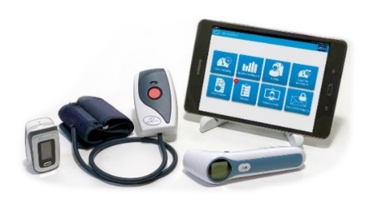
  - Medication Reminders

Remote patient monitoring is among the four telehealth modalities most useful. Benefits include:
- Improved health outcomes in underserved areas and populations.
- Better relationships between healthcare providers and the communities they serve and
provide them with resources that remote patients might not otherwise be able to access.

