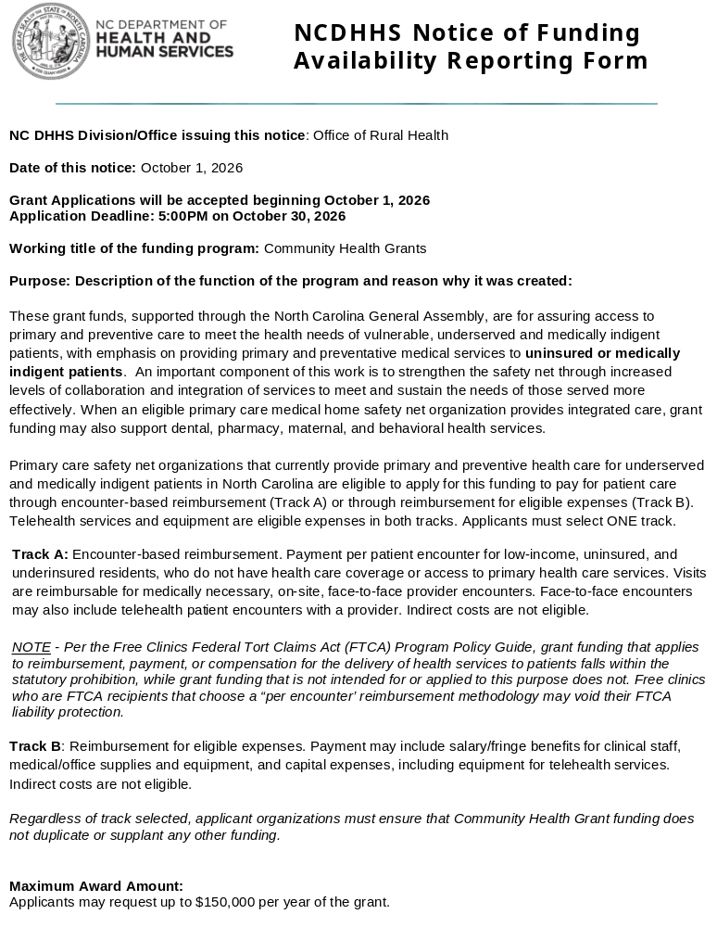ORH anticipates that approximately 33 applicants will receive three-year funding. Successful applicants will be required to attend a grant award workshop.

Proposed Project Period or Contract Term:
State Fiscal Year 2028: July 1, 2027 – June 30, 2028

Eligibility:
All primary care safety net organizations that currently provide direct primary and preventive care and serve as a medical home are eligible to apply. This includes:
- Federally Qualified Health Centers and Look-Alikes (FQHCs),
- Free and Charitable Clinics,
- Health Departments,
- Non-Profit, Hospital-Owned Primary Care Clinics,
- State-Designated Rural Health Centers,
- School-Based and School-Linked Health Centers,
- AHEC Clinics,
- Other Non-Profit Community Organizations that provide direct primary and preventive patient care to low-income, uninsured, underinsured and medically vulnerable populations.

The purpose of grants awarded under this program is to assure access to primary and preventive care for vulnerable, underserved and medically indigent patients in the state, with emphasis on providing primary and preventative medical services to uninsured or medically indigent patients.

Primary care* is defined as care provided by physicians specifically trained for and skilled in comprehensive first contact and continuing care for persons with any undiagnosed sign, symptom, or health concern. There are providers of health care other than physicians who render some primary care services. Such providers may include nurse practitioners, physician assistants, and some other healthcare providers.
*American Association of Family Practice: https://www.aafp.org

Integrated Care* is defined as the systematic blending and coordination of physical health, behavioral health (mental health and substance use services), and non-clinical social support services to treat the whole person.
*NCDHHS NC Medicaid Division of Health Benefits: https://medicaid.ncdhhs.gov

Uninsured* is defined as not having coverage under private health insurance, Medicare, Medicaid, a state-sponsored or other government-sponsored plan or program.
*Center for Disease Control and Prevention: https://www.cdc.gov

Underinsured* is defined as having coverage, but because of high premiums or out-of-pocket cost patients are unable to meet their share of costs and may skip necessary care.
*Centers for Medicare & Medicaid Services: https://www.cms.gov

Encounters* are defined as documented face-to-face contact between a beneficiary and a provider.
*Centers for Medicare & Medicaid Services: https://www.cms.gov

Only one application can be submitted per eligible organization. An eligible organization must submit one application rather than applications by service site, “doing business as” or under separate EINs that are all connected to the same eligible organization.

This application is for eligible organizations wishing to apply for new Year 1 funding. Organizations seeking Year 2 and/or Year 3 continuation funding must follow the separate Continuation Application process which will open mid-January.

Eligible organizations that currently provide direct primary and preventive care may use these funds to support any of the following:
- Health promotion, health maintenance, health counseling,
- Disease prevention,
- Patient education, AHEC Coaches,
- Diagnosis and treatment of acute and chronic illnesses,
- Integrated care services (dental, pharmacy, behavioral health, care coordination/care management by a primary care entity),
- Women’s health, maternal and child health that supports health care services in a primary care setting,
- Collaborative, community-based, whole person-centered health care delivery models,
- Telehealth patient care,
- Care coordination and navigation, including activities related to Medicaid Expansion,
- Community Health Workers.

As a condition of receiving a grant award, successful applicants must:
- Complete the contract process.
- Submit a monthly expense report in a specified format for reimbursement.
- Submit performance measures and reports, established by the Office of Rural Health, throughout the grant term.
- Use an electronic financial software application (EXCEL spreadsheets are not an acceptable format)
- Document collaboration among safety net and social support organizations specifying the distinct roles of each organization and the designated fiscal responsibilities.
- Connect or have a plan to connect NC HealthConnex (To meet the state’s mandate, a provider is “connected” when its clinical and demographic information is sent to NC HealthConnex at least twice daily.) For further information, please see the HIEA website: https://hiea.nc.gov)
- Comply with ORH’s policies and procedures for contract development, execution, and management. Organizations that do not follow ORH’s contract-signing process and ensure the contract is signed within 30 days of receipt may forfeit their award.
Eligible organizations that have a current Community Health Grant award entering Year 2 or Year 3 on July 1, 2026, must have a new project scope or serve a different patient population if submitting an application in response to this Request for Application.
How to Apply:
Access the Zengine application portal using the link below:

- Use the Zengine portal application link to create a profile to access the application. The profile will require creating a username and password. The Zengine portal to submit your application opens on October 1, 2026, and closes at 5:00 PM on October 30, 2026.

Click link to access electronic version of application:
https://webportalapp.com/sp/ncdhhs_orh_community_health_new

Applications must be complete, and agencies must respond to all application requirements. Incomplete applications, or applications not completed in accordance with the instructions, will not be reviewed.

All applicants will receive a confirmation notice after an application has been successfully submitted.

For assistance with the Zengine portal contact: Sharema Williams: sharema.williams@dhhs.nc.gov

Technical Assistance Webinars:
Webinars for all Community Health Grant applicants will be held on the following dates:
Organizations are invited to participate in one or both webinars.

October 8, 2026, at 10:00 am
Join: Join this meeting now
Meeting ID: 237 035 887 702 117
Passcode: dk79Jy7y

Need help? | System reference
Dial in by phone +1 984-204-1487,,11961538# United States, Raleigh
Phone conference ID: 119 615 38#
Join on a video conferencing device
Tenant key: ncgov@m.webex.com
Video ID: 119 971 331 7
More info
________________________________________________________________________________

October 19, 2026, at 10:00 am
Join: Join this meeting now
Meeting ID: 250 339 852 810 038
Passcode: Yo7MU3u8

Need help? | System reference
Dial in by phone +1 984-204-1487,,308506206# United States, Raleigh
Phone conference ID: 308 506 206#
Join on a video conferencing device
Tenant key: ncgov@m.webex.com
Video ID: 117 191 525 1
More info
_____________________________________________________________________

To obtain further information: Funding Agency Contact/Inquiry Information:
Nicole Fields-Pierre: nicole.fields-pierre@dhhs.nc.gov

For assistance with the application link:
Sharema Williams: sharema.williams@dhhs.nc.gov

