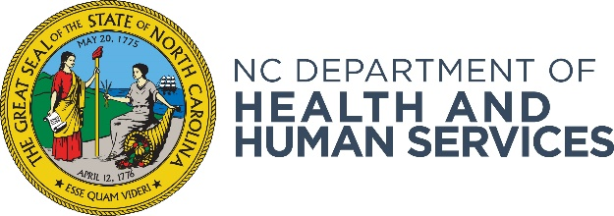

NC DHHS Notice of Funding Availability Reporting Form

DHHS Division/Office issuing this notice: Division of Social Services

Date of this Notice: February 1, 2024

Title of the Funding Program: Substance Abuse Prevention & Treatment Block Grant

Purpose of Program: Ten contracted counties to provide service delivery of child welfare services, case management, peer mentoring support and treatment coordination for the START model.

Description of the Program: In North Carolina, parental substance use disorder (SUD) is a top contributory factor to foster home placement. The START model has shown to have improved outcomes for families and children receiving child protection services. Mothers in the START program have nearly double the sobriety rate of non-START counterparts. START is a collaborative model which uses a variety of strategies to promote collaboration and systems-level change within and between child welfare agencies, substance use and mental health treatment providers, the judicial system, and other family-serving entities. Additional information about the START program can be found at https://www.cffutures.org/start/.

Eligibility: Upon review of the Request for Application (RFA) and the Technical Assistance Webinar, counties will be able to ascertain their eligibility; including their understanding of the START Model, the preliminary requirements and their willingness to engagement and to participate in technical assistance and trainings.

How to Apply:
Visit https://www.ncdhhs.gov/divisions/social-services/public-notices to download the application.

Technical Assistance Webinar: February 21, 2024 2:00 PM – 3:00 PM

Question Submission Deadline: February 23, 2024 by 5:00 PM

Application Deadline: Friday, March 15, 2024 by 5:00 PM

For More Information Contact: heather.mcallister@dhhs.nc.gov
Heather McAllister, MSW, LCSW, LCAS, CBIS
Family First Prevention Services Manager
Division of Social Servies, Child Welfare

