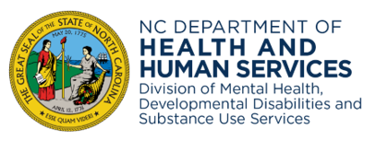

The State Consumer and Family
Advisory & State to Local Collaboration
2024-2025 Meeting Schedule
State CFAC Meeting
Hybrid Meeting
Every 2nd Wednesday, from 9:00-3:00 p.m.

Join link: Please see the monthly agenda for the correct link.
Register prior to the meeting to receive login details and dial-in information.

*Location: 2104 Umstead Drive, Raleigh, NC 27699, Ashby Building, CR 115
2024 Schedule  July10, 2024  August 14, 2024-Retreat  September 12,2024-Thursday  October 09, 2024 (Canceled)  November 13, 2024  December 4, 2024 | 2025  January 08,2025  February 12, 2025  March 12,2025  April 09, 2025  May 14,2025  June 11, 2025
State to Local Collaboration
Virtual Meeting
Every 4th Wednesday, from 6:00 – 7:30 p.m.
Join Link:
https://www.zoomgov.com/meeting/register/vJItcO-przMiGlBgjTpXMqNMtrPbDPI0Iw0
2024 Schedule  July 24, 2024  August 28, 2024  September 25, 2024  October 23, 2024  November No Cal  December 18, 2024 | 2025 Schedule  January 22, 2025  February 26, 2025  March 26, 2025  April 23, 2025  May 28, 2025  June 25, 2025
*Location subject to change.
Red indicates change in meeting

