Stephen E. Sallee Assistive Technology Awards of Excellence

Purpose of the Awards: To recognize individuals who have contributed significantly to the promotion of assistive technology services to North Carolinians with disabilities who need assistive technology.
Two Award Categories: 1) Professional, Volunteer, or Advocate and 2) Assistive Technology User, Family Member, or Caretaker
Stephen E. Sallee – A Brief Biography
The Stephen E. Sallee Assistive Technology Awards of Excellence offers us a great way to recognize professionals, advocates, volunteers, and family members, caretakers or users
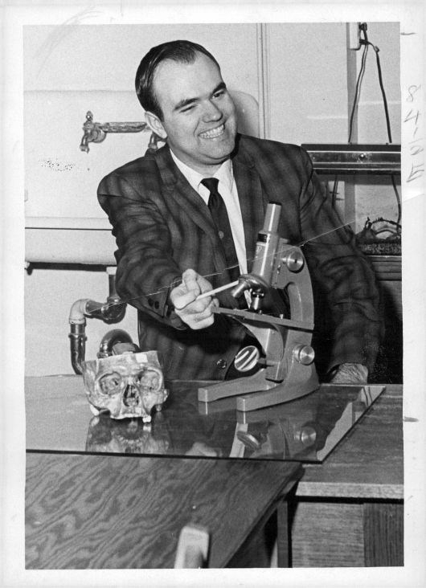
of assistive technology (AT) for their support of North Carolinians who use assistive technology.
Stephen E. Sallee became a wheelchair user after a diving accident in 1962. Despite physical challenges, he received both his BS and MS degrees from the University of Oklahoma and his EDS from Appalachian State University. After a number of years of teaching, Steve decided that he needed to devote more time to maintaining his health. He moved to Winston-Salem, where he co-founded the Adaptables, a cross-disability support group that became a staple in the community. In 2001, The Adaptables applied for and were awarded the distinction of becoming a federally funded Center for Independent Living and in 2020, The Adaptables rebranded the organization as “Solutions for Independence”.
He began volunteering with the NC Assistive Technology Program and, later, became a part-time technologist with the agency. Steve’s interest in technology that assisted people with disabilities led to him helping to develop the assistive technology center in Winston-Salem, which serves the north central region of North Carolina. Steve died on May 10, 2002.
The Stephen E. Sallee Assistive Technology Awards of Excellence commemorates his contributions to the field and acknowledges our deep gratitude for his service to persons with disabilities.

